Doxycycline Hyclate Tablets: Disintegration Image Analysis of Groups A and B
Edited English document of the drug-related discussion only

Scope of the Discussion
The task was to analyze disintegration images from two groups of Doxycycline Hyclate Tablets, Group A and Group B. Each group contained five images taken at 15-minute intervals: 0, 15, 30, 45, and 60 minutes. The purpose was to describe the disintegration process in English for each image and then determine whether the two image sets appeared to come from the same drug product or formulation.
The analysis below is based only on the visible image evidence. It cannot chemically confirm the active ingredient. It can, however, compare visible formulation-related behavior such as size, shape, surface breakdown, residue formation, turbidity, and disintegration speed.
Special attention was given to changes in tablet size and shape, because size, shape, contour loss, swelling, collapse, and residual-mass patterns are useful visual markers when comparing tablet disintegration behavior.

Knowledge-Base Framework Used for the Analysis
The disintegration-description framework used eight dimensions:
- Color change: Changes in tablet color, solution color, transparency, turbidity, and spatial distribution of color.
- Shape change: Transformation from intact tablet shape to swelling, rounding, flattening, cracking, fragmentation, or residue formation.
- Surface texture change: Changes in smoothness, roughness, porosity, powdering, peeling, cracking, and granular texture.
- Volume change: Reduction, swelling, collapse, or redistribution of the visible tablet mass over time.
- Dissolution speed and time: Time-based progression of wetting, swelling, erosion, particle release, collapse, and final residue.
- Physical state change: Transition from hard coherent tablet to softened, porous, weakened, collapsed, or dispersed material.
- Dissolution medium: Visible medium properties such as clarity, local turbidity, suspended particles, and sediment; pH or composition is not inferred unless provided.
- Fragment distribution with density: Location, size, density, suspension, settling, and horizontal spread of fragments and residue.

User Instructions Captured in the Discussion
- Analyze two groups of Doxycycline Hyclate Tablet disintegration images, labeled Group A and Group B.
- Each group contains five images, and each image is taken 15 minutes apart.
- Describe each image in English, with careful attention to tablet size and shape changes.
- Avoid unsupported assumptions and reduce hallucinations; describe only what can be seen from the images.
- At the end, compare Groups A and B across the eight dimensions and determine whether they appear to be from the same drug product/formulation.

Group A: Image-by-Image Disintegration Analysis

Group A — Picture 1, 0 minutes
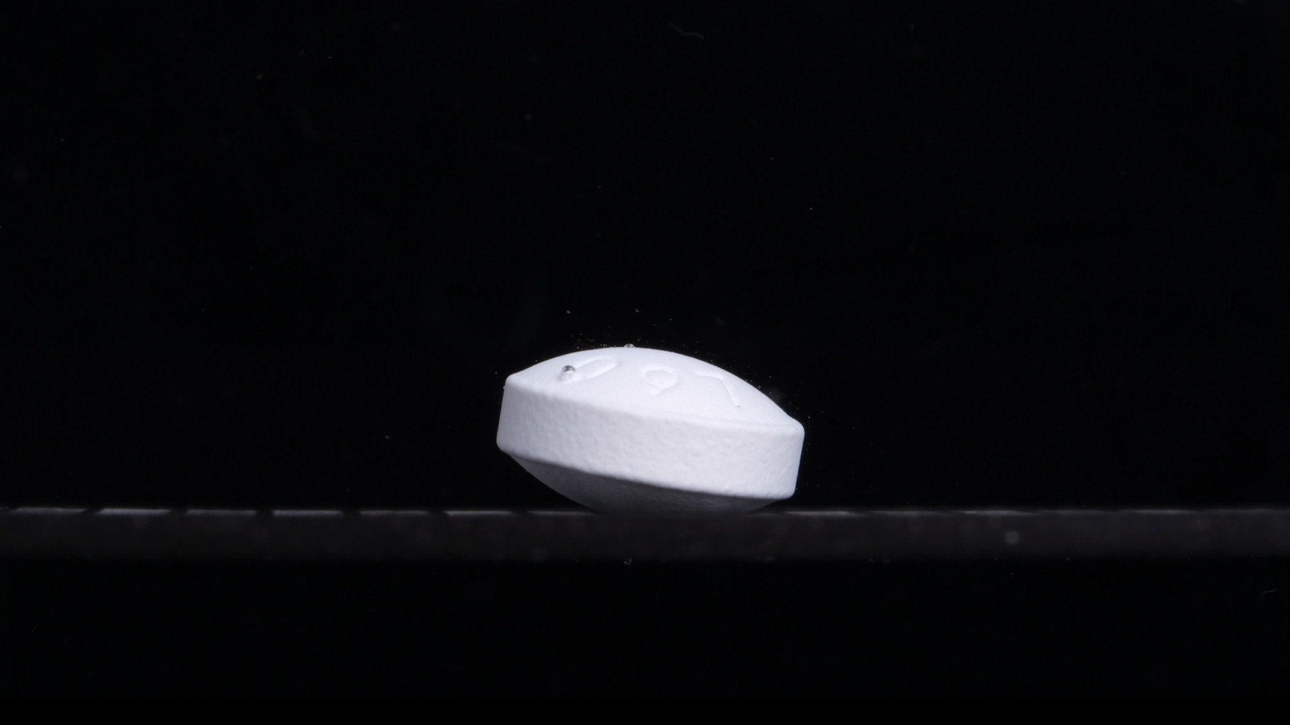
Group A, 0 minutes.
Overall observation: At 0 minutes, the tablet appears largely intact. It is a white to off-white, oval/oblong, thick, biconvex tablet resting at a slight angle on the bottom surface. No obvious disintegration, cracking, swelling, or fragment release is visible. This image serves as the baseline reference for the later time points.
Color change: The tablet is uniformly white/off-white. The surrounding visible medium/background appears dark and visually clear, with no obvious cloudiness, yellowing, or suspended powder. No color diffusion from the tablet into the medium is visible.
Shape change: The tablet maintains a complete oval/oblong shape with a thick side wall and a rounded biconvex upper surface. The contour remains sharp and continuous, with no visible breakage, splitting, or edge collapse.
Surface texture change: The surface appears mostly smooth and compact. A few small glossy spots or droplets are visible on the upper surface, but they do not clearly indicate erosion or disintegration. No obvious pores, peeling, rough powder layer, or fibrous structures are visible.
Volume change: No visible volume reduction is present. The tablet appears full-sized, with preserved thickness and width. There is no obvious swelling or collapse.
Dissolution speed and time: At this initial time point, the apparent dissolution/disintegration speed is not visually detectable. No particles or cloudy plume are seen around the tablet.
Physical state change: The tablet remains a solid, coherent body. There is no visible cracking, swelling, internal collapse, or fragmentation.
Dissolution medium: The visible medium appears clear. There is no obvious turbidity, sediment layer, foam, or colored diffusion around the tablet. The exact medium composition cannot be determined from the image.
Fragment distribution and density: No detached fragments are clearly visible around the tablet. Fragment density is visually near zero.
Baseline conclusion: Group A at 0 minutes is an intact, white/off-white, oval/oblong, thick biconvex tablet with no visible disintegration. The key baseline features are intact size, smooth surface, continuous oval outline, preserved thickness, and absence of visible fragments or turbidity.

Group A — Picture 2, 15 minutes
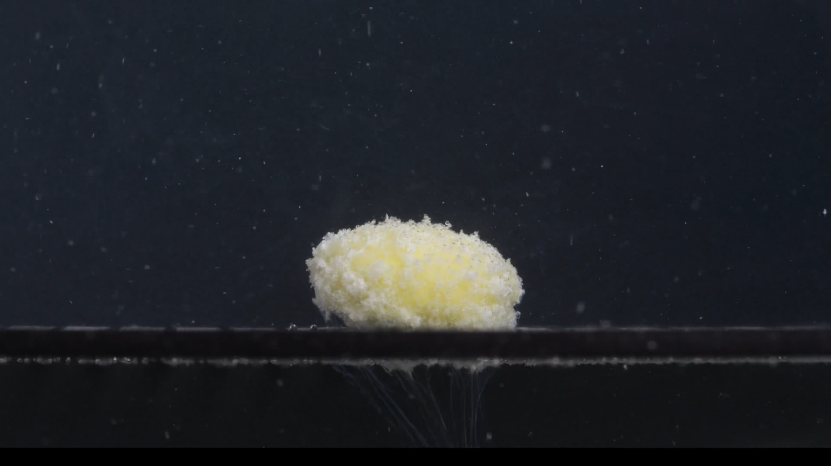
Group A, 15 minutes.
Overall observation: At 15 minutes, the tablet is no longer a smooth, sharply outlined oval tablet. It has changed into a swollen, rough, porous mound with a pale yellow central region and a white granular outer layer. The original tablet outline is still partly recognizable, but the sharp edges and smooth surface have largely disappeared.
Color change: The tablet has changed from mostly white/off-white to a white and pale yellow mixture. The yellow color is most visible in the central upper region, while the outer area remains more whitish. The surrounding medium contains small bright particles, suggesting suspended or detached material, but the whole medium does not appear uniformly yellow.
Shape change: The original smooth oblong/biconvex shape has changed into a rounded, irregular, dome-like mound. The tablet edge is no longer sharp; the contour is blurred, rough, and uneven. The original straight side wall has largely disappeared.
Surface texture change: The surface has become very rough, porous, granular, and powdery. The smooth coating-like surface is no longer visible. The outer layer appears loosened and crumbling, with many fine particles attached.
Volume change: The tablet does not simply look smaller; it appears swollen and expanded into a softer mound. The original compact volume has become looser and more porous, so the apparent size may look larger even though structural integrity has decreased.
Dissolution speed and time: By 15 minutes, visible disintegration is substantial. The process appears moderate to fast after the initial wetting stage, dominated by swelling, surface erosion, and granule release rather than immediate complete dissolution.
Physical state change: The tablet has changed from a hard coherent solid into a softened, swollen, partially collapsed structure. The core still appears to remain as one main mass, while the exterior is clearly crumbling.
Dissolution medium: The visible medium contains many small suspended specks or particles. It appears slightly more turbid than at 0 minutes, but not fully cloudy or uniformly colored. Faint downward trails below the tablet may reflect settling fine material.
Fragment distribution and density: Fragment density is highest on and immediately around the tablet surface. Most visible fragments are fine powder-like particles, not large broken pieces.
Progression from 0 to 15 minutes: Group A changes from an intact, smooth, white oblong tablet into a pale yellow-white, swollen, granular mound. The main changes are loss of sharp shape, surface roughening, possible swelling/spreading, and fine particle release.

Group A — Picture 3, 30 minutes
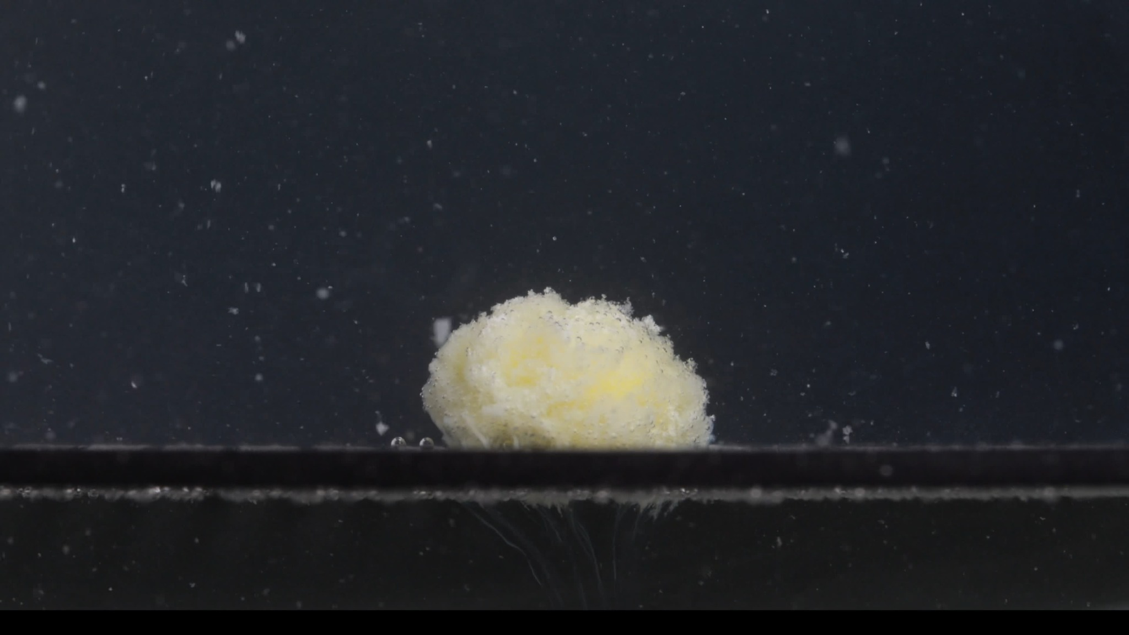
Group A, 30 minutes.
Overall observation: At 30 minutes, the tablet remains as a single main mound, but it is clearly softened, swollen, porous, and granular. Compared with the 15-minute image, the overall appearance is similar, although slightly more eroded and irregular. The original smooth oval tablet shape is no longer visible.
Color change: The tablet shows a pale yellow to creamy yellow center with a whitish outer granular layer. The yellow coloration remains mainly inside the tablet mass rather than spreading uniformly through the entire medium.
Shape change: The original oblong/biconvex tablet has transformed into an irregular dome-like mound. The surface outline is rough and uneven, especially along the upper and side edges. The tablet still remains as one main body.
Surface texture change: The surface is highly rough, porous, and powdery. Fine granules cover most of the visible surface. A shallow uneven area on the left side suggests localized weakening or partial collapse, but no definite deep crack can be confirmed from this image alone.
Volume change: The tablet has not fully dissolved. Compared with 0 minutes, the compact tablet volume has changed into a larger-looking but less dense porous mound. Compared with 15 minutes, the mound appears slightly lower and less sharply defined, suggesting gradual erosion rather than sudden collapse.
Dissolution speed and time: Between 15 and 30 minutes, disintegration continues at a moderate rate. The change is not dramatic; the tablet remains one main mass. The process appears dominated by surface erosion, swelling, and fine particle release.
Physical state change: The tablet has changed from a hard solid into a softened, weakened, partially disintegrated mass. The outside appears friable and powdery, and the inner yellow material seems partly exposed.
Dissolution medium: The medium contains scattered small particles. Local turbidity appears around the disintegration site, but the background remains relatively dark and transparent. Faint downward streaking below the tablet is visible.
Fragment distribution and density: Fragment density is highest on the tablet surface and immediately around it. Most fragments appear to be fine powder-like particles. Some particles are suspended nearby, while some material appears to settle downward.
Progression from 0 to 30 minutes: Group A changes from a smooth intact white oblong tablet into a yellow-white, swollen, porous, granular mound. The tablet loses its original sharp outline early but still remains as one main mass at 30 minutes.

Group A — Picture 4, 45 minutes
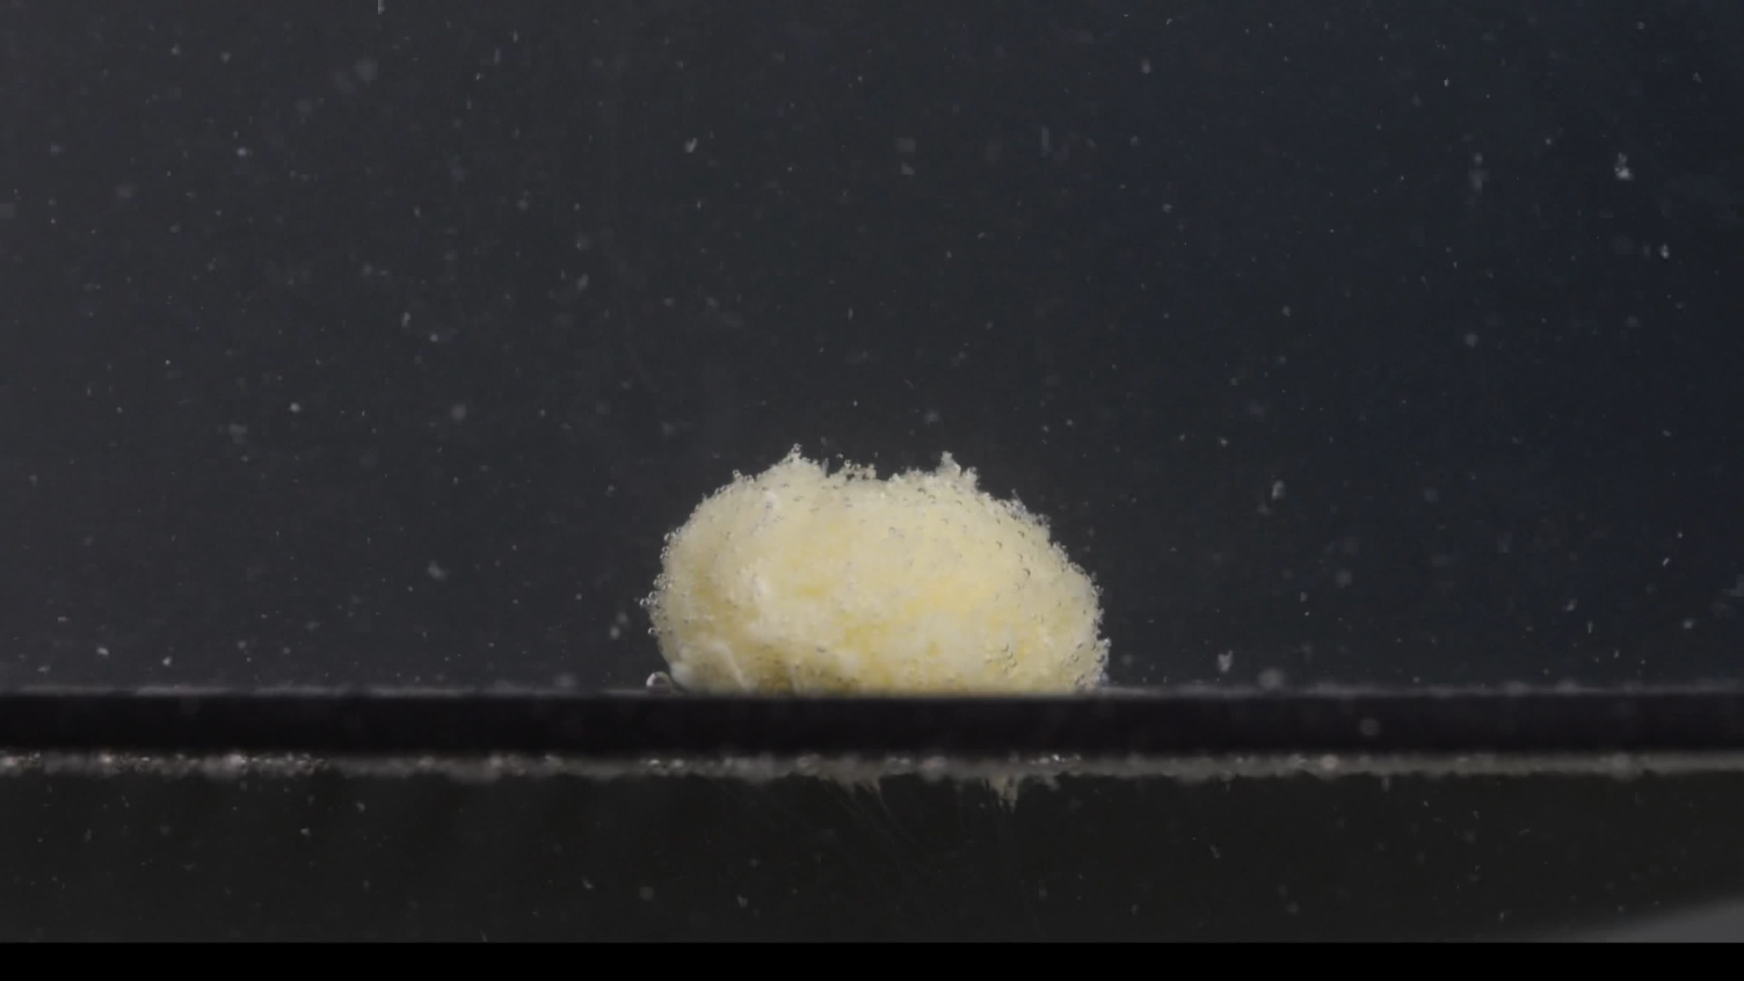
Group A, 45 minutes.
Overall observation: At 45 minutes, the tablet still remains as one main residual mass, but it is no longer a defined tablet. It appears as a soft, swollen, pale yellow-white porous mound with a very rough granular surface. Compared with 30 minutes, the change is gradual rather than dramatic.
Color change: The tablet is mainly pale yellow to creamy yellow, with some lighter whitish areas on the surface. The yellow color is broadly distributed across the mound but remains concentrated in the tablet mass rather than fully diffused into the whole medium.
Shape change: The original oblong biconvex tablet shape has disappeared. The residual body is now a rounded, irregular mound with a poorly defined outline. The upper edge is rough and uneven, with small protrusions and loose material.
Surface texture change: The surface is strongly rough, porous, and granular. Fine powder-like material covers the visible surface. No clear large crack line is visible, but the surface appears internally weakened and crumbly.
Volume change: Compared with the original 0-minute tablet, the compact tablet volume has clearly changed into a less dense, swollen-looking porous mass. Compared with 30 minutes, the visible mass does not appear much smaller; the main change is continued loss of compactness and edge definition.
Dissolution speed and time: From 30 to 45 minutes, the apparent disintegration rate is slow to moderate. The tablet is still not completely dispersed, indicating that late-stage dissolution is not rapid.
Physical state change: The tablet has changed from a hard intact solid into a softened, swollen, weakened residual mass. The core still appears to hold together as one main body; full collapse is not visible.
Dissolution medium: The visible medium contains many small suspended or floating particles. The area near the tablet appears slightly turbid, but the whole background remains relatively transparent/dark.
Fragment distribution and density: Fragment density is highest on the tablet surface and immediately around the mound. Most fragments are fine granules or powder-like particles, with some material collecting near the bottom plane.
Progression from 0 to 45 minutes: Group A consistently shows swelling, surface roughening, fine particle release, and gradual erosion. One main residual mass remains.

Group A — Picture 5, 60 minutes
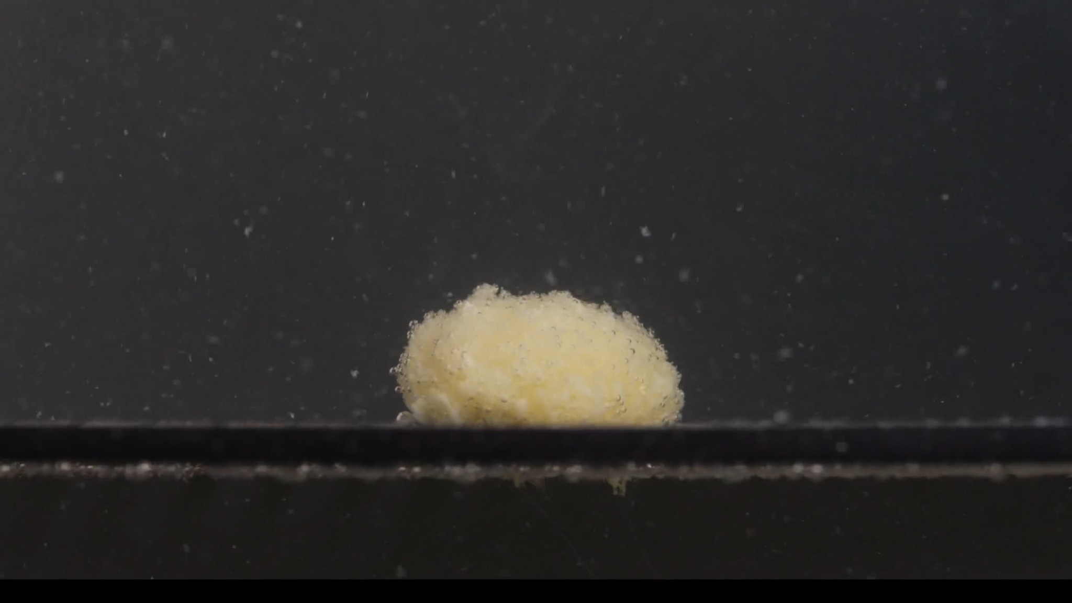
Group A, 60 minutes.
Overall observation: At 60 minutes, the tablet is still visible as one main residual mound. It has not fully dissolved or dispersed. The original 0-minute tablet shape is completely lost, but the remaining mass stays in one place and retains a rounded, dome-like form. Compared with 45 minutes, the change is limited and gradual.
Color change: The visible mass is mainly pale yellow/creamy yellow, with some lighter whitish areas. The yellow color remains concentrated in the tablet residue rather than spreading evenly through the whole medium.
Shape change: The original white oblong biconvex tablet is no longer recognizable. The tablet has become an irregular rounded mound with a rough uneven outline. The top edge is loose and granular, but the mass is still coherent.
Surface texture change: The surface is highly rough, porous, and granular. The outer layer looks soft and crumbly, with many fine particles attached. There are no obvious large cracks or separated large fragments in this frame.
Volume change: Compared with 0 minutes, the compact tablet volume has clearly changed into a looser, swollen-looking porous residue. Compared with 45 minutes, the mound does not appear dramatically smaller. The main size-related change is slight loss of edge definition rather than major shrinkage.
Dissolution speed and time: From 45 to 60 minutes, visible disintegration appears slow. The tablet remains as a single main mass after one hour, so complete disintegration is not observed within the 60-minute sequence.
Physical state change: The tablet has changed from a hard intact solid into a softened, swollen, weakened residue. The structure appears porous and friable, but the core still holds together.
Dissolution medium: The medium contains scattered small particles. Local turbidity is present around the tablet area, but the whole medium still appears relatively transparent against the dark background.
Fragment distribution and density: Fragment density is highest on and immediately around the residual mound. Most visible fragments are fine powder-like particles, not large chunks. Some particles are suspended, while others appear to settle near the bottom.
Group A summary from 0 to 60 minutes: The tablet undergoes early swelling and surface roughening, followed by slow sustained erosion. It releases fine particles but does not break into large fragments or fully dissolve within 60 minutes. The characteristic features are transition from white to pale yellow, loss of the original oblong shape by 15 minutes, and persistence of a single porous mound through 60 minutes.

Group B: Image-by-Image Disintegration Analysis

Group B — Picture 1, 0 minutes
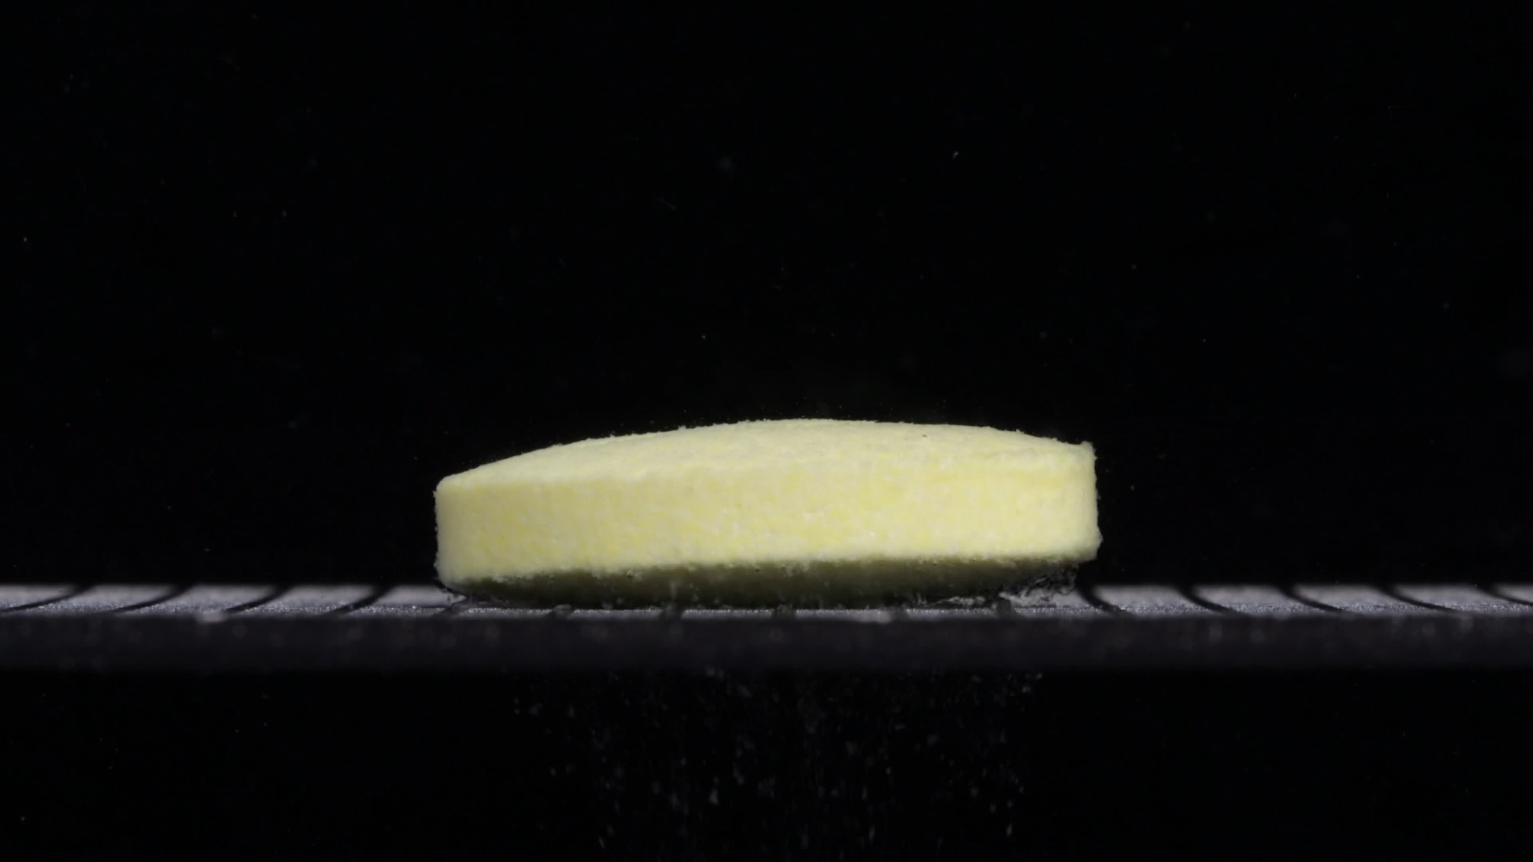
Group B, 0 minutes.
Overall observation: At 0 minutes, Group B shows an intact, pale yellow, elongated tablet resting horizontally on the bottom support. It appears more flat-sided and cylindrical/oblong than Group A at 0 minutes. No obvious disintegration, cracking, collapse, or fragment release is visible. This image serves as the baseline reference for Group B.
Color change: The tablet is already pale yellow/light cream-yellow at the starting point. The surrounding visible medium/background appears mostly clear and dark, with no obvious yellow diffusion or strong turbidity.
Shape change: The tablet appears elongated, oval-oblong, and horizontally positioned. The visible side wall is relatively straight and continuous. The top surface is broad and only slightly curved, not strongly dome-shaped.
Surface texture change: The surface is mostly intact, but not perfectly glossy. The side and top surface show a slightly matte or fine-grained texture. No clear pores, cracks, peeling, or powdery erosion are visible.
Volume change: No visible volume loss is present. The tablet retains its full length, height, and side-wall structure. It appears longer and flatter than Group A's 0-minute tablet, although exact size cannot be measured from the image alone because camera distance and angle may differ.
Dissolution speed and time: At 0 minutes, visible dissolution or disintegration has not yet begun. No obvious particles, clouding, or surface breakdown are seen.
Physical state change: The tablet remains a solid, coherent body. No swelling, cracking, internal weakening, or collapse is visible.
Dissolution medium: The visible medium appears mostly clear against the dark background. There is no obvious cloudiness or sediment cloud around the tablet.
Fragment distribution and density: No detached fragments are clearly visible around the tablet. Fragment density is visually near zero.
Immediate comparison with Group A at 0 minutes: Group B does not look identical to Group A. Group A started white/off-white and thicker/biconvex, whereas Group B starts pale yellow and appears longer, flatter, and more horizontally cylindrical/oblong. This baseline difference does not prove a different drug, but it is significant for later comparison.

Group B — Picture 2, 15 minutes
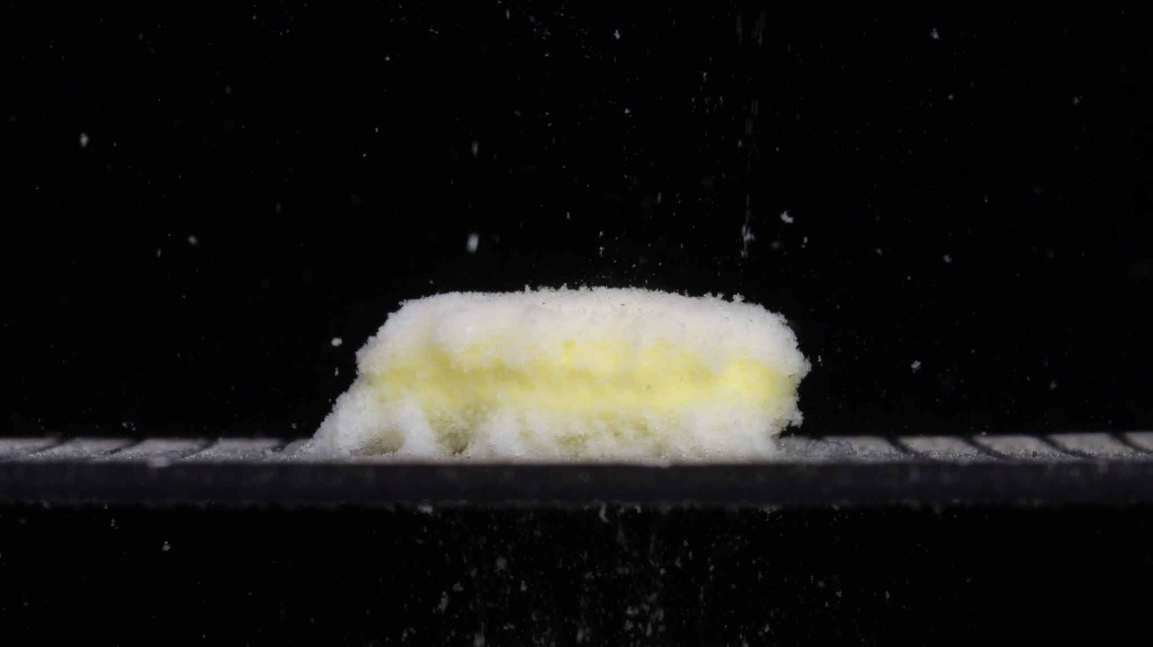
Group B, 15 minutes.
Overall observation: At 15 minutes, Group B shows clear disintegration, but the tablet still preserves much of its elongated horizontal form. It has changed from a compact pale-yellow tablet into a swollen, rough, yellow-white porous mass. The surface is no longer smooth, and fine particles are visible in the surrounding medium.
Color change: The tablet remains mainly pale yellow, but the surface now has more white powdery material, especially along the top and outer edges. The yellow color is distributed through the central body, while the outer layer appears whiter and more granular.
Shape change: The tablet still keeps a long, horizontal, oblong/cylindrical outline. The original straight side wall is softened, but the tablet's length remains clearly visible. The top edge is uneven and slightly fluffy/eroded.
Surface texture change: The surface has become rough, porous, and powdery. A white granular layer covers much of the top and side surface. No single deep crack is clearly visible, but the exterior appears weakened and eroded.
Volume change: Compared with 0 minutes, the tablet appears swollen and less compact. The height looks slightly increased or puffed due to water penetration and surface expansion. The tablet has not yet shrunk markedly.
Dissolution speed and time: By 15 minutes, Group B has entered an active disintegration stage. The disintegration appears moderate, with clear surface erosion and particle release but no complete breakup.
Physical state change: The tablet has changed from a firm solid into a softened, swollen, partially disintegrated mass. The core remains coherent because the tablet has not collapsed into large separate pieces.
Dissolution medium: The medium contains visible suspended particles around and above the tablet. Some fine material appears to be moving downward or settling below the support region. Local turbidity is increased but the liquid is not fully opaque.
Fragment distribution and density: Fragment density is greatest near the tablet surface, especially along the upper boundary and around the base. Most released material appears as fine powder-like particles, not large fragments.
Progression from 0 to 15 minutes: Group B changes from an intact pale-yellow elongated tablet into a yellow-white, swollen, rough, porous mass. Compared with Group A at 15 minutes, Group B remains longer and flatter, closer to its original elongated form.

Group B — Picture 3, 30 minutes
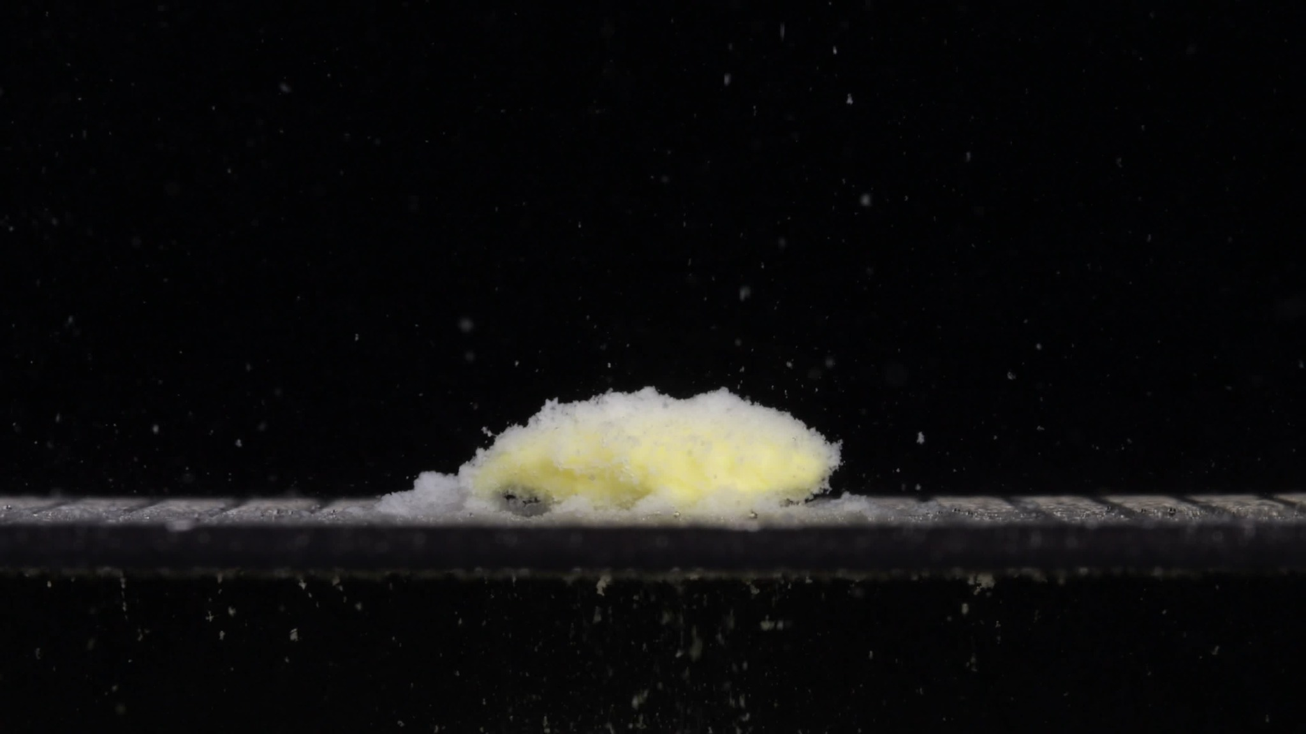
Group B, 30 minutes.
Overall observation: At 30 minutes, Group B has progressed from a swollen elongated tablet into a lower, flatter, partially collapsed yellow-white porous mass. The tablet still remains as one main residue, but compared with 15 minutes, it has lost height, spread more along the bottom surface, and released more fine white material around the base.
Color change: The main body remains pale yellow to creamy yellow. A white powdery/granular layer is visible on the top and around the edges. The yellow region is still mainly inside the residual tablet mass, not evenly diffused through the whole medium.
Shape change: The tablet no longer keeps the original intact cylindrical/oblong shape. Compared with 15 minutes, it is flatter and lower, with a more collapsed profile. The residue still extends horizontally, so the original elongated direction is partly preserved.
Surface texture change: The surface is rough, porous, and friable. The upper surface looks uneven and fluffy, with many fine granules attached. There is no clear single deep fracture line, but the whole surface appears weakened and crumbly.
Volume change: Compared with 0 minutes, the compact tablet volume has clearly lost structural integrity. Compared with 15 minutes, visible height is reduced, suggesting partial collapse or compression of the swollen mass. The tablet has spread laterally along the support surface.
Dissolution speed and time: From 15 to 30 minutes, Group B shows noticeable continuation of disintegration. The process appears moderate, with visible collapse, erosion, and particle release.
Physical state change: The tablet has changed from a swollen coherent body into a softer, partially collapsed residue. The inner yellow material remains visible, while the outer white layer appears loosened and powdery.
Dissolution medium: The medium around the tablet contains many suspended particles. Local turbidity is stronger than at 0 minutes and similar or slightly greater than at 15 minutes. Fine material appears to be settling near the bottom region.
Fragment distribution and density: Fragment density is highest around the tablet surface and along the base, especially on the left side and directly beneath the residual mass. Most fragments are fine powder-like particles.
Progression from 0 to 30 minutes: Group B changes from an intact pale-yellow elongated tablet into a swollen yellow-white mass and then a lower, flatter, more eroded residue. Compared with Group A at 30 minutes, Group B is more horizontally spread and flatter, while Group A remains a rounded mound.

Group B — Picture 4, 45 minutes
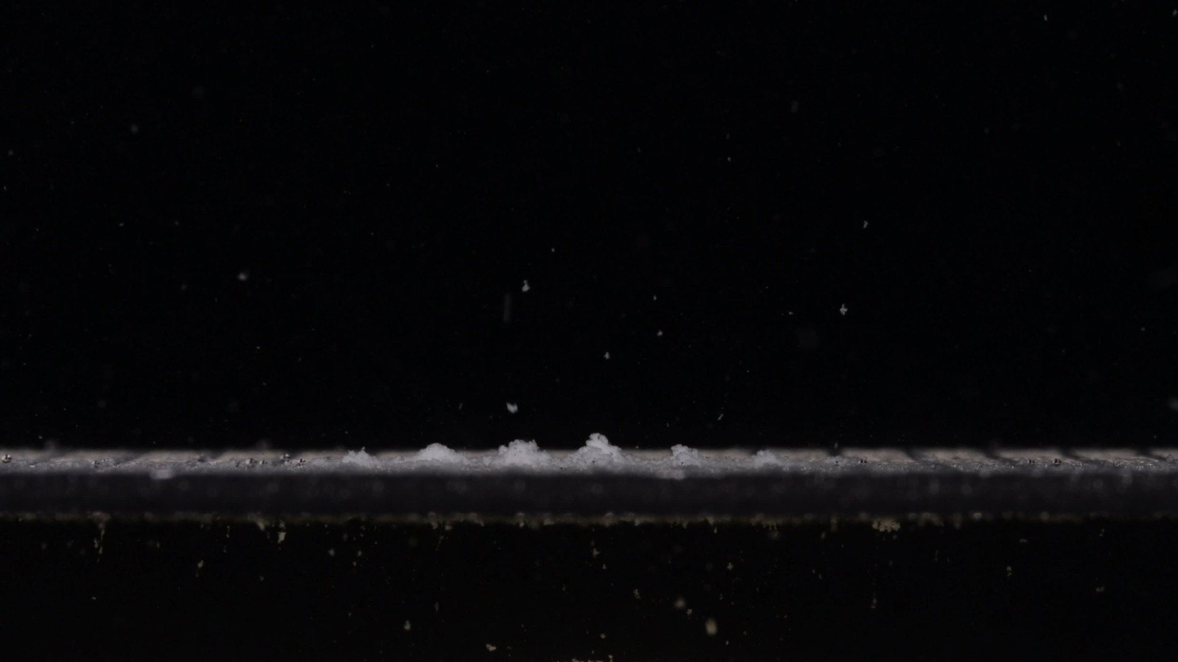
Group B, 45 minutes.
Overall observation: At 45 minutes, Group B has changed dramatically compared with the 30-minute image. The previous yellow-white residual mass is no longer visible as a coherent mound. Instead, only a thin, low layer of pale/whitish granular residue remains along the bottom surface, with a few small raised clumps. This indicates near-complete structural collapse or dispersion.
Color change: The obvious yellow central mass seen at 15 and 30 minutes is no longer clearly visible. The remaining material appears mostly whitish to very pale yellow-white. There is no strong yellow region left in the center.
Shape change: The original elongated tablet shape has disappeared. The partially collapsed mound seen at 30 minutes has flattened into a thin residue line along the bottom, with only a few small irregular clumps remaining.
Surface texture change: A continuous tablet surface is no longer present. The visible residue is powdery, granular, and uneven. Because the main tablet body has collapsed, the texture is better described as sediment texture rather than tablet-surface texture.
Volume change: Visible tablet volume is greatly decreased. Compared with 30 minutes, the reduction is especially obvious: the raised yellow-white mass has nearly disappeared. Remaining material is spread horizontally as a low-density residue layer.
Dissolution speed and time: From 30 to 45 minutes, Group B shows rapid late-stage breakdown. The tablet changes from a visible residual mound at 30 minutes to mostly dispersed residue by 45 minutes.
Physical state change: The tablet is no longer a coherent solid or swollen mass. Its physical state has changed into dispersed powder/residual sediment. The main core is no longer recognizable as a single tablet body.
Dissolution medium: The medium contains scattered suspended particles, and some material has settled along the bottom support surface. The image does not show a dense uniform cloud throughout the entire field.
Fragment distribution and density: Fragment density is concentrated mainly along the bottom surface. The residue spreads horizontally as a thin sediment-like band, with a few small clumps but no large tablet-sized fragment.
Progression from 0 to 45 minutes: Group B is much more fully broken down than Group A. At 45 minutes, Group A still has a clear rounded yellow-white residual mound, while Group B has mostly collapsed into a thin sediment layer.

Group B — Picture 5, 60 minutes
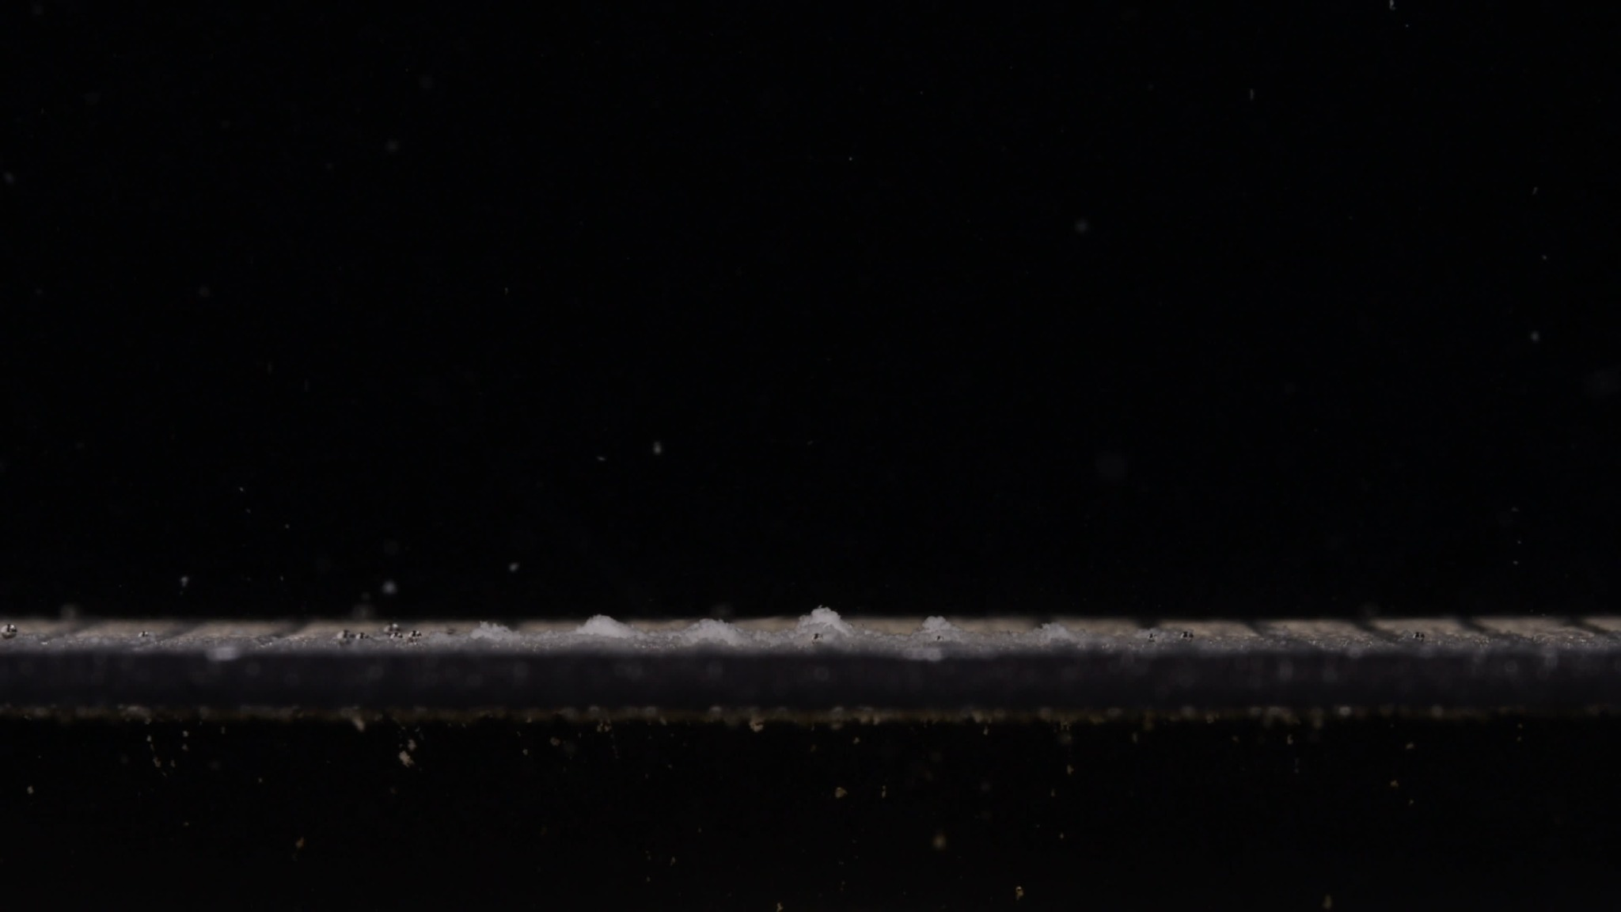
Group B, 60 minutes.
Overall observation: At 60 minutes, Group B shows almost complete loss of the original tablet body. No coherent yellow tablet core remains visible. The remaining material appears as a thin, low, whitish to very pale yellow granular residue layer spread along the bottom surface, with only a few small raised clumps.
Color change: The strong pale-yellow tablet body seen at 0 to 30 minutes is no longer visible. The residue is mostly whitish/very pale yellow-white, with no obvious concentrated yellow core.
Shape change: The original long oblong tablet shape has completely disappeared. The tablet has changed into a flat sediment-like line along the bottom surface, with only small irregular clumps remaining.
Surface texture change: A tablet surface is no longer identifiable. The remaining material is powdery, granular, and uneven. The texture is now residual sediment rather than tablet surface.
Volume change: Visible tablet volume is greatly reduced compared with 0 minutes. The raised tablet body has almost disappeared. Only a thin residue layer remains, indicating major loss of height and structural mass.
Dissolution speed and time: From 45 to 60 minutes, Group B remains in a near-complete disintegration state. The major breakdown occurred between 30 and 45 minutes. By 60 minutes, the process appears mostly residual settling rather than active large-scale tablet breakdown.
Physical state change: The tablet is no longer a coherent solid or swollen mass. It has become dispersed powder and settled residue, with no recognizable core or original tablet contour remaining.
Dissolution medium: The visible medium contains scattered suspended particles, and some material has settled along the bottom support. The medium is not fully opaque; turbidity appears mainly particle-based and localized.
Fragment distribution and density: Fragment density is concentrated along the bottom surface. The residue spreads horizontally as a thin band, with only a few small clumps and no large tablet fragment visible.
Group B summary from 0 to 60 minutes: Group B begins as a pale-yellow, longer and flatter oblong tablet. It swells and erodes by 15 minutes, flattens by 30 minutes, undergoes major collapse between 30 and 45 minutes, and becomes a thin granular residue layer by 60 minutes.

Final Comparison: Group A vs Group B
Based on the visible disintegration behavior across the full 0–60 minute sequence, Groups A and B are unlikely to be the same drug product/formulation. The images alone cannot prove whether the active ingredient is chemically the same; however, the two groups do not behave like the same tablet formulation. They may both be labeled as Doxycycline Hyclate Tablets, but the visual evidence suggests differences in tablet design, excipients, coating, compression hardness, porosity, manufacturer, or formulation process.

Concise Comparison Across the Eight Dimensions
Dimension | Group A | Group B | Interpretation
Color change | Starts white/off-white; becomes pale yellow-white by 15 min; yellow residue persists through 60 min. | Starts pale yellow; yellow body persists through 30 min, then mostly disappears by 45–60 min, leaving whitish residue. | Initial color and final color persistence differ.
Shape change | Thick oblong/biconvex tablet becomes a rounded mound by 15 min; mound persists through 60 min. | Longer/flatter oblong tablet swells, flattens by 30 min, and becomes a thin residue layer by 45–60 min. | One of the strongest differences.
Surface texture | Rough, porous, fluffy, granular surface develops, but a mound-like tablet surface remains visible. | Rough/porous surface develops early, then the tablet surface disappears and becomes sediment-like residue. | Group B reaches a more advanced collapse state.
Volume change | Swollen porous mound remains large at 60 min; limited late-stage shrinkage. | Large height loss and structural collapse; only a thin residue layer remains by 45–60 min. | Group B shows much greater volume reduction.
Dissolution speed/time | Rapid initial visible change by 15 min, then slow erosion through 60 min; incomplete disintegration. | Moderate early swelling, flattening at 30 min, rapid collapse between 30 and 45 min; near-complete by 60 min. | Group B disintegrates faster overall.
Physical state | Hard tablet becomes a softened, swollen, weakened residual mound; core remains coherent. | Hard tablet becomes swollen, then flattened, then dispersed powder/sediment; core disappears. | Group A remains coherent; Group B loses coherent structure.
Dissolution medium | Scattered particles and local turbidity; residue remains concentrated around one mound. | Scattered particles plus more material spreading/settling along the bottom after 45 min. | Medium appearance is broadly similar, but residue behavior differs.
Fragment distribution/density | Fine particles release but stay mainly around a persistent mound. | Fine residue spreads horizontally along the bottom; only small clumps remain. | Group B shows more complete dispersion and sedimentation.

Why the Two Groups Are Unlikely to Be the Same Formulation
The strongest evidence is the whole time sequence rather than any single image.
At 0 minutes, the two tablets already look different. Group A is whiter, thicker, and more biconvex, while Group B is pale yellow from the start and appears longer and flatter. Because initial size, shape, and color can strongly influence and reflect tablet formulation, this baseline difference is important.
At 15 minutes, both groups show swelling, yellow-white coloration, roughening, and fine particle release. However, their shapes diverge: Group A becomes a compact rounded mound, while Group B keeps a longer horizontal form.
At 30 minutes, Group A remains a raised rounded mound. Group B is lower, flatter, and more spread along the bottom surface.
At 45 and 60 minutes, the difference becomes decisive. Group A still has a large yellow-white porous residual mound, while Group B has almost completely collapsed into a thin granular sediment layer. This means their disintegration rates, volume-loss patterns, and physical-state transitions are substantially different.

Final Judgment
Conclusion: Groups A and B are likely not the same drug product/formulation.
They could still possibly contain the same active ingredient, because image analysis cannot confirm chemical identity. But based on the eight visible disintegration dimensions—especially initial size/shape, volume collapse, disintegration speed, physical state change, and final residue pattern—the two groups behave more like different formulations or different manufacturers' tablets than the same tablet.

