Edited English Conversation and Analysis
Drug Disintegration Images of Doxycycline Hyclate Tablets
Scope: This Word document contains the English edited content of the conversation up to and including the drug disintegration discussion. The final Chinese request for document creation is excluded.

Knowledge Base Framework Used
Before analyzing the images, the disintegration-description framework was reloaded from the Knowledge Base. Each uploaded image was described across the following eight dimensions:
- Color change — solution clarity or turbidity, color intensity, and spatial spread of color.
- Shape change — whether the tablet remains intact, cracks, deforms, flakes, or breaks into irregular fragments.
- Surface texture change — smoothness, roughness, pores, cracks, peeling, powdering, and fibrous or flaky structures.
- Volume / size change — reduction in height, width, contour, swelling, collapse, and remaining mass.
- Dissolution speed and time — rate of visible change at each 15-minute interval, including acceleration or slowing.
- Physical state change — liquid penetration, swelling, cracking, softening, collapse, particle generation, and sedimentation.
- Dissolution medium — whether the medium stays clear, becomes cloudy, forms sediment, or shows localized opacity.
- Fragment distribution and density — fragment size, amount, density, location, settling, suspension, and spreading.
Special attention was given to tablet size and shape because these features can help distinguish different drug products or formulations during disintegration.

Edited Conversation Content

1. Initial User Request
User: I need you to try analyzing the disintegration images of two groups of Doxycycline Hyclate Tablets, Group A and Group B. These may be images of the same drug or of different drugs. I need you to determine whether the images are from the same drug or not. For each group, I will upload five images, and each picture is taken 15 minutes apart. Please describe the drug disintegration process in English for each image in the group, and finally determine whether the two sets of images are from the same drug. You can call the Knowledge Base to remember how to describe drug disintegration. As you describe the tablets in English, pay attention to the changes in tablet size and shape. If you are prepared, I will upload Group A, Picture 1 at 0 minutes.

2. Preparation Response
Assistant: I am ready. Please upload Group A, Picture 1 at 0 minutes. I will analyze each image in English using the eight disintegration dimensions: color change, shape change, surface texture, volume / size change, dissolution speed and time, physical state, dissolution medium, and fragment distribution / density. I will pay special attention to tablet size and shape changes, then compare Group A and Group B after all 10 images are uploaded to judge whether they are likely the same drug.

3. User Request to Reload the Knowledge Base
User: You are not fully prepared. Please call the Knowledge Base again to remember how to describe drug disintegration.
Assistant: The Knowledge Base was reloaded, and the fixed eight-dimension framework was restated. Each image would be described using color change, shape change, surface texture change, volume / size change, dissolution speed and time, physical state change, dissolution medium, and fragment distribution with density. The analysis would also focus carefully on size and shape because these features can help distinguish drug products or formulations.

Group A Image Sequence
The five images below correspond to Group A at 0, 15, 30, 45, and 60 minutes, respectively. They were uploaded as one sequence, with each picture taken 15 minutes apart.
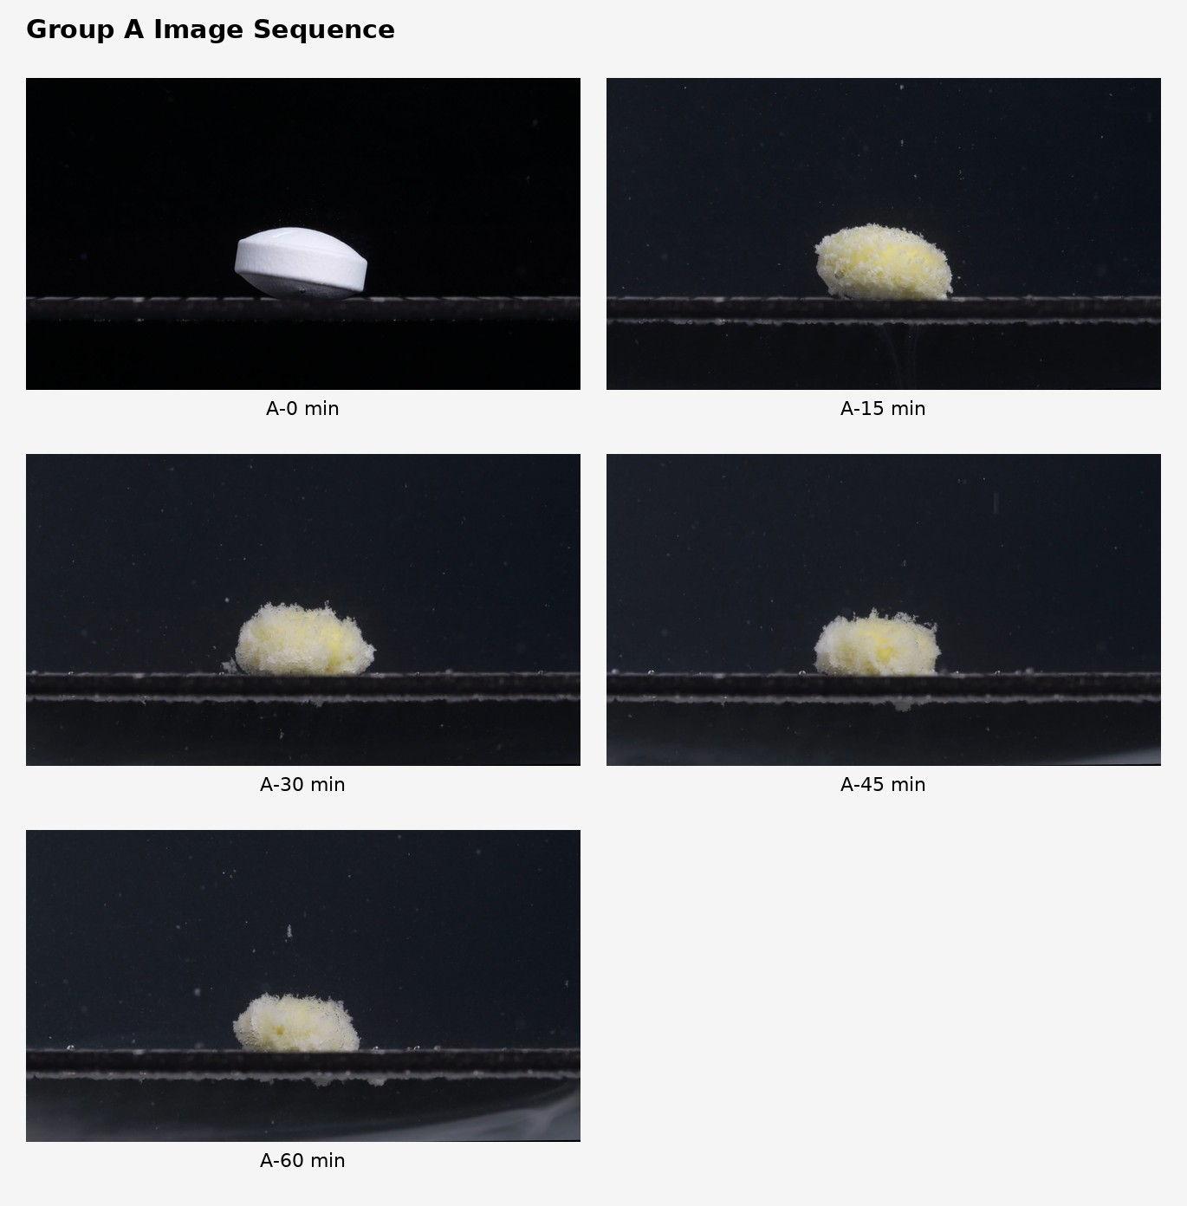

Group A — Disintegration Description

A-0 min
Color change: The tablet is mainly white. No yellow color is visible yet. The surrounding medium appears visually clear or dark because of the background, with no obvious turbidity.
Shape change: The tablet is still intact. It appears as a biconvex, oblong or oval tablet viewed from the side, with a smooth rounded upper surface and a more defined side wall. The original shape is well preserved.
Surface texture change: The surface looks mostly smooth and compact, with only minor surface roughness caused by lighting or magnification. No clear cracks, pores, peeling, or powder shedding are visible.
Volume / size change: This is the baseline size. The tablet retains its full apparent height and width. No visible swelling, shrinkage, or collapse is present.
Dissolution speed and time: At the starting point, disintegration has not visibly begun.
Physical state change: The tablet appears solid and structurally stable. There is no visible softening or fragmentation.
Dissolution medium: The medium around the tablet appears mostly clear, without obvious suspended particles.
Fragment distribution and density: No detached fragments are visible around the tablet.

A-15 min
Color change: A clear color transition has occurred. The tablet is no longer pure white; a pale yellow internal region is visible, while white material remains around the surface. This suggests the outer layer has eroded and exposed yellow material underneath.
Shape change: The original oblong tablet shape has largely disappeared. It has changed into a rounded, irregular mound. The sharp tablet edges and smooth biconvex contour are no longer visible.
Surface texture change: The surface has become rough, porous, fluffy, and granular. Fine white particles cover the outside, giving the tablet a sponge-like or powdery appearance.
Volume / size change: The apparent footprint is broader and the tablet looks swollen or loosened. The dense solid core is likely smaller than at 0 minutes, but the loosened porous material makes the visible mass appear enlarged.
Dissolution speed and time: The major visible disintegration happens between 0 and 15 minutes. This stage shows rapid loss of the original coating or compact outer structure.
Physical state change: The tablet has softened strongly. Liquid penetration appears to have caused swelling, surface loosening, and partial collapse into a porous mass.
Dissolution medium: The medium contains many small suspended particles, but the cloudiness remains localized rather than uniformly opaque.
Fragment distribution and density: Fine particles are concentrated close to the tablet, with some small particles suspended above it. Fragment density is highest around the mound.

A-30 min
Color change: The tablet remains pale yellow-white. Yellow areas are visible inside the porous white matrix, but the color is not evenly distributed.
Shape change: The tablet continues as an irregular low mound. No original tablet edge or side wall remains. The contour is uneven, with small protrusions and loose material at the surface.
Surface texture change: The surface remains highly rough and porous. Fine granules and fluffy particles are visible, especially along the upper and side surfaces.
Volume / size change: Compared with 15 minutes, the mound appears somewhat more compact and lower. The original tablet has clearly lost its defined volume, but a substantial residual mass remains.
Dissolution speed and time: Disintegration continues, but the rate appears slower than the first 15 minutes. The process has shifted from rapid structural breakdown to gradual erosion of the remaining porous mass.
Physical state change: The material appears soft, swollen, and partially collapsed. The remaining mass is no longer a solid tablet but a wet, particulate aggregate.
Dissolution medium: Fine particles are visible in the medium. The medium is not completely clear, but turbidity is still moderate and scattered.
Fragment distribution and density: Most fragments remain close to the original tablet location. Small particles are dispersed upward and outward, while denser material stays on the platform.

A-45 min
Color change: The visible mass remains white to pale yellow, with yellow concentrated in the central region and white material forming the outer loose layer.
Shape change: The mass becomes more flattened and irregular. The top edge is ragged, and the mound has lost more height compared with the earlier intact tablet.
Surface texture change: The surface is very uneven, with fluffy, powder-like projections. The structure looks fragile and porous rather than compact.
Volume / size change: The apparent height is reduced compared with the original tablet. The width of the loose material is still relatively broad, suggesting lateral spreading while the vertical structure collapses.
Dissolution speed and time: The disintegration continues slowly. There is no sudden complete dissolution; instead, the residue gradually erodes and settles.
Physical state change: The remaining tablet material behaves like a soft, wet, granular mass. The structure is partially collapsed but still cohesive enough to remain as one main mound.
Dissolution medium: Suspended particles are still visible in the medium. The background remains mostly dark or clear, so the turbidity is not extremely dense throughout the whole field.
Fragment distribution and density: Fragment density remains highest around the central mound. Fine particles are scattered above and around it, while heavier residues stay near the base.

A-60 min
Color change: The residue remains pale yellow-white. Yellow patches are still visible inside the remaining mass, so the material has not fully dissolved or dispersed.
Shape change: The tablet is now a low, irregular, porous residue mound. The original oblong tablet shape is completely absent.
Surface texture change: The surface remains rough and fluffy, but the mound looks slightly more compact and lower than earlier. Fine particles are still attached to the surface.
Volume / size change: The remaining mass is clearly smaller and lower than the original tablet. However, a significant residue persists at 60 minutes, indicating incomplete disintegration or dissolution within this observation period.
Dissolution speed and time: The fastest visible change occurred from 0 to 15 minutes. From 15 to 60 minutes, the process appears slower, dominated by gradual erosion and persistence of an insoluble or slowly dissolving residue.
Physical state change: The tablet has transformed from a hard, intact solid into a soft, porous particulate aggregate. It has not fully disappeared.
Dissolution medium: Fine suspended particles remain visible. The medium shows scattered particulate matter rather than complete uniform cloudiness.
Fragment distribution and density: Most dense residue remains localized on the platform. Smaller particles are dispersed around the mound and suspended in the surrounding medium.

Provisional Group A Pattern
Group A shows rapid early structural collapse within the first 15 minutes, changing from a smooth white oblong/biconvex tablet into a pale yellow-white porous mound. From 15 to 60 minutes, the remaining mass erodes slowly but does not fully disappear. The most important size and shape feature is that the tablet loses its original smooth oblong form very early, then persists as a low, fluffy, irregular residue.

Group B Image Sequence
The five images below correspond to Group B at 0, 15, 30, 45, and 60 minutes, respectively. They were uploaded as one sequence, with each picture taken 15 minutes apart.
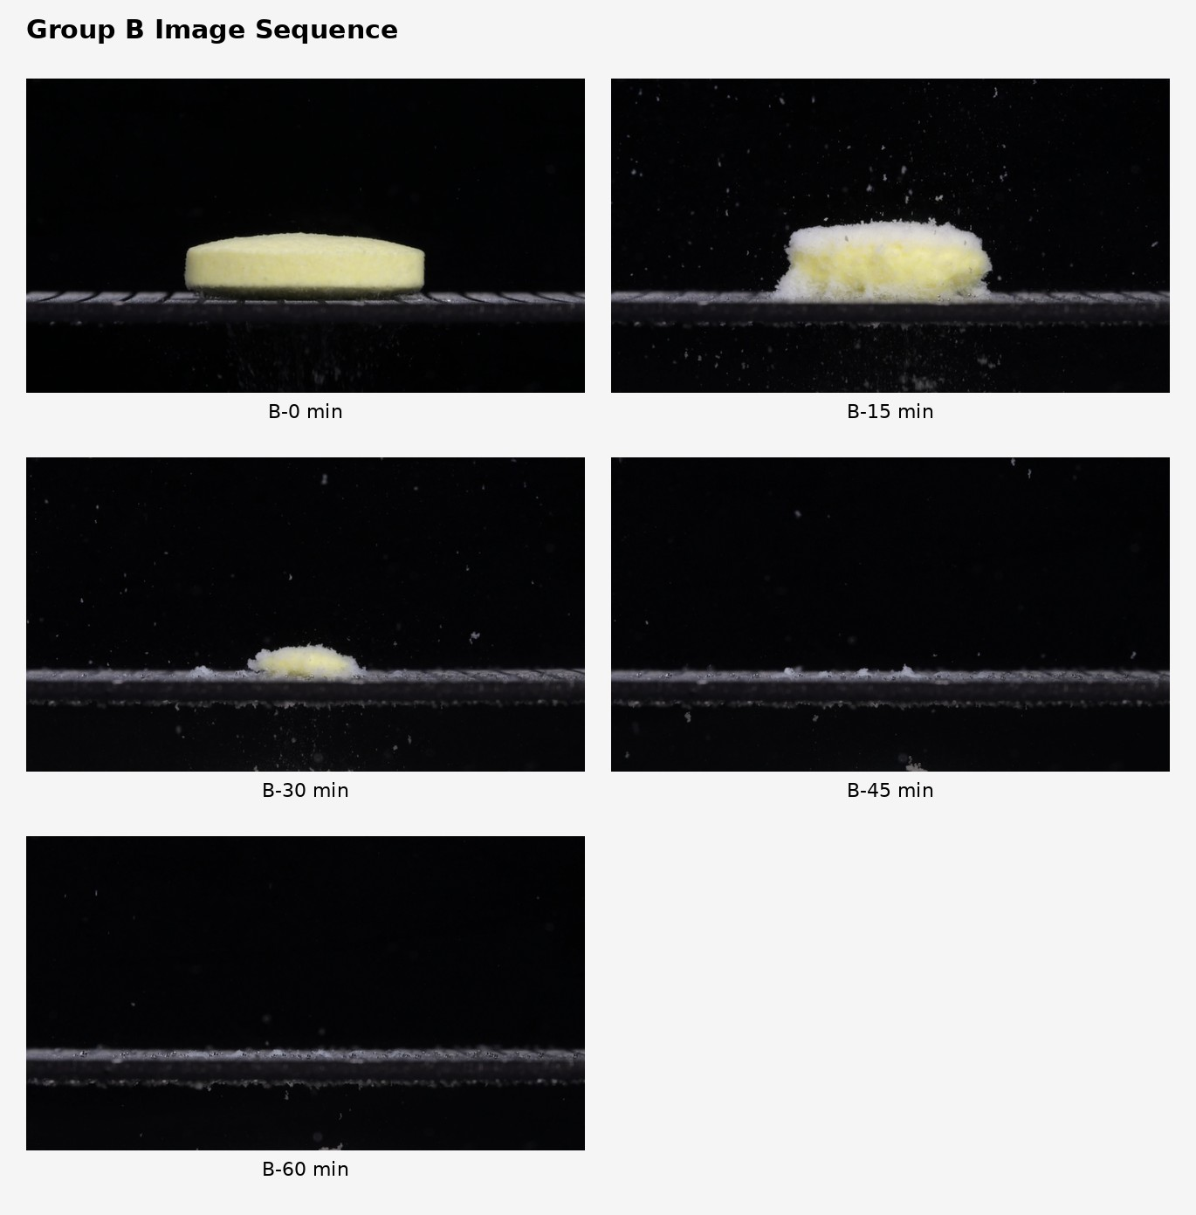

Group B — Disintegration Description

B-0 min
Color change: The tablet is already pale yellow at the start. Unlike Group A, it is not white at baseline.
Shape change: The tablet appears as a flat, round or cylindrical disk viewed from the side. It has a long horizontal profile and relatively straight side wall.
Surface texture change: The surface is slightly rough or matte, but still compact. No major cracks or collapse are visible.
Volume / size change: This is the baseline for Group B. The tablet is broad and low, with a much flatter shape than Group A’s initial biconvex/oblong tablet.
Dissolution speed and time: At 0 minutes, visible disintegration is minimal, although the bottom edge already shows slight contact erosion.
Physical state change: The tablet remains mostly solid and intact.
Dissolution medium: The medium appears mostly clear or dark, with only a few scattered particles visible.
Fragment distribution and density: Very few fragments are visible. Most material remains inside the intact tablet.

B-15 min
Color change: The tablet remains yellow in the center, but the surface and edges show more white, powdery material. The yellow core is still obvious.
Shape change: The original flat cylindrical outline is partly preserved, but the edges are now softened and irregular. The lower edge is especially eroded.
Surface texture change: The surface has become fluffy, granular, and porous. A loose white layer surrounds much of the yellow core.
Volume / size change: The tablet has lost clear edge definition. Its height is slightly reduced, and the bottom appears to be spreading outward as loose powder.
Dissolution speed and time: Strong disintegration occurs between 0 and 15 minutes. The process is more aggressive than in the first image, with many particles released.
Physical state change: Liquid penetration appears to have softened the outer layer. The tablet is changing from a compact disk into a loose, partially collapsed mass.
Dissolution medium: Many particles are suspended around the tablet, especially above and below it. The medium is visibly more particulate than at 0 minutes.
Fragment distribution and density: Fragment density is high around the tablet and on the support surface. Numerous fine particles are dispersed upward and downward.

B-30 min
Color change: The remaining central mass is still pale yellow, but the surrounding residue is mostly white. The yellow region is smaller than at 15 minutes.
Shape change: The tablet has collapsed into a low, irregular mound. The original cylindrical shape is mostly gone.
Surface texture change: The surface is highly rough, loose, and powdery. The edges look fragmented rather than solid.
Volume / size change: There is a major size reduction. The remaining mound is much lower and narrower than the original tablet at 0 minutes.
Dissolution speed and time: Disintegration continues rapidly from 15 to 30 minutes. By 30 minutes, most of the original tablet body has broken down.
Physical state change: The tablet is no longer a coherent solid tablet. It is mainly a wet, granular residue with a small yellow core.
Dissolution medium: The medium contains many suspended particles, but the densest material is near the support surface.
Fragment distribution and density: Fine fragments are widely scattered. A thin layer of sediment extends along the support surface, with a small central mound remaining.

B-45 min
Color change: The visible yellow tablet mass has almost disappeared. The remaining material is mostly white or pale residue.
Shape change: There is no recognizable tablet shape. Only a thin, uneven residue line and a few small clumps remain.
Surface texture change: The remaining material is powdery and fragmented. No smooth tablet surface is visible.
Volume / size change: The original tablet volume has almost completely disappeared. Only low sediment remains on the support.
Dissolution speed and time: By 45 minutes, Group B is near complete disintegration. The change from 30 to 45 minutes is substantial.
Physical state change: The tablet has transitioned from a solid disk into dispersed powder/sediment.
Dissolution medium: The medium contains scattered suspended particles. The main visible residue lies along the support surface.
Fragment distribution and density: Fragments are no longer concentrated in a large mound. They are spread thinly across the platform, with a few small denser clumps.

B-60 min
Color change: No obvious yellow core remains. The visible residue is mainly pale or white and very sparse.
Shape change: The original tablet shape is completely absent.
Surface texture change: Only fine powder-like sediment remains; no intact surface texture can be assessed.
Volume / size change: The tablet has essentially reduced to a thin residual layer. Compared with 0 minutes, the visible solid volume is almost gone.
Dissolution speed and time: Disintegration appears essentially complete or near complete by 60 minutes.
Physical state change: The tablet has changed from a compact solid disk into dispersed fine residue.
Dissolution medium: The medium still shows scattered small particles, but no large tablet mass remains.
Fragment distribution and density: Residue is distributed as a thin, low-density layer along the support, with small suspended particles in the surrounding medium.

Preliminary Comparison After Group B

Initial Tablet Appearance
Group A at 0 minutes: white, biconvex, oblong/oval tablet, thicker central profile, smooth compact surface.
Group B at 0 minutes: pale yellow, flat cylindrical/round disk, broader and lower, less biconvex.
This is a major difference. Tablet size and shape are important identification features when comparing whether two tablets may belong to the same drug or formulation.

Disintegration Behavior
Group A shows rapid early swelling and collapse by 15 minutes, but a large pale yellow-white porous mound remains even at 60 minutes.
Group B shows rapid breakdown that continues strongly after 15 minutes; by 45 to 60 minutes, the central tablet mass is almost gone.

Residue Pattern
Group A retains a persistent localized mound, still visible and relatively dense at 60 minutes.
Group B residue spreads into a thin sediment layer, with almost no central mound at 60 minutes.

Color Pattern
Group A starts white, then exposes yellow material after disintegration begins.
Group B starts yellow from the beginning, with white powdery residue appearing during breakdown.

Preliminary Judgment
Based on the visible evidence, Group A and Group B are unlikely to be the same tablet formulation. They may be different drugs or, at minimum, different formulations or manufacturers of the same labeled active ingredient. From images alone, the active ingredient cannot be chemically confirmed, but visually and by disintegration behavior, they do not appear to be the same tablet product.

Final Comparison Across the Eight Dimensions
The user then asked for a direct comparison of Groups A and B across the eight disintegration dimensions, with an explanation of whether they are from the same drug or not. The final comparison is summarized below.
Dimension | Group A | Group B | Assessment
1. Color change | Starts white at 0 minutes. Yellow material appears only after disintegration begins. At 15 to 60 minutes, the residue is white to pale yellow. | Starts pale yellow at 0 minutes. White powdery residue appears during disintegration, while the yellow core gradually disappears. | Different
2. Shape change | Starts as a white biconvex, oblong/oval tablet. By 15 minutes, the original shape is almost lost and becomes a porous mound. A mound remains through 60 minutes. | Starts as a flat cylindrical/round disk, broader and lower than Group A. By 30 minutes it becomes a small low mound; by 45 to 60 minutes the tablet shape is almost completely gone. | Strongly different
3. Surface texture change | Smooth and compact at 0 minutes; quickly becomes rough, fluffy, porous, and granular by 15 minutes. | Slightly rough or matte at 0 minutes; becomes fluffy, porous, and powdery by 15 minutes. | Partly similar
4. Volume / size change | Rapid structural collapse by 15 minutes, but a substantial residual mound remains even at 60 minutes. | Much faster volume loss. By 45 to 60 minutes, the original tablet body is almost gone, leaving mainly a thin sediment layer. | Strongly different
5. Dissolution speed and time | Fastest visible change occurs from 0 to 15 minutes, then the process slows. The remaining mass persists from 15 to 60 minutes. | Fast from 0 to 15 minutes and continues strongly from 15 to 45 minutes. Near-complete disintegration occurs by 45 to 60 minutes. | Different
6. Physical state change | Changes from hard intact tablet to soft, swollen, porous aggregate. The residue remains cohesive and localized. | Changes from compact disk to loose powder/sediment. The material disperses more completely and loses cohesion earlier. | Different
7. Dissolution medium | Suspended particles appear, but turbidity and residue remain mostly localized near the tablet. | Many fine particles are released, especially at 15 to 30 minutes, with broader distribution along the support surface. | Moderately different
8. Fragment distribution and density | Fragments stay concentrated around the original tablet position. A dense central mound remains at 60 minutes. | Fragments spread more widely. By 45 to 60 minutes, residue is thin, low, and dispersed along the platform. | Strongly different

Key Reasons for the Final Judgment
The initial tablets are visibly different. Group A begins as a white, biconvex oblong tablet, while Group B begins as a pale-yellow, flat cylindrical disk. This is the strongest evidence against them being the same tablet product.
Their disintegration endpoints are also very different. Group A still has a clear, dense, mound-like residue at 60 minutes, while Group B has almost completely dispersed by 45 to 60 minutes.
Their fragment behavior differs as well. Group A remains localized and cohesive; Group B spreads into a thinner sediment layer with much less central mass.

Final Determination
Groups A and B are unlikely to be the same drug product or formulation. A cautious conclusion is that they may possibly share the same labeled active ingredient, but they do not appear to be the same tablet formulation, manufacturer, or physical product based on visible disintegration characteristics.
Important limitation: image-based disintegration analysis cannot chemically confirm whether both tablets contain doxycycline hyclate. Chemical identity would require appropriate laboratory testing.

