Edited English Transcript and Analysis
Doxycycline Hyclate Tablet Disintegration: Groups A and B
Scope: Conversation content related to the drug disintegration discussion only.
Language: English only.

Drug named by user | Doxycycline Hyclate Tablets
Groups | Group A and Group B
Image timing | Five images per group, taken 15 minutes apart: 0, 15, 30, 45, and 60 min
Analysis basis | Eight-dimensional drug disintegration description framework from the Knowledge Base

1. Conversation Setup and Knowledge Base Framework
User: I need you to try analyzing the disintegration images of two groups of Doxycycline Hyclate Tablets, A and B. These may be images of the same drug or different drugs. I need you to determine whether the images are from the same drug or not. For each group, I will upload five images, each picture taken 15 minutes apart. Please describe the drug disintegration process in English for each image in the group, and finally determine whether the two sets of images are from the same drug. You can call the Knowledge Base to remember how to describe drug disintegration. As you describe the tablets in English, pay attention to changes in the size and shape of the tablets. If you are prepared, I will upload Group A, Pic 1 at 0 minutes.
Assistant: I’m prepared. Please upload Group A, Pic 1 at 0 minutes. I will analyze each image using the eight dimensions from the disintegration guide: color change, shape change, surface texture, volume/size change, dissolution speed and time, physical state, dissolution medium, and fragment distribution/density. For each uploaded image, I will describe it in English and keep a running comparison for Group A at 0, 15, 30, 45, and 60 min and Group B at 0, 15, 30, 45, and 60 min. At the end, I will judge whether A and B are likely the same drug/formulation or different, based mainly on tablet size/shape evolution, disintegration speed, fragment pattern, turbidity, residue, and final appearance.
User: You are not totally prepared. Please call the Knowledge Base again to remember how to describe drug disintegration.
Assistant: You are right. I called the Knowledge Base again and refreshed the full disintegration-description framework.

Eight Required Dimensions Used for Every Image
Dimension | Description
Color change | Tablet color, liquid color, transparency, turbidity, and whether color spreads locally or uniformly.
Shape change | Whether the tablet remains intact, becomes cracked, deforms, collapses, or breaks into irregular fragments.
Surface texture change | Smoothness, roughness, pores, cracks, peeling, flaking, or fibrous structures.
Volume / size change | Whether the tablet swells first, shrinks, collapses, loses height, loses diameter, or reduces unevenly.
Dissolution speed and time | Slow, moderate, or fast disintegration; whether speed increases after cracking or particle formation.
Physical state change | Liquid penetration, swelling, cracking, internal weakening, particle generation, and collapse.
Dissolution medium | Clarity, cloudiness, viscosity-like appearance, suspended particles, sediment, and visible medium change.
Fragment distribution and density | Whether fragments stay near the tablet, spread outward, suspend in the liquid, or settle at the bottom.

The assistant also stated that special attention would be paid to tablet size and shape, because the Knowledge Base identifies size and shape as important features for distinguishing disintegration behavior and possible formulation differences.

2. Group A: Image-by-Image Disintegration Description

Group A — Group A, Pic 1, 0 min
User: Group A, Pic 1. Each picture is taken 15 minutes apart. Please describe the drug accurately in English, think carefully, and reduce hallucinations.
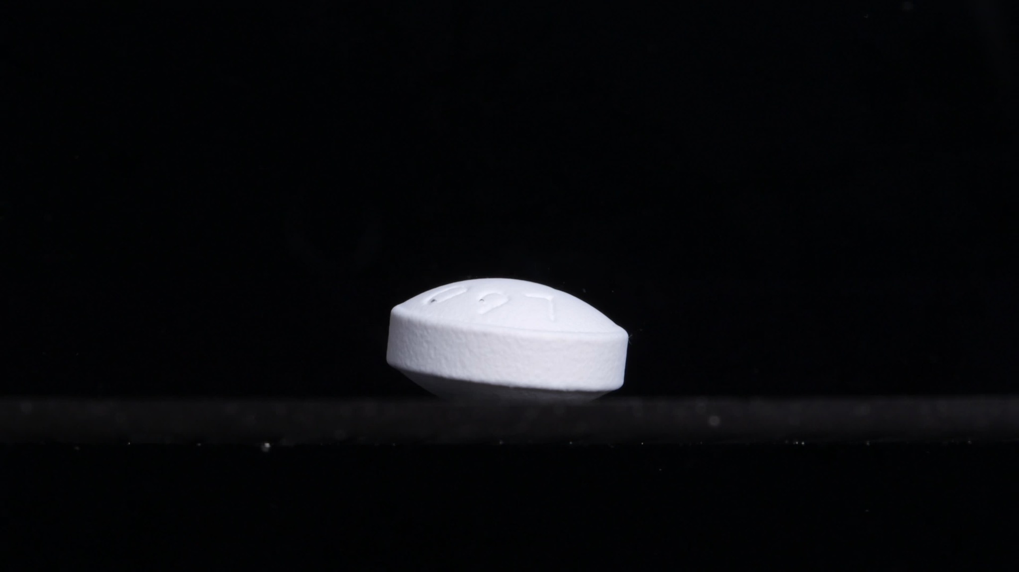
Group A, Pic 1, 0 min
Assistant: Analysis at 0 min:
Dimension | Description
Color change | The tablet appears white to very pale off-white. No obvious discoloration, yellowing, or color diffusion is visible around the tablet. The surrounding medium/background appears dark, but liquid color or turbidity cannot be judged confidently from this image alone.
Shape change | The tablet is intact. It appears as a round, thick tablet viewed from the side, with a slightly convex upper surface and a flat-to-slightly beveled side wall. The outline is clear and continuous, with no visible splitting, collapse, or major deformation.
Surface texture change | The side surface looks matte and slightly rough or granular, which may be normal compressed-tablet texture. The top surface looks smoother but has a few small shallow marks or wet-looking spots. No clear cracks, peeling, flaking, pores, or powder shedding are visible yet.
Volume / size change | At 0 min, there is no observable volume loss. The tablet maintains its original thickness and diameter. This image provides the starting size for judging later swelling, erosion, shrinking, or collapse.
Dissolution speed and time | At this initial time point, the disintegration speed is not yet visually measurable. There is no visible formation of particles or fragments, so dissolution/disintegration has either not started or is still in a very early wetting stage.
Physical state change | The tablet remains in a solid, compact state. No internal weakening is visible from the outside. There is no clear swelling, cracking, rupture, or softening apparent in this image.
Dissolution medium | The medium is not clearly visible because of the dark background and low contrast. No obvious cloudiness, sediment, or dispersed particles can be seen around the tablet. The visible horizontal line near the lower part may indicate the liquid/container boundary, but this cannot be confirmed with certainty from the image alone.
Fragment distribution and density | No detached fragments are visible. No powder cloud, suspended particles, or settled debris can be seen around the tablet. Fragment density is therefore zero or not visually detectable at this stage.

Interim note: At 0 min, Group A shows a white, intact, thick round tablet with a clear contour and no visible disintegration. The key baseline features are a large intact body, slightly convex top, defined side wall, pale white color, and no visible fragments.

Group A — Group A, Pic 2, 15 min
User: Group A, Pic 2. Each picture is taken 15 minutes apart. Please describe the drug accurately in English, think carefully, and reduce hallucinations.
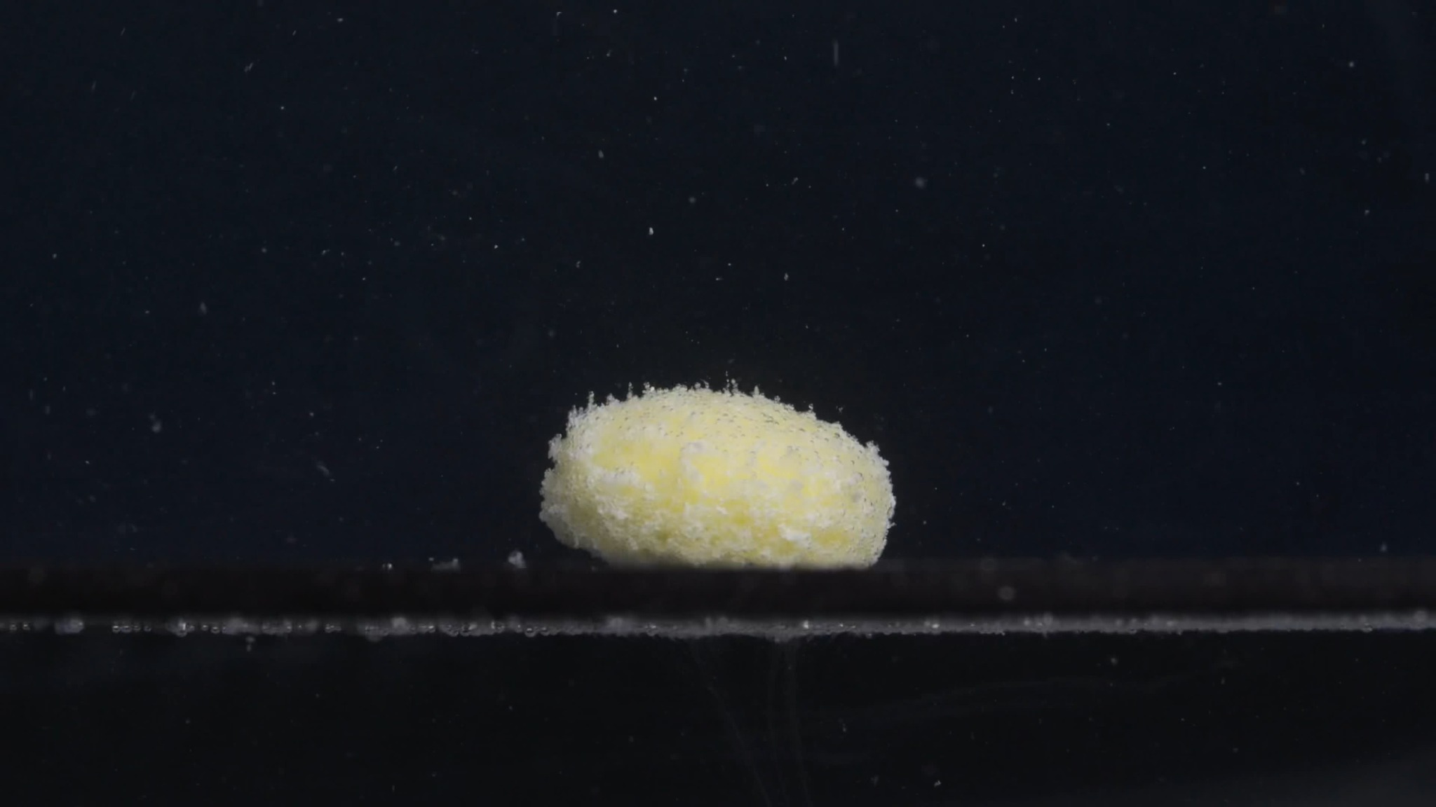
Group A, Pic 2, 15 min
Assistant: Analysis at 15 min:
Dimension | Description
Color change | The tablet has changed from the earlier white/off-white appearance to a pale yellow to yellow-white appearance. The yellow color is strongest on the central and upper exposed areas, while some outer areas remain whitish. The surrounding medium still appears mostly dark/clear, but many small light particles are visible around the tablet.
Shape change | The tablet is no longer a sharply defined thick round tablet. Its outline has become rounded, softened, and mound-like. The original side wall is largely lost; the edge now looks irregular and crumbly rather than smooth and cylindrical. No large split into separate chunks is visible yet, but the tablet body has clearly weakened.
Surface texture change | The surface has changed from relatively smooth/matte to rough, granular, and powdery. The upper and side surfaces show many fine particles attached to the tablet, giving it a fuzzy or eroded appearance. The rim appears especially rough, suggesting surface erosion and loosening of the outer layer.
Volume / size change | The tablet still retains a main central mass, but its effective shape and volume have changed. The height appears reduced or collapsed compared with the intact 0 min tablet, and the edges are less defined. The diameter may be roughly similar, but the boundary is irregular, so the apparent size is now harder to define precisely.
Dissolution speed and time | By 15 min, disintegration is clearly active but not complete. The tablet has not dispersed into many large fragments; instead, it shows gradual surface erosion and fine-particle release. The process appears moderate: the main body remains, but the surface has already become substantially loosened.
Physical state change | The tablet has changed from a compact solid to a softened, partially eroded mass. Liquid penetration is likely occurring, shown visually by the loss of sharp edges and formation of a granular surface. The structure appears weakened, but the core has not fully collapsed into separate pieces.
Dissolution medium | The medium/background still appears mostly dark, so the overall transparency of the liquid is difficult to judge. Fine suspended particles are visible above and around the tablet. Some residue is visible along the bottom line, suggesting early sedimentation near the tablet base.
Fragment distribution and density | Fragment density is highest on and immediately around the tablet surface. Small particles are scattered upward and outward in the surrounding medium, but they are not yet densely distributed throughout the whole field. Most visible material remains concentrated near the original tablet location, with minor sediment-like particles along the lower boundary.

Interim note: At 15 min, Group A shows a transition from an intact white tablet to a yellowish, softened, granular mound. The most important changes are loss of sharp cylindrical shape, rough powdery surface, yellow exposure, slight apparent volume collapse, and early fine-particle release.

Group A — Group A, Pic 3, 30 min
User: Group A, Pic 3. Each picture is taken 15 minutes apart. Please describe the drug accurately in English, think carefully, and reduce hallucinations.
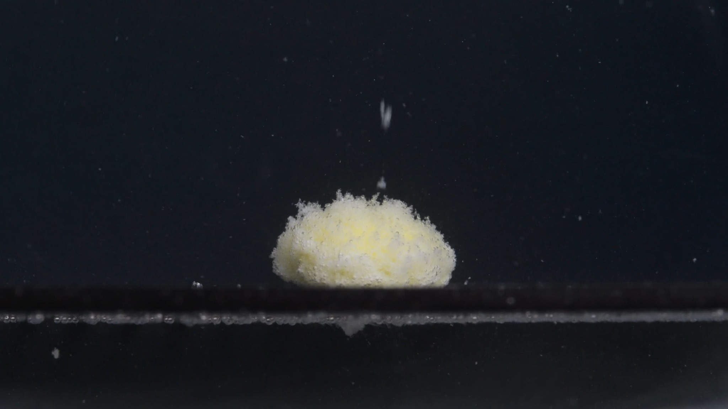
Group A, Pic 3, 30 min
Assistant: Analysis at 30 min:
Dimension | Description
Color change | The tablet remains pale yellow to yellow-white. The yellow tone is visible across the central body, while some surface particles remain whitish. Compared with 15 min, the color looks more evenly yellow-white over the exposed surface, but not dramatically darker. The surrounding medium still appears mostly dark/clear, with scattered light particles.
Shape change | The tablet has lost its original cylindrical tablet shape. It now appears as a low, rounded, irregular mound. The original sharp side wall and clear bevel are no longer visible. No complete split into large separate fragments is visible; the drug still remains mainly as a single softened mass.
Surface texture change | The surface is strongly rough, granular, and powder-coated. The upper surface looks uneven and fluffy, with many fine particles attached. The edge is irregular, especially along the left and upper margins, suggesting continued erosion from the outside inward. No clean crack line is visible, but the whole surface appears weakened and crumbly.
Volume / size change | The main body still occupies a similar horizontal area to the 15 min image, but the original tablet height and defined contour are clearly reduced compared with 0 min. The tablet looks more like a flattened mound than a compact tablet. Volume loss is present mainly through edge erosion and surface loosening rather than large-piece breakage.
Dissolution speed and time | By 30 min, disintegration is ongoing but incomplete. The process appears gradual: the tablet is not rapidly dispersing into the medium, but it is steadily losing surface material. Compared with 15 min, the main change is increased surface granularity and continued weakening, not sudden collapse.
Physical state change | The tablet has changed from a compact solid into a softened, porous, eroded mass. Liquid penetration appears to have weakened the outer layer, producing fine powder-like material on the surface. The core still seems to remain present because the mound keeps a central body and has not fully collapsed.
Dissolution medium | The medium appears mostly dark, so overall turbidity cannot be judged confidently. Fine suspended specks are visible around the tablet. A thin line of residue or particles is visible near the bottom boundary, suggesting settled material or material attached to the container surface.
Fragment distribution and density | Fragment density is highest on the tablet surface and immediately around the base. Small particles are visible in the surrounding field, but they are relatively sparse and scattered. There are no large detached fragments near the tablet; the visible material is mostly fine particulate matter.

Interim note: At 30 min, Group A shows continued slow-to-moderate disintegration. The tablet is still one main mound, but it is more eroded, more granular, and more yellow-white than at 0 min. The key pattern so far is intact white tablet → yellow softened mound → rougher granular yellow-white mound with gradual surface erosion.

Group A — Group A, Pic 4, 45 min
User: Group A, Pic 4. Each picture is taken 15 minutes apart. Please describe the drug accurately in English, think carefully, and reduce hallucinations.
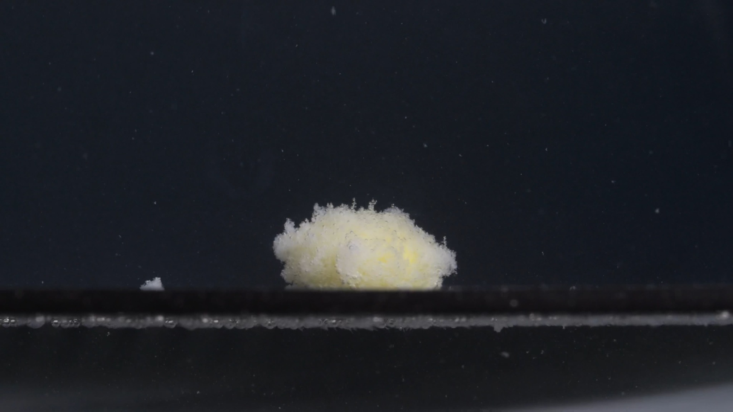
Group A, Pic 4, 45 min
Assistant: Analysis at 45 min:
Dimension | Description
Color change | The tablet remains pale yellow to yellow-white. The yellow color is visible mainly in the central body, while the outer surface and loose particles look more whitish. The surrounding medium still appears mostly dark/clear, with scattered white particles visible around the tablet.
Shape change | The original round tablet shape is no longer present. The tablet appears as a flattened, irregular mound rather than a defined cylindrical tablet. The top edge is uneven and fluffy-looking. A small detached white fragment is visible to the left of the main tablet mass, showing that some material has separated from the body.
Surface texture change | The surface is highly rough, porous, granular, and powdery. The outer layer looks loose and fragile, especially along the upper and left edges. The tablet surface no longer looks compact; it appears more like a wet, crumbly powder mass.
Volume / size change | The tablet’s apparent height is clearly reduced compared with the original 0 min image. The main body is lower and more spread out horizontally. The tablet has not completely disappeared, but its compact volume has decreased through surface erosion and partial collapse.
Dissolution speed and time | At 45 min, disintegration is still gradual and incomplete. The tablet has not rapidly dispersed into the whole medium. The main visible change from 30 min to 45 min is increased loosening of the surface and the appearance of at least one detached fragment.
Physical state change | The tablet is no longer a firm compact solid. It appears as a softened, partially collapsed, porous mass. The outer layer has weakened enough to shed particles and small fragments, while the central core still remains.
Dissolution medium | The medium itself still appears visually dark, so full-liquid turbidity cannot be assessed confidently. Fine suspended specks are visible above and around the tablet. A line of residue or sediment-like material remains visible along the lower boundary.
Fragment distribution and density | Fragment density is highest around the main tablet body and along the lower boundary near the base. One larger detached piece is visible to the left of the tablet. Smaller particles are scattered in the surrounding medium, but they are not dense enough to make the whole field cloudy.

Interim note: At 45 min, Group A shows continued slow-to-moderate erosion. The main tablet remains as a pale yellow-white mound, but it is lower, rougher, looser, and more irregular than at earlier time points. The first clearly visible detached fragment appears near the left side, suggesting progressive weakening but not complete disintegration.

Group A — Group A, Pic 5, 60 min
User: Group A, Pic 5. Each picture is taken 15 minutes apart. Please describe the drug accurately in English, think carefully, and reduce hallucinations.
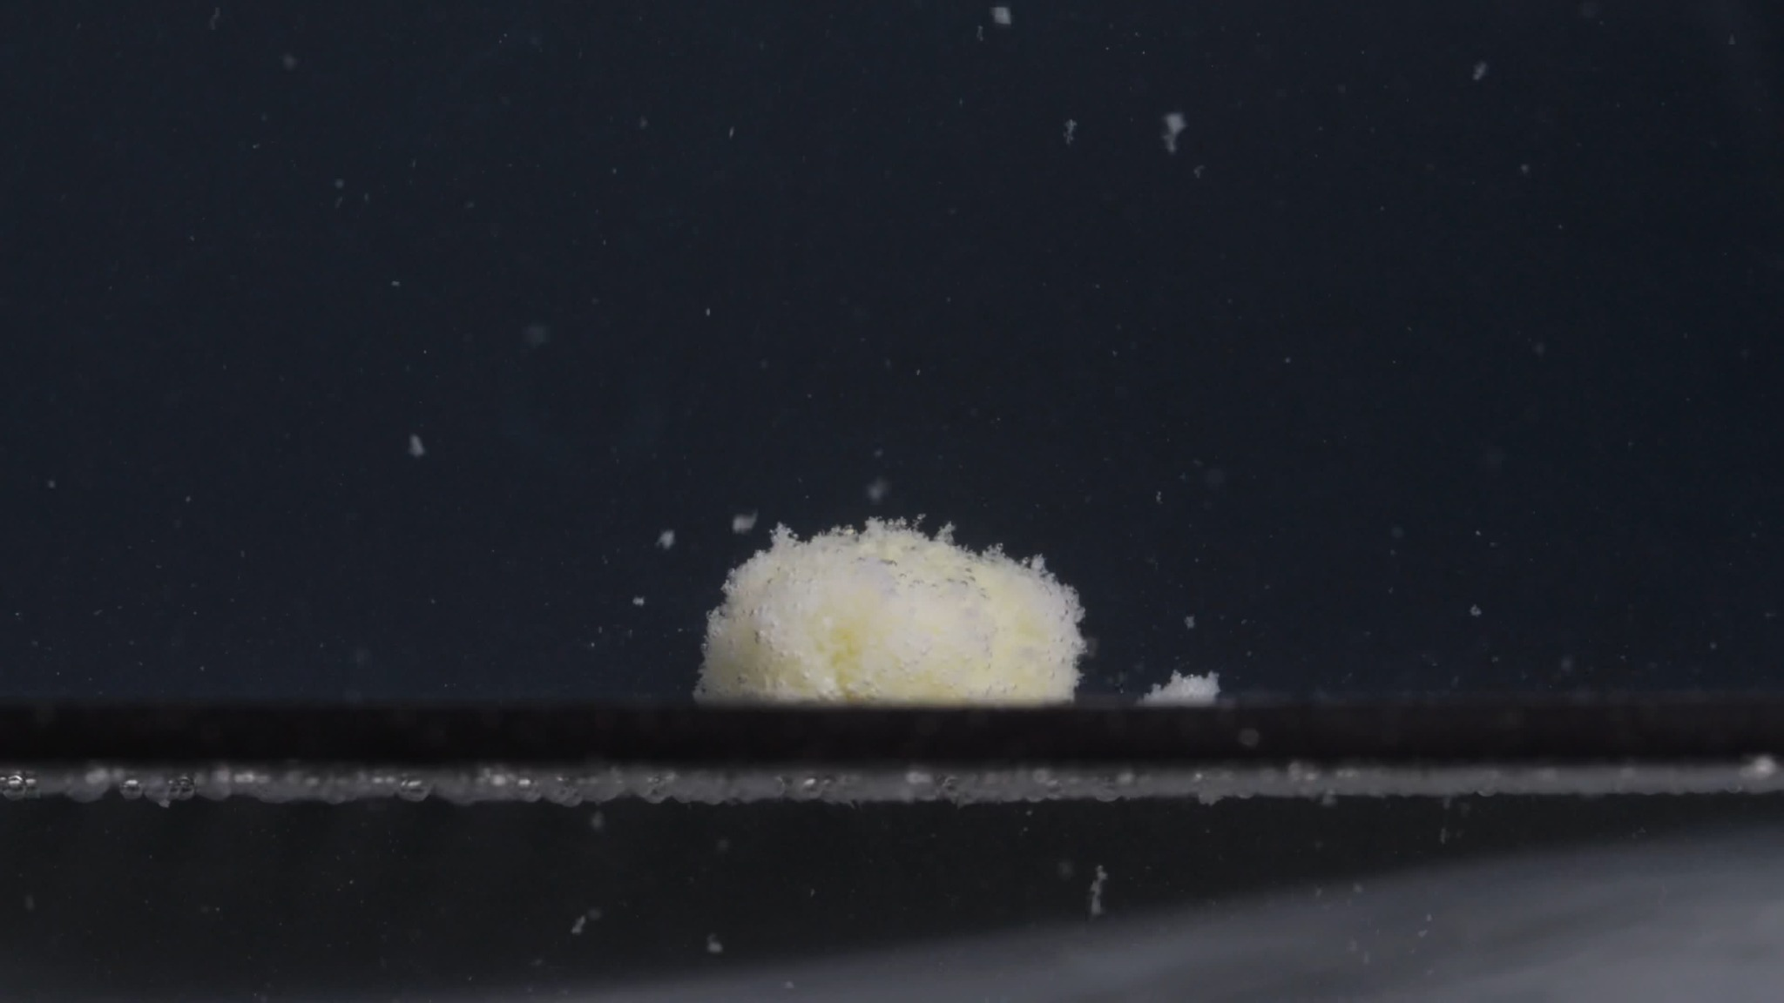
Group A, Pic 5, 60 min
Assistant: Analysis at 60 min:
Dimension | Description
Color change | The remaining tablet mass is still pale yellow to yellow-white. The central region has a faint yellow tone, while the outer eroded surface appears more whitish. The surrounding medium remains visually dark, so full transparency or turbidity cannot be judged confidently. White particles are visible in the surrounding field, indicating continued particle release.
Shape change | The original round, thick tablet shape is completely lost. The tablet now appears as a low, irregular, dome-like mound. The upper edge is uneven and fluffy, with no sharp side wall or clean tablet boundary. A small detached fragment or powder pile is visible to the right of the main mass.
Surface texture change | The surface is very rough, porous, granular, and powder-like. The top and edges look loose and fragile, suggesting the outer layer has softened and eroded. There is no smooth coating-like surface remaining. The surface looks more like a wet, crumbly powder aggregate than a compact tablet.
Volume / size change | Compared with the 0 min image, the tablet has clearly lost height and compact volume. Compared with 45 min, the main body looks broadly similar in size, but its surface appears slightly more eroded and less compact. The remaining mass is still substantial, meaning disintegration is incomplete at 60 min.
Dissolution speed and time | The disintegration speed appears slow to moderate over the 60-minute sequence. Most of the change occurred through gradual surface erosion, softening, and powder shedding rather than rapid breakup into many large fragments. By 60 min, the tablet has not fully dispersed into the medium, so the formulation appears to maintain a persistent core or dense residue.
Physical state change | The tablet has changed from a compact solid into a softened, partially collapsed, porous residue mass. The main body still holds together, but the outer region is weakened and sheds fine particles. The image suggests progressive liquid penetration and erosion, but not complete structural collapse.
Dissolution medium | The medium/background appears mostly dark, and overall liquid cloudiness is difficult to assess from this lighting. Some suspended particles are visible above and around the tablet. A residue line remains visible along the bottom boundary, suggesting settled or attached particulate material.
Fragment distribution and density | Fragment density is greatest around the main mass and along the bottom boundary. A small separated accumulation is visible to the right of the tablet. Several fine particles are scattered in the surrounding medium, but the field is not densely clouded with particles. The fragment pattern is mainly local erosion plus limited nearby sedimentation, not complete dispersion.

Interim note: Group A sequence summary: Group A begins as a white, intact, thick round tablet. By 15 min, it becomes a yellowish softened mound with a rough granular surface. From 30 to 60 min, it continues to erode slowly, becoming a low, irregular yellow-white powdery mass, while still retaining a central body. The most important Group A pattern is loss of cylindrical shape, gradual yellow exposure, persistent central mound, slow surface erosion, and limited fragment separation.

3. Group B: Image-by-Image Disintegration Description

Group B — Group B, Pic 1, 0 min
User: Group B, Pic 1. Each picture is taken 15 minutes apart. Please describe the drug accurately in English, think carefully, and reduce hallucinations.
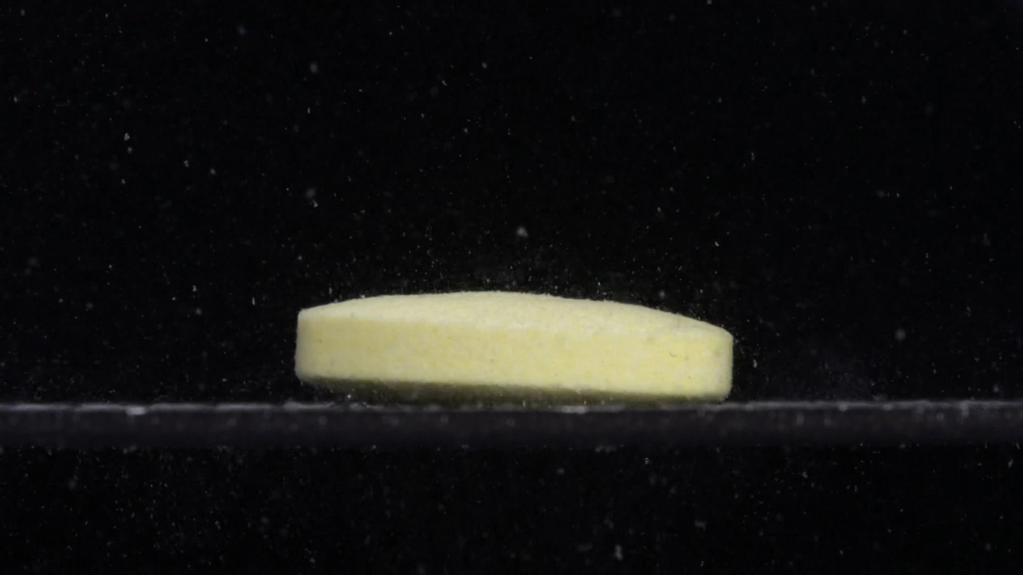
Group B, Pic 1, 0 min
Assistant: Analysis at 0 min:
Dimension | Description
Color change | The tablet already appears pale yellow to light yellow at 0 min. This is different from Group A at 0 min, where the tablet appeared more white/off-white. No clear color diffusion from the tablet into the surrounding medium is visible yet.
Shape change | The tablet is still intact. It appears as a round, flat-to-slightly-convex tablet viewed from the side. The side wall is relatively straight and continuous, with a clearly defined lower edge. Compared with Group A at 0 min, this tablet looks wider and flatter, while Group A looked more compact and thicker with a more dome-like top.
Surface texture change | The surface appears mostly smooth to slightly matte. The side surface is relatively uniform, without obvious cracking, peeling, or collapse. A few tiny specks are visible around the tablet, but they cannot confidently be attributed to tablet disintegration; they may also be background particles or air bubbles.
Volume / size change | At this 0 min baseline, there is no visible volume loss. The tablet maintains a clear cylindrical body. Its apparent profile is lower and broader than Group A’s 0 min tablet, which is an important comparison point.
Dissolution speed and time | No clear disintegration is visible yet. The tablet has not started to break apart, collapse, or release obvious fragments. This image represents the starting point before measurable visual dissolution.
Physical state change | The tablet remains a solid, compact body. No visible swelling, cracking, internal weakening, or edge erosion is apparent. The tablet structure still looks mechanically stable.
Dissolution medium | The surrounding medium appears dark, so full transparency or turbidity cannot be judged confidently. The medium contains scattered bright specks, but they are not concentrated enough to indicate obvious tablet-derived cloudiness at this stage.
Fragment distribution and density | No definite detached tablet fragments are visible. Fragment density near the tablet is very low or not visually detectable. The visible specks are sparse and widely distributed, not forming a dense sediment or particle cloud around the tablet.

Interim note: At baseline, Group B does not look identical to Group A. The main visible differences are color and geometry: Group A began white/off-white and thicker/dome-like, while Group B begins pale yellow and flatter/wider. This does not yet prove different drugs, because lighting, camera angle, coating, and batch/formulation differences can affect appearance.

Group B — Group B, Pic 2, 15 min
User: Group B, Pic 2. Each picture is taken 15 minutes apart. Please describe the drug accurately in English, think carefully, and reduce hallucinations.
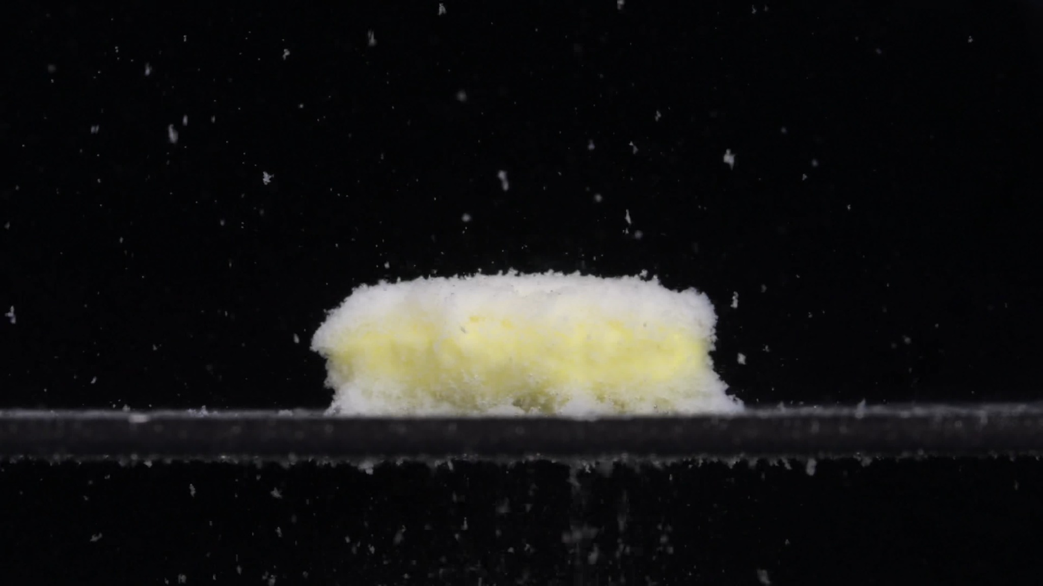
Group B, Pic 2, 15 min
Assistant: Analysis at 15 min:
Dimension | Description
Color change | The tablet remains pale yellow to yellow-white. The inner or central exposed areas appear more yellow, while the loose outer layer appears more white. There is no obvious strong yellow diffusion into the surrounding medium, but many white particles are visible around the tablet.
Shape change | The original broad, flat cylindrical shape is still partly recognizable, but the outline has become irregular and softened. The top edge is no longer smooth; it is uneven and fuzzy because of attached fine particles. The side wall has lost its clean, straight boundary, especially along the lower and upper edges. The tablet has not split into large separate pieces, but its surface has clearly eroded.
Surface texture change | The surface has changed from relatively smooth at 0 min to rough, granular, fluffy, and powder-coated. The upper surface and side edges show extensive fine-particle loosening. The tablet looks porous and fragile, with a wet powder-like layer covering much of the surface.
Volume / size change | The tablet still has a broad horizontal body, but the original compact volume has started to weaken. The height appears slightly reduced or softened compared with 0 min. The apparent width remains large, but the border is now less sharply defined because of surface erosion and loose powder around the edges.
Dissolution speed and time | By 15 min, Group B shows active disintegration. The process appears faster than simple wetting: there is clear particle generation and surface breakdown. However, the tablet is not fully dispersed; the main body remains intact as a broad softened mass.
Physical state change | The tablet has changed from a compact solid into a softened, porous, partially eroded mass. Liquid penetration appears to have weakened the outer layer, producing powdery material on the surface and around the base. The internal core may still be present because the overall tablet mass has not collapsed completely.
Dissolution medium | The surrounding medium appears dark, so full liquid turbidity cannot be judged confidently. Many suspended or floating white specks are visible in the field. Some residue is also visible along the lower boundary, suggesting released particles have begun to settle or attach near the bottom.
Fragment distribution and density | Fragment density is highest on the tablet surface and around the lower edge. Fine particles are widely scattered above and around the tablet. No large detached fragments are clearly visible, but there is a dense powder-like layer surrounding the main mass.

Interim note: At 15 min, both groups show similar general behavior: yellow-white exposed body, rough powdery surface, softened outline, and fine particle release. However, Group B remains wider and flatter, while Group A looked more like a smaller rounded mound.

Group B — Group B, Pic 3, 30 min
User: Group B, Pic 3. Each picture is taken 15 minutes apart. Please describe the drug accurately in English, think carefully, and reduce hallucinations.
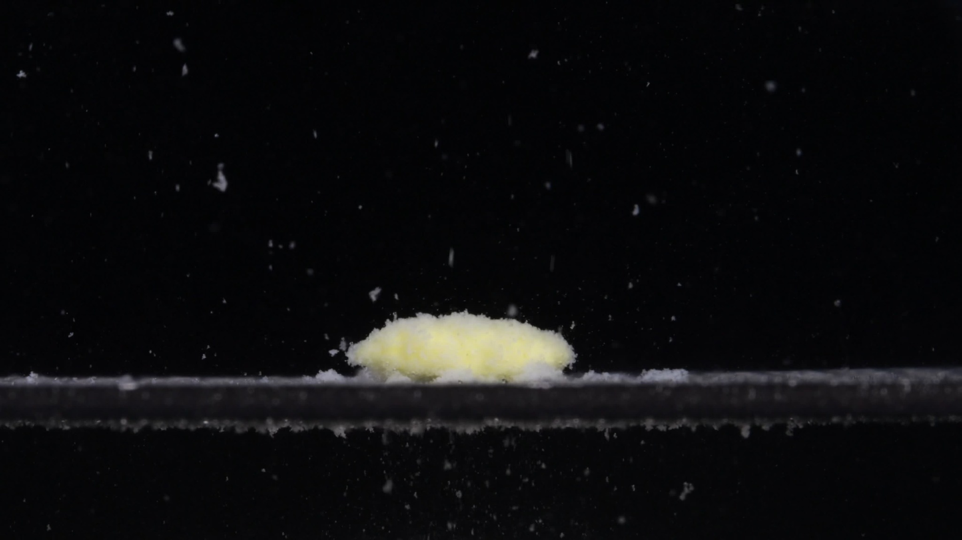
Group B, Pic 3, 30 min
Assistant: Analysis at 30 min:
Dimension | Description
Color change | The remaining tablet mass is pale yellow to yellow-white. The central area appears more yellow, while the outer loose material appears whiter. The surrounding medium still appears dark, so full-liquid turbidity cannot be judged reliably. Many bright particles are visible around the tablet, suggesting ongoing particle release.
Shape change | The tablet no longer retains a clear cylindrical shape. It has changed into a low, flattened, irregular mound. Compared with 15 min, the height appears reduced, and the outline is less defined. The main mass remains continuous; no complete split into several large pieces is visible.
Surface texture change | The surface is rough, fluffy, granular, and powder-like. The upper surface and edges are uneven, with many fine particles attached. The lower edge appears eroded, with powdery residue extending along the base.
Volume / size change | The tablet has clearly lost height compared with the 0 min baseline. The horizontal footprint is still broad, but the compact tablet volume has decreased. The mass is now more flattened and less structurally defined than at 15 min.
Dissolution speed and time | By 30 min, Group B shows moderate disintegration. The main mechanism appears to be gradual surface erosion and particle shedding rather than sudden large-fragment breakup. Compared with 15 min, the process has advanced noticeably: the tablet is lower, softer-looking, and more dispersed along the base.
Physical state change | The tablet has changed from a compact solid into a softened, porous, partially collapsed residue. The central body still remains, suggesting the core has not completely dispersed. The outer layer appears weakened and crumbly.
Dissolution medium | The liquid/background appears dark, and overall transparency cannot be determined confidently. Numerous suspended particles are visible in the field. A visible residue band lies along the bottom boundary near and around the tablet.
Fragment distribution and density | Fragment density is highest around the main residue and along the bottom boundary. Fine particles are scattered widely above the tablet, more visibly than in the 0 min image. No large detached tablet pieces are clearly identifiable; most fragments appear fine and powder-like.

Interim note: At 30 min, both groups show a yellow-white, rough, granular remaining mass with fine particle release. However, Group B remains wider and flatter, with more horizontal spreading along the base. Group A at 30 min looked more like a smaller rounded mound, while Group B looks like a flattened elongated residue.

Group B — Group B, Pic 4, 45 min
User: Group B, Pic 4. Each picture is taken 15 minutes apart. Please describe the drug accurately in English, think carefully, and reduce hallucinations.
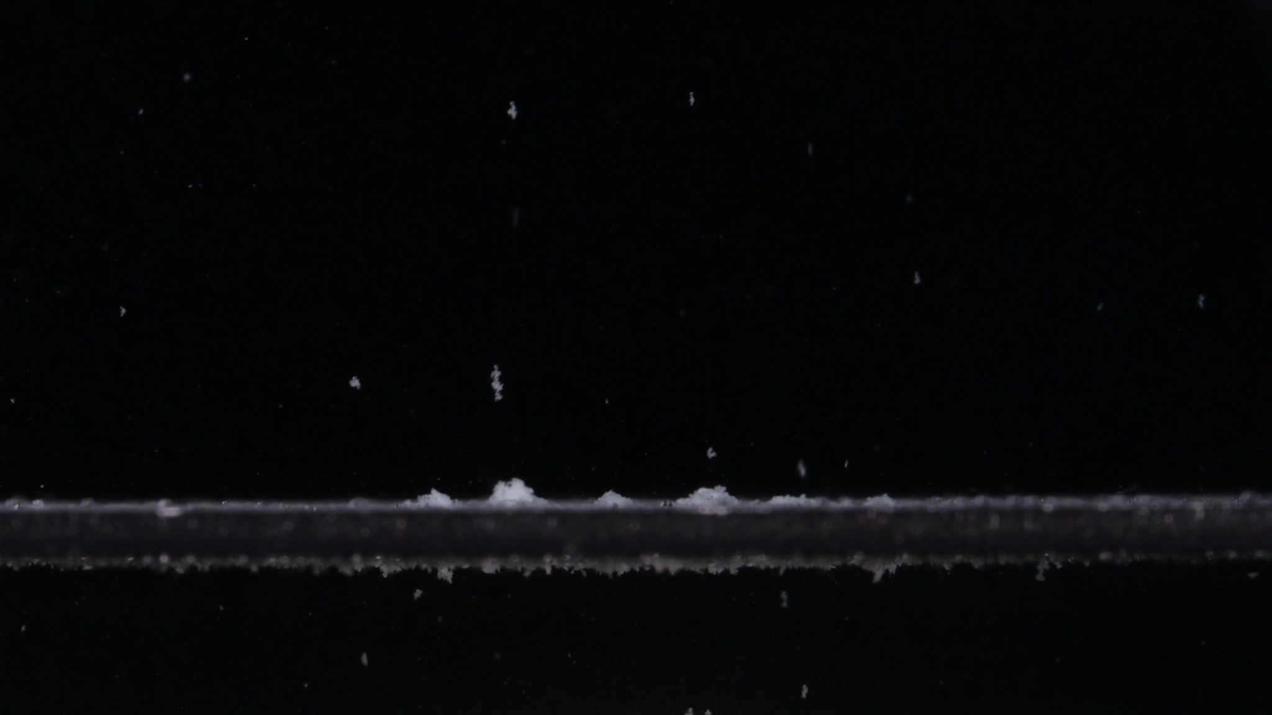
Group B, Pic 4, 45 min
Assistant: Analysis at 45 min:
Dimension | Description
Color change | The large yellow-white central tablet mass seen at 30 min is no longer visible. The remaining material appears mostly white to off-white, with little visible yellow remaining. The surrounding field remains dark, so full liquid color or turbidity cannot be judged confidently. Scattered white particles are visible in the medium.
Shape change | The original tablet shape is now lost completely. There is no longer a continuous mound or recognizable tablet body. Only several small, irregular powder-like deposits remain along the lower boundary. This is a much more advanced shape collapse than at 30 min.
Surface texture change | Because the main tablet body is gone, there is no intact surface left to assess. The remaining material appears as loose, granular residue rather than a coherent tablet surface. The small deposits look crumbly and irregular.
Volume / size change | The tablet volume has decreased dramatically compared with 0, 15, and 30 min. At 45 min, only a very small fraction of visible solid material remains. The original broad tablet footprint is replaced by a thin residue line and small powder piles.
Dissolution speed and time | Between 30 and 45 min, Group B shows a marked acceleration or completion of disintegration. The main mass that was still present at 30 min is no longer present at 45 min. This indicates that Group B disintegrated much more completely by 45 min than Group A did at the same time point.
Physical state change | The tablet has changed from a softened central mound into dispersed residue and fine particulate matter. The solid structure has collapsed almost entirely. No persistent central core is visible in this image.
Dissolution medium | The medium/background appears dark, and full transparency or cloudiness cannot be reliably assessed from this image alone. Suspended particles are visible throughout the field, but they are not dense enough to make the whole image uniformly cloudy. A thin residue band is visible along the bottom boundary.
Fragment distribution and density | The remaining fragments are concentrated along the bottom boundary as small powder piles and a thin sediment-like line. Some fine particles are suspended above the bottom, but the main visible residue is settled. Fragment density is no longer concentrated in a central tablet-shaped mass; it is spread as low-density sediment and scattered particles.

Interim note: This is an important difference. At 45 min, Group A still had a clear central yellow-white mound with a substantial remaining body. Group B at 45 min has almost no central mass left, only small residues and scattered particles. This suggests that Group B disintegrates faster and more completely than Group A.

Group B — Group B, Pic 5, 60 min
User: Group B, Pic 5. Each picture is taken 15 minutes apart.
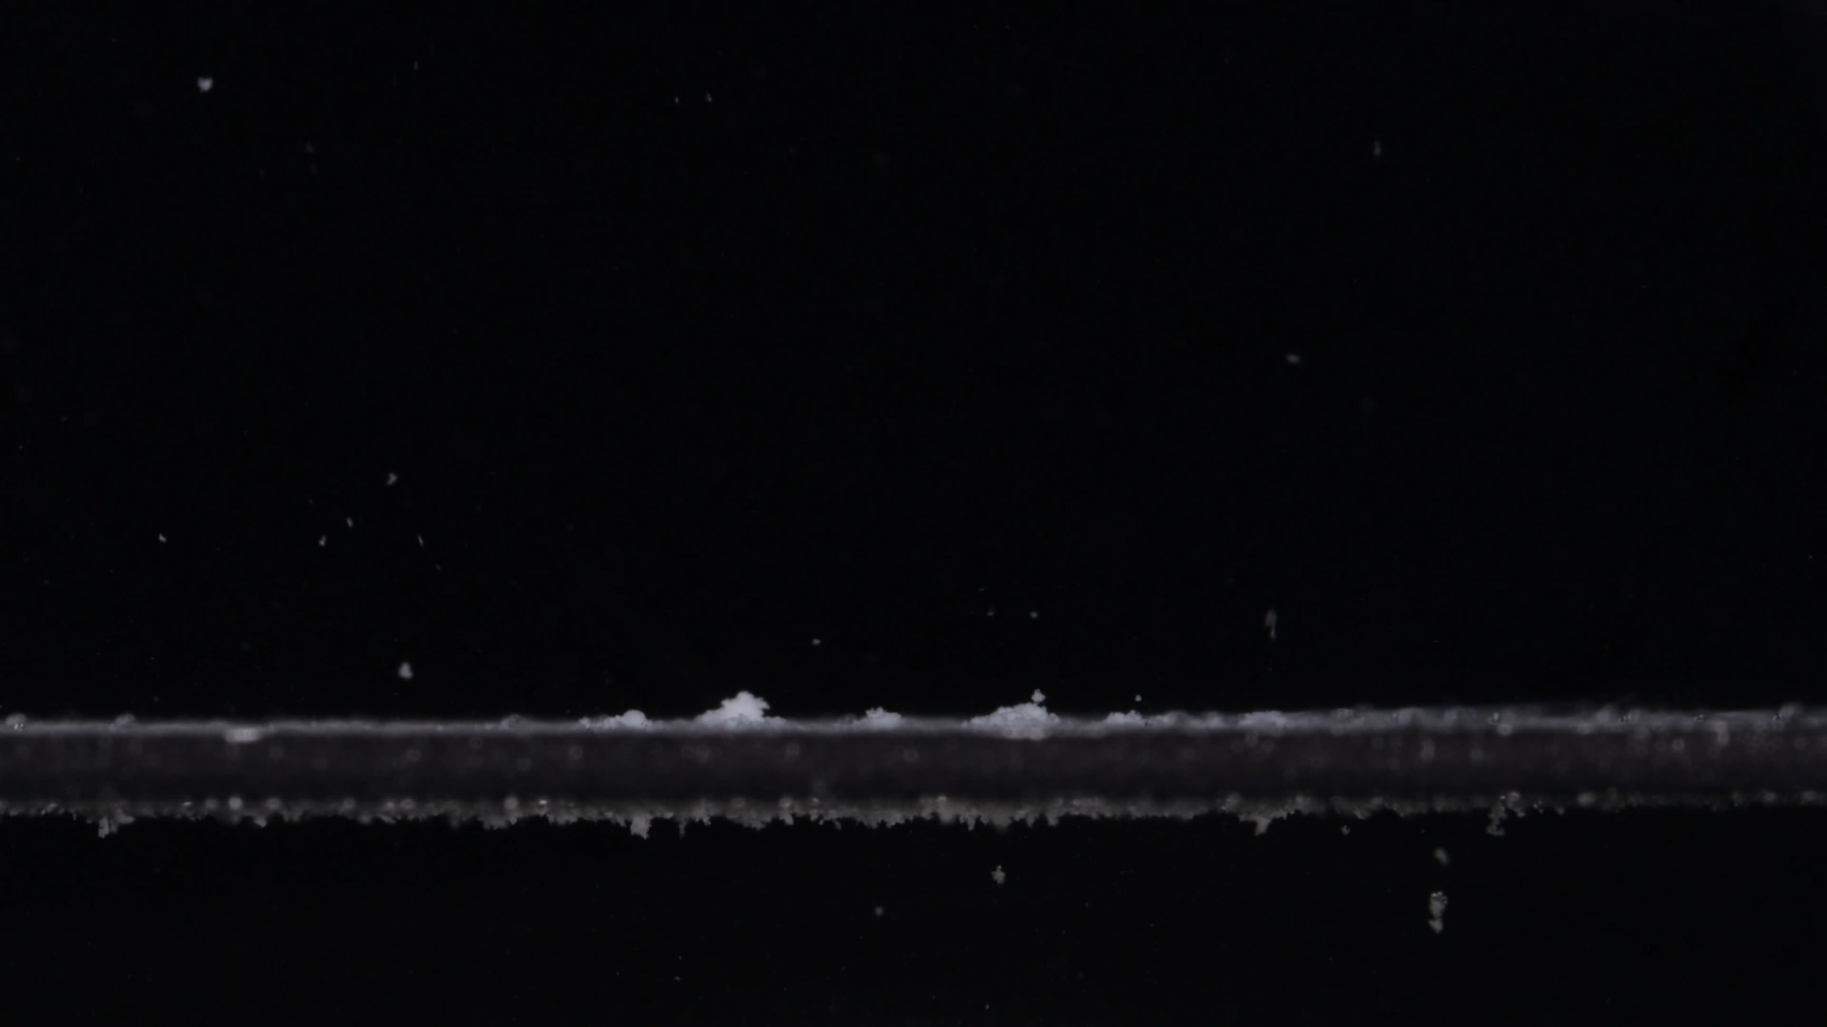
Group B, Pic 5, 60 min
Assistant: Analysis at 60 min:
Dimension | Description
Color change | The remaining visible material is mostly white to off-white. The yellow tablet body seen at 0–30 min is no longer visible. The surrounding medium still appears dark in the image, so total solution turbidity cannot be judged confidently.
Shape change | The original tablet shape is completely lost. There is no central mound, no cylindrical side wall, and no intact contour. Only small irregular residue piles remain along the bottom boundary.
Surface texture change | No intact tablet surface remains. The visible residue appears loose, granular, powder-like, and sedimented.
Volume / size change | The visible solid volume has decreased dramatically from the original wide tablet. At 60 min, only trace residue remains, indicating near-complete visual disintegration.
Dissolution speed and time | Group B appears to have disintegrated substantially between 30 and 45 min, and by 60 min the process is essentially complete visually. This is much faster than Group A, which still retained a clear central mound at 60 min.
Physical state change | The tablet has changed from a compact solid to dispersed fine residue. No persistent core is visible.
Dissolution medium | Fine particles are visible in the field, but the image does not allow reliable judgment of total liquid clarity. Most visible material appears settled near the bottom boundary.
Fragment distribution and density | Residue is distributed as a thin sediment-like line with several small powder piles. Fragment density is low overall and concentrated near the bottom rather than in a central tablet mass.

Interim note: At 60 min, Group B shows almost complete disintegration. No recognizable tablet body remains.

4. Final Eight-Dimension Comparison and Determination
User: Please compare Groups A and B based on their disintegration characteristics across the eight dimensions to determine if they are from the same drug or not, and explain why you think so.
Assistant: Overall conclusion: Based on the full 0–60 min image sequence, Groups A and B are unlikely to be the same physical tablet/formulation. Images alone cannot prove chemical identity, so they cannot prove whether the active ingredient is the same or different. However, they are visually inconsistent with being the same drug product, same formulation, or same tablet type.
Dimension | Group A | Group B | Interpretation
Color change | Starts white/off-white at 0 min, then becomes pale yellow to yellow-white after wetting and erosion. Yellow remains visible in the central mound even at 60 min. | Starts already pale yellow at 0 min. By 45–60 min, the remaining visible residue becomes mostly white/off-white, with little yellow central mass left. | The starting color is different. Group A appears to reveal yellow gradually during disintegration, while Group B is yellow from the beginning. This suggests different coating/excipient exposure or different tablet structure.
Shape change | Starts as a thicker, compact, round tablet with a slightly domed top. Over time it becomes a rounded mound, but a central body remains through 60 min. | Starts as a wider, flatter, cylindrical tablet. By 30 min it becomes a low flattened mound; by 45–60 min the recognizable tablet body is gone. | The initial shape and the shape-loss pathway are different. Group A keeps a mound-like core; Group B collapses/disperses much more completely.
Surface texture change | Surface changes from smooth/matte to rough, fluffy, granular, and powdery, but the eroded surface stays attached to a persistent central mass. | Surface also becomes rough and powdery, but the loosened material separates more completely, leaving only sediment-like residue by 45–60 min. | Both show granular erosion, but Group B loses structural integrity much faster.
Volume / size change | Volume decreases gradually. Even at 60 min, a substantial low mound remains. | Volume decreases sharply between 30 and 45 min. By 45–60 min, only small residue piles and a thin sediment line remain. | This is one of the clearest differences. Group A has slow volume loss; Group B has near-complete visible volume loss by 45 min.
Dissolution speed and time | Slow-to-moderate disintegration. The tablet is still visibly present at 60 min. | Faster disintegration. The main tablet mass is present at 30 min but nearly gone by 45 min. | The time profile is inconsistent with the same formulation under similar conditions.
Physical state change | Compact solid → softened porous mound → partially collapsed residue, but with a persistent core-like mass. | Compact solid → softened porous flat mass → dispersed residue, with no persistent core by 45–60 min. | Group A behaves like a tablet with a more resistant remaining core. Group B behaves like a tablet that loses cohesion more completely.
Dissolution medium | Medium appears dark in the images, so full turbidity cannot be judged confidently. Visible particles remain mostly near the tablet and bottom boundary. | Medium also appears dark, with scattered particles. By 45–60 min, most visible material is settled along the bottom boundary. | Medium appearance is not the strongest evidence because lighting limits turbidity assessment. Still, Group B shows more complete transfer of solid material into settled residue.
Fragment distribution and density | Fragments and particles remain concentrated around the persistent central mound, with only limited detached pieces. | Fragments become distributed as small powder piles and sediment along the bottom; no central mass remains after 45 min. | Group A has localized erosion around a remaining body. Group B has dispersed/sedimented residue after full structural collapse.

Why the Two Groups Are Likely Not the Same Formulation
The strongest evidence is not a single image, but the whole time sequence.
- At 0 min, Group A and Group B already look different. Group A is a whiter, thicker, more dome-like tablet. Group B is a flatter, wider, pale-yellow tablet.
- From 15 to 30 min, both groups show some similar behavior: yellow-white exposure, rough powdery surface, and particle shedding. This means they may share some general tablet-disintegration behavior, and possibly even a similar active-drug color appearance after wetting.
- At 45 and 60 min, the difference becomes decisive. Group A still has a substantial central yellow-white mound at 60 min. Group B has almost no recognizable tablet body by 45 min and only small sediment-like residues at 60 min.
- The two groups differ in initial tablet geometry, disintegration speed, persistence of the central core, and final residue pattern.

Final Determination
Final judgment: Groups A and B are visually inconsistent with being the same tablet/formulation. Likely different drug product/formulation.
They could theoretically still contain the same active ingredient, such as doxycycline hyclate, but based on these images alone, they do not appear to be the same physical drug product because their initial appearance, size/shape profile, disintegration speed, persistence of the core, and final residue pattern are clearly different. Chemical identity cannot be confirmed from images alone.

Analytical Limitations
- The conclusion is based on visible image features only, not on chemical testing.
- Lighting, camera angle, medium conditions, tablet batch, coating, and manufacturing differences can affect appearance.
- The strongest visual evidence still supports a difference in physical formulation because the time-dependent disintegration pathways differ substantially.

