Drug Disintegration Image Analysis
Groups A and B
Edited English record of the discussion and final comparison

Subject described by user: Doxycycline Hyclate Tablets
Image timing: 0, 15, 30, 45, and 60 minutes for each group

1. Scope of the Document
This document compiles the English drug-disintegration discussion and analysis for two uploaded image groups, Group A and Group B. The final Chinese request used to ask for this document is intentionally not included. The analysis is based on visible image evidence only; it does not confirm chemical identity, manufacturer, dose, excipient composition, or dissolution-medium chemistry.

2. Knowledge Base Framework Recalled for the Analysis
Before evaluating the images, the drug-disintegration description framework was recalled. Each image was analyzed using eight fixed dimensions:
- Color change: solution clarity or turbidity, color intensity, and location of color release.
- Shape change: whether the tablet remains intact, cracks, deforms, collapses, or becomes fragments.
- Surface texture change: smoothness, roughness, pores, cracks, peeling, fluffy residue, or fibrous structures.
- Volume / size change: swelling, shrinking, height reduction, footprint changes, and collapse pattern.
- Dissolution speed and time: stage-by-stage speed changes across 0, 15, 30, 45, and 60 minutes.
- Physical state change: transition from a hard solid to a hydrated, soft, fragmented, or powder-like mass.
- Dissolution medium: visible clarity, haze, suspended particles, and local turbidity.
- Fragment distribution and density: whether fragments remain near the original tablet, spread outward, float, suspend, or settle.
Special attention was given to tablet size and shape because initial tablet geometry is an important visual comparison feature when judging whether two image sequences may represent the same product or formulation.

3. User's Task and Analysis Approach
The user requested an English analysis of disintegration images for two groups of Doxycycline Hyclate Tablets, labeled Group A and Group B. Each group contained five images taken 15 minutes apart. The user asked whether the two groups might represent the same drug or different drugs, with special attention to changes in tablet size and shape.
To reduce hallucination, the analysis below stays close to visible image features. Statements such as exact pH, excipient chemistry, or confirmed drug identity are avoided because those cannot be determined from these images alone.

4. Group A Image Descriptions

Group A Uploaded Image Sequence
Images are shown as thumbnails for reference. Each image was taken 15 minutes after the previous one.
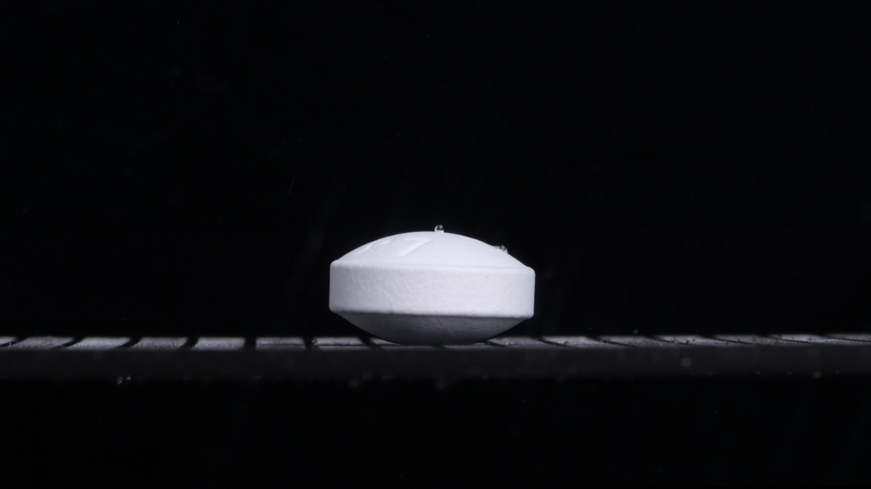  Group A - 0 min | 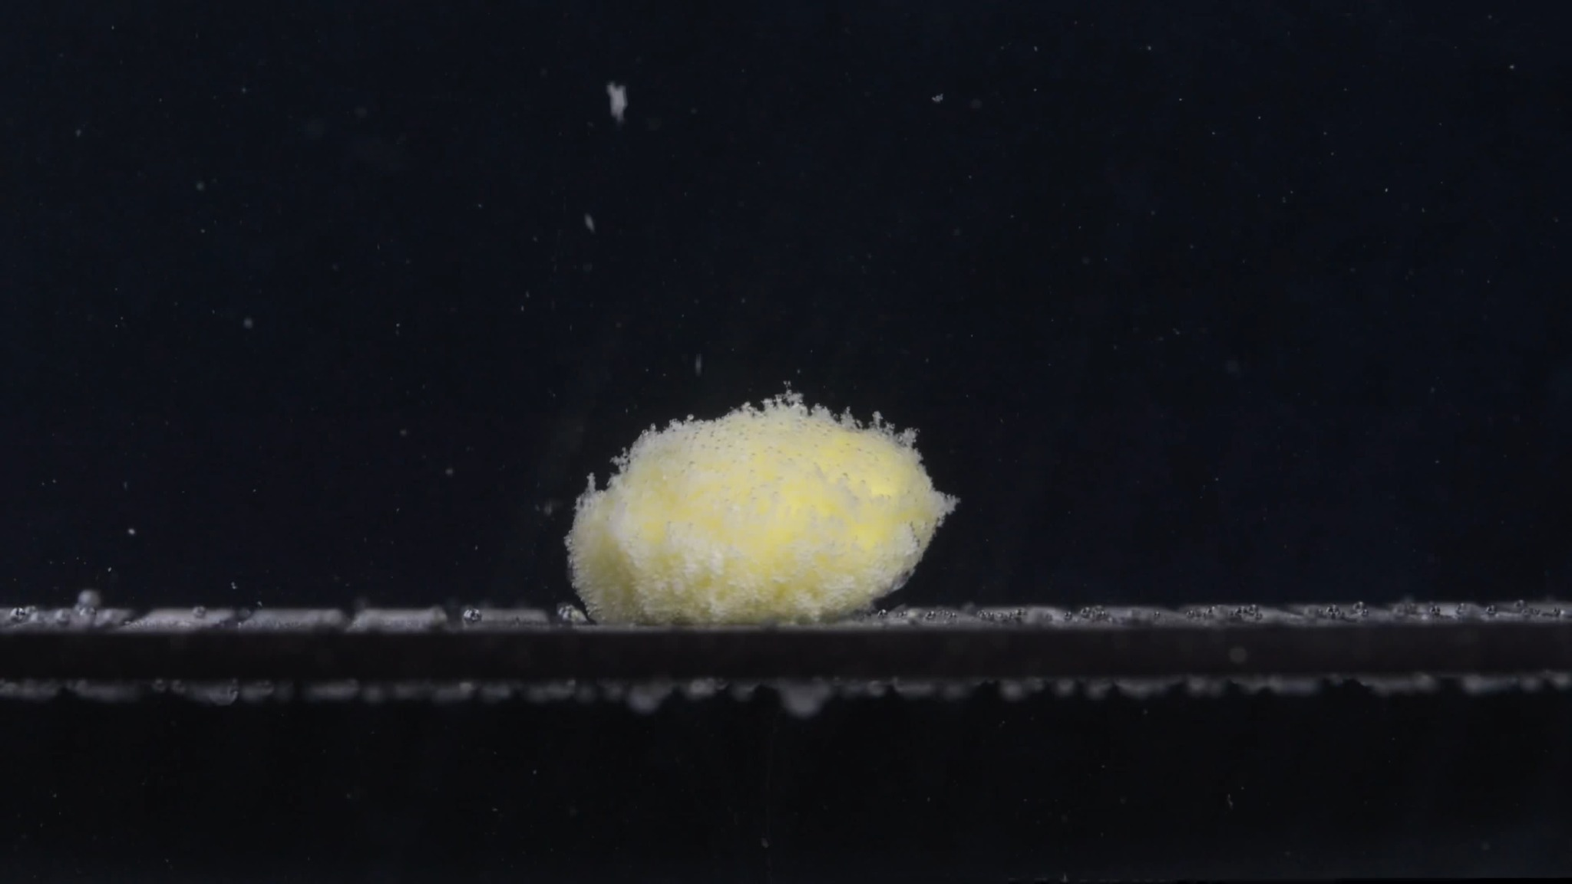  Group A - 15 min | 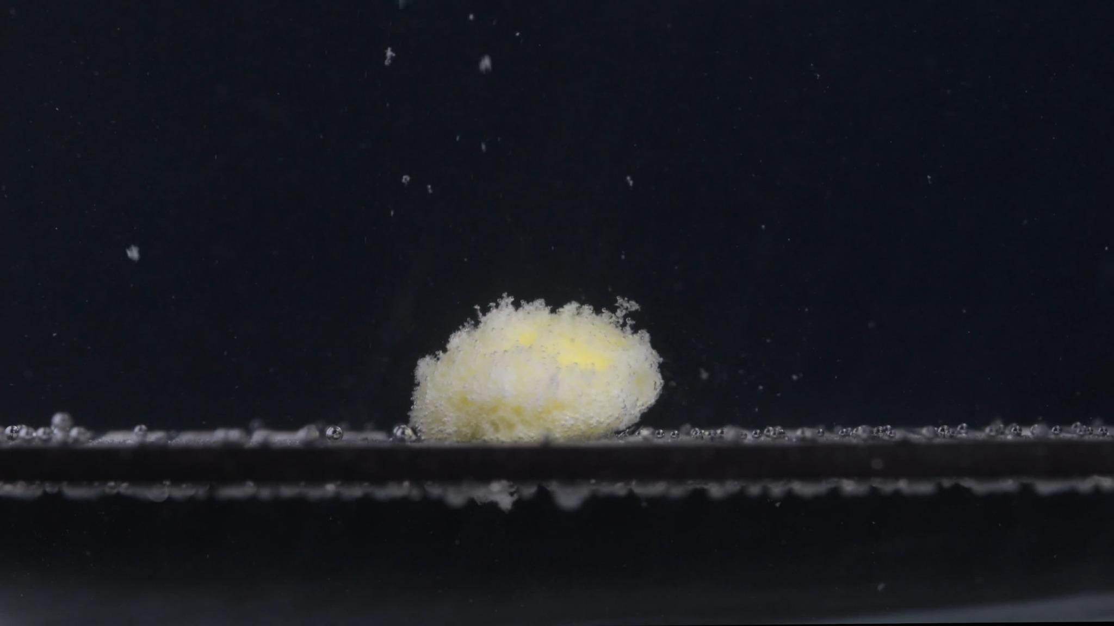  Group A - 30 min
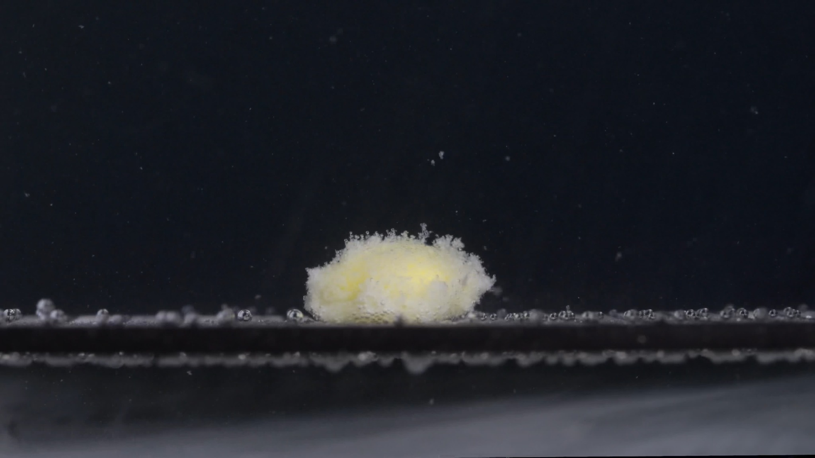  Group A - 45 min | 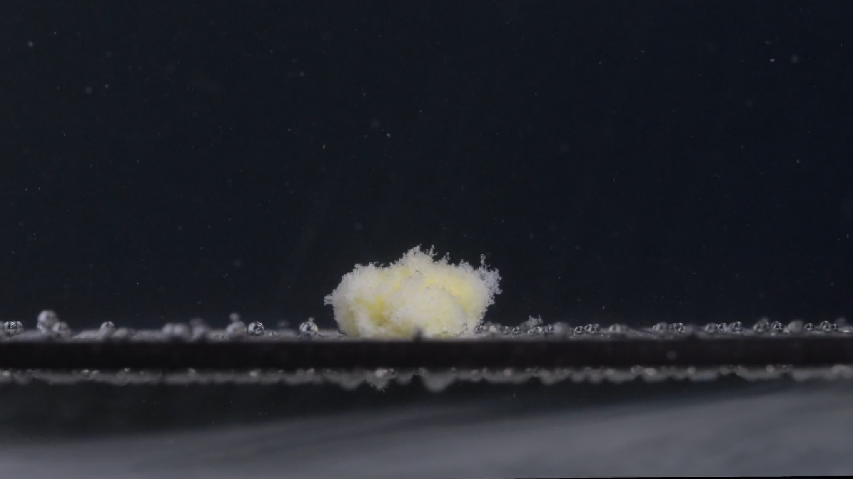  Group A - 60 min

Group A - Picture 1 - Time: 0 min
- Color change: The tablet is uniformly white. No visible yellow color release or cloudiness is present around the tablet.
- Shape change: The tablet is intact and appears round/biconvex when viewed from the side, with a flat central side band and curved upper and lower faces.
- Surface texture change: The surface looks mostly smooth and compact. A few small droplets or bubbles are visible on the upper surface, but no erosion, cracks, or flakes are visible.
- Volume / size change: This is the baseline size. The tablet has the greatest clearly defined height and width in the sequence.
- Dissolution speed and time: No visible disintegration has occurred yet. This stage mainly shows initial wetting.
- Physical state change: The tablet remains a solid, coherent structure.
- Dissolution medium: The surrounding medium appears visually clear. The dark background and support surface remain sharply visible.
- Fragment distribution and density: No detached fragments are visible around the tablet.
- Interim judgment: At 0 min, Group A starts as a compact white, biconvex tablet with a well-defined outline.

Group A - Picture 2 - Time: 15 min
- Color change: A yellow inner material is visible, especially in the central region. The outer area appears white to off-white, forming a pale fibrous layer around the yellow center.
- Shape change: The original biconvex tablet shape has disappeared. The tablet has transformed into a swollen, irregular oval mound.
- Surface texture change: The surface is no longer smooth. It appears fluffy, porous, and granular, with many fine projections along the top and edges.
- Volume / size change: The compact tablet has lost its original sharp contour. The apparent volume looks expanded because of swelling and the formation of a loose hydrated particle layer, although the original solid core has clearly broken down.
- Dissolution speed and time: The largest visual change occurs between 0 and 15 min, indicating rapid early disintegration after liquid penetration.
- Physical state change: The tablet has changed from a hard solid into a soft, hydrated, partially collapsed mass. The yellow interior is exposed.
- Dissolution medium: The medium is still mostly clear, but small suspended particles are visible above and around the mound.
- Fragment distribution and density: Fragment density is highest at the original tablet position. A few fine particles are suspended upward, but most material remains localized.
- Interim judgment: Group A shows strong early swelling and rupture by 15 min, with exposure of yellow internal material and loss of the original tablet shape.

Group A - Picture 3 - Time: 30 min
- Color change: The yellow color remains visible inside the mass, while the outer layer is more whitish or off-white. Local turbidity and small particles are visible around the tablet residue.
- Shape change: The mound is lower and less regular than at 15 min. The original round/biconvex form is completely unrecognizable.
- Surface texture change: The surface remains very rough and fibrous, with a cotton-like or flocculent appearance. The top edge is uneven and fragmented.
- Volume / size change: Compared with 15 min, the visible height appears slightly reduced, while the base remains spread out. The compact portion seems to be slowly collapsing.
- Dissolution speed and time: After the rapid first-stage rupture, the process appears slower. The main change from 15 to 30 min is gradual erosion and particle shedding rather than a sudden break.
- Physical state change: The mass is soft and porous. Fine particles continue to detach from the surface.
- Dissolution medium: The medium contains more visible suspended specks than at 15 min, but it does not appear uniformly opaque.
- Fragment distribution and density: Most fragments remain concentrated near the original tablet location. Some fine particles are suspended above the mound, and some material appears to settle near the support surface.
- Interim judgment: By 30 min, Group A is in a slower erosion phase: the tablet is no longer intact, but a central residue still remains.

Group A - Picture 4 - Time: 45 min
- Color change: The yellow areas are still present but appear more diffuse and partly covered by pale fibrous material.
- Shape change: The residue has become a lower, irregular mound. The top surface is uneven, with a ragged crest rather than a smooth dome.
- Surface texture change: The surface is highly porous and feathery. No smooth tablet coating remains visible.
- Volume / size change: The height is further reduced compared with 15 and 30 min. The mass appears more collapsed, while loose material spreads along the base.
- Dissolution speed and time: Disintegration continues slowly. There is no obvious large break event; instead, the residue gradually erodes and disperses.
- Physical state change: The structure looks weak, hydrated, and partially collapsed. The remaining mass appears soft rather than rigid.
- Dissolution medium: Slight local cloudiness is visible near the tablet residue and support surface. The background remains mostly visible, so turbidity is localized rather than uniform.
- Fragment distribution and density: Fine fragments are concentrated around the base of the mound, with scattered suspended particles above it.
- Interim judgment: At 45 min, the tablet residue is smaller and more collapsed, but dissolution or disintegration is not complete.

Group A - Picture 5 - Time: 60 min
- Color change: Pale yellow remains visible inside the residue, but the overall appearance is more off-white and diffuse than at 15 min.
- Shape change: The original tablet shape is completely lost. Only an irregular, fluffy, collapsed residue remains.
- Surface texture change: The residue has a loose, fibrous, porous texture. The edges are ragged and poorly defined.
- Volume / size change: The height is clearly reduced compared with the 15 min image. The remaining material is more flattened and spread near the support surface.
- Dissolution speed and time: The sequence suggests rapid initial disintegration from 0 to 15 min, followed by slower erosion from 15 to 60 min.
- Physical state change: The tablet has changed into a soft particulate mass with remaining undissolved or slowly dissolving residue.
- Dissolution medium: The medium shows suspended fine particles and local haze, but it is not fully cloudy throughout the frame.
- Fragment distribution and density: Fragment density remains highest at the original tablet position. Some fine particles are suspended above, while much of the material appears settled or attached near the bottom surface.
- Interim judgment: At 60 min, Group A still has visible residue. The tablet has disintegrated substantially but has not visually disappeared.

Group A Overall Disintegration Pattern
Group A shows a rapid early transition from a smooth, white, intact biconvex tablet at 0 min to a yellow-white swollen fibrous mound by 15 min. From 15 to 60 min, the process becomes slower: the mound gradually loses height, becomes more porous and ragged, and sheds fine particles into the surrounding medium. The residue remains mostly localized near the original tablet position, with limited long-distance dispersion.

5. Group B Image Descriptions

Group B Uploaded Image Sequence
Images are shown as thumbnails for reference. Each image was taken 15 minutes after the previous one.
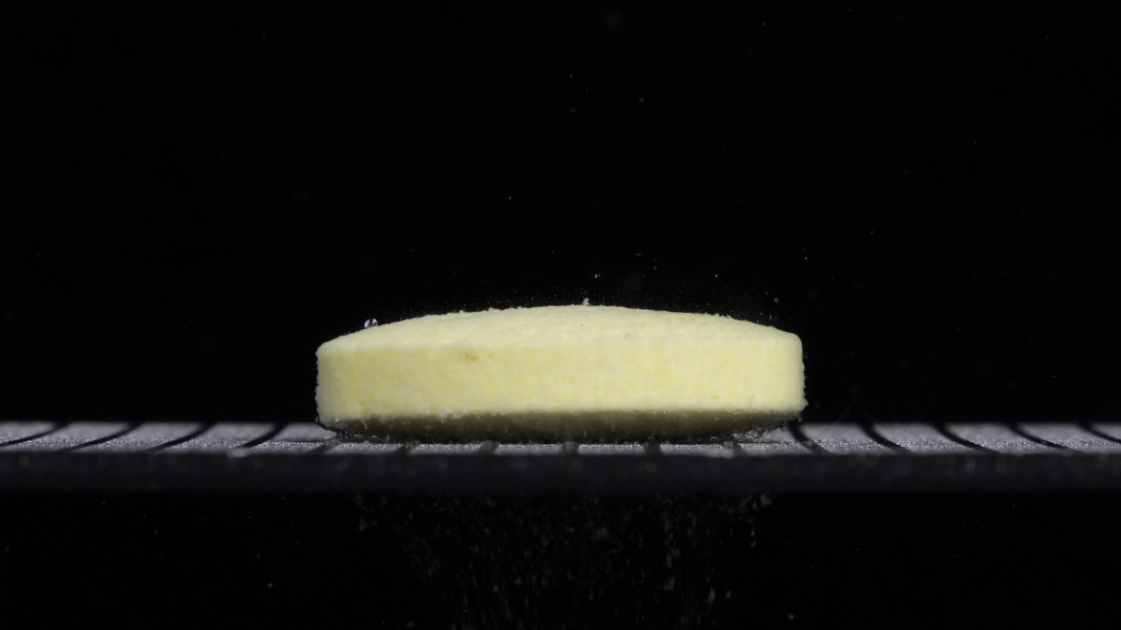  Group B - 0 min | 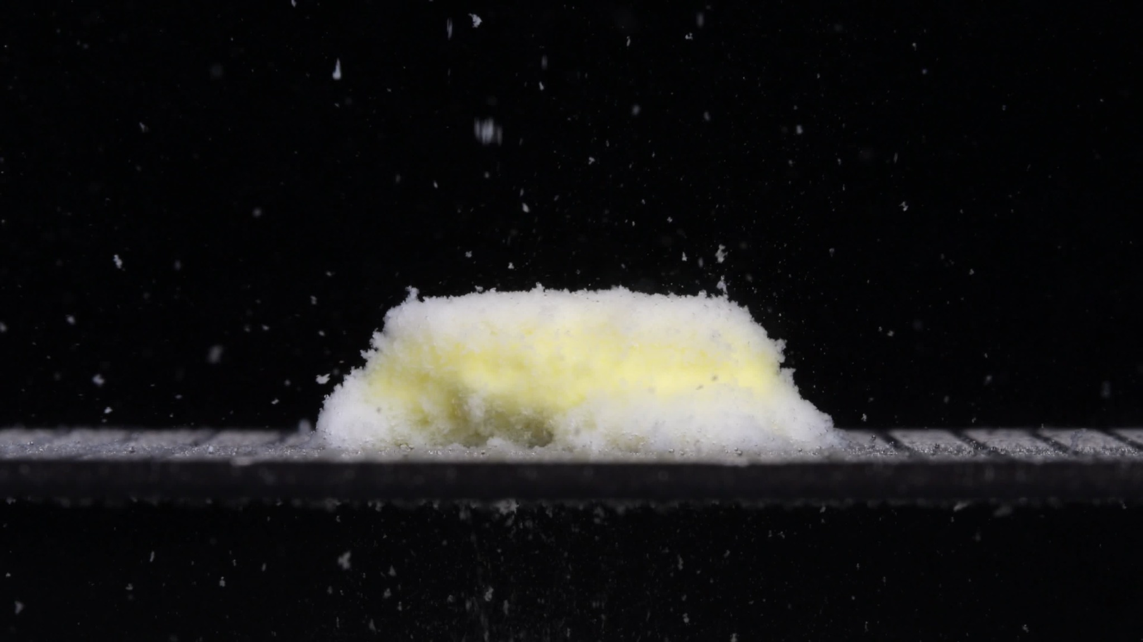  Group B - 15 min | 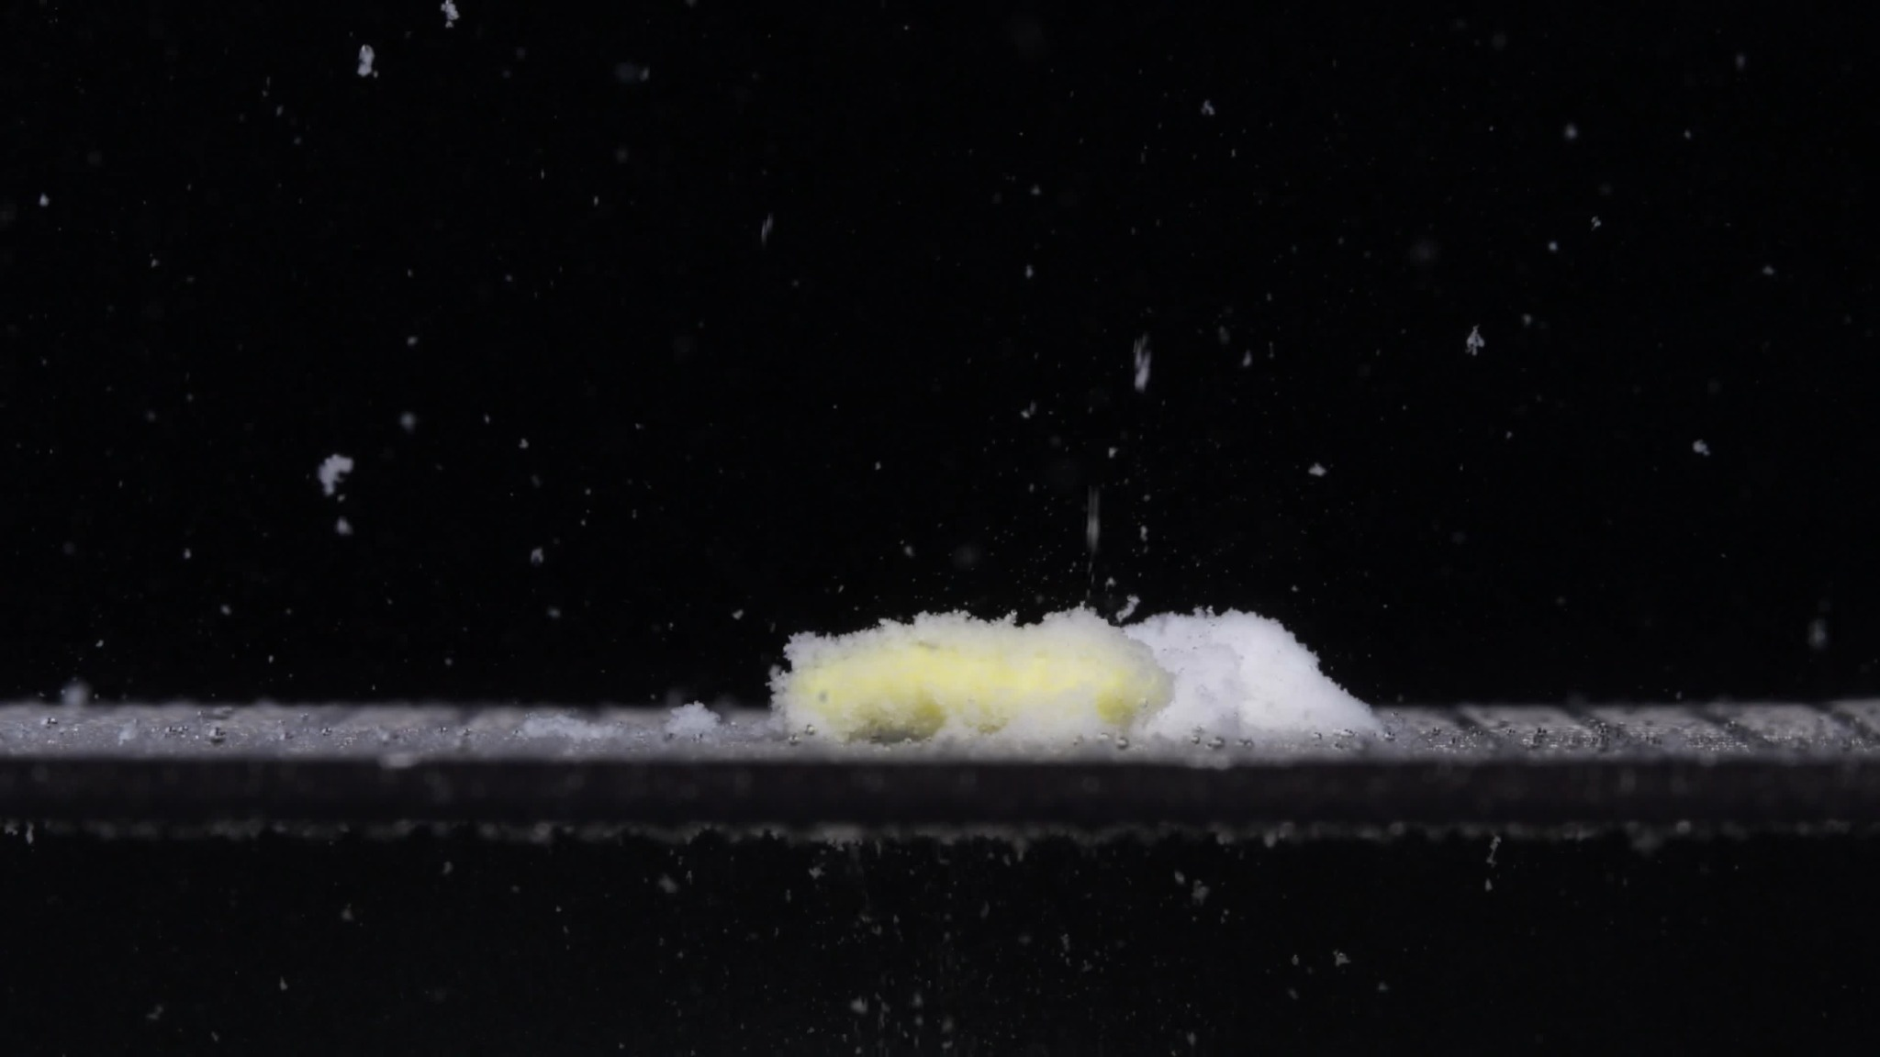  Group B - 30 min
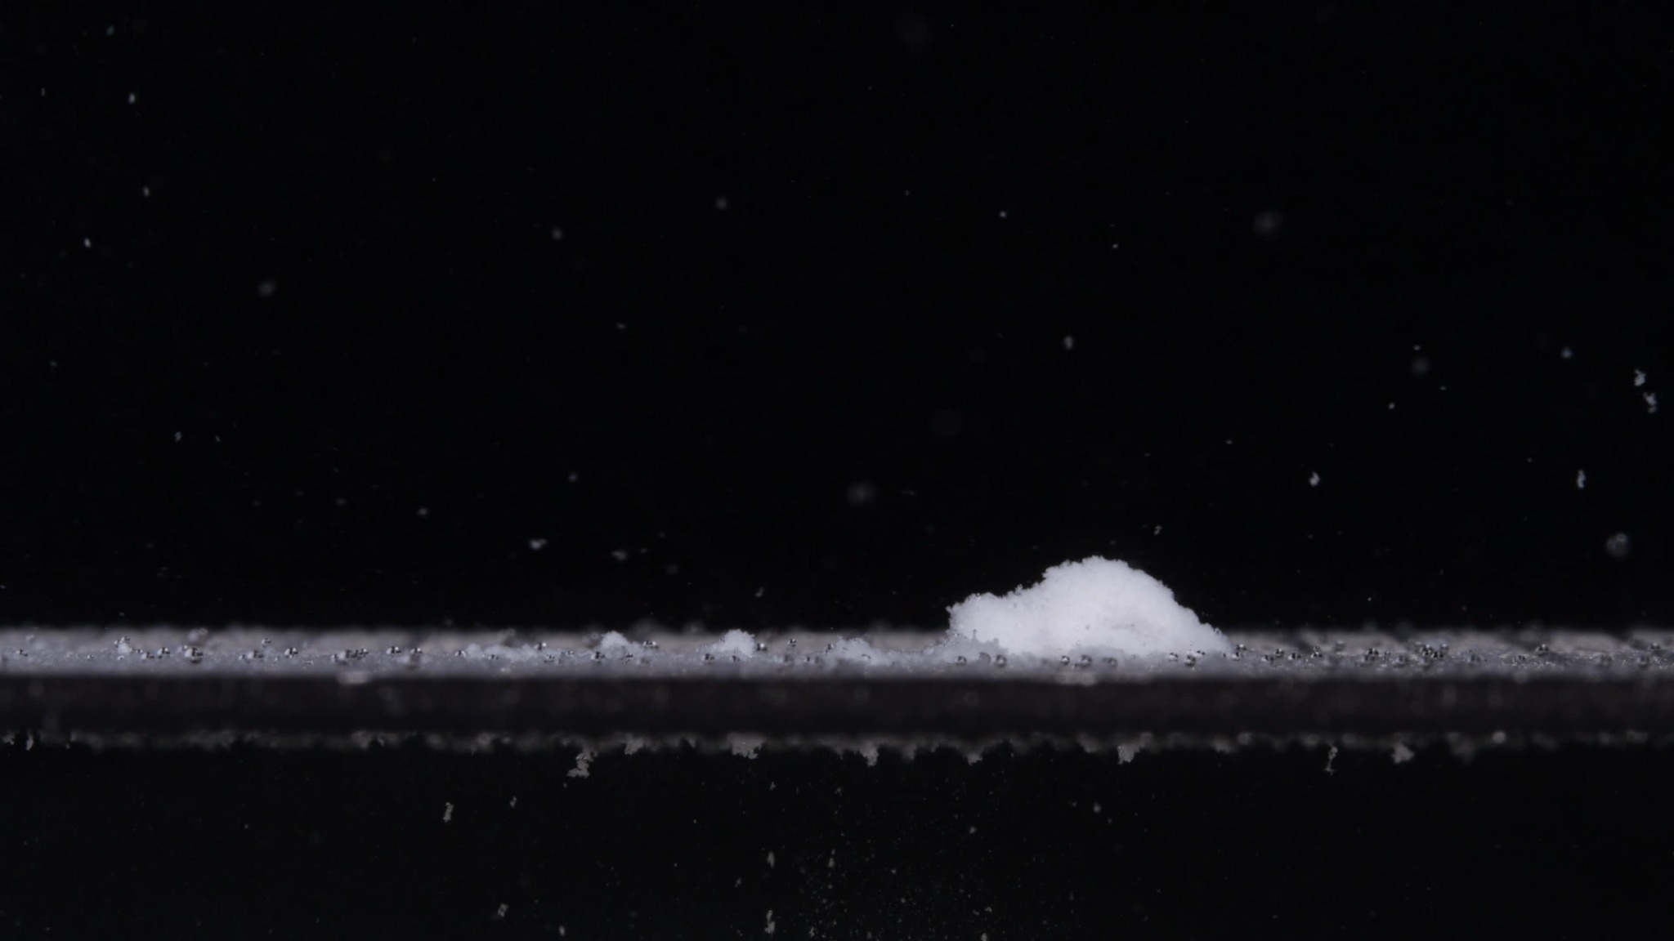  Group B - 45 min | 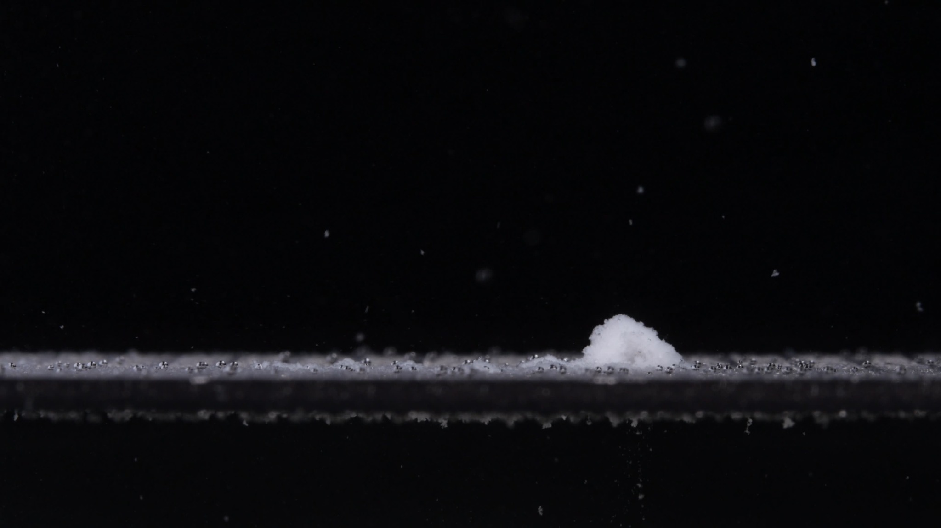  Group B - 60 min

Group B - Picture 1 - Time: 0 min
- Color change: The tablet is pale yellow from the beginning. No clear white outer coating is visible. The surrounding medium appears mostly clear.
- Shape change: The tablet is a wide, flat cylindrical tablet with a long horizontal profile and relatively straight side wall. It is not biconvex like Group A at 0 min.
- Surface texture change: The surface appears slightly rough or matte, but the tablet is still structurally intact.
- Volume / size change: This is the baseline for Group B. The tablet appears much wider and flatter than Group A's initial tablet.
- Dissolution speed and time: No major disintegration is visible yet, although very fine particles appear to be present around the lower edge.
- Physical state change: The tablet remains mostly solid and coherent.
- Dissolution medium: The medium is visually clear with only slight local particles near the tablet and platform.
- Fragment distribution and density: Fragment density is very low; a few fine particles are close to the bottom edge.
- Interim judgment: Group B starts as a pale-yellow, wide, flat cylindrical tablet, visually different from Group A's white, smaller biconvex tablet.

Group B - Picture 2 - Time: 15 min
- Color change: The tablet mass shows yellow material inside and a white/off-white hydrated layer around the outside. The yellow color is still broad and visible.
- Shape change: The original flat cylindrical outline has collapsed into a wide, low mound. The sides are no longer straight.
- Surface texture change: The surface has become fluffy, porous, and granular, with many small particles and rough projections.
- Volume / size change: The compact tablet has expanded into a loose hydrated mass. Its apparent footprint remains wide, but the original solid form has broken down.
- Dissolution speed and time: A large change has occurred between 0 and 15 min, showing fast early disintegration.
- Physical state change: The tablet changes from a firm solid into a soft, swollen, partially fragmented mass.
- Dissolution medium: Many suspended particles are visible above and around the tablet, more numerous than in Group A at 15 min.
- Fragment distribution and density: Fragment density is high around the original tablet area. Fine particles are dispersed upward and outward, not only attached to the mound.
- Interim judgment: Group B also shows rapid early breakdown, but it produces a wider debris field and more visible suspended particles than Group A.

Group B - Picture 3 - Time: 30 min
- Color change: Yellow material remains mainly in the left or central low residue. A larger white mound is visible on the right side.
- Shape change: The residue is separated into uneven regions: a low yellowish mass on the left and a higher white/off-white mound on the right.
- Surface texture change: Both residues are rough and porous. The right-side mound appears more compact and powdery; the left-side yellow area appears flatter and more eroded.
- Volume / size change: The total height has decreased compared with 15 min, and the material has spread laterally along the platform.
- Dissolution speed and time: Disintegration continues strongly from 15 to 30 min. The original tablet body is no longer recognizable.
- Physical state change: The tablet has separated into soft particulate residues. The yellow component appears to be diminishing.
- Dissolution medium: Many fine suspended particles are visible throughout the frame, with local haze near the platform.
- Fragment distribution and density: Fragments are distributed over a wider horizontal region than in Group A. Material is concentrated in two visible zones, especially the right-side white mound.
- Interim judgment: By 30 min, Group B is more dispersed than Group A at the same time point, and its residue pattern is asymmetric.

Group B - Picture 4 - Time: 45 min
- Color change: The visible yellow color has mostly disappeared. The remaining main residue is predominantly white or off-white.
- Shape change: Only a smaller white mound remains on the right side, with a thin layer of dispersed material spread along the platform.
- Surface texture change: The mound is rough, porous, and powder-like. The edges are soft and poorly defined.
- Volume / size change: The remaining residue is much smaller than at 15 and 30 min. The height and footprint have both decreased.
- Dissolution speed and time: Group B shows substantial loss of visible yellow material by 45 min, suggesting faster visual clearance of the yellow component than Group A.
- Physical state change: The tablet has mostly converted into loose particulate residue.
- Dissolution medium: The medium contains scattered fine particles, but the main visible residue is now localized.
- Fragment distribution and density: A low-density particle layer spreads across the platform, while the highest density remains in the small white mound.
- Interim judgment: At 45 min, Group B is closer to late-stage residue than Group A, because the yellow core-like material is largely gone.

Group B - Picture 5 - Time: 60 min
- Color change: The remaining residue is almost entirely white/off-white. Yellow material is not clearly visible.
- Shape change: The original tablet shape is completely absent. A small irregular mound remains on the right, with scattered low residue along the base.
- Surface texture change: The residue appears loose, powdery, and porous, with a soft mound shape.
- Volume / size change: The remaining visible mass is small compared with the 0 and 15 min images. The residue has reduced more strongly than Group A by 60 min.
- Dissolution speed and time: Group B shows rapid early disintegration and continued reduction through 60 min. By the final image, only a small residue remains.
- Physical state change: The tablet has changed into dispersed fine particles and a small settled powder-like mound.
- Dissolution medium: Fine particles remain suspended and settled, but there is no large intact or semi-intact tablet mass.
- Fragment distribution and density: Fragment density is highest in the small right-side mound; a thin layer of particles is spread along the platform.
- Interim judgment: At 60 min, Group B has much less visible colored residue than Group A and appears more completely dispersed.

Group B Overall Disintegration Pattern
Group B begins as a pale-yellow, wide, flat cylindrical tablet. It shows rapid early breakdown by 15 min, producing a broad, low, fluffy mass with substantial visible particle shedding. By 30 min, the residue becomes asymmetric, with yellow material remaining in a lower region and a higher white/off-white mound forming to the side. By 45 to 60 min, yellow material is no longer clearly visible, and only a smaller mostly white mound with scattered low-density residue remains.

6. Final Comparison Across the Eight Dimensions
The following table compares Groups A and B across the same eight dimensions used for the image descriptions.
Dimension | Group A | Group B | Comparison Judgment
Color change | Starts as a white tablet. Yellow material appears after wetting and remains visible through 60 min. | Starts as a pale-yellow tablet. Yellow is visible early but mostly disappears by 45-60 min, leaving mainly white residue. | Different. The starting color and persistence of yellow material are not the same.
Shape change | Starts as a smaller biconvex tablet with curved upper/lower faces. By 15 min it becomes a localized swollen oval mound. | Starts as a wide, flat cylindrical tablet with a long horizontal profile and straighter side wall. By 15 min it becomes a broader, flatter collapsed mass. | Strongly different. Initial shape is one of the most important differences.
Surface texture change | Smooth at 0 min, then fluffy, fibrous, porous, and ragged. | Slightly rough/matte at 0 min, then also fluffy, porous, and powder-like. | Partly similar. Both develop porous/fluffy residues, but this is common during disintegration and does not prove sameness.
Volume / size change | Swells into a mound at 15 min, then gradually loses height but still leaves a relatively large residue at 60 min. | Collapses into a wide mass at 15 min, then reduces more strongly; by 60 min only a smaller white mound remains. | Different. Group B reduces and disperses more completely by the final time point.
Dissolution speed and time | Rapid change from 0-15 min, followed by slower erosion from 15-60 min. Visible residue remains substantial at 60 min. | Rapid change from 0-15 min, with continued strong breakdown from 15-45 min. By 45-60 min, the yellow component is mostly gone. | Different in the later stage. Both start fast, but Group B progresses further by 45-60 min.
Physical state change | Changes from a hard intact tablet to a swollen soft fibrous mass. The central residue remains coherent for a long time. | Changes from an intact flat tablet to broad soft residue, then separates into dispersed material and a smaller white mound. | Different. Group A retains a more localized core-like residue; Group B separates and clears more.
Dissolution medium | Medium remains mostly clear with localized haze and suspended particles near the tablet. | Medium shows more visible suspended particles, especially at 15-30 min, with broader particle spread. | Moderately different. Group B appears to shed more particles into the medium.
Fragment distribution and density | Fragments remain mostly concentrated near the original tablet position. The residue stays localized. | Fragments spread more widely along the platform and into the surrounding medium. By 30 min, residue appears split into separate zones. | Different. Group B has wider dispersion and lower final localized residue.

Key Similarities
- Both groups show rapid visible disintegration within the first 15 minutes.
- Both groups form a yellow-and-white hydrated mass after wetting.
- Both groups develop rough, fluffy, porous, granular textures during breakdown.
- Both groups produce fine suspended particles in the surrounding medium.
- Both groups lose their original tablet outline by 15 to 30 minutes.

Key Differences
- Group A begins as a white, smaller, biconvex tablet; Group B begins as a pale-yellow, much wider, flatter cylindrical tablet.
- Group A retains yellow-white fibrous residue through 60 min; Group B loses most visible yellow material by 45 to 60 min.
- Group A residue remains more localized; Group B spreads more broadly along the platform and shows more suspended debris.
- Group A leaves a larger visible residue at 60 min; Group B leaves a smaller, mostly white mound.

7. Final Determination
Based on the visible evidence, Groups A and B are unlikely to be the same tablet or the same formulation.
The strongest reason is the 0-minute appearance before disintegration begins. Group A is a white, smaller, biconvex tablet with curved upper and lower faces. Group B is a pale-yellow, wider, flatter cylindrical tablet with a longer horizontal profile and straighter side wall. This difference is too large to explain only as normal variation in disintegration behavior.
The second reason is the late-stage residue pattern. Group A keeps a yellow-white fibrous mound through 60 min, whereas Group B loses most visible yellow color by 45 to 60 min and leaves a smaller, mainly white residue. If the two image sequences were from the same formulation under the same test conditions, the initial tablet geometry, residue color, residue size, and fragment distribution would be expected to be more consistent.
The third reason is fragment distribution. Group A remains more localized around the original tablet position, while Group B spreads more widely along the platform and produces more visible suspended debris.
Final conclusion: Groups A and B may possibly share the same active ingredient, but visually they do not appear to be the same tablet product or formulation. From image-based disintegration analysis alone, they should be classified as different tablets or different formulations.

8. Caution
This conclusion is based only on visual comparison of disintegration images. A definitive identification would require independent information such as tablet imprint, dimensions, formulation details, manufacturer data, assay results, or controlled dissolution testing.

