Edited English Conversation Record and Disintegration Comparison
Doxycycline Hyclate Tablets — Groups A and B
Scope: This document contains the English-only edited conversation and analysis up to the completion of the drug disintegration discussion. The final Chinese document-formatting request is intentionally excluded.

1. Initial User Request and Analysis Framework
User request
The user requested analysis of disintegration images for two groups of Doxycycline Hyclate Tablets, Group A and Group B. Each group contains five images taken 15 minutes apart. The goal was to describe the disintegration process for each image in English, paying special attention to changes in tablet size and shape, and then determine whether the two image sets appear to be from the same drug product or different products.
Knowledge Base preparation
The analysis was prepared using the Knowledge Base framework for describing drug disintegration. The framework requires a consistent evaluation across eight dimensions.
- Color change: color intensity, transparency, turbidity, and spatial spread of color in the medium.
- Shape change: whether the tablet remains intact, cracks, collapses, or becomes irregular fragments.
- Surface texture change: smoothness, roughness, pores, cracks, peeling, powdering, or flaking.
- Volume change: visible reduction, swelling, collapse, or changes in height and diameter.
- Dissolution speed and time: how quickly the tablet changes at 0, 15, 30, 45, and 60 minutes.
- Physical state change: liquid penetration, swelling, cracking, internal weakening, and particle generation.
- Dissolution medium: clarity, turbidity, sediment, suspension, and interaction between tablet and liquid.
- Fragment distribution with density: number, size, density, spreading, suspension, and sedimentation of fragments.
For the final comparison, the focus was placed on initial tablet appearance, size and shape change, surface erosion pattern, speed of collapse, turbidity or particle-release pattern, fragment density and distribution, and final residue pattern.

2. Group A Image-by-Image Disintegration Description

Pic 1, 0 minutes
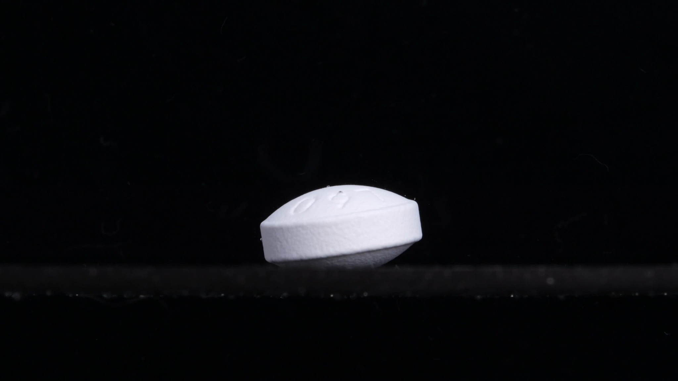
Group A – Pic 1 – 0 minutes
Color Change: The tablet appears uniformly white. No visible yellowing, staining, or color diffusion is present around the tablet. The surrounding medium or background appears dark, so the liquid color and transparency cannot be judged confidently from this image alone.
Shape Change: The tablet is intact. It has a round, thick, biconvex tablet-like shape with a slightly beveled edge. The upper surface shows shallow markings, but no obvious breakage is visible.
Surface Texture Change: The surface appears mostly smooth and compact. The side surface shows fine compression texture, but there are no visible cracks, pores, peeling, swelling, or powder shedding.
Volume Change: No visible volume reduction is observed. The tablet keeps its original height and diameter.
Dissolution Speed and Time: At 0 minutes, visible disintegration has not begun. This image serves as the baseline for later time points.
Physical State Change: The tablet remains in a solid, coherent state, without visible fragmentation, swelling, internal collapse, or edge softening.
Dissolution Medium: The medium is not clearly visible because of the dark background and lighting. No obvious cloudiness, suspended particles, sediment, or color plume can be confirmed.
Fragment Distribution with Density: No fragments are visible around the tablet. Fragment density is zero or not detectable at this stage.

Summary: Baseline: Group A starts as a white, intact, round/biconvex tablet with stable size and shape and no visible fragment release.

Pic 2, 15 minutes
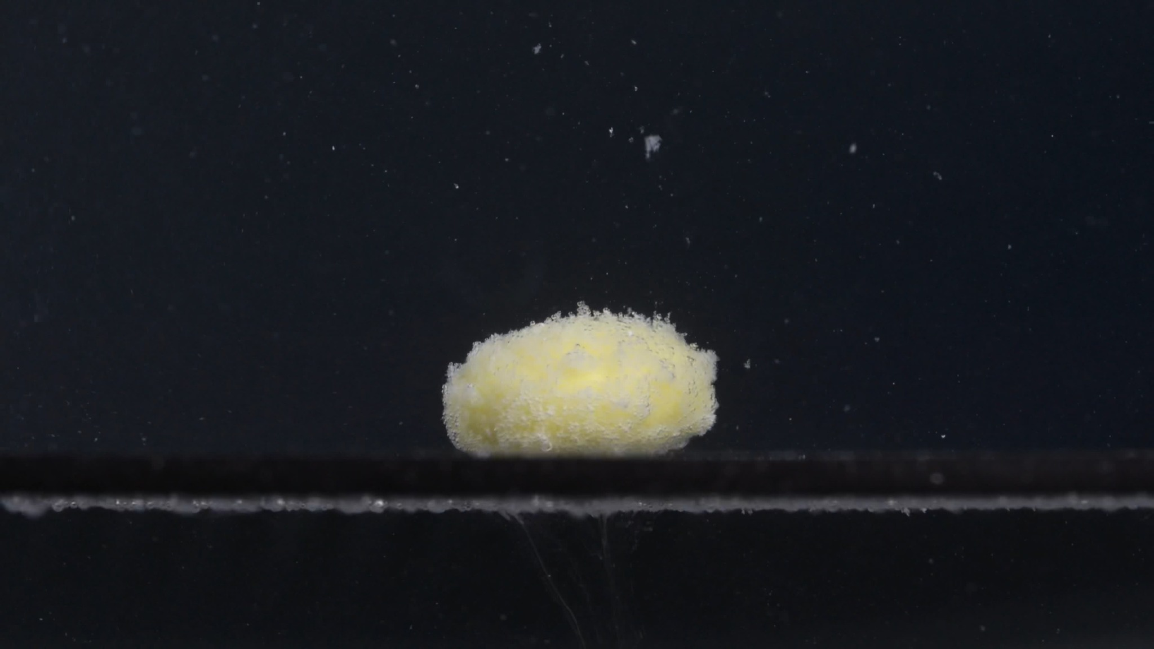
Group A – Pic 2 – 15 minutes
Color Change: The tablet has changed from uniform white to pale yellow or yellow-white, especially on the exposed upper and central areas. This suggests hydration or partial erosion of the outer surface, exposing a yellow internal layer.
Shape Change: The tablet is still mostly one piece, but its original smooth round contour is no longer sharp. The edges appear softened and irregular, and the tablet looks more like a rounded mound with a fuzzy boundary.
Surface Texture Change: The surface has become rough, porous, and powdery. A loose granular layer is visible across much of the tablet, especially along the top and edges.
Volume Change: The tablet does not show complete collapse. Its footprint remains similar, while the surface appears expanded and fluffy. This stage is better described as surface swelling and erosion rather than obvious volume loss.
Dissolution Speed and Time: Between 0 and 15 minutes, disintegration has clearly begun. The tablet remains largely intact, but the surface has softened and released fine particles.
Physical State Change: The tablet has changed from a compact solid to a hydrated, weakened solid with a powdery outer layer. No major cracks or large separated fragments are clearly visible.
Dissolution Medium: Small light-colored particles are visible around the tablet. The whole-medium turbidity cannot be confidently determined, but localized particle suspension is apparent.
Fragment Distribution with Density: Fine particles are visible above and around the tablet, with the highest density near the tablet surface. A thin residue or particle layer appears along the bottom line. No obvious large detached fragments are present.

Summary: Key point: At 15 minutes, Group A shows clear surface disintegration but retains most of its size and overall shape.

Pic 3, 30 minutes
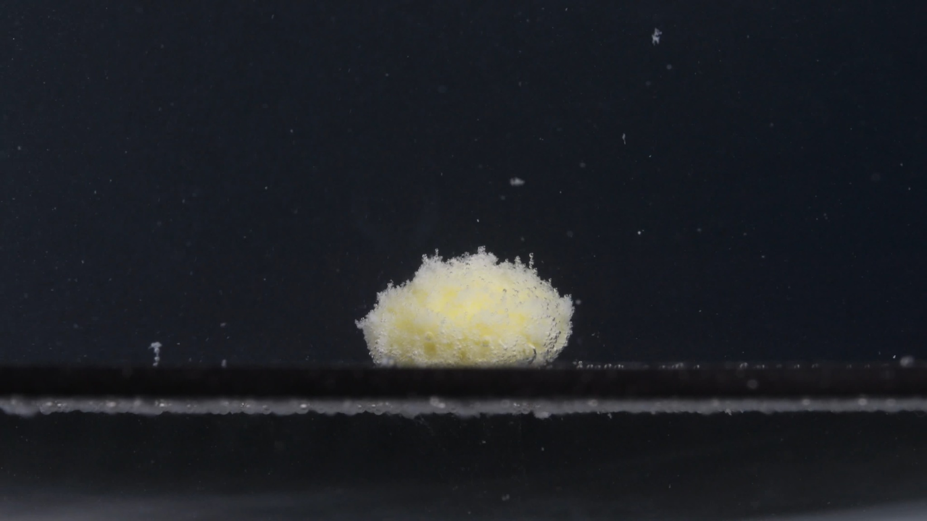
Group A – Pic 3 – 30 minutes
Color Change: The tablet remains mainly yellow-white. The yellow tone is more visible in the central body, while the outer surface is covered with a whitish powder-like layer.
Shape Change: The original biconvex tablet shape is increasingly obscured. The tablet appears as an irregular mound-like mass with a fuzzy, uneven outline.
Surface Texture Change: The surface is rough, porous, and granular. The outer layer looks loosened, with many fine particles attached to the surface.
Volume Change: The tablet retains visible central bulk, but the original clean height and edge definition are reduced. The visible structure appears less dense and more porous.
Dissolution Speed and Time: From 15 to 30 minutes, the process progresses gradually rather than abruptly. The tablet continues to erode from the surface and produce fine particles without breaking into large pieces.
Physical State Change: The tablet has become a softened, hydrated, fragile mass. The outer structure is weakened and crumbly, but no major split is clearly visible.
Dissolution Medium: The medium remains difficult to evaluate due to the dark background, although small suspended or floating pale particles are visible around the tablet.
Fragment Distribution with Density: Fine particles are distributed around the tablet, especially near the upper and side regions. The highest density remains close to the original tablet position.

Summary: Key point: At 30 minutes, Group A continues slow surface softening and powder formation, while a central mass remains.

Pic 4, 45 minutes
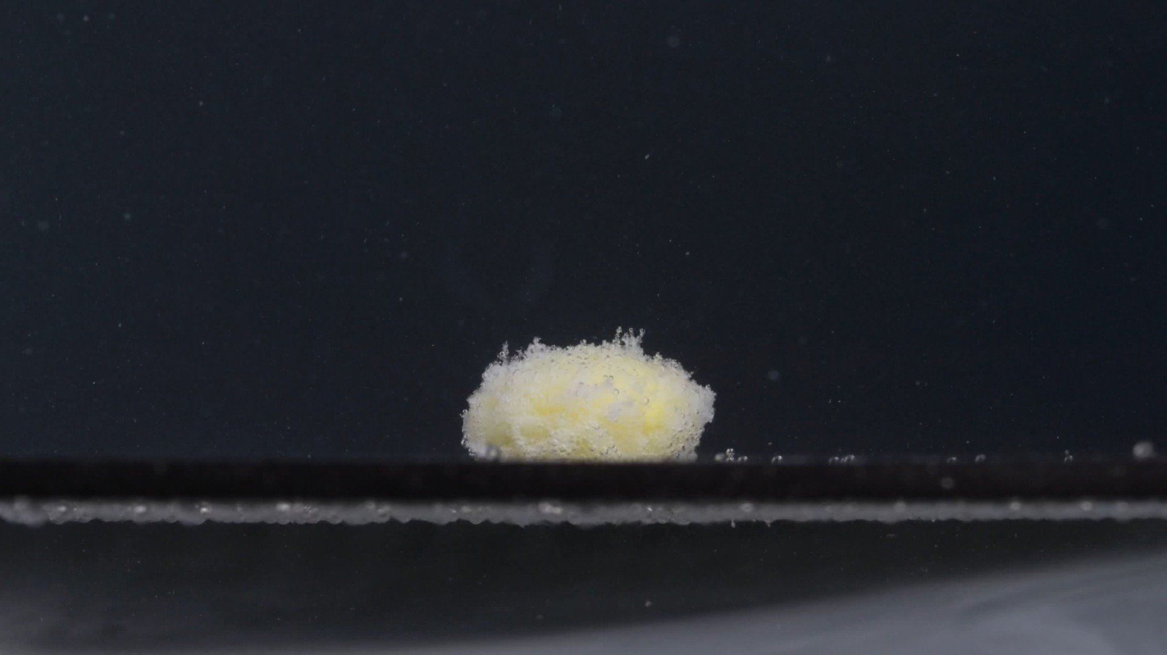
Group A – Pic 4 – 45 minutes
Color Change: The remaining mass is still pale yellow to yellow-white. The center is slightly more yellow, while the outer surface remains covered by a whitish granular layer.
Shape Change: The original round, biconvex tablet shape is no longer clearly recognizable. The tablet appears as a low, irregular mound with a soft and fuzzy outline.
Surface Texture Change: The surface is very rough, porous, and powdery. Fine granules cover almost the entire visible surface, and small protruding particles appear along the upper boundary.
Volume Change: The tablet retains a central bulk, but its compact original volume is reduced or loosened. The height appears lower than the original tablet, and edge definition is much weaker.
Dissolution Speed and Time: From 30 to 45 minutes, disintegration continues slowly. The tablet remains as one main mass while the surface sheds fine particles.
Physical State Change: The tablet is no longer hard and intact. It appears hydrated, fragile, and powdery, with a weakened outer structure but a core that has not fully dispersed.
Dissolution Medium: The surrounding medium remains difficult to evaluate, but small pale particles are visible around the tablet and along the lower boundary.
Fragment Distribution with Density: Fragments are mainly fine particles. The highest density remains close to the tablet surface, with a thin sediment-like line visible near the bottom.

Summary: Key point: At 45 minutes, Group A still has a central yellow-white mound and has not split into large fragments.

Pic 5, 60 minutes
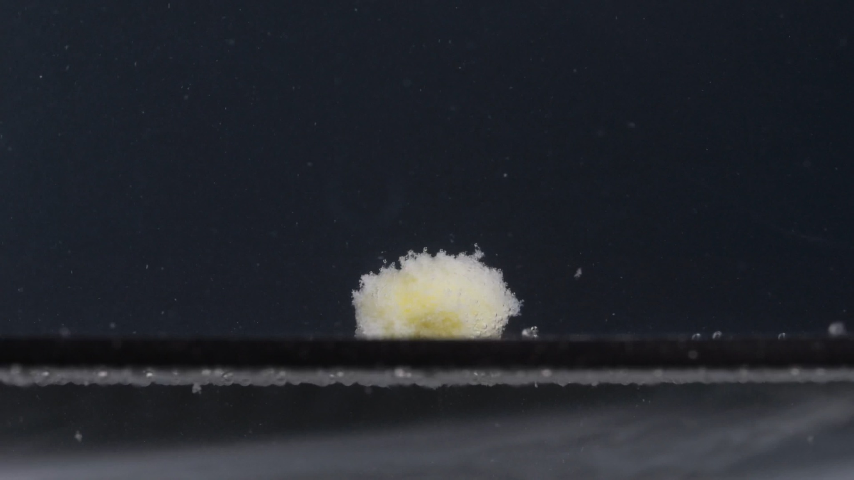
Group A – Pic 5 – 60 minutes
Color Change: The remaining tablet mass is pale yellow to yellow-white. The center has a slightly stronger yellow tone, while the outer layer is whitish and powdery.
Shape Change: The original tablet shape has almost completely disappeared. The remaining material appears as a small, irregular, soft mound with a fuzzy outline.
Surface Texture Change: The surface is highly rough, porous, and granular. The outer layer looks loose and powder-like, with many tiny particles attached.
Volume Change: Compared with 0 minutes, visible tablet volume is clearly reduced. Compared with 45 minutes, the remaining mass appears similar or slightly smaller, with a lower and less defined profile.
Dissolution Speed and Time: By 60 minutes, disintegration is still incomplete. The process appears slow and gradual, dominated by surface erosion and fine-particle shedding rather than rapid fragmentation.
Physical State Change: The tablet has changed from a hard solid into a hydrated, fragile, powdery residue mass. The core still appears to persist but is no longer compact or sharply defined.
Dissolution Medium: Small pale particles are visible around the tablet and along the lower boundary, but the overall clarity or turbidity of the liquid cannot be confidently judged.
Fragment Distribution with Density: Most visible fragments are fine particles. They remain densest near the tablet and along the bottom line. No clearly separated large chunks are visible.

Summary: Overall pattern: Group A shows surface softening, yellow internal exposure, powdery roughening, gradual size reduction, and persistent central residue at 60 minutes.

3. Group B Image-by-Image Disintegration Description

Pic 1, 0 minutes
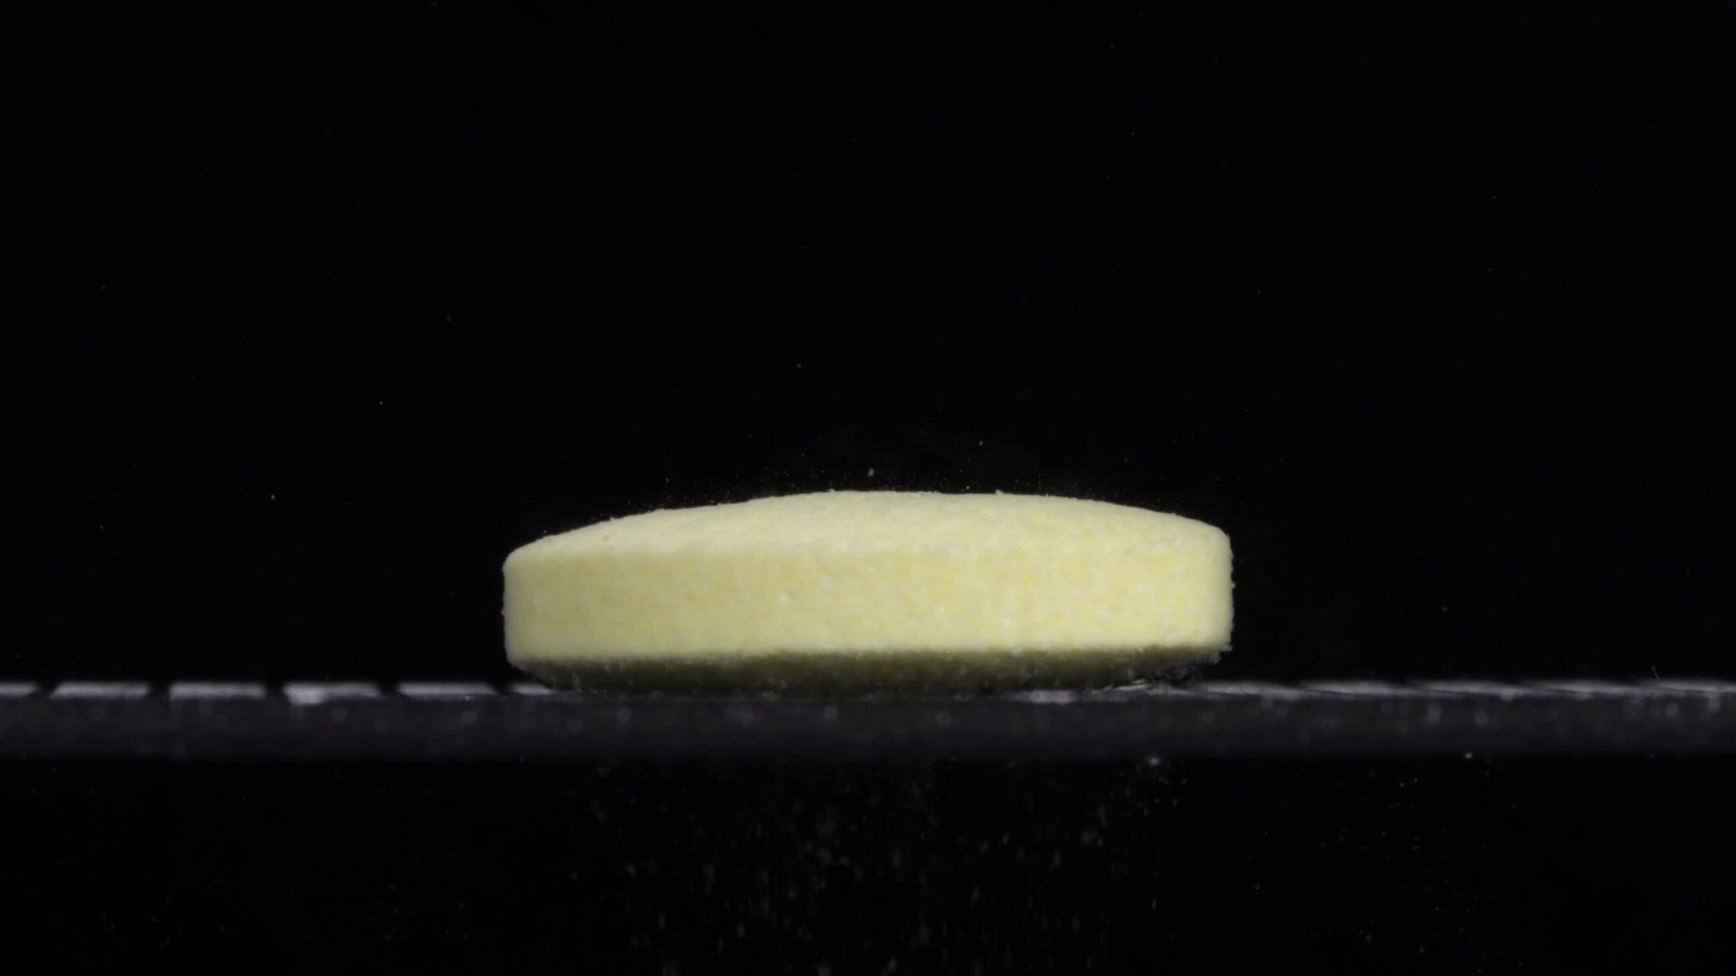
Group B – Pic 1 – 0 minutes
Color Change: The tablet already appears pale yellow to yellow-white at the starting point. No obvious color diffusion into the surrounding medium is visible.
Shape Change: The tablet is intact and appears as a flat, thick, cylindrical tablet with a broad horizontal profile and relatively straight side wall.
Surface Texture Change: The surface is slightly matte and finely granular, especially on the upper surface. No clear cracks, peeling areas, or detached fragments are visible.
Volume Change: No visible volume loss is present at 0 minutes. The tablet keeps stable height and diameter, and it appears wider and flatter than Group A's initial tablet.
Dissolution Speed and Time: At 0 minutes, no obvious disintegration has begun. This image is the baseline for Group B.
Physical State Change: The tablet remains a solid, coherent body without visible swelling, collapse, splitting, or powder shedding.
Dissolution Medium: The surrounding medium or background is dark, so the full clarity of the liquid cannot be judged confidently. No obvious turbidity cloud is visible.
Fragment Distribution with Density: No clear tablet fragments are visible around the main body. A few tiny light specks are present but cannot be confidently identified as drug fragments.

Summary: Baseline: Group B starts as a pale yellow, intact, flat cylindrical tablet with a broad side profile and slightly granular surface.

Pic 2, 15 minutes
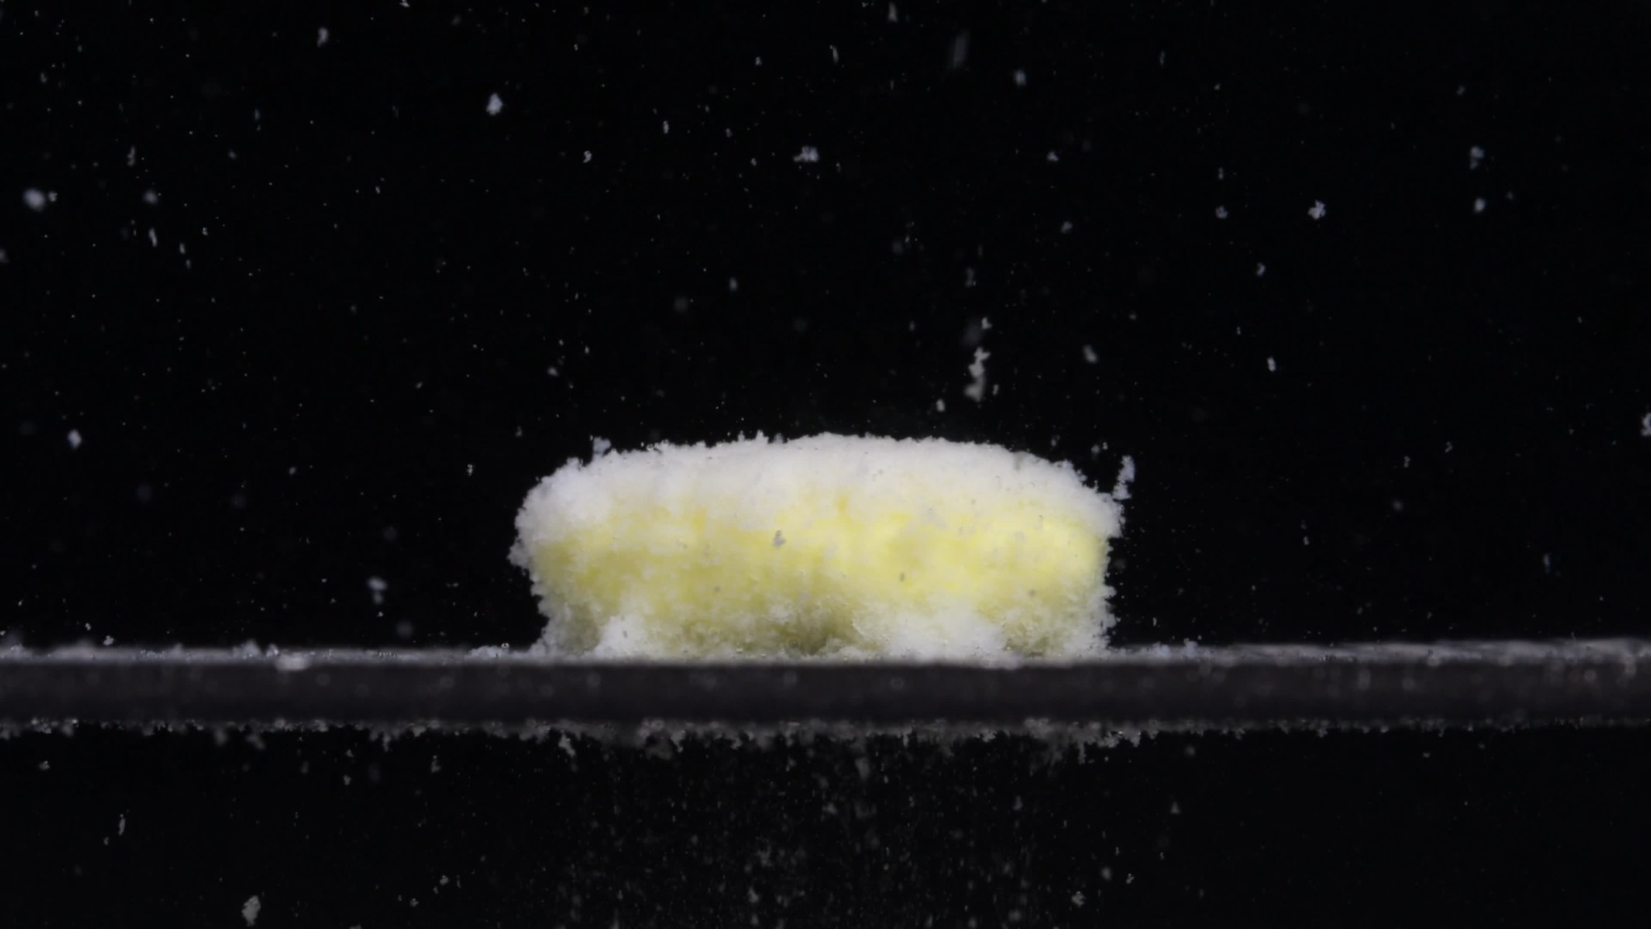
Group B – Pic 2 – 15 minutes
Color Change: The tablet remains pale yellow to yellow-white. The surface looks slightly whiter in some areas, especially along the upper and lower edges, likely because of loosened powder or hydrated surface material.
Shape Change: The tablet is still largely one intact, flat cylindrical body. Its straight side profile is still recognizable, but the top and bottom edges are less sharp.
Surface Texture Change: The surface has become rough, powdery, and porous. A loose whitish layer appears on the top surface and around the edges.
Volume Change: There is no obvious large volume loss yet. The tablet keeps most of its original width and height, but the surface appears softened or loosened.
Dissolution Speed and Time: By 15 minutes, Group B shows active but incomplete disintegration through surface erosion and fine-particle release, while the central body remains stable.
Physical State Change: The tablet has shifted from a compact solid to a hydrated, weakened solid with a powdery outer layer. The edges look softer.
Dissolution Medium: Many small pale particles are visible around the tablet, especially above it and near the bottom boundary.
Fragment Distribution with Density: Fine particles are more numerous than at 0 minutes. They are distributed around the tablet, with higher density near the lower edge and bottom line. No large detached fragments are visible.

Summary: Key point: At 15 minutes, Group B still retains its wide, flat cylindrical shape but shows clear surface powdering and particle shedding.

Pic 3, 30 minutes
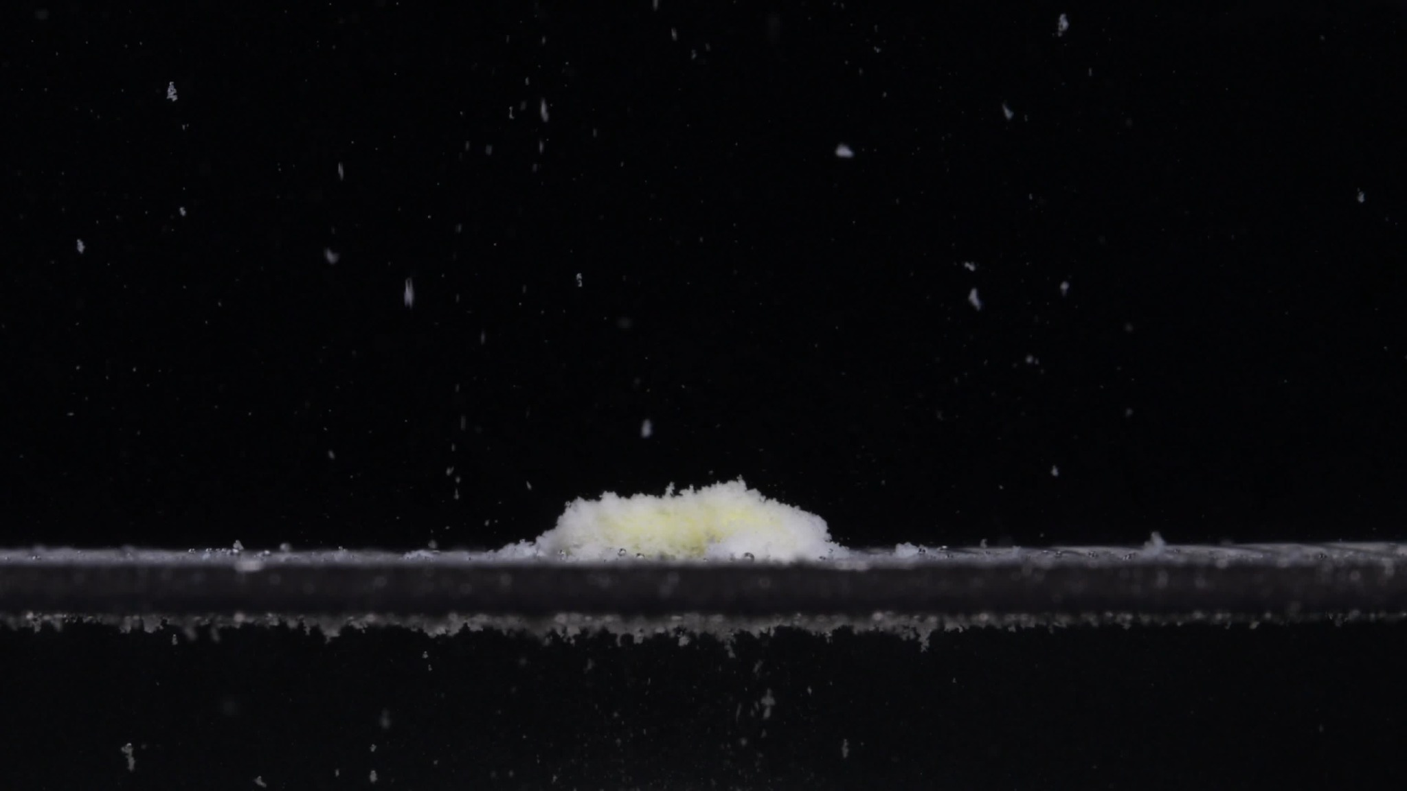
Group B – Pic 3 – 30 minutes
Color Change: The remaining material is mostly white to yellow-white, with only a faint pale-yellow area near the center. The yellow tablet body is less prominent than at 15 minutes.
Shape Change: The original flat cylindrical shape has largely collapsed. The drug now appears as a low, irregular mound of residue.
Surface Texture Change: The surface is very loose, rough, fluffy, and granular. The remaining mound resembles a pile of softened powder rather than a solid tablet.
Volume Change: There is clear and substantial reduction in visible volume compared with 0 and 15 minutes. The height has decreased greatly, and the original broad body has collapsed.
Dissolution Speed and Time: Between 15 and 30 minutes, Group B shows a major acceleration in disintegration, changing from a mostly intact cylinder to a collapsed powdery mound.
Physical State Change: The tablet has changed from a coherent hydrated solid into a soft, fragmented, powder-like residue. A faint yellow central area suggests some remaining undispersed material.
Dissolution Medium: Many pale particles are visible throughout the surrounding field, especially above the residue and along the bottom line.
Fragment Distribution with Density: Fragment density is much higher than at 15 minutes. Fine particles and small flakes are dispersed above and around the residue, while a dense sediment layer is visible along the bottom.

Summary: Key point: At 30 minutes, Group B has undergone major structural collapse.

Pic 4, 45 minutes
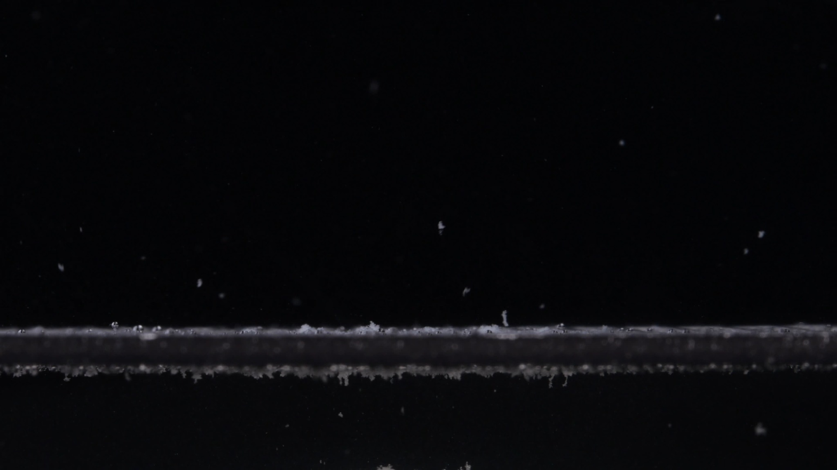
Group B – Pic 4 – 45 minutes
Color Change: Only small white or pale particles are visible. The previous yellow-white central tablet mass is no longer clearly present.
Shape Change: The original flat cylindrical tablet shape has disappeared. No central mound comparable to the 30-minute image is visible.
Surface Texture Change: No coherent tablet surface remains. The visible material appears as loose fine particles and small flakes.
Volume Change: There is a major reduction in visible volume. Compared with 0 and 15 minutes, the tablet body is essentially absent; compared with 30 minutes, even the low powdery mound has mostly disappeared.
Dissolution Speed and Time: From 30 to 45 minutes, disintegration progresses rapidly toward near-complete breakdown.
Physical State Change: The drug is no longer a coherent solid and appears to have transitioned into fine suspended particles and settled sediment.
Dissolution Medium: The full clarity of the liquid is difficult to judge, but visible particles are suspended in the field, and a sediment-like line is present along the lower boundary.
Fragment Distribution with Density: Fragments are mainly fine particles. They are spread sparsely through the field, with a denser sediment layer along the bottom. No large fragments or intact core are visible.

Summary: Key point: By 45 minutes, Group B's central tablet structure is almost completely lost.

Pic 5, 60 minutes
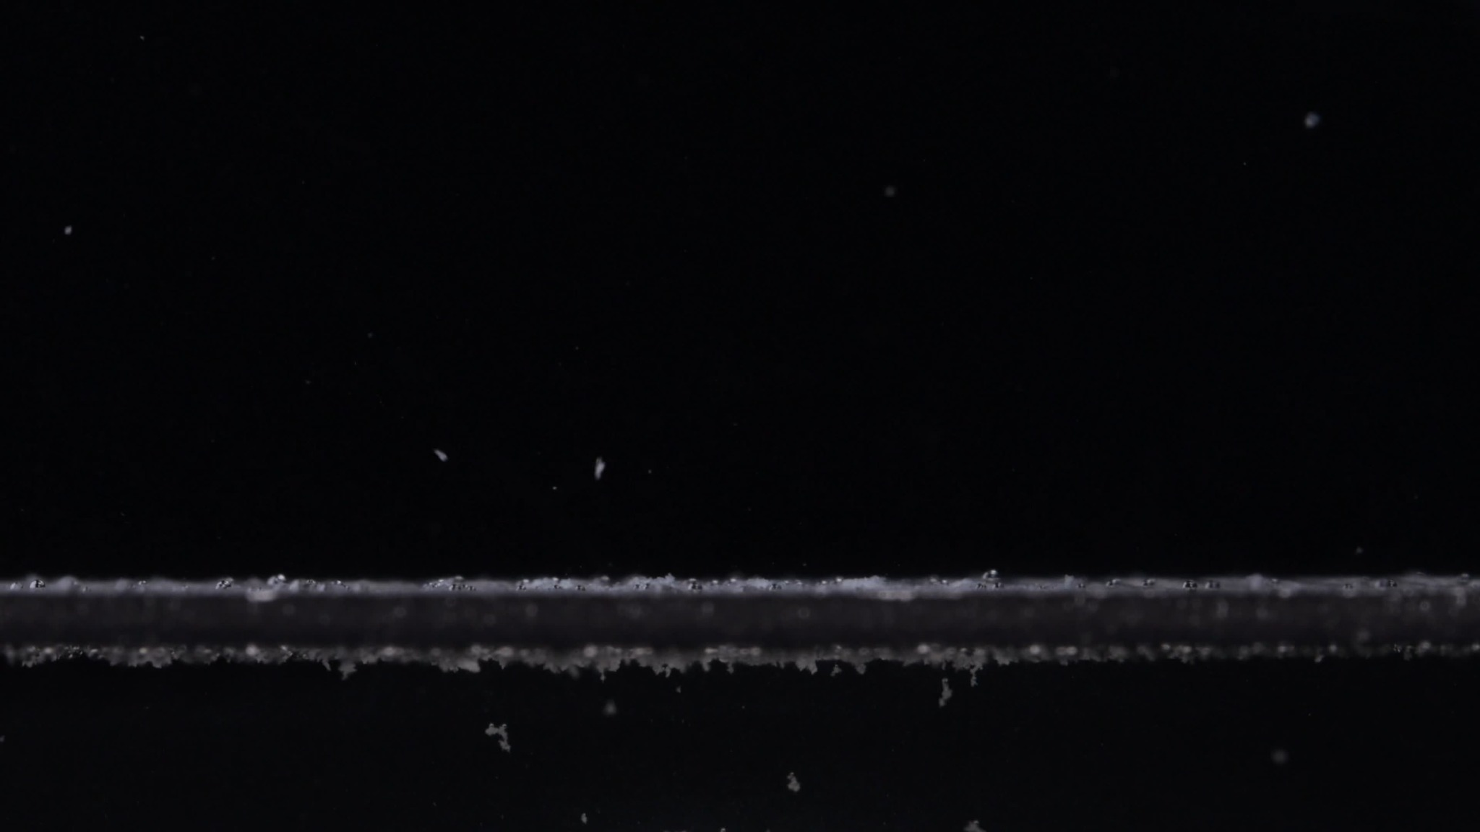
Group B – Pic 5 – 60 minutes
Color Change: The original pale yellow tablet body is no longer visible. Only small white or pale particles remain, and no yellow central residue is identifiable.
Shape Change: The original flat cylindrical tablet shape has completely disappeared. There is no intact tablet, central mound, or recognizable tablet contour.
Surface Texture Change: No coherent tablet surface remains. The visible material consists of scattered fine particles and sediment-like residue.
Volume Change: The visible tablet volume has been almost completely lost. Compared with 0 minutes, the tablet body has disappeared; compared with 30 minutes, the remaining powder mound is no longer present.
Dissolution Speed and Time: By 60 minutes, Group B shows near-complete visual disintegration. Most of the major breakdown occurred between 15 and 45 minutes, especially between 15 and 30 minutes.
Physical State Change: The drug has changed from a solid tablet into dispersed fine particles and settled residue. Complete chemical dissolution cannot be confirmed from the image alone, but the original solid structure is visually gone.
Dissolution Medium: Sparse suspended particles and a sediment layer along the lower boundary are visible, although the overall medium clarity remains difficult to judge.
Fragment Distribution with Density: Fragments are mainly fine particles, sparsely suspended in the field and more densely accumulated along the bottom boundary. No large fragments or intact core remain.

Summary: Overall pattern: Group B shows a flat yellow tablet, powdery softening, rapid collapse by 30 minutes, and near-complete disappearance by 45 to 60 minutes.

4. Final Comparison Across the Eight Dimensions
Dimension | Observed Comparison | Interpretation
Color Change | Group A starts white at 0 minutes and becomes yellow-white from 15 minutes onward. Group B starts pale yellow/yellow-white at 0 minutes. | The different starting color suggests a different initial tablet appearance or formulation structure. Group A seems to reveal yellow material after hydration, while Group B is yellow from the beginning.
Shape Change | Group A starts as a round, biconvex tablet and gradually becomes a mound that persists at 60 minutes. Group B starts as a wide, flat cylindrical tablet and loses recognizable tablet shape by 45 minutes. | Initial shape and shape evolution are clearly different.
Surface Texture Change | Group A slowly changes from smooth and compact to rough, porous, fluffy, and powdery. Group B becomes powdery quickly and has no coherent surface by 45 minutes. | Both show powdering, but Group B loses surface integrity much faster.
Volume Change | Group A shows gradual volume reduction with a visible central residue at 60 minutes. Group B shows rapid volume loss, especially between 15 and 30 minutes, with the tablet body essentially absent by 45–60 minutes. | This is one of the strongest differences between the two groups.
Dissolution Speed and Time | Group A disintegrates slowly and incompletely over 60 minutes. Group B shows faster, more complete visual disintegration, with major collapse by 30 minutes. | The time-course behavior is substantially different.
Physical State Change | Group A changes from a compact tablet to a hydrated powdery mound with persistent residue. Group B changes from a compact tablet to a softened cylinder, then to collapsed powder and dispersed residue. | Group B shows stronger internal weakening and collapse.
Dissolution Medium | Group A shows localized fine particles around the persistent mound. Group B shows wider visible particle release and sediment along the lower boundary after 15–30 minutes. | The full medium clarity cannot be judged confidently, but Group B releases more visible dispersed material earlier.
Fragment Distribution with Density | Group A has fine particles concentrated near the central mound, with dense residue at the original tablet site. Group B has more dispersed particles and sediment, with no central core by 45–60 minutes. | Group A has localized residue; Group B has dispersed/sedimented residue.

5. Reasoning and Final Judgment
Based on the eight disintegration dimensions, Groups A and B do not appear to be from the same drug product or formulation. They may still contain the same labeled active ingredient, but their visible tablet design and disintegration behavior differ substantially.

Key Reasons
- Different initial appearance: Group A begins as a white, round/biconvex tablet, while Group B begins as a pale yellow, wider, flatter cylindrical tablet.
- Different shape evolution: Group A retains a central mound through 60 minutes, while Group B loses its tablet body by 45 minutes.
- Different volume-loss pattern: Group A shows gradual size reduction; Group B shows rapid collapse, especially between 15 and 30 minutes.
- Different disintegration speed: Group A is slow and incomplete at 60 minutes; Group B is near-completely visually disintegrated by 45–60 minutes.
- Different residue pattern: Group A has a dense central residue; Group B disperses into fine particles and sediment with no persistent central core.

Conclusion
Visual conclusion: Groups A and B are likely not the same drug product or formulation. The strongest evidence is the combination of different starting tablet color and shape, different collapse timing, and different final residue patterns.
Caution: Image-based disintegration analysis cannot prove chemical identity. Two products with the same active ingredient, such as doxycycline hyclate, may still differ because of excipients, coating, compression force, tablet size, or manufacturing process. Therefore, the most accurate conclusion is that the two groups should be treated as different samples unless chemical testing or label verification proves otherwise.

