Drug Disintegration Image Analysis Conversation
Edited English Version | Doxycycline Hyclate Tablets, Groups A and B

This document edits the conversation into clear English and excludes the final Chinese request for document preparation. The image-based analysis is based only on visible evidence in the uploaded sequences.

1. Initial Task and Analysis Framework
User
I need you to analyze the disintegration images of two groups of Doxycycline Hyclate Tablets, Group A and Group B. These may be images of the same drug or different drugs. I will upload five images for each group, and each picture is taken 15 minutes apart. Please describe the drug disintegration process in English for each image in the group. Finally, determine whether the two sets of images are from the same drug. You may call the Knowledge Base to remember how to describe drug disintegration. When describing the tablets in English, please pay attention to changes in tablet size and shape. If you are prepared, I will upload Group A, picture 1 at 0 minutes.
Assistant
I am prepared. Please upload Group A, Picture 1 at 0 minutes.
I will describe each image using the eight disintegration dimensions: color change, shape change, surface texture, volume/size change, dissolution speed and timing, physical state, dissolution medium, and fragment distribution/density. The comparison will especially focus on tablet size, shape, contour, fragmentation pattern, swelling/collapse, and residue distribution, because these are useful for judging whether Group A and Group B may be the same drug.
User
You are not totally prepared. Please call the Knowledge Base again to remember how to describe drug disintegration.
Assistant
I refreshed the Knowledge Base guidance and restated the exact observation framework to be used for every uploaded image.

Knowledge Base Observation Framework
Color change: solution color, turbidity, opacity, and where the color spreads from.
Shape change: whether the tablet remains intact, becomes cracked, deformed, flattened, split, or fragmented.
Surface texture change: smoothness, roughness, pores, cracks, peeling, powdering, or fibrous/flaky edges.
Volume / size change: reduction in tablet diameter, thickness, contour clarity, swelling, collapse, or shrinkage.
Dissolution speed and time: how much change occurs at 0, 15, 30, 45, and 60 minutes, and whether the speed is slow, moderate, or rapid.
Physical state change: liquid penetration, swelling, cracking, softening, collapse, powder formation, or residue formation.
Dissolution medium: clarity, cloudiness, sediment, floating particles, and visible interaction between tablet and liquid.
Fragment distribution and density: where fragments are located, whether they are dense around the tablet, dispersed, suspended, or settled at the bottom.
Special emphasis will be placed on tablet size and shape, because size and shape can affect disintegration behavior and can help identify whether two image groups may represent the same drug.

2. Group A Uploaded Sequence and Analysis
User
The user uploaded five Group A images at 0, 15, 30, 45, and 60 minutes, and requested accurate English descriptions with reduced hallucination.
Assistant
I reviewed the five Group A images as a 0–60 minute sequence. The comments below are based only on visible image evidence.

Group A Image Sequence
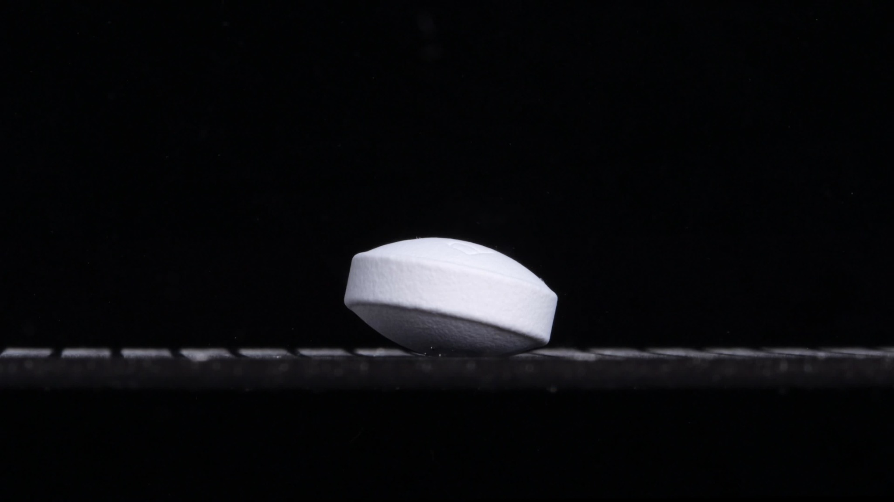  0 min | 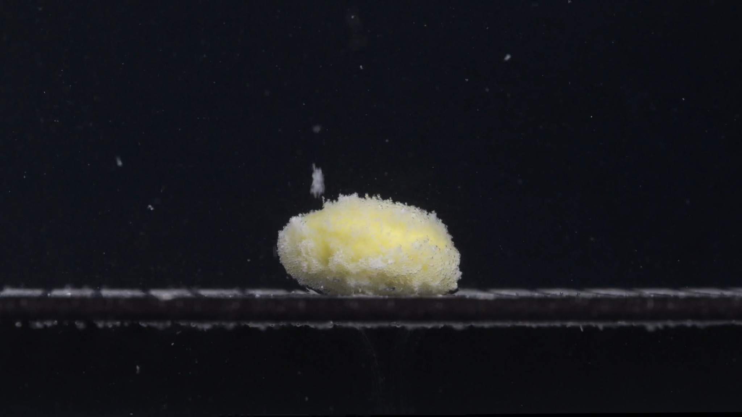  15 min
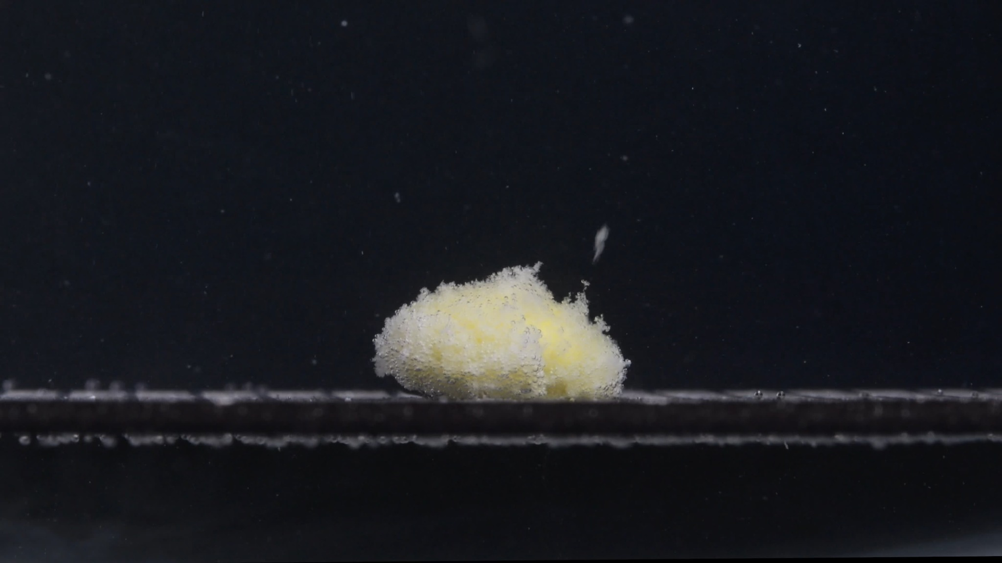  30 min | 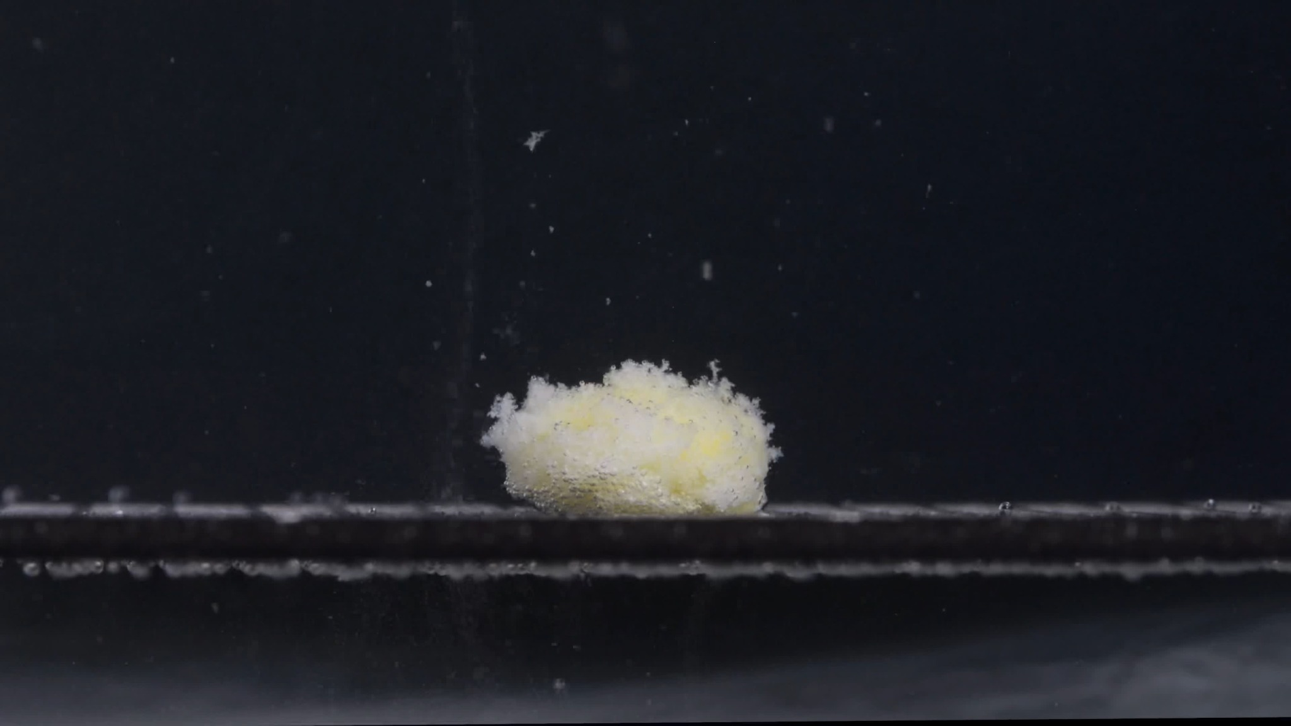  45 min
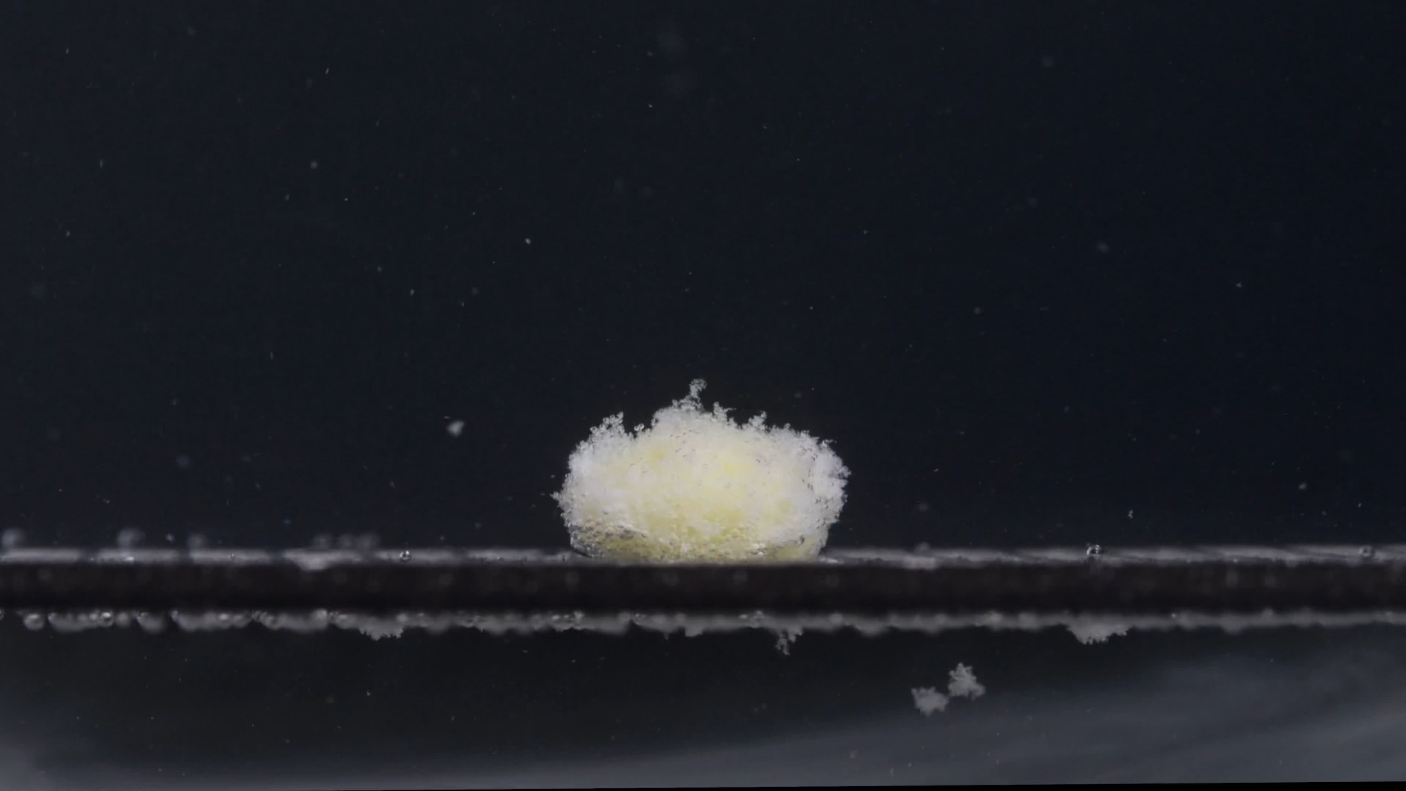
60 min

Group A — 0 min
Color change: The tablet appears mainly white to off-white. No yellow inner material is visible yet. The surrounding medium/background remains visually dark and mostly clear, with no obvious clouding around the tablet.
Shape change: The tablet is largely intact. It has an oblong, capsule-like or oval biconvex tablet shape, with a thick side wall and rounded upper/lower faces. The contour is sharp and well defined.
Surface texture change: The surface looks relatively smooth and compact. A faint shallow mark or surface line is visible on the upper face, but there are no clear cracks, pores, peeling, or powder shedding.
Volume / size change: This is the baseline size. The tablet still has its original height and width and is slightly tilted on the support surface.
Dissolution speed and time: At 0 minutes, there is no visible disintegration. Dissolution has not produced obvious particles or turbidity.
Physical state change: The tablet remains solid and structurally coherent. No swelling, collapse, or internal exposure is visible.
Dissolution medium: The medium appears visually clear around the tablet. No strong local haze is visible.
Fragment distribution and density: No detached fragments are visible around the tablet.

Group A — 15 min
Color change: A clear pale yellow inner region becomes visible, especially in the central body of the tablet. The outer material remains whitish, suggesting that the white exterior has opened or eroded and exposed yellow internal material.
Shape change: The original oblong tablet outline is mostly lost. The tablet has changed into a low, swollen, irregular mound with ragged top and side areas.
Surface texture change: The surface is very rough and porous. It appears fluffy, granular, and sponge-like, with many small particles or loosened fragments attached to the surface.
Volume / size change: Compared with the intact tablet, the height appears reduced and the shape is flattened. However, the disintegrated mass has spread outward and become less compact, suggesting swelling plus surface erosion rather than simple shrinkage.
Dissolution speed and time: A major change occurs between 0 and 15 minutes. The disintegration rate appears fastest during this early interval, because the tablet changes from intact to a porous, collapsed mass.
Physical state change: The tablet appears softened and partially collapsed. The internal structure is exposed, with a yellow core-like area surrounded by white loosened material.
Dissolution medium: The bulk medium still appears mostly clear, but visible suspended specks are present above and around the tablet.
Fragment distribution and density: Most fragments remain densely concentrated around the original tablet position. A few fine particles are suspended above it.

Group A — 30 min
Color change: The yellow inner material remains visible but is partly covered by white, powdery material. The yellow color is localized within the mound rather than evenly coloring the whole medium.
Shape change: The mass remains mound-like and irregular. The left and right edges are more uneven, with small protrusions and rough margins. The original tablet shape is no longer recognizable.
Surface texture change: The surface remains highly porous and granular, looking like a loose network of fine particles rather than a firm tablet surface.
Volume / size change: The mound appears slightly lower and more eroded than at 15 minutes. Its contour is less stable, with edge material breaking away. A central residual mass remains.
Dissolution speed and time: Disintegration continues, but the visible change from 15 to 30 minutes is less dramatic than from 0 to 15 minutes. This suggests that rapid initial breakdown has slowed into gradual erosion and particle release.
Physical state change: The tablet is now a softened residue with exposed inner material. The structure looks weak and friable.
Dissolution medium: The medium contains more visible fine specks than at 0 minutes, but the image does not show strong uniform turbidity across the whole field.
Fragment distribution and density: Fragments are still densest around the tablet mass. Fine particles are suspended above and around it, while heavier material appears to remain near the support surface.

Group A — 45 min
Color change: The yellow color is still present but appears more muted and partially covered by pale white residue. The visible mass is mainly whitish-yellow.
Shape change: The residual mass is smaller and more compact than before. It is still irregular, with fuzzy edges, but the mound looks less tall and less sharply defined.
Surface texture change: The surface remains fluffy and powder-like. Fine material is lifting or separating from the surface, especially near the left/top area.
Volume / size change: There is continued reduction in the visible central mass. Height and contour appear reduced compared with 15 and 30 minutes.
Dissolution speed and time: The process appears slower and more gradual at this stage. The main visible mechanism is erosion and shedding of fine particles rather than large-scale breakage.
Physical state change: The tablet is no longer a coherent solid tablet. It is a fragile, partially collapsed residue with loose powder-like material.
Dissolution medium: The medium contains scattered suspended particles. A faint vertical trail or disturbed region is visible near the left side of the mass, possibly from particle movement or fluid disturbance, but this cannot be confirmed from a still image.
Fragment distribution and density: Fragments remain concentrated close to the residue. Some fine particles are dispersed upward and outward, but there is still a dense local particle zone around the original tablet location.

Group A — 60 min
Color change: The remaining mass is mostly pale white with faint yellow areas still visible inside. The yellow region is weaker and more diffuse than earlier.
Shape change: The tablet has become a small, rounded, irregular mound. The original oblong biconvex shape is completely lost.
Surface texture change: The surface is very fine, porous, and powdery. The edges are fuzzy and fragmented, showing continued erosion.
Volume / size change: The remaining mound is smaller and lower than at 15–30 minutes. The image suggests progressive volume loss and collapse over time.
Dissolution speed and time: By 60 minutes, the process appears to be in a late erosion stage. Most dramatic structural breakdown already occurred before 15 minutes, while 15–60 minutes shows slower reduction of the residual mass.
Physical state change: The material is now mostly a soft residue or powder aggregate rather than an intact tablet. It appears fragile and partially dispersed.
Dissolution medium: The surrounding medium shows more visible suspended and settled fine particles than at the beginning, but it is not uniformly opaque in the image.
Fragment distribution and density: Fine fragments are visible around and below the support level. Some particles appear settled near the bottom/lower region, while others remain suspended.

Group A Overall Disintegration Profile
Group A shows a rapid early transformation: an intact white, oblong, biconvex tablet at 0 minutes becomes a swollen, porous, yellow-white disintegrating mound by 15 minutes. After that, the process becomes more gradual. The mass remains localized but slowly shrinks, loses contour, sheds fine particles, and becomes a smaller powdery residue by 60 minutes.
- Initial form: white, oblong/capsule-like, biconvex tablet.
- Early change: strong structural loss by 15 minutes.
- Color pattern: white exterior with exposed pale yellow internal material.
- Texture pattern: fluffy, porous, granular residue.
- Size/shape trend: intact tablet to swollen/flattened irregular mound to smaller powdery mound.
- Fragment pattern: fragments mostly remain localized near the original tablet position, with fine suspended and settled particles increasing over time.

3. Group B Uploaded Sequence and Analysis
User
The user uploaded five Group B images at 0, 15, 30, 45, and 60 minutes, and requested accurate English descriptions with reduced hallucination.
Assistant
I reviewed all five Group B images. The conclusion remains based only on visible evidence, not on the label 'Doxycycline Hyclate Tablets.'

Group B Image Sequence
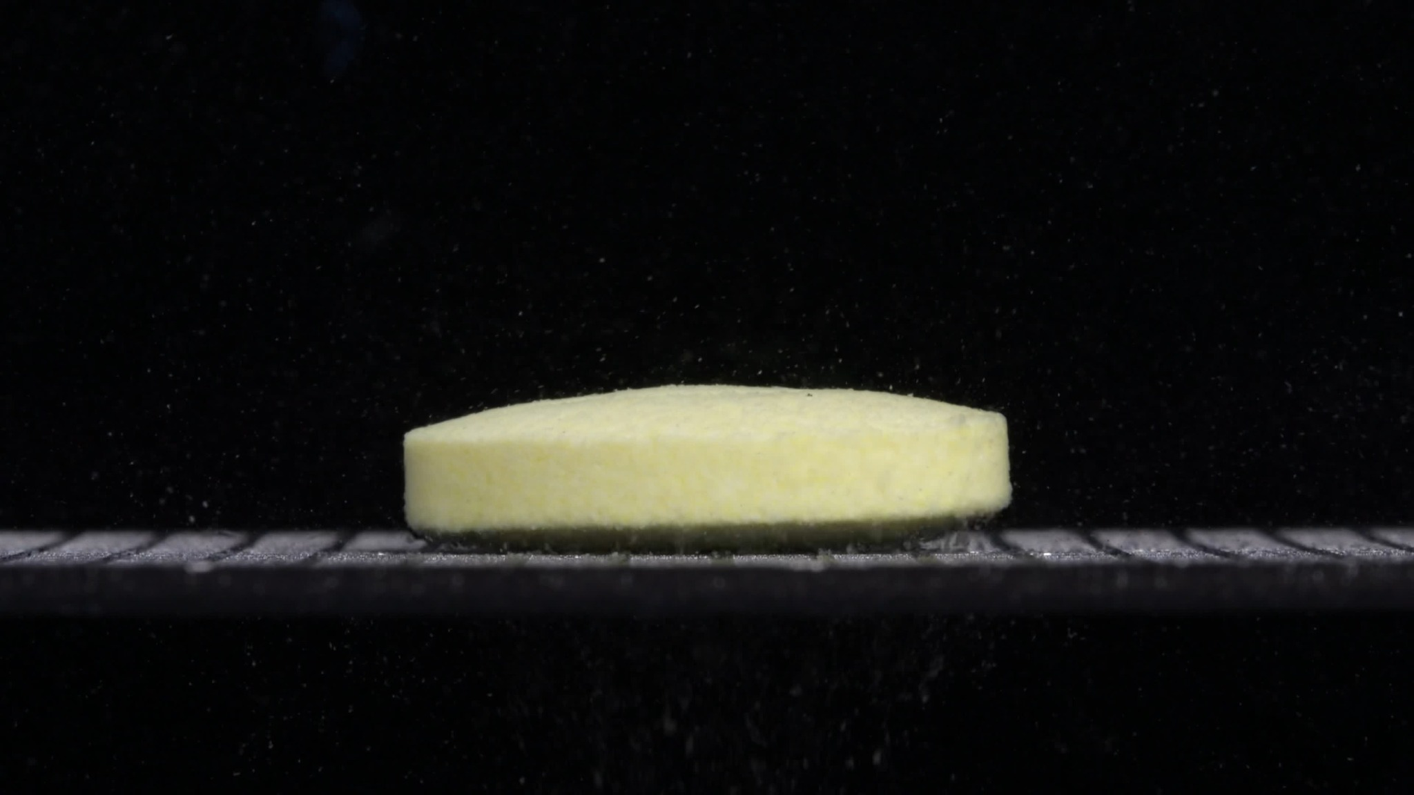  0 min | 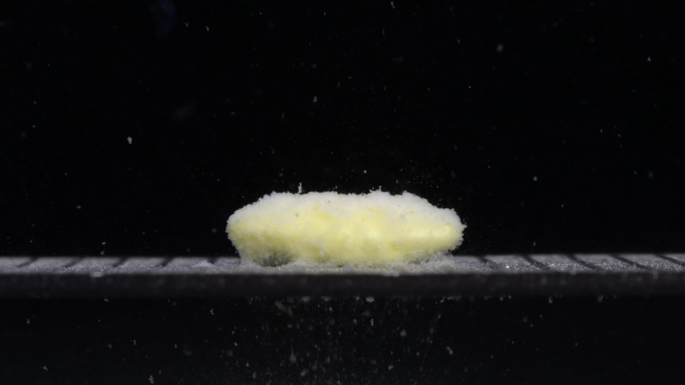  15 min
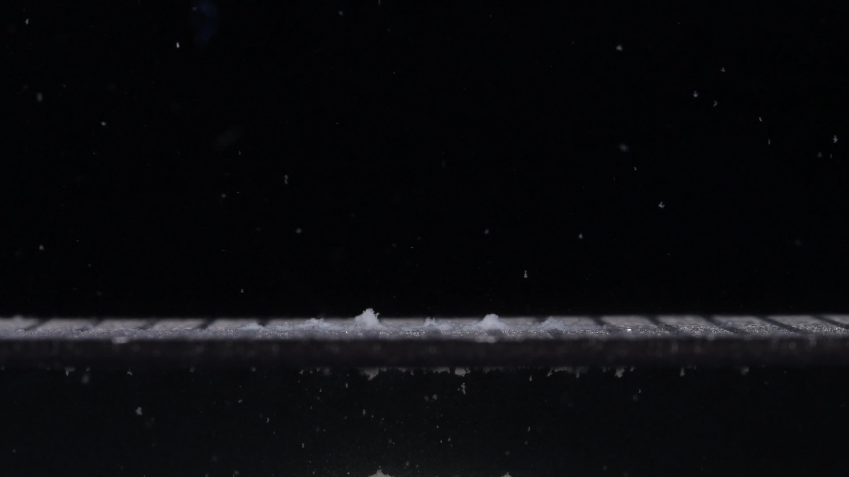  30 min | 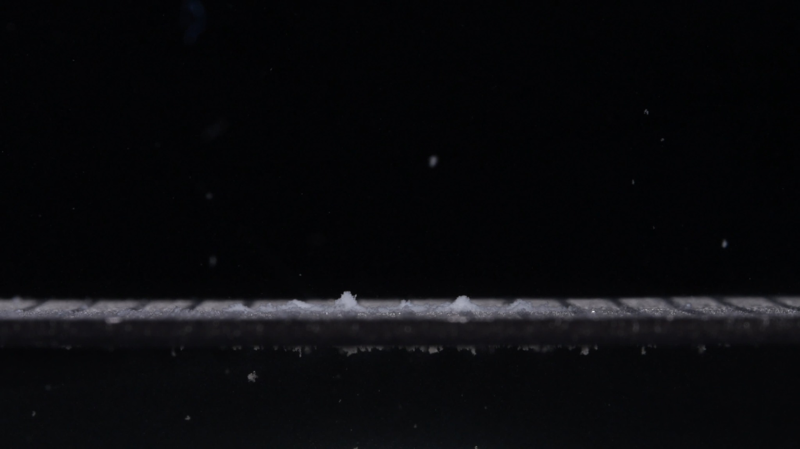  45 min
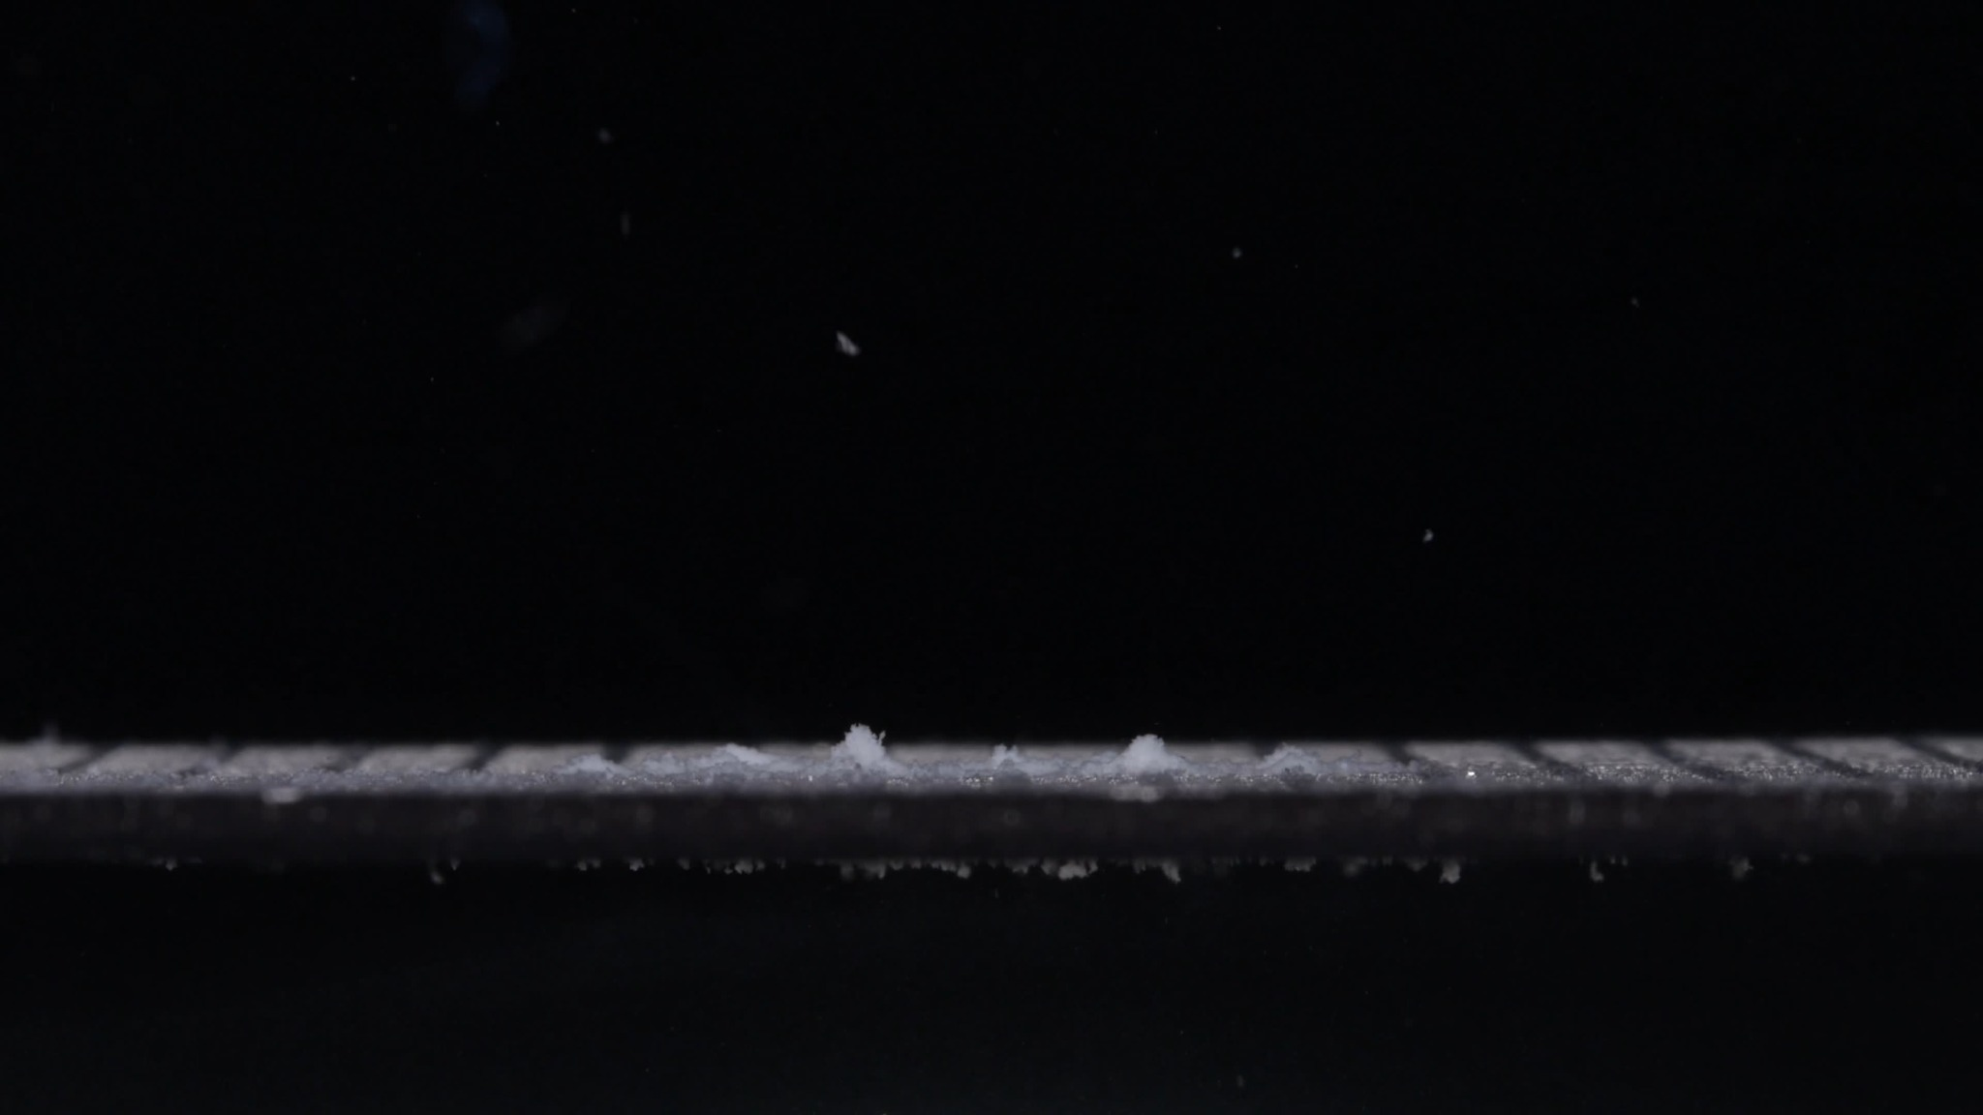
60 min

Group B — 0 min
Color change: The tablet is already pale yellow to light yellow at the beginning. Unlike Group A, it does not appear white at baseline.
Shape change: The tablet is a large, flat, round/oval disk-like tablet lying horizontally. It has a broad diameter, relatively low height, and a fairly straight vertical side wall.
Surface texture change: The surface appears compact but slightly matte or porous. No large cracks or detached fragments are visible yet.
Volume / size change: This is the baseline. The tablet appears wide and flat, with a larger horizontal footprint than Group A at 0 minutes.
Dissolution speed and time: At 0 minutes, there is no obvious collapse, but the tablet already looks wet and slightly softened along the lower edge.
Physical state change: The structure is still coherent and solid.
Dissolution medium: The surrounding visible field is mostly clear, with some tiny suspended specks.
Fragment distribution and density: No major fragments are detached. Only very fine particles are visible in the surrounding medium.

Group B — 15 min
Color change: The tablet remains pale yellow, but its surface becomes lighter and more whitish in some areas because of loosened powder on the surface.
Shape change: The tablet is still broadly disk-like, but the edges have become rounded, fuzzy, and irregular. It has not retained the sharp side wall seen at 0 minutes.
Surface texture change: The surface becomes fluffy, porous, and powdery, especially along the upper and lower edges. The outer layer appears loosened.
Volume / size change: The height appears reduced slightly, while the horizontal shape remains broad. The tablet looks swollen/softened and less compact.
Dissolution speed and time: A clear disintegration phase occurs between 0 and 15 minutes. Compared with Group A, Group B still preserves a recognizable broad tablet mass at 15 minutes.
Physical state change: The tablet appears softened and friable. Surface erosion is active, with powder shedding from the lower edge.
Dissolution medium: There are more suspended particles around the tablet, especially above and below the support line.
Fragment distribution and density: Fine fragments are dense around the tablet and along the lower support surface. Some particles are suspended in the medium, while heavier residue begins to settle below.

Group B — 30 min
Color change: The main yellow tablet body is no longer visible. The remaining material appears mostly whitish to pale gray-white residue on the support surface.
Shape change: The original tablet shape has essentially disappeared. Only small irregular residue piles remain.
Surface texture change: The remaining material is fine, powdery, and loose. There is no coherent tablet surface left.
Volume / size change: There is a major volume reduction from 15 to 30 minutes. The large tablet mass has almost completely collapsed or dispersed.
Dissolution speed and time: This is the fastest visible transition in Group B. Between 15 and 30 minutes, the tablet changes from a recognizable softened disk into scattered residue.
Physical state change: The tablet has changed from a softened solid mass into dispersed powder/sediment.
Dissolution medium: Fine particles are visible throughout the field, and residue is present along the bottom/support area.
Fragment distribution and density: Fragments are no longer concentrated as one tablet mound. They are spread as low-density powdery deposits across the support surface, with some suspended particles above and settled particles below.

Group B — 45 min
Color change: Only pale whitish residue remains. No clear yellow central tablet mass is visible.
Shape change: There is no intact tablet shape. The residue forms small, irregular piles and thin powdery bands along the support surface.
Surface texture change: The residue is granular and powder-like, without a continuous tablet surface.
Volume / size change: The visible volume remains very low, similar to 30 minutes. Most of the original tablet has disappeared.
Dissolution speed and time: After 30 minutes, the process appears to slow. The major disintegration has already occurred, and only minor redistribution of residue is visible.
Physical state change: The material is in a residue/sediment state rather than a tablet state.
Dissolution medium: The medium still contains scattered suspended particles, but there is no dense central cloud around a tablet body.
Fragment distribution and density: Fragments are widely distributed as small deposits along the bottom/support line. Density is low to moderate, with a few slightly taller residue clusters.

Group B — 60 min
Color change: The scene remains dominated by pale whitish residue. The original yellow color is no longer apparent in a central mass.
Shape change: No tablet-like outline remains. The residue is thin, scattered, and irregular.
Surface texture change: The remaining particles appear powdery and sediment-like.
Volume / size change: The original tablet volume is almost completely lost. Only small residue piles remain.
Dissolution speed and time: From 45 to 60 minutes, there is little visible additional change. The disintegration is essentially complete by 30 minutes, with later images showing residue persistence.
Physical state change: The drug material appears fully transitioned from tablet form into dispersed/sedimented particulate residue.
Dissolution medium: The medium contains sparse suspended particles and settled residue.
Fragment distribution and density: Particles are distributed mainly along the support/bottom region, with low-density suspended specks in the surrounding field.

4. Eight-Dimension Comparison and Final Determination
User
Please compare Groups A and B based on their disintegration characteristics across the eight dimensions to determine if they are from the same drug or not, and explain why.
Assistant
Based on the eight-dimension comparison, Groups A and B are likely not from the same tablet product or formulation. They could theoretically share the same active ingredient, but from the images alone they do not look like the same physical drug form. The strongest evidence is the very different initial size, shape, color, and later residue pattern.

Eight-Dimension Comparison
Dimension | Group A | Group B | Interpretation
1. Color change | Starts white/off-white at 0 minutes. Yellow material becomes visible after disintegration, especially from 15 minutes onward. | Starts pale yellow already at 0 minutes. Later residue becomes whitish/pale gray after the main tablet body disappears. | Different. Group A shows a white exterior with yellow inner exposure; Group B is yellow from the beginning.
2. Shape change | Starts as an oblong, biconvex, capsule-like tablet, then becomes a localized irregular mound. | Starts as a large, flat, disk-like tablet with a broad horizontal footprint. By 30 minutes the tablet body is almost gone. | Strongly different. This is the clearest mismatch.
3. Surface texture change | Smooth at 0 minutes, then fluffy, porous, granular, and powdery. | Also becomes fluffy and powdery, especially at 15 minutes. | Partly similar, but this is a general disintegration feature and is not enough to prove sameness.
4. Volume / size change | Major collapse by 15 minutes, but a central yellow-white residue mound remains visible through 60 minutes. | Still broad at 15 minutes, then nearly disappears by 30 minutes, leaving scattered low residue. | Different. Group A retains a central mass much longer; Group B loses volume more completely by 30 minutes.
5. Dissolution speed and time | Fastest visible change occurs from 0 to 15 minutes, followed by slow erosion from 15 to 60 minutes. | Major disappearance occurs from 15 to 30 minutes. By 30 minutes the tablet is mostly residue. | Different timing profile.
6. Physical state change | Intact tablet to swollen/softened mound to persistent friable residue. | Intact flat disk to softened broad mass to dispersed sediment/powder by 30 minutes. | Different collapse behavior.
7. Dissolution medium | Scattered particles are visible, but much material remains concentrated around the original tablet position. | More obvious spreading and sediment-like residue along the support surface after 30 minutes. | Moderately different.
8. Fragment distribution and density | Fragments remain relatively dense and localized around a central mound. | Fragments become thin, scattered, and spread along the support surface, with no central mound after 30 minutes. | Different.

Why the Groups Are Likely Not the Same
The most important reason is the 0-minute appearance. Group A begins as a white, oblong, biconvex tablet, while Group B begins as a pale yellow, flat, wide disk-like tablet. These are baseline physical differences before the process has meaningfully started, not differences created by disintegration.
The second reason is the disintegration pathway. Group A forms a persistent yellow-white, fluffy mound that remains visible even at 60 minutes. Group B loses its main tablet body by 30 minutes and leaves only scattered powdery residue. This difference in volume reduction and contour loss is significant.
The third reason is the fragment pattern. Group A’s fragments stay concentrated around the original tablet site, while Group B spreads into a flatter residue layer. This suggests different internal structure, excipient behavior, compression, coating/exterior, or formulation.

Final Conclusion
Conclusion: Groups A and B are likely different drug products or different formulations. I would not classify Group A and Group B as the same tablet based on these image sequences.
Confidence: High for 'not the same physical tablet/formulation.' Confidence is lower for active ingredient identity, because images alone cannot chemically confirm whether both contain doxycycline hyclate.

