Edited English Conversation Record
Doxycycline Hyclate Tablet Disintegration Image Analysis: Groups A and B
Scope: This document includes the English-edited conversation through the drug-image discussion and excludes the later document-request message.

Knowledge Base Framework Used
The analysis used the uploaded drug-disintegration description framework. Each image was described using eight dimensions: color change, shape change, surface texture change, volume or size change, dissolution speed and time, physical state change, dissolution medium, and fragment distribution with density. For this comparison, special attention was given to tablet size, tablet shape, edge erosion, surface cracking, residue formation, turbidity, sediment density, and overall disintegration rate.

Edited Conversation Content
User:
I need you to analyze the disintegration images of two groups of Doxycycline Hyclate Tablets, Group A and Group B. These may be images of the same drug or of different drugs. I need you to determine whether the images are from the same drug. For each group, I will upload five images, with each picture taken 15 minutes apart. Please describe the drug disintegration process in English for each image in the group. Finally, determine whether the two sets of images are from the same drug. You can call the Knowledge Base to remember how to describe drug disintegration. As you describe the tablets in English, pay attention to changes in tablet size and shape. If you are prepared, I will upload Group A, Picture 1 at 0 minutes.
Assistant:
I am prepared. Please upload Group A, Picture 1 at 0 minutes.
I will describe each image in English using the eight dimensions: color change, shape change, surface texture, volume or size change, dissolution speed and time, physical state, dissolution medium, and fragment distribution with density. This follows the uploaded disintegration-description guide and drug-identification guide.
After you upload all five images for Group A and all five images for Group B, I will compare the full 0–60 minute sequences and judge whether they appear to be the same drug formulation or different drugs, focusing especially on tablet size, shape, erosion pattern, fragmentation, turbidity, and dissolution speed.
User:
You are not fully prepared. Please call the Knowledge Base again to remember how to describe drug disintegration.
Assistant:
I have called the Knowledge Base again. I will use the fixed eight-dimension framework for every uploaded image: color change, shape change, surface texture change, volume change, dissolution speed and time, physical state change, dissolution medium, and fragment distribution with density.
For the Doxycycline Hyclate Tablets comparison, I will especially focus on:
- Size and shape of the tablet: whether the tablet remains round, oval, cylindrical, blurred, cracked, swollen, flattened, or fragmented.
- Surface texture: smoothness, roughness, cracks, pores, peeling, powdery layers, or fibrous/flaky structures.
- Volume and size reduction: whether the tablet shrinks uniformly, collapses in height, expands first, or loses volume mainly at the edges.
- Color and turbidity: whether the medium remains clear, becomes yellowish, cloudy, locally colored around the tablet, or uniformly turbid.
- Dissolution speed over time: whether disintegration is slow at first, accelerates after cracking, or produces fine particles after liquid penetrates the tablet core.
- Physical state: swelling, cracking, internal weakening, collapse, particle generation, and sedimentation.
- Dissolution medium: visible clarity, viscosity-like behavior, sediment movement, and whether the medium seems to promote fast or slow disintegration.
- Fragment distribution and density: whether large fragments stay near the original tablet position, fine particles suspend in the liquid, or dense sediment settles at the bottom.
I will describe each image at 0, 15, 30, 45, and 60 minutes for Group A and Group B, then compare both groups by tablet shape, size, edge erosion, surface cracking, fragmentation pattern, medium turbidity, sediment density, and overall disintegration rate.
Please upload Group A — Picture 1, 0 minutes.
User:
Here are the five images for Group A. Each picture was taken 15 minutes apart. Please make the English description accurate, think carefully, and reduce the occurrence of hallucinations.

Group A Uploaded Images
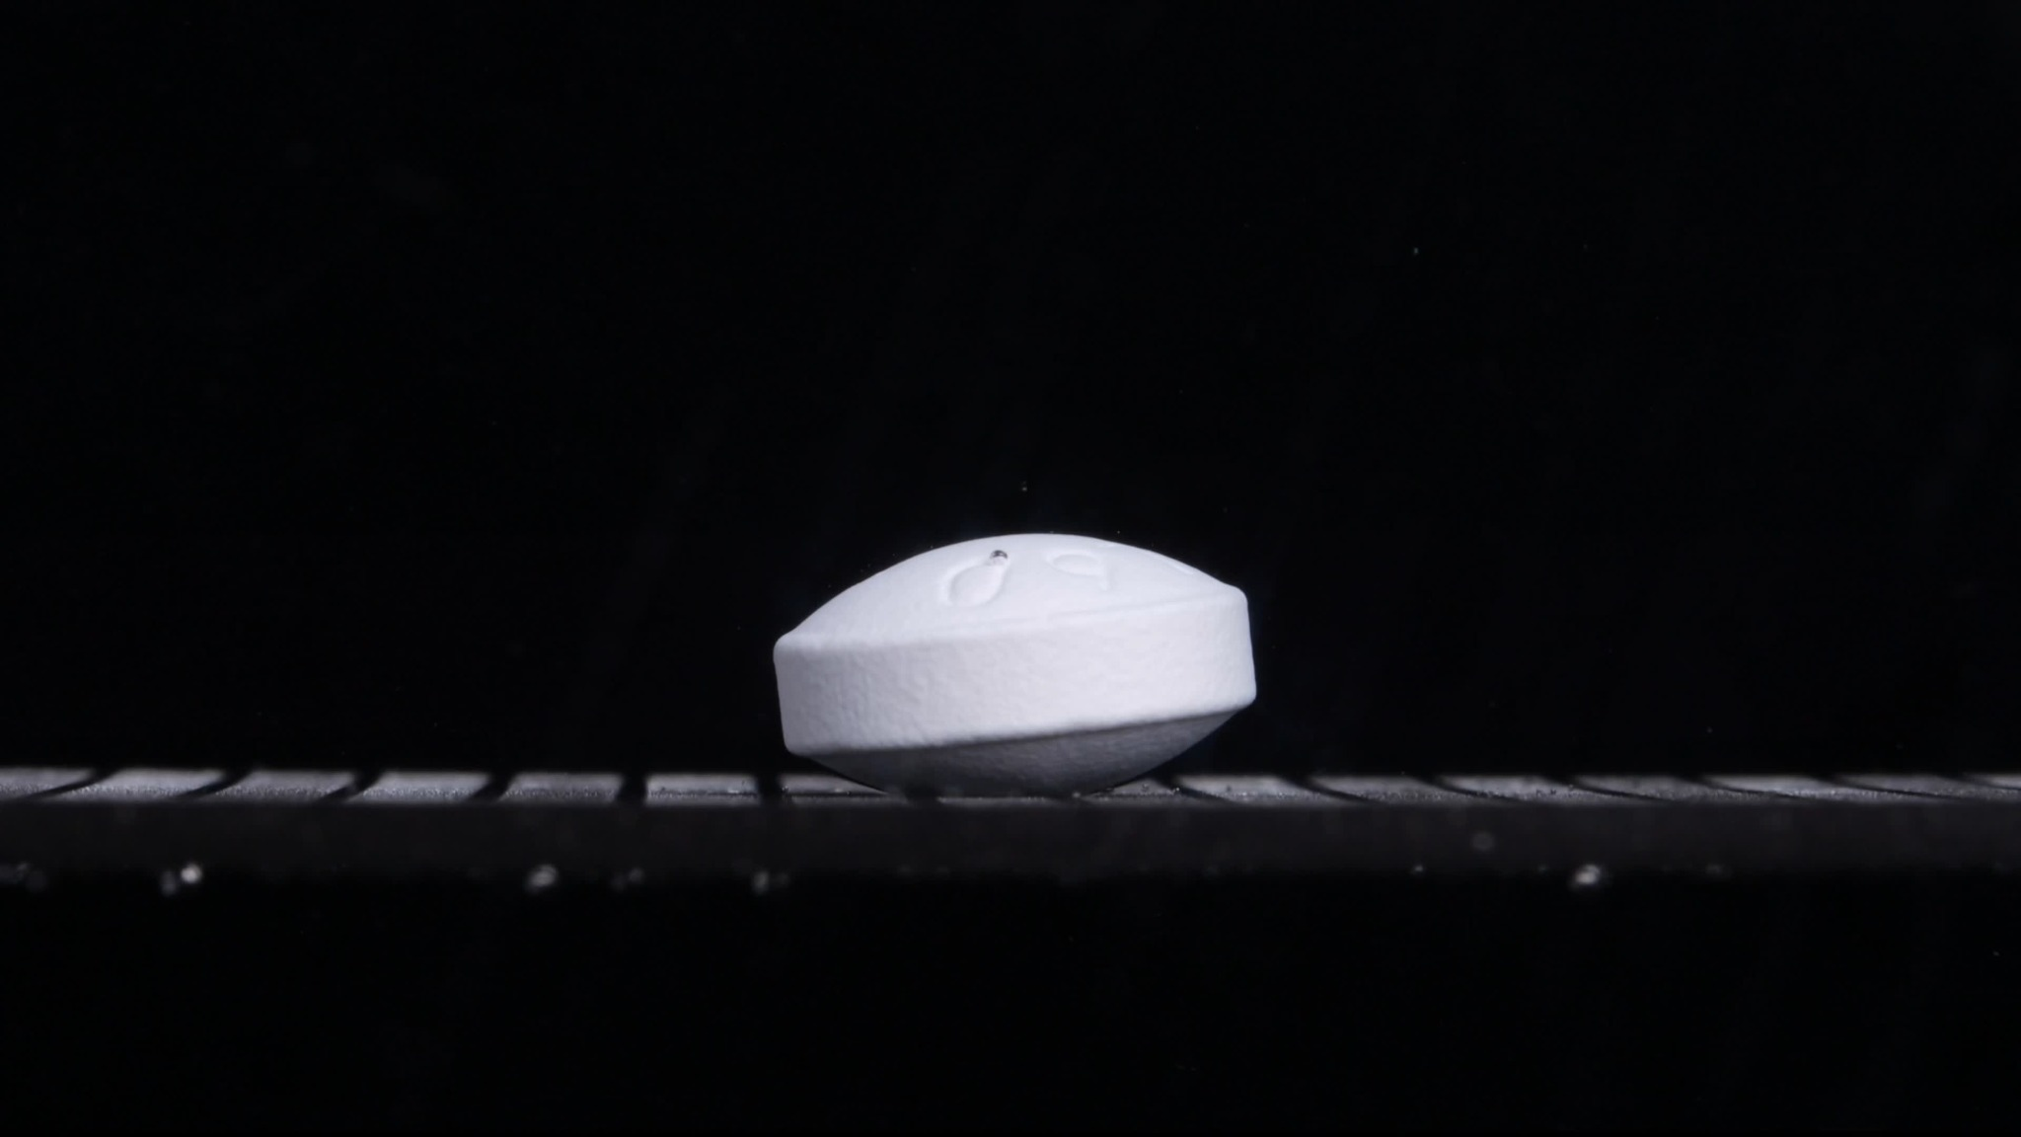
Group A — 0 minutes
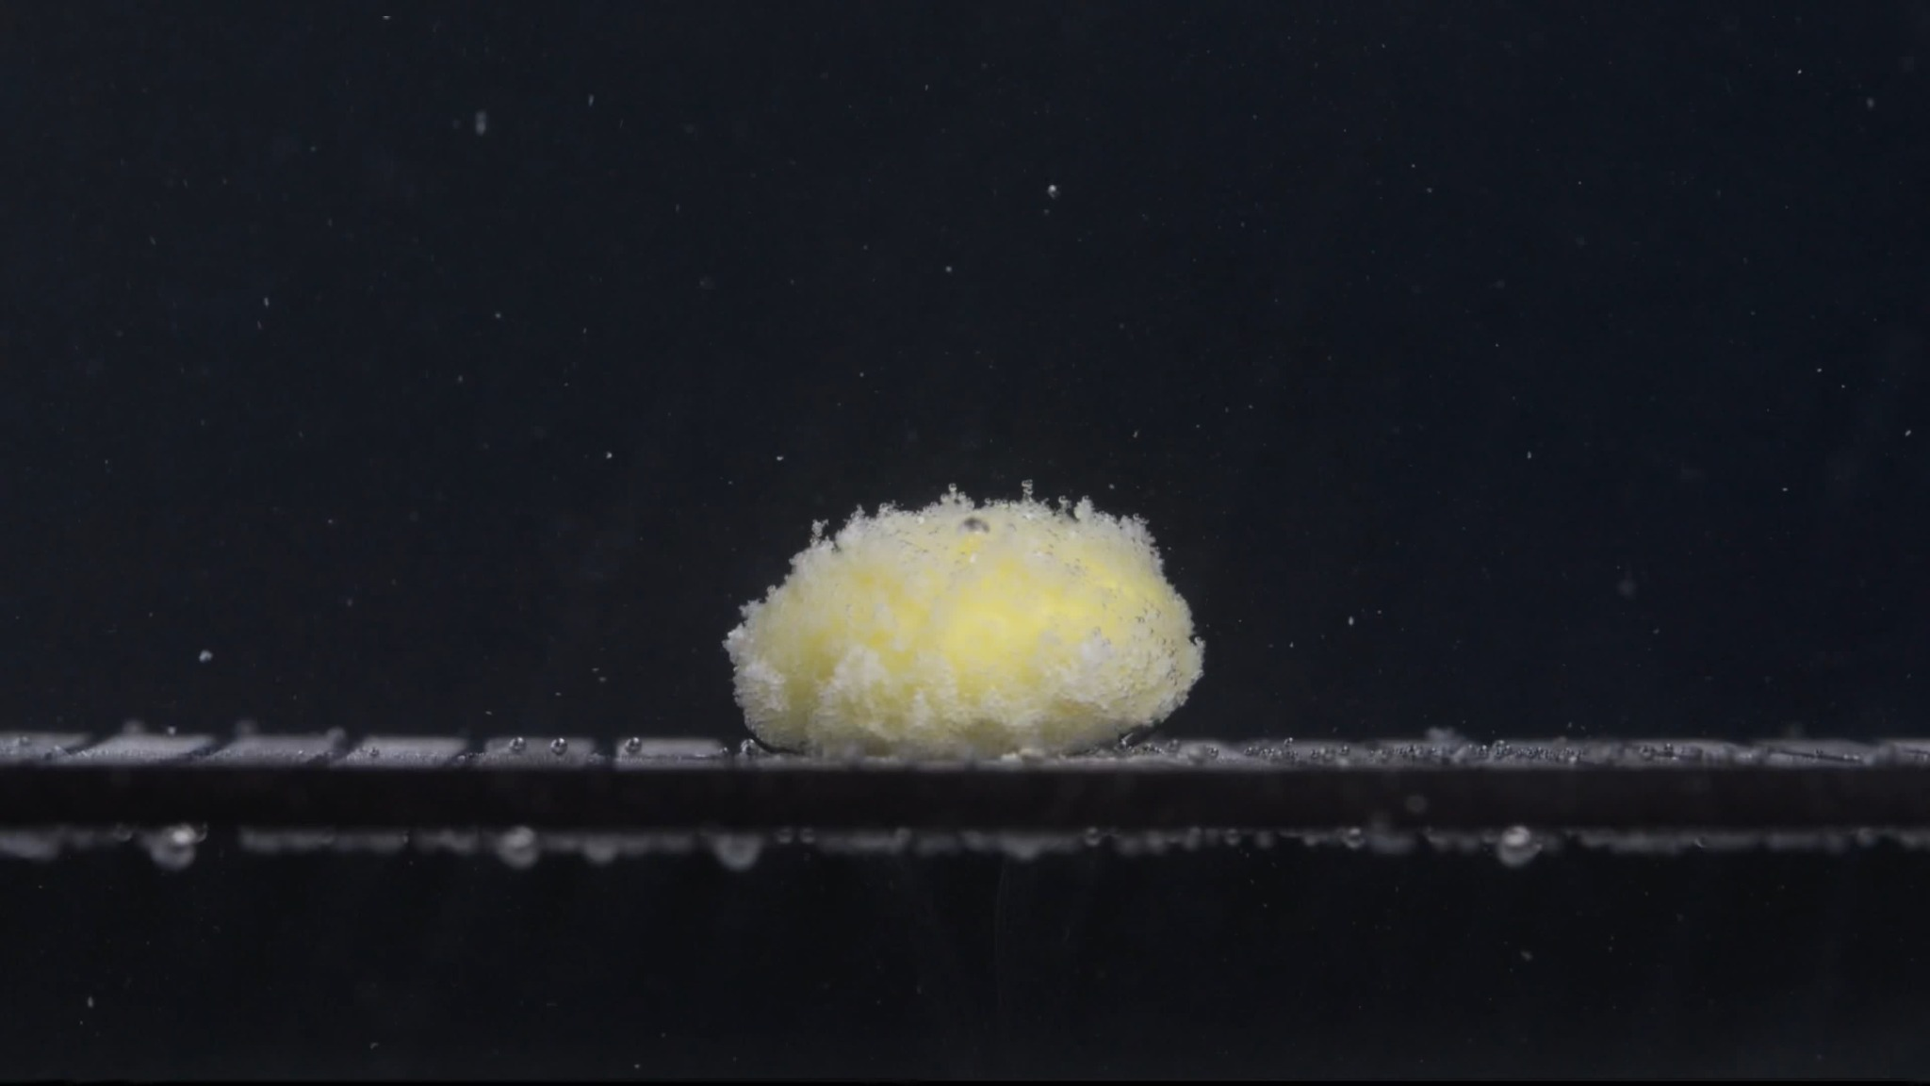
Group A — 15 minutes
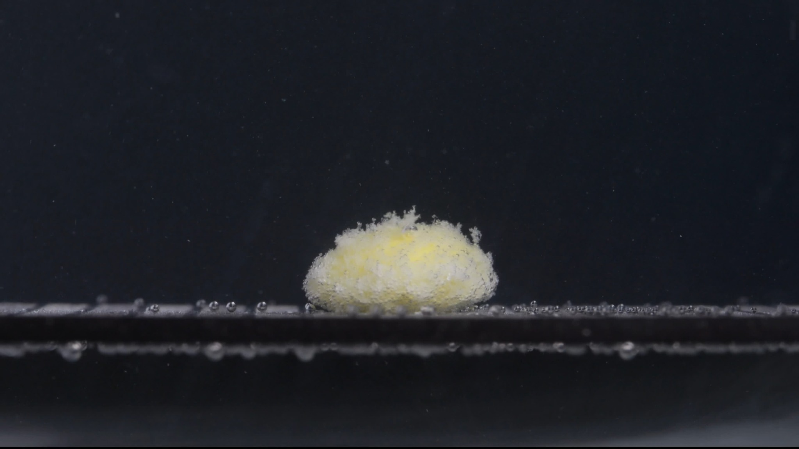
Group A — 30 minutes
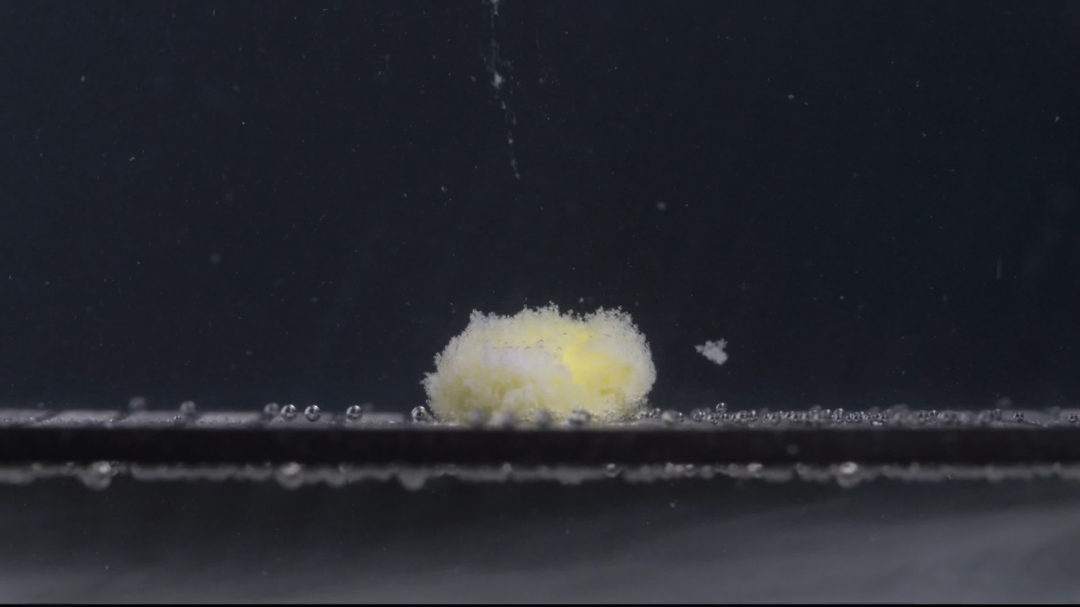
Group A — 45 minutes
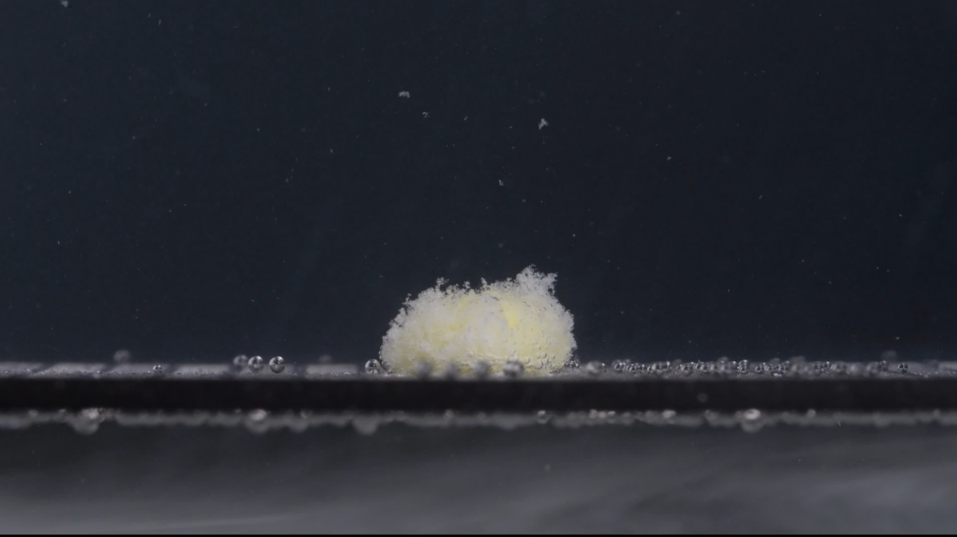
Group A — 60 minutes
Assistant:

Group A — Image Analysis, 0–60 Minutes
I analyzed Group A from 0 to 60 minutes using the eight-dimension disintegration framework. Size and shape are especially important for later comparison between Group A and Group B.

Group A — Picture 1, 0 minutes
- Color change: The tablet is mainly white. No yellow inner material is visible yet, except for very small shadowed or marked areas on the top surface. The surrounding medium/background appears clear and dark, with no visible turbidity.
- Shape change: The tablet is still intact. It appears as a thick, round-to-oval, biconvex tablet viewed from the side, with a relatively flat vertical side wall and rounded upper surface. The original contour is clear.
- Surface texture change: The surface looks mostly smooth and compact, with slight embossing or shallow markings on the top. No obvious cracks, swelling, peeling, or powder shedding are visible.
- Volume/size change: This is the baseline size. The tablet has full height and width, with no visible volume loss.
- Dissolution speed and time: At 0 minutes, there is no visible disintegration. The dissolution rate appears negligible at this moment.
- Physical state change: The tablet remains a solid, coherent body. No collapse, fragmentation, or internal exposure is visible.
- Dissolution medium: The visible medium is not cloudy. There are no obvious suspended particles around the tablet.
- Fragment distribution and density: No fragments are visible. The tablet mass is fully concentrated in the original intact form.

Group A — Picture 2, 15 minutes
- Color change: A clear color transition has occurred. The original white exterior has become mixed with pale yellow areas, especially near the central and upper regions. The yellow material appears to be exposed from inside or released through the softened surface. The medium remains mostly clear, with only local cloudiness around the tablet.
- Shape change: The original tablet shape is largely lost. Instead of a compact biconvex tablet, it has become a swollen, dome-like, fluffy mound. The edges are irregular and no longer sharply defined.
- Surface texture change: The surface has changed from smooth to highly rough, porous, and powdery. Many small fibrous or granular projections are visible along the top and sides, suggesting strong surface loosening.
- Volume/size change: The apparent volume has expanded compared with 0 minutes, mainly because the tablet has swollen and loosened into a porous mound. The compact tablet body is no longer visible as a firm solid.
- Dissolution speed and time: The largest change so far occurred between 0 and 15 minutes. This indicates a relatively rapid early disintegration stage after liquid penetration.
- Physical state change: The tablet appears to have absorbed liquid, softened, swollen, and partially collapsed into a wet powder-like mass. The yellow inner region is exposed, while the white outer material forms a loose porous shell.
- Dissolution medium: Small bubbles are visible along the support surface. The medium itself is not uniformly cloudy; the visible turbidity is mainly localized around the disintegrating tablet.
- Fragment distribution and density: Fine fragments are dense around the original tablet position. Most material remains attached to the central mound rather than dispersing widely.

Group A — Picture 3, 30 minutes
- Color change: The mound remains white-yellow, with yellow still visible in the central region. The yellow area appears less sharply exposed than at 15 minutes, partly covered by white powdery material. The surrounding medium remains mostly transparent.
- Shape change: The mass is still mound-shaped, but the contour is slightly lower and more flattened than at 15 minutes. The original tablet shape is completely absent.
- Surface texture change: The surface remains rough and fluffy, with many fine granular particles. The upper surface looks uneven, but slightly more compact than the very fresh swelling seen at 15 minutes.
- Volume/size change: The visible height appears slightly reduced compared with 15 minutes, while the base remains broad. This suggests gradual erosion or settling after the initial swelling.
- Dissolution speed and time: After the strong early disintegration, the process appears slower. The remaining mass persists as a semi-coherent powdery mound.
- Physical state change: The tablet has transitioned from a solid tablet into a hydrated, porous residue. No large hard tablet core is clearly visible.
- Dissolution medium: The medium remains mostly clear, with some small particles visible in suspension. Bubbles remain along the lower support surface.
- Fragment distribution and density: Fragments are still concentrated near the original tablet location. Fine particles are present around the mound, but there is limited wide dispersion.

Group A — Picture 4, 45 minutes
- Color change: The mass remains pale yellow and white. A more noticeable yellow region is visible on the right/central part of the mound, while the outer surface remains mostly white and powdery.
- Shape change: The mound is lower and more irregular. A small detached fragment or cluster is visible to the right of the main mass, indicating that part of the loosened material has separated.
- Surface texture change: The surface is still rough, fluffy, and eroded. The edges look fragile and feathery, with no smooth tablet boundary remaining.
- Volume/size change: The main mass appears somewhat reduced in height compared with 15 and 30 minutes. The material is less like a swollen whole tablet and more like a compacted powder deposit.
- Dissolution speed and time: Disintegration continues, but the rate appears slower than during the 0–15 minute interval. The remaining material erodes gradually rather than breaking suddenly into large pieces.
- Physical state change: The tablet is now a loose, partially sedimented residue. The detached particle on the right suggests ongoing weakening and separation of surface material.
- Dissolution medium: The medium is still not uniformly turbid. Fine particles are visible in the liquid, but most visible material remains near the tablet location.
- Fragment distribution and density: Fragment density is highest around the main mound. A small separated fragment appears to the right, while finer particles are sparsely suspended above and around the mass.

Group A — Picture 5, 60 minutes
- Color change: The remaining mass is mostly white with faint yellow areas still visible inside. The yellow color is less dominant than in the earlier swollen stage. The surrounding medium remains relatively clear.
- Shape change: No original tablet shape remains. The residue is a low, irregular mound with a slightly raised, fluffy peak toward the upper right. The contour is diffuse and unstable.
- Surface texture change: The surface is very loose, powdery, and fibrous-looking. It resembles a hydrated powder aggregate rather than a solid tablet surface.
- Volume/size change: The visible mass appears smaller and lower than the early swollen mound at 15 minutes. The volume reduction is gradual after the initial expansion.
- Dissolution speed and time: By 60 minutes, the tablet has not completely disappeared. The process shows rapid initial disintegration followed by slow persistence of powdery residue.
- Physical state change: The tablet has fully changed from a compact solid into a hydrated, porous, powder-like residue. No firm core is clearly visible, but undissolved or slowly dissolving material remains.
- Dissolution medium: The medium remains mostly transparent, with bubbles along the support and scattered fine particles. There is no strong whole-vessel cloudiness visible in these frames.
- Fragment distribution and density: Most fragments remain concentrated at the original tablet position. Fine particles are dispersed lightly in the surrounding medium, but the residue is still locally dense.

Group A Overall Disintegration Pattern
Group A shows a rapid early transformation between 0 and 15 minutes: the intact white biconvex tablet loses its original shape, swells, exposes yellow material, and becomes a fluffy porous mound. From 15 to 60 minutes, the process becomes slower: the mound gradually lowers, compacts, and sheds fine fragments, but a visible residue remains at 60 minutes.
- Initial form: a thick, white, round/oval biconvex tablet.
- Main disintegration style: swelling and fluffy powder formation rather than clean splitting into large hard fragments.
- Color behavior: white exterior changes to white-yellow residue after wetting.
- Size/shape behavior: strong shape loss by 15 minutes, followed by slow reduction of the powdery mound.
- Fragment pattern: dense local residue near the original tablet position, with limited wide dispersion.
- Medium behavior: mostly clear medium with local particles and bubbles, not uniformly cloudy.
User:
Here are the five images for Group B. Each picture was taken 15 minutes apart. Please make the English description accurate, think carefully, and reduce the occurrence of hallucinations.

Group B Uploaded Images
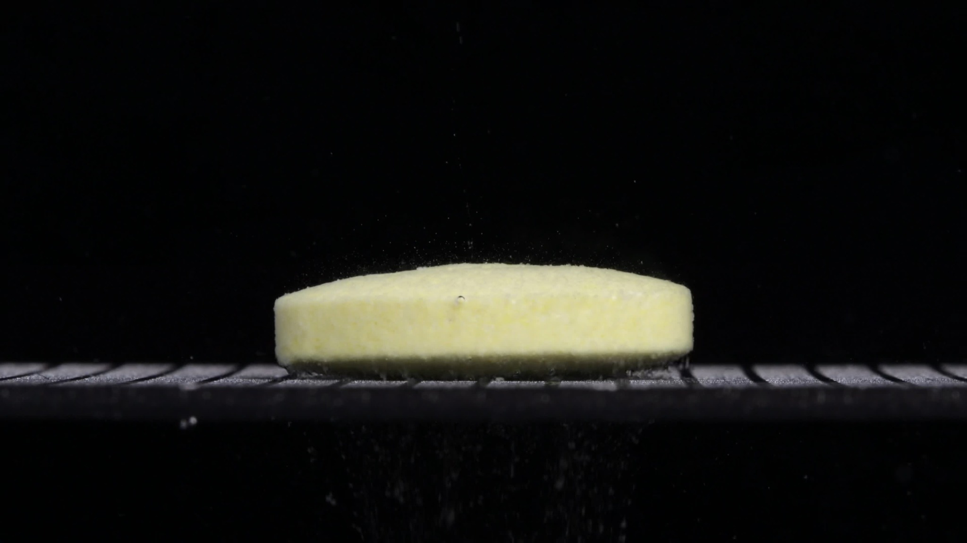
Group B — 0 minutes
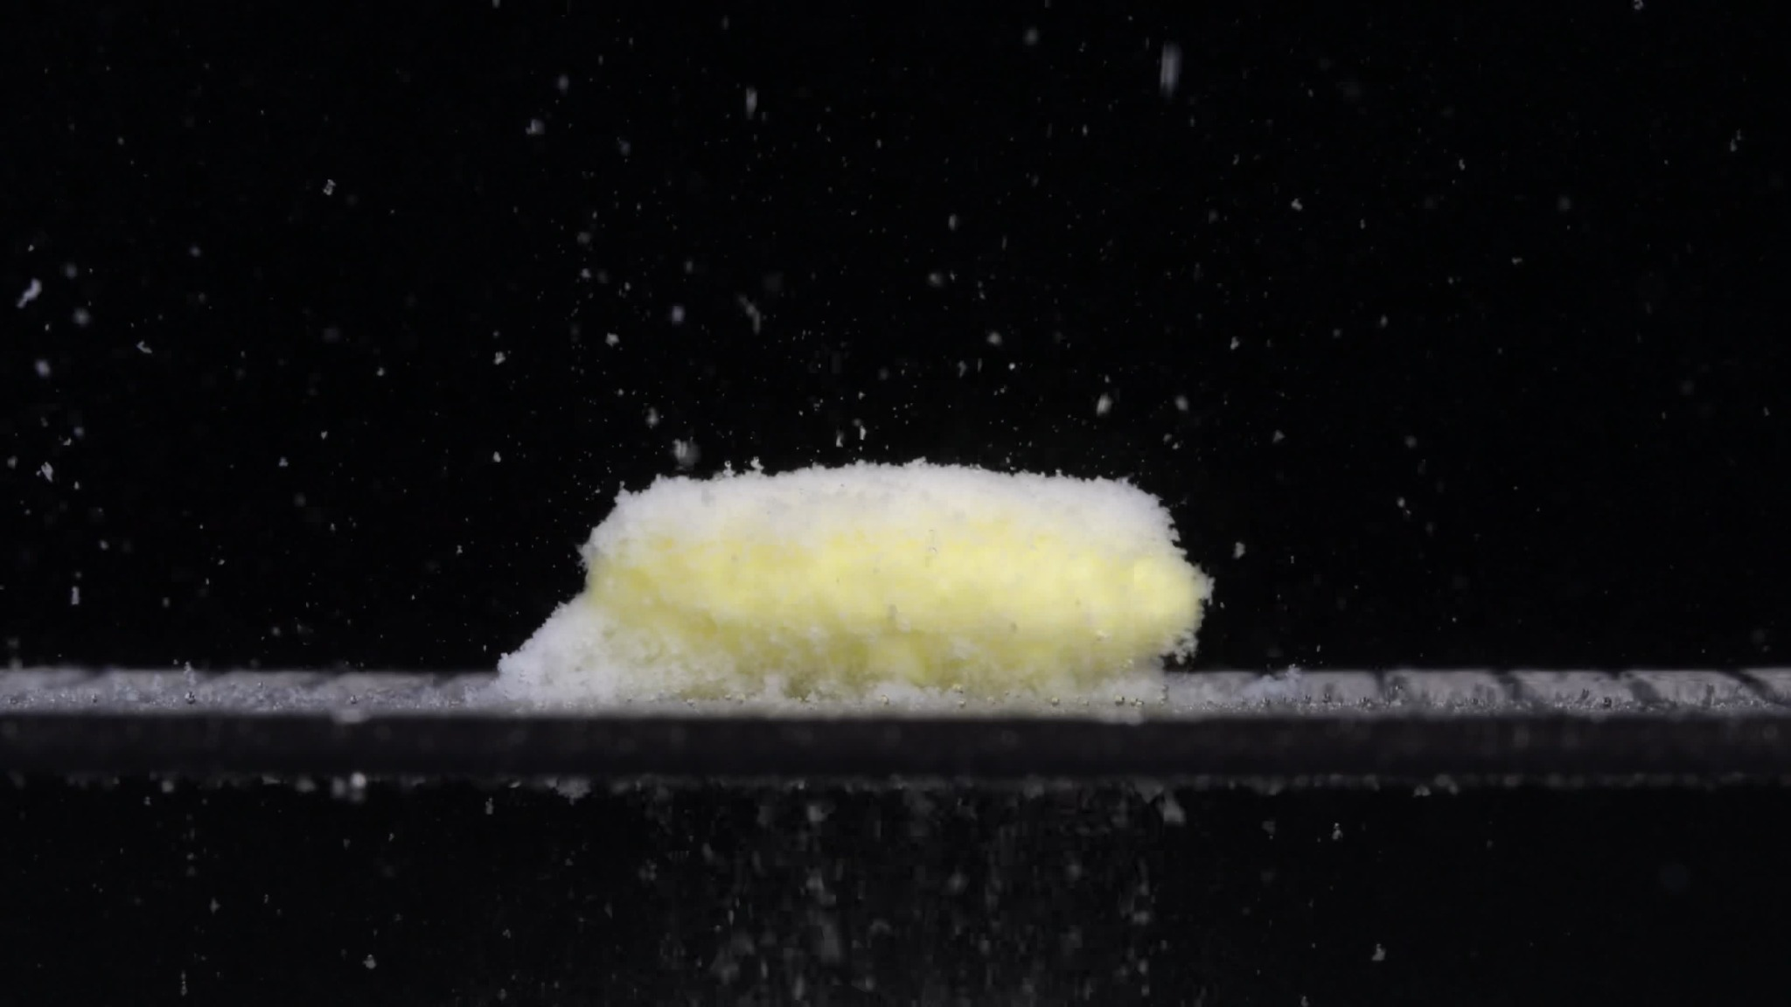
Group B — 15 minutes
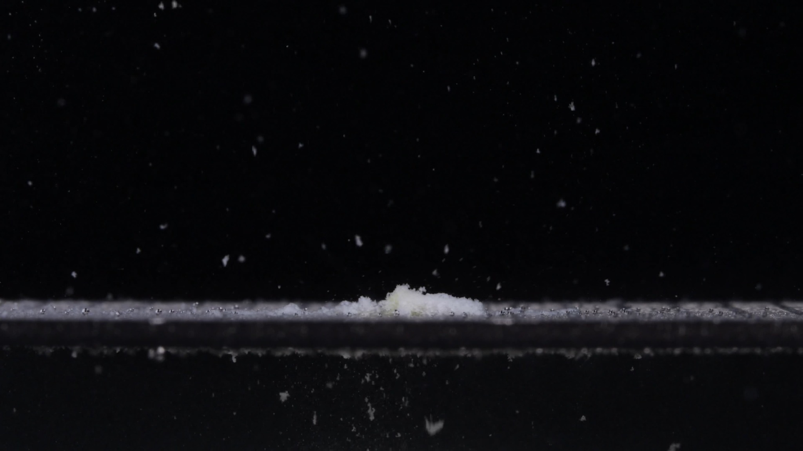
Group B — 30 minutes
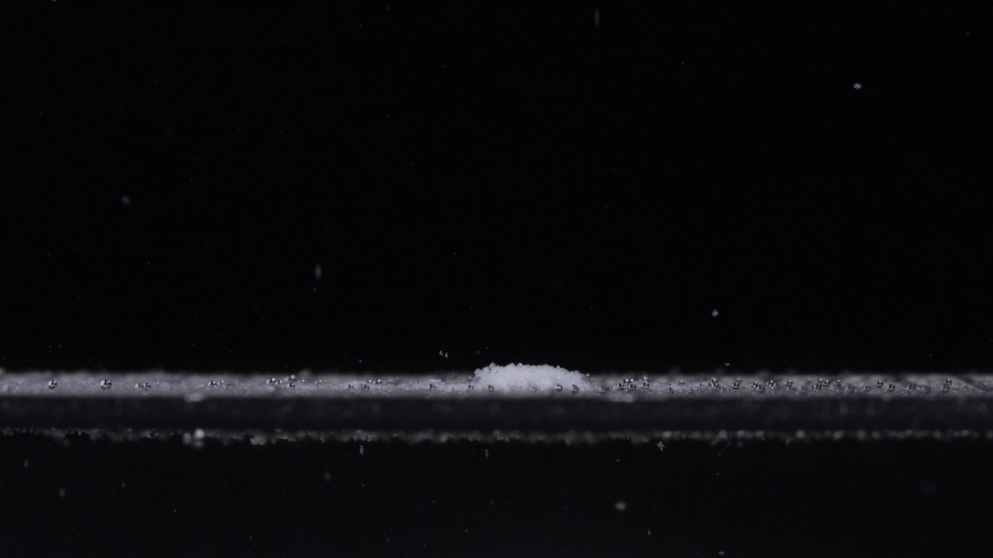
Group B — 45 minutes
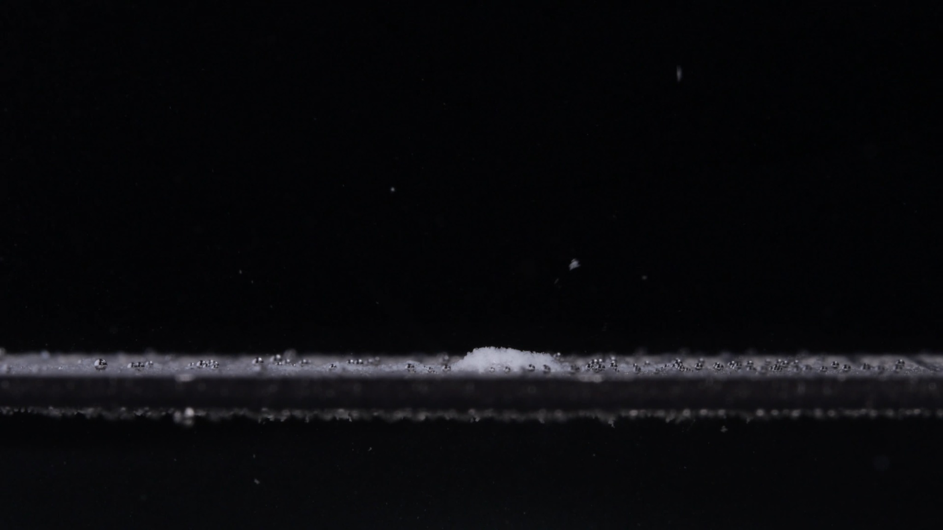
Group B — 60 minutes
Assistant:

Group B — Image Analysis, 0–60 Minutes
I analyzed Group B from 0 to 60 minutes and then compared it with Group A. I used the eight-dimension framework: color, shape, surface texture, volume/size, dissolution speed and time, physical state, dissolution medium, and fragment distribution/density. I will avoid making a chemical-identification claim from images alone. My conclusion is based only on visible disintegration behavior.

Group B — Picture 1, 0 minutes
- Color change: The tablet is already pale yellow to yellow-white, not pure white. No strong color diffusion is visible in the surrounding medium, but tiny particles can be seen around the tablet.
- Shape change: The tablet appears as a large, flat cylindrical disk with a long horizontal profile and relatively straight vertical side wall. It is flatter and wider than Group A at 0 minutes.
- Surface texture change: The surface is not glossy or smooth. It looks slightly matte, porous, and powdery, especially along the upper edge.
- Volume/size change: This is the baseline for Group B. The tablet has a broad diameter and moderate height, with no major collapse yet.
- Dissolution speed and time: At 0 minutes, the tablet is mostly intact, but the presence of small particles suggests surface shedding may have already begun.
- Physical state change: The tablet remains a coherent solid body, but the surface appears less compact than Group A's initial tablet.
- Dissolution medium: The visible medium is mostly clear, though small suspended particles are present.
- Fragment distribution and density: A light particle field is visible around the tablet, but most material remains in the main tablet body.

Group B — Picture 2, 15 minutes
- Color change: The tablet remains mainly yellow-white. The upper central body is yellowish, while the lower and left-side residue appears whiter and powderier.
- Shape change: The original flat disk shape is already heavily damaged. The tablet has become a low, elongated mound, with the left side spreading outward into a powdery deposit.
- Surface texture change: The surface becomes very rough, fuzzy, and granular. The top edge is uneven, and the sides look loosened rather than sharply bounded.
- Volume/size change: The tablet has lost height and structural compactness. The visible mass is still broad, but it is no longer a firm cylinder.
- Dissolution speed and time: There is strong disintegration between 0 and 15 minutes. Compared with Group A, Group B shows more extensive particle release into the surrounding medium at this same time point.
- Physical state change: The tablet appears softened and partially collapsed. A powdery layer has spread from the main body, especially toward the left and along the base.
- Dissolution medium: Many white particles are visible throughout the surrounding liquid. The medium itself is not uniformly opaque, but the particle load is high.
- Fragment distribution and density: Fragments are widely dispersed upward and laterally. Larger loose residue remains near the original tablet position, while many fine particles are suspended in the medium.

Group B — Picture 3, 30 minutes
- Color change: Only a small amount of pale yellow remains near the central residue. Most visible residue is now white to yellow-white.
- Shape change: The original tablet shape is essentially gone. The remaining material is a small, low pile near the center, with a thin powder layer spreading along the platform.
- Surface texture change: The residue is fine, loose, and powder-like. No smooth tablet surface remains.
- Volume/size change: There is a major reduction in visible volume. Compared with 15 minutes, most of the tablet mass has disappeared from the main mound.
- Dissolution speed and time: The 15–30 minute interval shows very rapid loss of the main tablet body. By 30 minutes, Group B is already near the late residue stage.
- Physical state change: The tablet has changed from a solid disk into dispersed particles and sediment. No firm core is visible.
- Dissolution medium: Many suspended flakes and particles remain visible in the liquid, suggesting strong particle release.
- Fragment distribution and density: Fragments are widely scattered. A small dense residue remains at the original location, while many fine particles are suspended above and around it.

Group B — Picture 4, 45 minutes
- Color change: The remaining residue appears mostly white, with little visible yellow. Any yellow tone is faint and localized.
- Shape change: The residue is now a small, low mound. It is much smaller than the original tablet and has no defined tablet contour.
- Surface texture change: The residue looks powdery and granular. The surface is irregular but low and compacted.
- Volume/size change: Visible volume is very small compared with 0 and 15 minutes. Most of the original tablet has already disintegrated or dispersed.
- Dissolution speed and time: After the rapid 0–30 minute breakdown, the process slows. The remaining small residue persists rather than disappearing completely.
- Physical state change: The physical state is now mainly loose sediment and fine particles.
- Dissolution medium: The medium remains visually dark and clear overall, but scattered particles and bubbles are present along the lower support surface.
- Fragment distribution and density: Most dense residue is localized at the center. Fine fragments are sparsely distributed in the surrounding medium and along the support.

Group B — Picture 5, 60 minutes
- Color change: The residue remains mostly white to very pale yellow-white. No strong yellow core is visible.
- Shape change: Only a small residual mound remains. The original flat cylindrical tablet shape is completely lost.
- Surface texture change: The residue is loose, powdery, and granular. There is no intact smooth surface.
- Volume/size change: The visible material remains very small. Compared with the 0 minute tablet, the volume reduction is severe.
- Dissolution speed and time: Group B shows rapid early and middle-stage disintegration, with most of the tablet gone by 30 minutes. From 45 to 60 minutes, the remaining residue changes only slightly.
- Physical state change: The tablet has fully converted into dispersed/sedimented particulate material. No solid core is visible.
- Dissolution medium: The medium is not uniformly cloudy in the frame, but suspended particles and bottom sediment remain visible.
- Fragment distribution and density: A small dense residue remains near the original tablet location, with fine particles dispersed around it.

Group B Overall Disintegration Pattern
Group B starts as a large, pale yellow, flat cylindrical tablet. It loses structural integrity quickly. By 15 minutes, it has already become a rough, elongated, powdery mound with many suspended particles. By 30 minutes, most of the original tablet body has disappeared, leaving only a small residue and dispersed fragments. By 45–60 minutes, only a small white powder-like mound remains.

Preliminary Group A vs Group B Comparison
Feature | Group A | Group B
Initial color | Mainly white | Pale yellow/yellow-white
Initial shape | Smaller, thick, biconvex/rounded tablet | Larger, flatter cylindrical disk
0 minute surface | Compact and smooth | More matte, porous, powdery-looking
15 minute behavior | Swells into a fluffy dome; large mound remains | Strong collapse/spreading; many particles dispersed
30 minute behavior | Still a clear mound with yellow-white body | Most tablet body already gone; small residue only
45–60 minute behavior | Persistent fluffy mound remains | Only a small powder mound remains
Fragment distribution | Mostly localized near original tablet | More widely dispersed particles, especially early
Disintegration speed | Rapid 0–15 minutes, then slower persistence | Faster overall; major loss by 30 minutes
Based on the visible evidence, Groups A and B are unlikely to be the same exact tablet or formulation. The strongest reasons are their different initial size and shape, different disintegration rate, different fragmentation behavior, and different color pattern. Chemical identity cannot be confirmed from images alone.
User:
Please compare Groups A and B based on their disintegration characteristics across the eight dimensions to determine if they are from the same drug or not, and explain why you think so.
Assistant:

Final Eight-Dimension Comparison and Determination
Based on the eight disintegration dimensions, Groups A and B are unlikely to be the same exact drug product or formulation. They may theoretically contain the same active ingredient, but from the images alone, their tablet design and disintegration behavior are too different to confidently classify them as the same drug product.

1. Color Change
- Group A: At 0 minutes, the tablet is mainly white. After wetting, yellow material gradually appears inside the swollen residue. The yellow color seems to emerge after the outer layer breaks down.
- Group B: At 0 minutes, the tablet is already pale yellow/yellow-white. The yellow tone is present before major disintegration begins.
- Comparison: This is a major difference. Group A appears to have a white exterior with yellow material exposed later, while Group B is yellowish from the beginning.

2. Shape Change
- Group A: The initial tablet is smaller, thicker, and biconvex/rounded. After 15 minutes, it becomes a swollen dome-like mound. Even at 60 minutes, a relatively large mound remains.
- Group B: The initial tablet is larger, wider, flatter, and cylindrical, with a long horizontal profile. By 30 minutes, the original tablet shape is almost completely gone.
- Comparison: The starting shape is clearly different. Group A looks like a thick rounded tablet; Group B looks like a flat disk. This strongly suggests a different tablet design or formulation.

3. Surface Texture Change
- Group A: The 0 minute surface is smooth and compact. During disintegration, it becomes fluffy, porous, and fibrous/powdery, but the loosened material mostly stays as a central mound.
- Group B: The 0 minute surface already appears more matte and porous. By 15 minutes, the surface releases many particles into the medium, and the tablet collapses more extensively.
- Comparison: Both become powdery, but Group B sheds particles much more aggressively and earlier.

4. Volume / Size Change
- Group A: The tablet first appears to swell into a large fluffy mound by 15 minutes. From 15 to 60 minutes, the mound slowly decreases but remains visible and relatively substantial.
- Group B: The tablet rapidly loses volume. By 30 minutes, only a small central residue remains. By 45–60 minutes, the residue is much smaller than Group A's remaining mound.
- Comparison: Group A shows swelling followed by slow erosion. Group B shows faster collapse and much greater volume loss by 30 minutes.

5. Dissolution Speed and Time
- Group A: Fast initial disintegration occurs from 0 to 15 minutes, but the later stage is slow. A large powdery residue remains at 60 minutes.
- Group B: Disintegration is faster overall. The major tablet body is mostly gone by 30 minutes, leaving only a small powder mound afterward.
- Comparison: Group B disintegrates faster than Group A. The difference is especially clear at 30 minutes: Group A still has a clear mound, while Group B is already mostly reduced to residue.

6. Physical State Change
- Group A: The tablet changes from compact solid to swollen hydrated mass, then to a persistent porous powder aggregate. The residue remains locally dense.
- Group B: The tablet changes from flat solid disk to loosened powder and dispersed particles very quickly. No clear solid core remains after 30 minutes.
- Comparison: Group A maintains a semi-coherent hydrated mound much longer. Group B breaks down into dispersed/sedimented particles faster.

7. Dissolution Medium
- Group A: The surrounding medium remains mostly clear, with localized particles and bubbles near the tablet. Turbidity is mainly around the residue.
- Group B: The medium also remains dark and mostly clear overall, but many more suspended particles are visible, especially at 15 and 30 minutes.
- Comparison: Group B produces a heavier visible particle field in the medium. Group A's disintegration remains more localized.

8. Fragment Distribution and Density
- Group A: Fragments are concentrated around the original tablet position. The residue stays as a dense central mound, with limited wide dispersion.
- Group B: Fragments are more widely dispersed upward and laterally. By 30 minutes, there is a thin spread of powder along the platform and only a small central mound.
- Comparison: Group A has localized, dense residue. Group B has broader particle dispersion and faster sediment spreading.

Final Judgment
Groups A and B are probably not from the same exact drug product or formulation.
The strongest evidence is:
- Different initial tablet morphology: Group A is thick, white, and biconvex; Group B is wider, flatter, and yellow-white.
- Different disintegration rate: Group A still has a large residue at 60 minutes, while Group B is mostly reduced by 30 minutes.
- Different fragmentation behavior: Group A forms a localized swollen mound; Group B disperses particles more widely and collapses faster.
- Different color behavior: Group A exposes yellow material after disintegration begins; Group B is yellowish from the start.
Therefore, the image-based conclusion is that Groups A and B are unlikely to be the same drug product. More precisely, they are unlikely to be the same tablet formulation, manufacturer, strength, or coating design. Image analysis alone cannot prove whether the active pharmaceutical ingredient is different, but visually and behaviorally, the two groups do not match as the same tablet.

