Drug Disintegration Image Analysis
Edited English Conversation Transcript and Comparative Assessment
Scope: This document includes the conversation content related to the drug disintegration discussion only. The final Chinese request for document creation is intentionally excluded.
Image timing: Each picture was taken 15 minutes apart. Group A and Group B were analyzed across 0, 15, 30, 45, and 60 minutes.

1. Initial Request and Preparation
User
I need you to try analyzing the disintegration images of two groups of Doxycycline Hyclate Tablets, A and B. These may be images of the same drug or different drugs. I need you to determine whether the images are from the same drug or not. For each group, I will upload 5 images. Each picture is taken 15 minutes apart. Please describe the drug disintegration process in English for each image in the group, and finally determine whether the two sets of images are from the same drug.
You can call the Knowledge Base to remember how to describe the drug disintegration. As you describe the tablets in English, pay attention to the changes in the size and shape of the tablets. If you are prepared, then I will upload the picture of Group A, Picture 1 at 0 minutes.
Assistant
Yes, I am prepared.
Please upload Group A - Picture 1 at 0 minutes.
For each image, I will describe the disintegration in English using the eight required dimensions: color change, shape change, surface texture change, volume/size change, dissolution speed and time, physical state change, dissolution medium, and fragment distribution/density. I will pay special attention to tablet size, contour, shape deformation, cracking, fragmentation, and remaining tablet mass across the 15-minute intervals.
After all 10 images are provided, I will compare Group A vs Group B and judge whether they are likely the same drug/tablet formulation or different, based on the full disintegration pattern. I will follow the knowledge-base framework for systematic drug-disintegration description.
User
You are not totally prepared. Please call the Knowledge Base to remember how to describe the drug disintegration again.
Assistant
I have called the Knowledge Base again and refreshed the full framework.
For every image you upload, I will describe the tablet using these eight dimensions:
1. Color change - tablet color, local color diffusion, solution transparency/turbidity.
2. Shape change - whether the tablet stays intact, becomes distorted, cracks, or fragments.
3. Surface texture change - smoothness, roughening, pores, peeling, cracks, powdery surface.
4. Volume / size change - reduction in diameter, height, thickness, remaining tablet mass, swelling or collapse.
5. Dissolution speed and time - how fast disintegration progresses at each 15-minute interval.
6. Physical state change - swelling, internal weakening, breaking, collapse, particle formation.
7. Dissolution medium - clarity, viscosity appearance, turbidity, floating/sinking behavior.
8. Fragment distribution and density - number, size, density, location, sedimentation, suspension of fragments.
I will especially focus on size and shape, because the Knowledge Base states that tablet size and shape affect disintegration behavior and can help distinguish drugs or formulations.
For each image, I will write in English using this structure:
Group A / B - Image X - Time: XX min
- Color change:
- Shape change:
- Surface texture change:
- Volume / size change:
- Dissolution speed and time:
- Physical state change:
- Dissolution medium:
- Fragment distribution and density:
- Short interpretation:
After all 10 images are uploaded, I will compare Group A and Group B by: initial appearance -> rate of size reduction -> shape deformation -> cracking pattern -> remaining mass -> turbidity -> fragment density -> final residue pattern.
Then I will decide whether the two groups are likely the same drug/formulation or likely different drugs/formulations.
Please upload Group A, Picture 1, 0 minutes.

2. Group A Images and Analysis
User
When you describe the drug, please make sure your description in English is accurate. Think carefully and reduce the occurrence of hallucinations. Each picture is taken 15 minutes apart. These are Group A pictures.
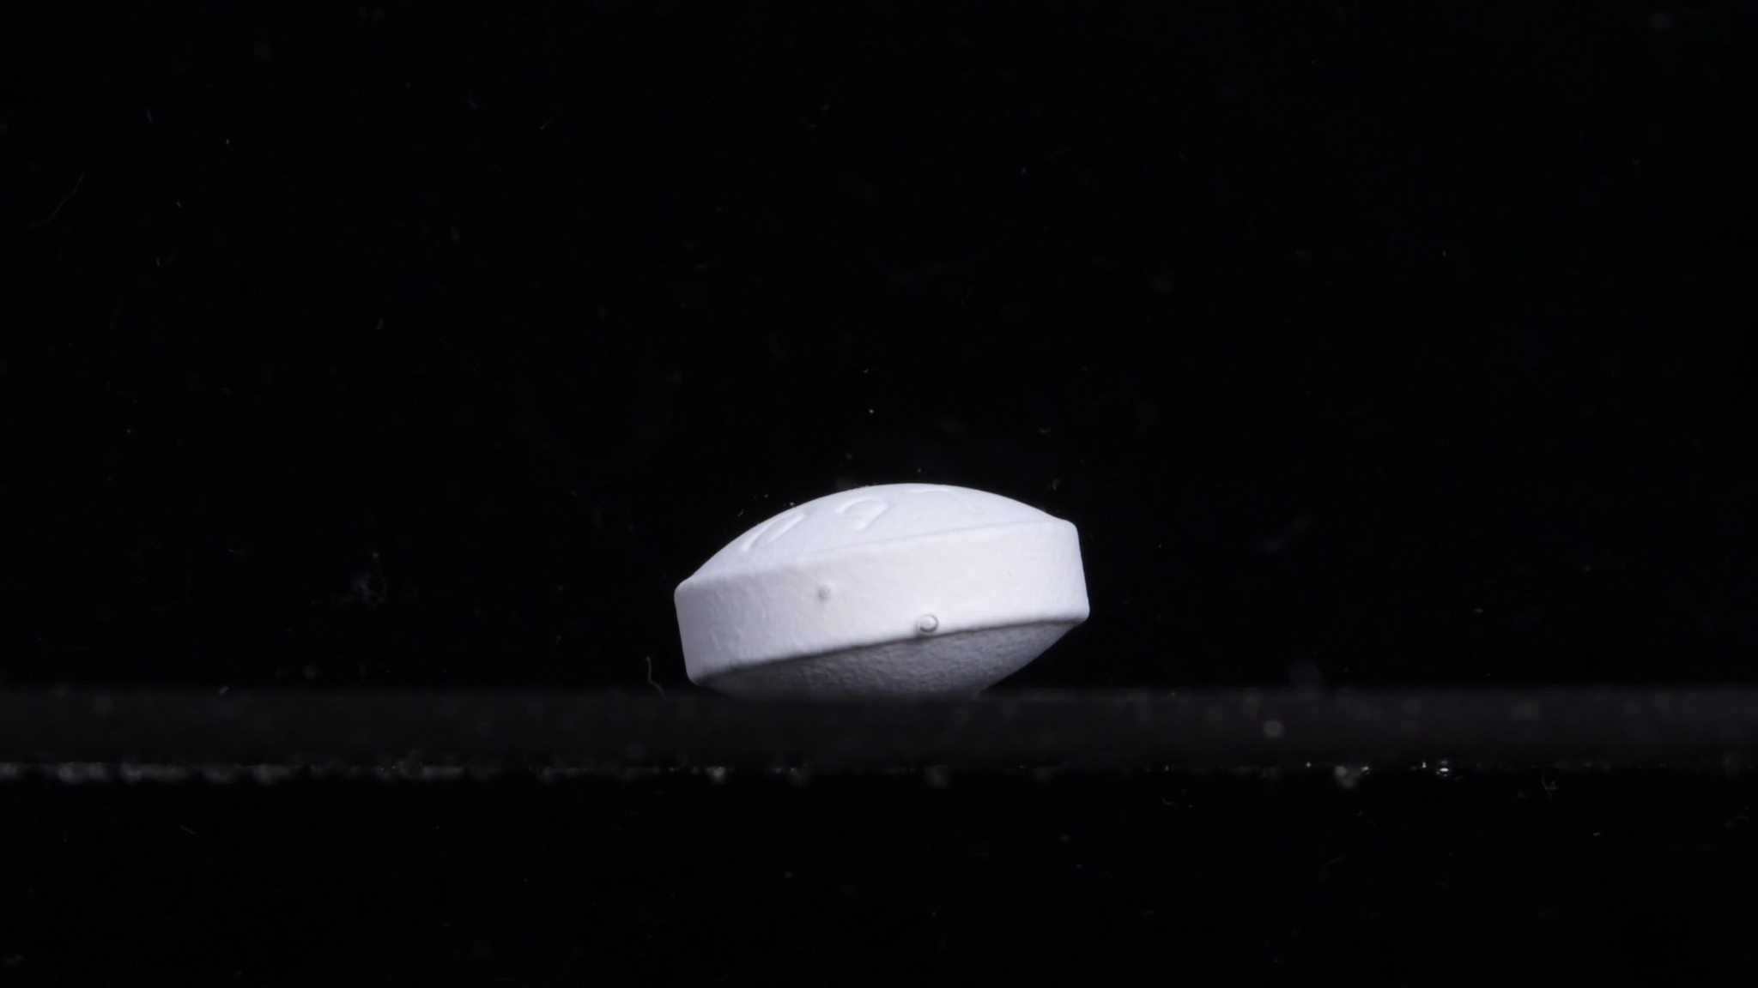
Group A - Picture 1 - 0 minutes
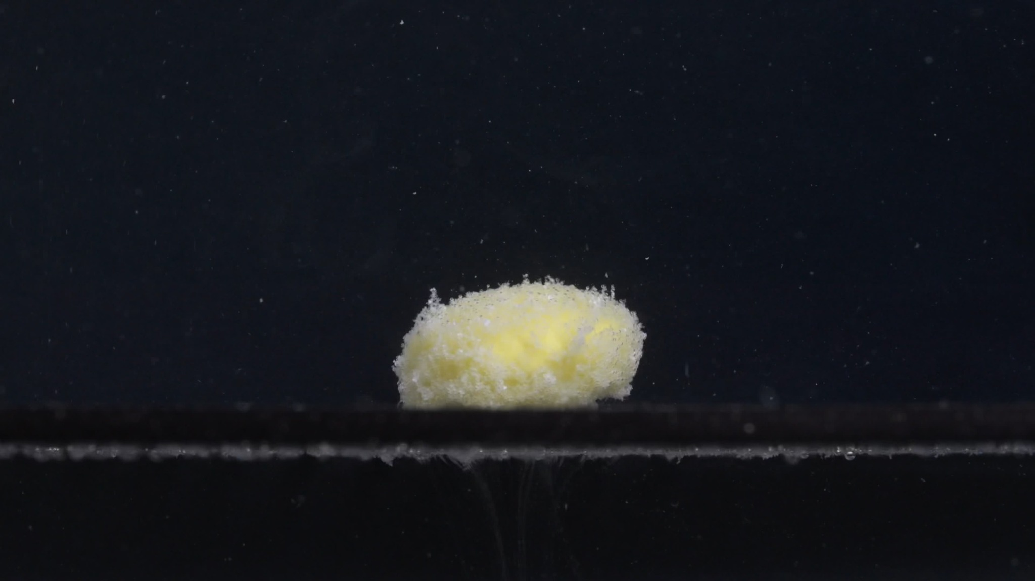
Group A - Picture 2 - 15 minutes
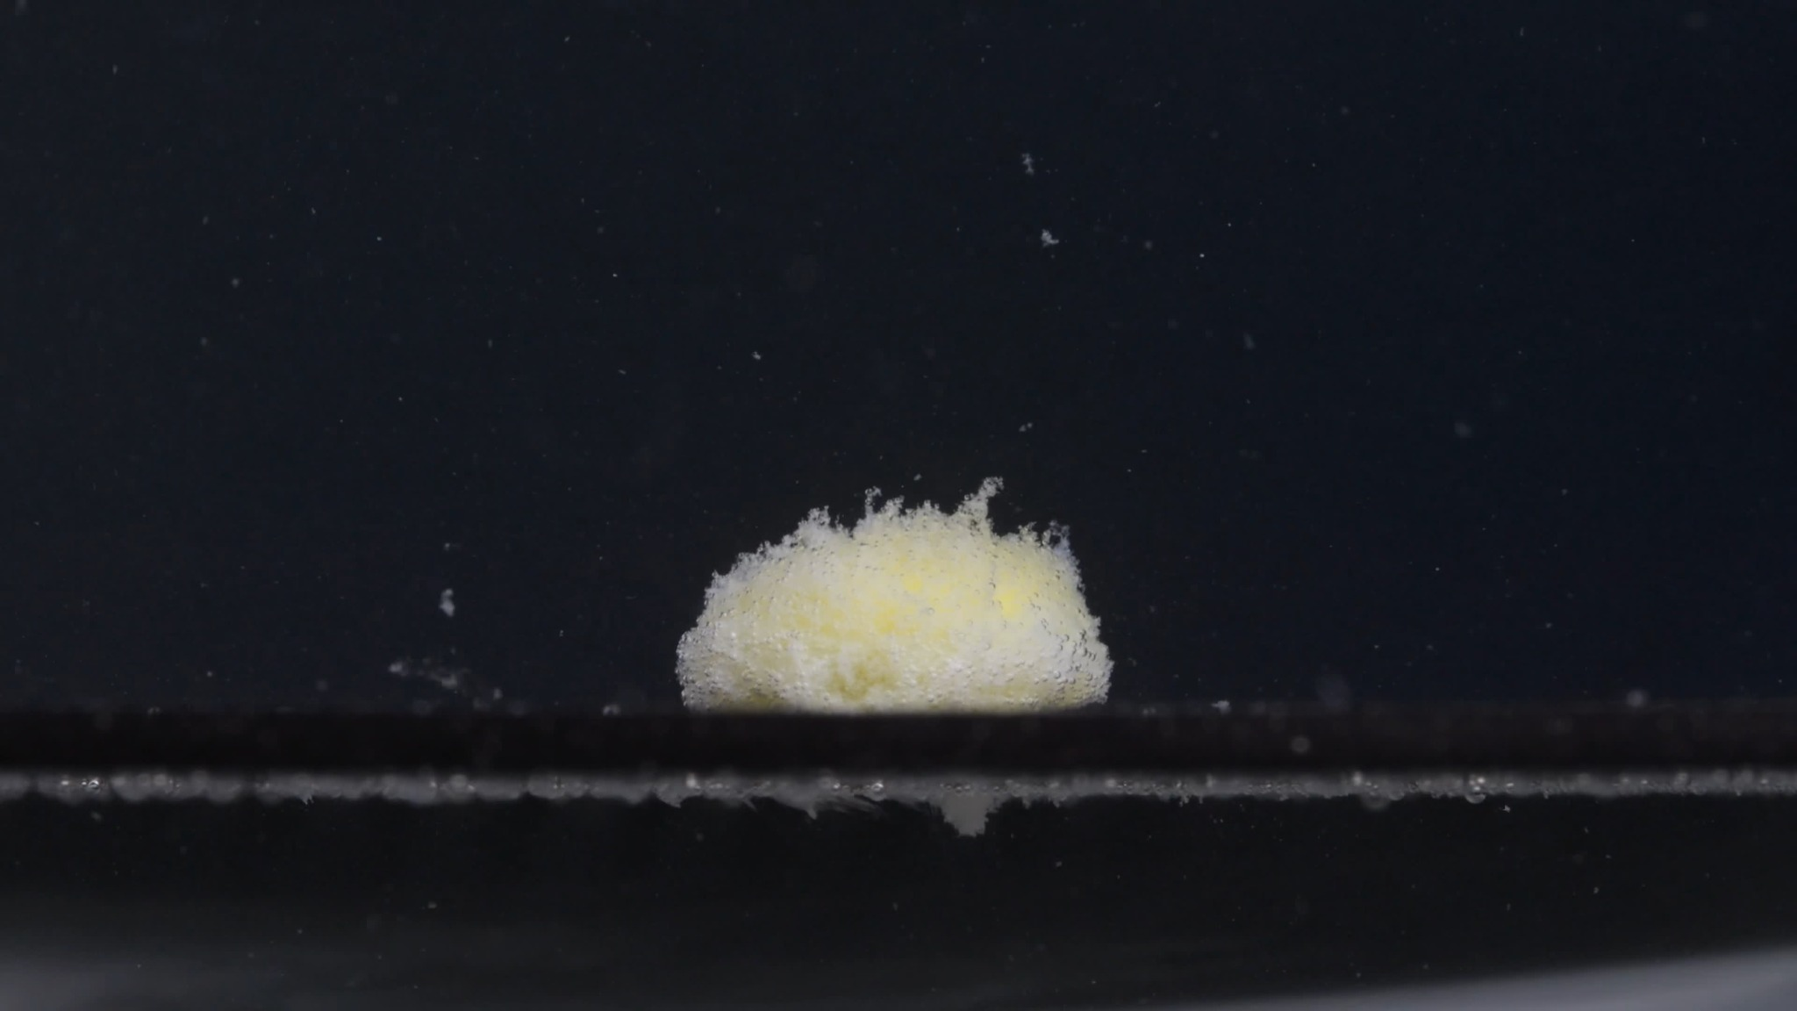
Group A - Picture 3 - 30 minutes
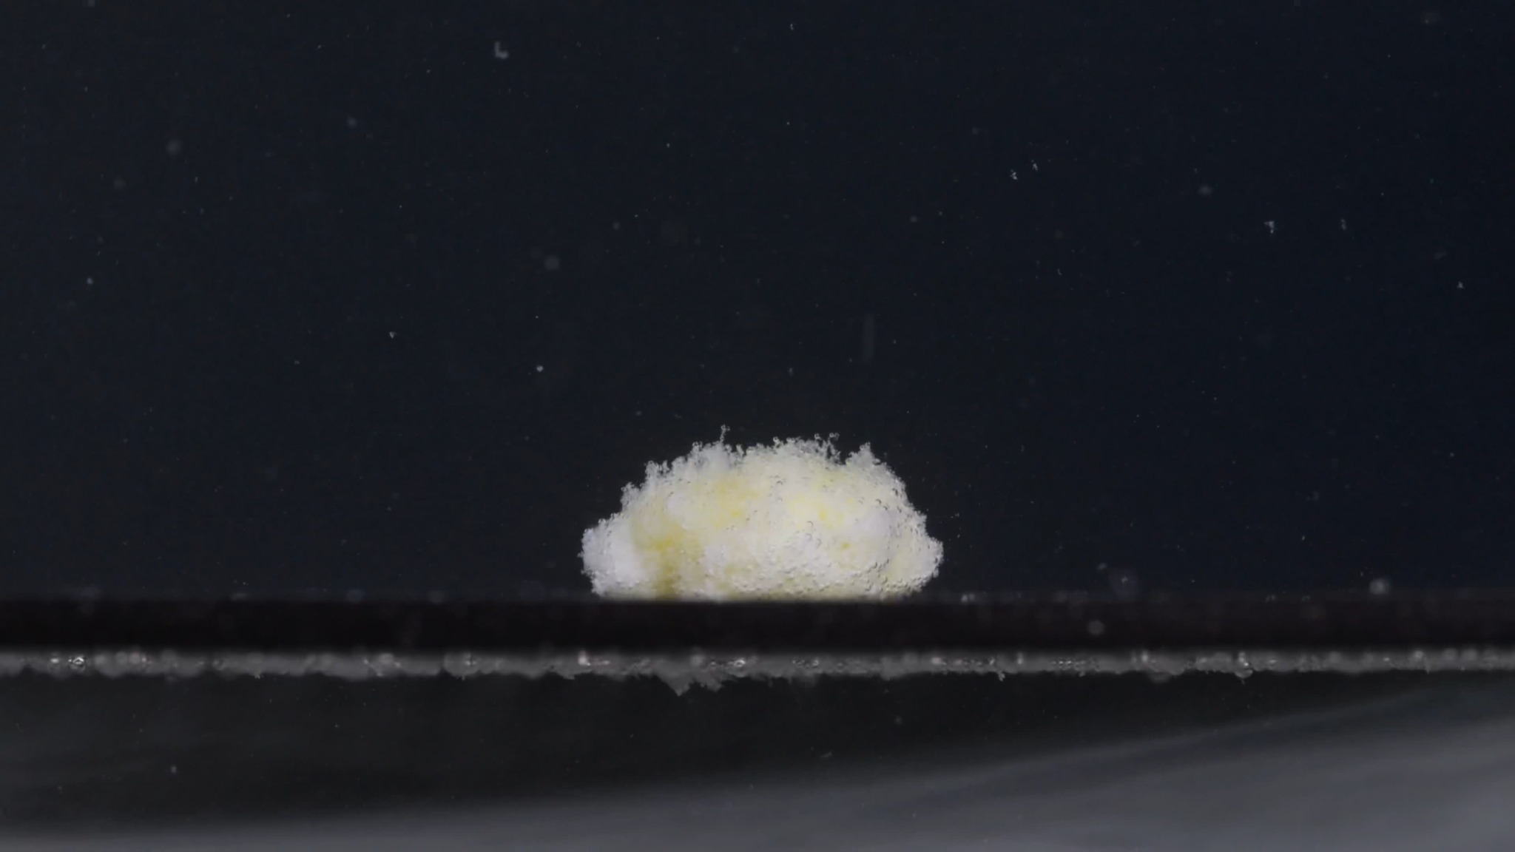
Group A - Picture 4 - 45 minutes
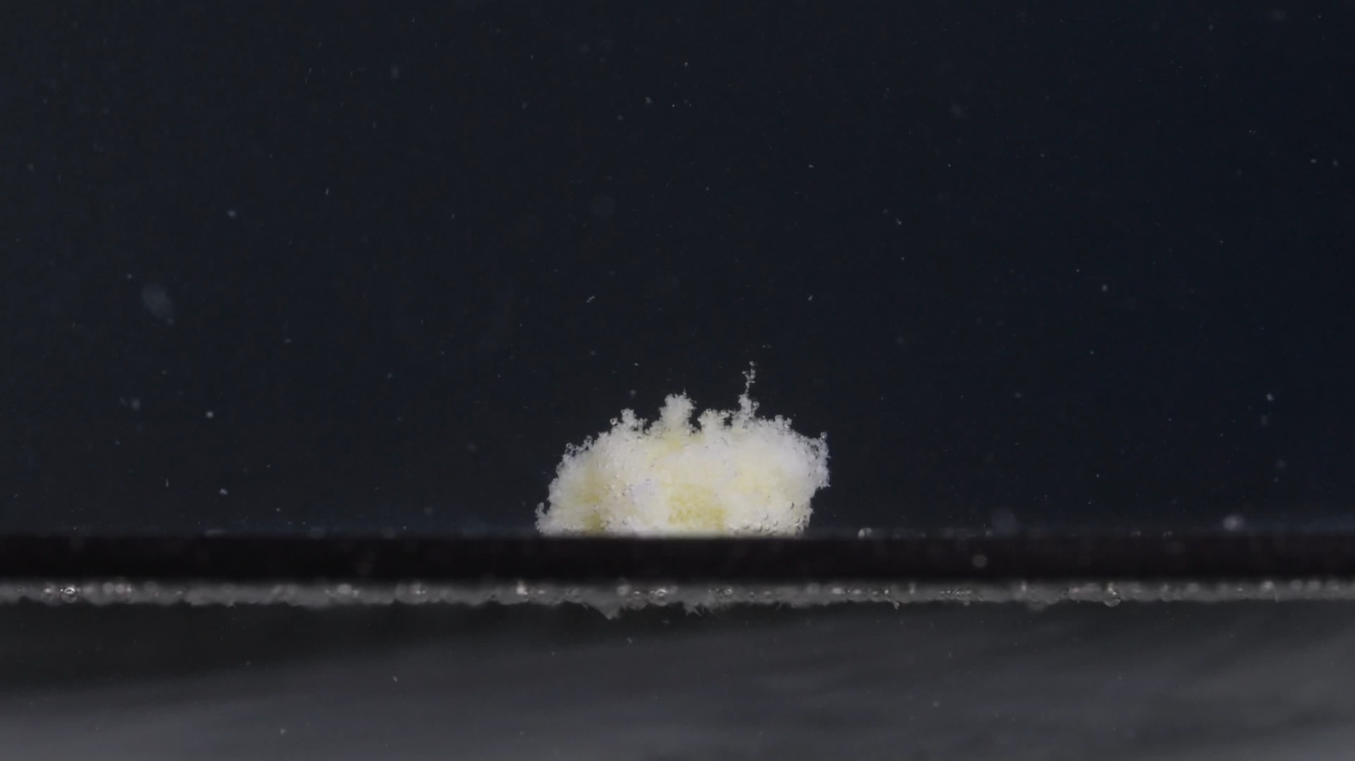
Group A - Picture 5 - 60 minutes
Assistant
I will treat these as Group A, Images 1-5 at 0, 15, 30, 45, and 60 minutes. I will describe only what is visible in the images and avoid assuming chemical identity from appearance alone. The knowledge-base framework emphasizes using eight dimensions, especially time sequence, size/shape change, surface roughening, volume reduction, physical collapse, medium turbidity, and fragment distribution. The guide also notes that tablet size and shape can help compare disintegration behavior between samples.

Group A - Image 1 - Time: 0 minutes
- Color change: The tablet appears mainly white to off-white. No visible yellow material is exposed yet. The surrounding medium looks mostly clear against the dark background.
- Shape change: The tablet is still intact, with a compact, biconvex/rounded tablet form. Its edge is continuous and well-defined.
- Surface texture change: The surface appears relatively smooth and solid, with only minor surface marks or small spots visible.
- Volume / size change: This is the initial reference state. The tablet retains its full apparent size, thickness, and contour.
- Dissolution speed and time: At 0 minutes, there is no visible disintegration yet.
- Physical state change: The tablet remains a coherent solid body. No obvious swelling, cracking, peeling, or collapse is visible.
- Dissolution medium: The liquid appears clear; there is no obvious clouding around the tablet.
- Fragment distribution and density: No fragments are visible. The tablet mass is concentrated in one intact body.
- Short interpretation: Group A begins as a solid, white, intact tablet with a clear outline and no visible fragmentation.

Group A - Image 2 - Time: 15 minutes
- Color change: The tablet has changed from mostly white to a white-yellow porous mass. Yellow material is now visible mainly in the central region, while the outer parts remain paler or whitish.
- Shape change: The original smooth tablet outline has largely disappeared. The tablet has become a rounded, irregular mound rather than a defined tablet.
- Surface texture change: The surface is now very rough, granular, and foam-like, with many fine pores or powdery protrusions.
- Volume / size change: The compact tablet has lost its original solid contour. The apparent mass may look swollen or expanded because it has become loose and porous, but the original tablet boundary is no longer preserved.
- Dissolution speed and time: Between 0 and 15 minutes, disintegration is substantial and rapid: the tablet changes from intact to a loose porous structure.
- Physical state change: The tablet appears to have absorbed liquid and weakened internally, producing a soft, crumbly, porous mass.
- Dissolution medium: The area near the tablet shows some fine suspended particles. The medium still appears mostly clear away from the tablet.
- Fragment distribution and density: Most fragments remain densely concentrated at the original tablet position. A small amount of fine material is visible around or above the main mound.
- Short interpretation: By 15 minutes, Group A shows major disintegration, with the white exterior disrupted and yellow inner/residual material exposed.

Group A - Image 3 - Time: 30 minutes
- Color change: The mass remains pale yellow and white, with yellow color visible through the center and white powdery material around the surface.
- Shape change: The tablet is no longer tablet-shaped. It remains as a low, irregular mound with uneven upper edges.
- Surface texture change: The surface continues to look porous, granular, and fluffy, with small projections on the upper surface.
- Volume / size change: Compared with 15 minutes, the mound appears slightly lower and less compact. The vertical height of the remaining mass is reduced, while the base still occupies a similar area.
- Dissolution speed and time: Disintegration continues but appears slower than the first 15 minutes. The main event has already occurred, and the remaining material is gradually eroding.
- Physical state change: The structure appears mechanically weak, with the surface shedding fine particles. No large solid tablet core is clearly visible.
- Dissolution medium: Fine particles are visible in the liquid, especially around the tablet area, but the whole medium is not strongly opaque.
- Fragment distribution and density: Fragment density is still highest near the original tablet location. Some fine particles are dispersed upward and outward, while larger residue remains settled at the bottom.
- Short interpretation: At 30 minutes, the sample is mainly a porous residue mound, with gradual erosion rather than large-scale new breakup.

Group A - Image 4 - Time: 45 minutes
- Color change: The remaining material is still white-yellow, but the yellow areas appear more diffuse and partly covered by whitish powder.
- Shape change: The residue is flatter and more irregular. The original tablet shape is completely lost.
- Surface texture change: The surface remains rough and powdery, with a soft, sponge-like appearance. The top edge is uneven but slightly less tall than before.
- Volume / size change: The remaining mass appears reduced in height and slightly spread along the bottom surface. The compact volume continues to decrease.
- Dissolution speed and time: From 30 to 45 minutes, the dissolution/disintegration rate appears moderate to slow. The mass is not disappearing suddenly, but it is gradually becoming lower and less defined.
- Physical state change: The residue appears to be collapsing and eroding. The structure is loose, with no coherent tablet shell remaining.
- Dissolution medium: Some suspended particulate matter is visible. The medium remains relatively clear away from the residue.
- Fragment distribution and density: Dense residue remains at the bottom. Finer fragments are lightly distributed nearby, with limited wide dispersion.
- Short interpretation: At 45 minutes, Group A shows continued collapse of the porous mass, with decreasing height and persistent yellow-white residue.

Group A - Image 5 - Time: 60 minutes
- Color change: The residue remains yellow-white, with pale yellow patches still visible inside the remaining mass.
- Shape change: The residue is now a smaller, irregular mound with several narrow upward protrusions. It no longer resembles the original tablet.
- Surface texture change: The surface is highly irregular, powdery, and porous. The upward projections suggest fragile, loosened material rather than a firm structure.
- Volume / size change: The remaining mass is smaller and lower than earlier disintegrated stages. The original tablet volume has been greatly reduced.
- Dissolution speed and time: By 60 minutes, most visible disintegration has already occurred. The remaining process appears to be slow erosion of residual material.
- Physical state change: The tablet has changed from a compact solid into a fragile, partially eroded residue. No intact core or smooth coating is visible.
- Dissolution medium: The liquid contains scattered fine particles. The strongest particulate density remains near the bottom residue rather than uniformly throughout the medium.
- Fragment distribution and density: Residue is concentrated at the original tablet location. Fine fragments are present nearby, with a few suspended particles in the surrounding liquid.
- Short interpretation: At 60 minutes, Group A has mostly disintegrated into a loose yellow-white residue, but some material remains settled at the bottom.

Group A overall disintegration pattern
Group A shows a rapid early transformation: from an intact white tablet at 0 minutes to a yellow-white porous mound by 15 minutes. After that, the process becomes slower, with gradual reduction in height, loss of compactness, and persistent bottom residue from 30 to 60 minutes.
- Initial tablet: white, intact, rounded/biconvex, smooth surface.
- Early disintegration: very strong change by 15 minutes.
- Color exposure: yellow material appears after disintegration begins.
- Shape evolution: intact tablet -> irregular porous mound -> flatter eroded residue.
- Texture: smooth -> granular/porous/fluffy.
- Final state at 60 minutes: not fully dissolved; visible yellow-white residue remains.

3. Group B Images and Analysis
User
When you describe the drug, please make sure your description in English is accurate. Think carefully and reduce the occurrence of hallucinations. Each picture is taken 15 minutes apart. It is Group B, Picture 0 minutes.
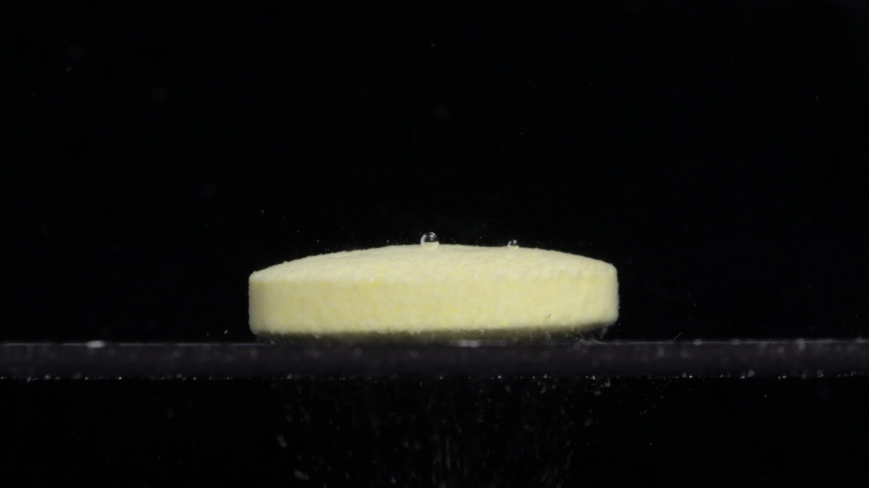
Group B - Picture 1 - 0 minutes
Assistant

Group B - Image 1 - Time: 0 minutes
- Color change: The tablet is already pale yellow to light yellow at the starting point. Unlike Group A at 0 minutes, which appeared mostly white, this tablet shows a uniform yellow tone from the beginning. The surrounding liquid remains mostly clear.
- Shape change: The tablet is intact and keeps a regular, flat cylindrical tablet shape. Its side wall is straight and continuous, and the upper surface is broad and nearly flat. No visible cracking, bending, splitting, or edge collapse is present.
- Surface texture change: The surface appears slightly matte and fine-grained, not glossy. The top and side surfaces look compact, with no obvious pores, peeling, or powder shedding. The two small round structures on the upper surface look more like air bubbles or liquid droplets than tablet damage.
- Volume / size change: This is the initial reference image for Group B. The tablet appears wide and relatively low in height, with a larger horizontal diameter and flatter profile than Group A's 0-minute tablet. No visible size reduction has occurred yet.
- Dissolution speed and time: At 0 minutes, there is no clear visible disintegration. The tablet has not yet started to break into fragments.
- Physical state change: The tablet remains a coherent solid body. There is no clear swelling, internal collapse, crack formation, or fragmentation visible at this stage.
- Dissolution medium: The medium appears mostly transparent. There may be a few tiny suspended specks in the background, but there is no obvious local turbidity cloud around the tablet.
- Fragment distribution and density: No true tablet fragments are visible. The tablet mass remains concentrated as one intact solid disk. Any small particles in the background are sparse and cannot confidently be identified as disintegration fragments.
- Short interpretation: Group B at 0 minutes shows an intact pale-yellow, flat cylindrical tablet with a broad, regular outline and no obvious disintegration. Its initial appearance is notably different from Group A at 0 minutes, especially in color, width, height, and overall tablet shape, but a final same/different judgment should wait until the remaining 15, 30, 45, and 60-minute Group B images are compared.
User
When you describe the drug, please make sure your description in English is accurate. Think carefully and reduce the occurrence of hallucinations. Each picture is taken 15 minutes apart. It is Group B, Picture 15 minutes.
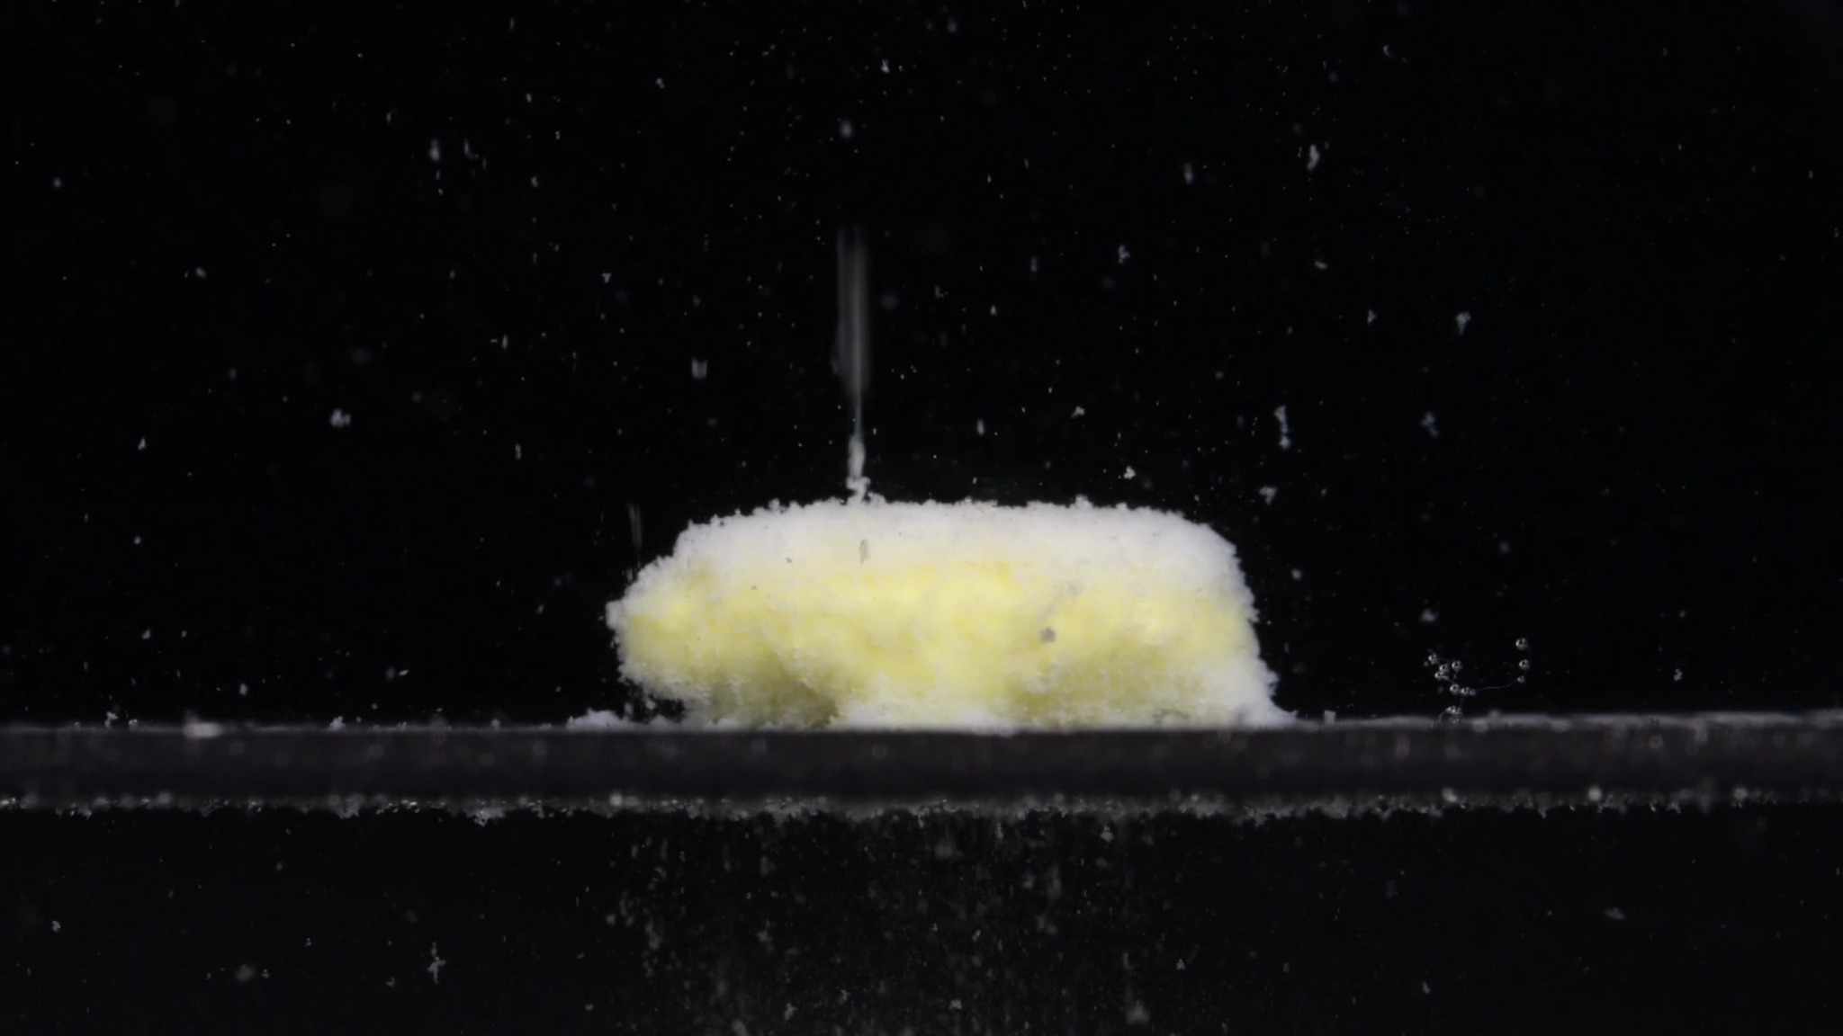
Group B - Picture 2 - 15 minutes
Assistant

Group B - Image 2 - Time: 15 minutes
- Color change: The tablet remains mainly pale yellow, but a whitish, powdery layer is now visible over much of the surface and around the edges. The yellow color is still strongest in the central body, while the outer surface looks lighter and more fragmented.
- Shape change: The original flat cylindrical shape is partly preserved, but the outline is no longer smooth. The side wall has become uneven, swollen-looking, and softened. The tablet has not fully collapsed, but it has changed from a clean disk into a rough, low, elongated mound.
- Surface texture change: The surface has changed clearly from compact and smooth to granular, porous, and fluffy. Fine powder-like material is visible on the top and edges. The upper boundary looks irregular, with small loose particles protruding from the surface.
- Volume / size change: Compared with Group B at 0 minutes, the tablet still keeps a broad horizontal footprint, but the edges look expanded and eroded. The height appears slightly reduced or softened rather than sharply collapsed. The apparent volume is difficult to judge because swelling and surface loosening may make the tablet look larger while the solid core is weakening.
- Dissolution speed and time: Between 0 and 15 minutes, disintegration has clearly begun and progressed substantially. The rate appears moderate to fast in the early stage, mainly through surface erosion, powder shedding, and softening rather than complete breakup.
- Physical state change: The tablet has absorbed liquid and become structurally weaker. It now appears soft, porous, and friable, with the outer layer breaking into fine particles. No large separated fragments are obvious, but the surface is actively shedding small material.
- Dissolution medium: The surrounding medium contains many visible suspended specks and small particles, especially above and around the tablet. The medium is not uniformly opaque, but local particulate density is higher than at 0 minutes.
- Fragment distribution and density: Fine fragments are dispersed around the tablet and suspended in the liquid. Most of the dense material remains concentrated in the original tablet position, while smaller particles have moved upward and outward. There are no clearly defined large broken pieces yet.
- Short interpretation: At 15 minutes, Group B shows clear early disintegration: the intact pale-yellow disk has become a rough, porous, yellow-white mound with strong surface powdering. The tablet remains relatively broad and partially coherent, but its smooth cylindrical shape has been lost. This image should be compared later with Group A's 15-minute image and the later Group B time points before making a final same-drug judgment.
User
When you describe the drug, please make sure your description in English is accurate. Think carefully and reduce the occurrence of hallucinations. Each picture is taken 15 minutes apart. It is Group B, Picture 30 minutes.
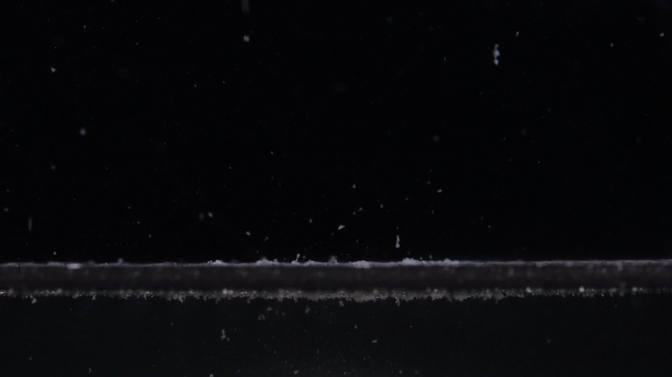
Group B - Picture 3 - 30 minutes
Assistant

Group B - Image 3 - Time: 30 minutes
- Color change: The large pale-yellow tablet body seen at 0 and 15 minutes is no longer visible as a coherent mass. Only a thin, pale whitish to faint yellow residue remains along the bottom surface. The surrounding medium contains many small light-colored particles.
- Shape change: The original flat cylindrical tablet shape has completely disappeared within the visible field. There is no remaining disk-like outline, no intact side wall, and no clear central mound. The visible material has changed into a thin, irregular sediment layer.
- Surface texture change: Because no solid tablet body remains, the original surface texture can no longer be evaluated directly. The remaining material appears powdery, loose, and finely fragmented, distributed as small particles rather than as a continuous tablet surface.
- Volume / size change: Compared with 15 minutes, the visible tablet volume has decreased dramatically. The broad mound present at 15 minutes has almost completely collapsed or dispersed. Only a very low residue layer remains at the bottom.
- Dissolution speed and time: Between 15 and 30 minutes, Group B shows a very fast disintegration stage. The tablet changes from a still-recognizable porous mound into almost complete loss of visible tablet structure. This suggests rapid breakup and dispersion during this interval.
- Physical state change: The tablet has changed from a softened porous body into fine particulate residue. No intact core, shell, or large fragment is visible. The physical state is now mainly suspended and settled particles.
- Dissolution medium: The medium contains many fine suspended specks throughout the field, especially above and around the original tablet position. The liquid is not uniformly milky, but the particle load is clearly higher than at 0 minutes.
- Fragment distribution and density: Fine fragments are widely dispersed in the medium, with a denser sediment line along the bottom surface. Fragment size appears mostly small; no large detached chunks are visible.
- Short interpretation: At 30 minutes, Group B appears nearly completely disintegrated in the visible area. The most important change is the loss of the broad tablet/mound structure between 15 and 30 minutes, leaving only scattered fine particles and a thin bottom residue. This is faster and more complete than Group A at 30 minutes, where a visible yellow-white mound still remained.
User
When you describe the drug, please make sure your description in English is accurate. Think carefully and reduce the occurrence of hallucinations. Each picture is taken 15 minutes apart. It is Group B, Picture 45 minutes.
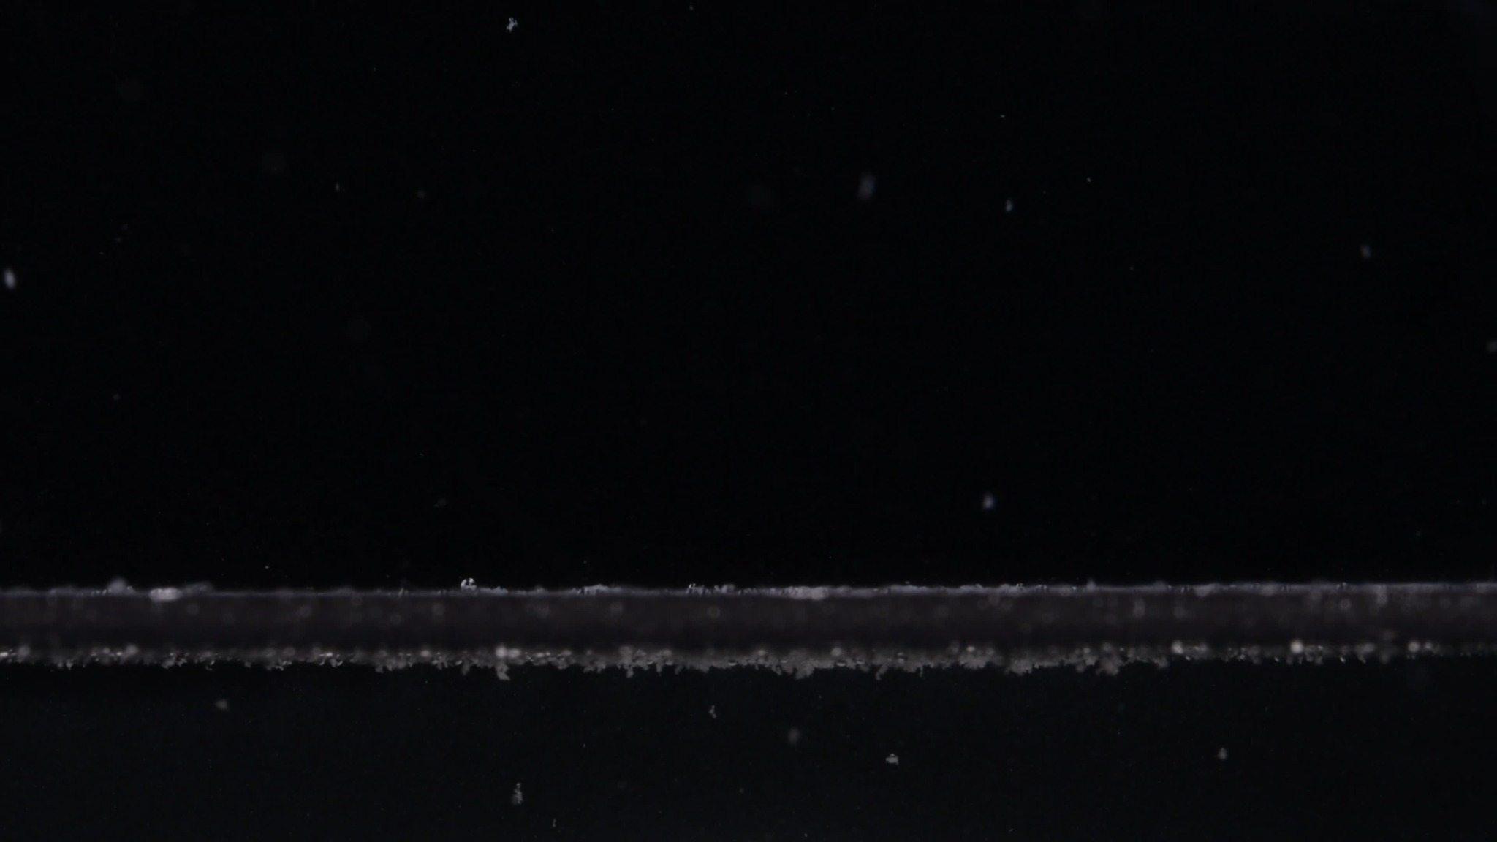
Group B - Picture 4 - 45 minutes
Assistant

Group B - Image 4 - Time: 45 minutes
- Color change: The visible tablet body has essentially disappeared. Only a very thin pale whitish residue is visible along the bottom surface. The earlier yellow color is no longer clearly visible as a concentrated tablet mass.
- Shape change: No intact tablet shape remains. The original flat cylindrical disk seen at 0 minutes and the softened mound seen at 15 minutes have changed into a low, discontinuous residue line. There is no visible central mound, side wall, or recognizable tablet contour.
- Surface texture change: A true tablet surface is no longer present. The remaining material appears as fine powdery sediment and small scattered particles, rather than a continuous solid surface.
- Volume / size change: The apparent tablet volume is now extremely small. Compared with 15 minutes, and even compared with 30 minutes, the remaining visible material is reduced to a thin bottom layer with only tiny raised deposits.
- Dissolution speed and time: By 45 minutes, Group B appears to be in a late stage of disintegration. Most structural breakdown likely occurred between 15 and 30 minutes, while the change from 30 to 45 minutes is mainly further thinning and dispersion of residual particles.
- Physical state change: The tablet has changed from a coherent solid into settled and suspended fine particulate residue. No intact core, compact fragment, or large remaining piece is visible.
- Dissolution medium: The medium appears mostly dark and relatively clear, with sparse suspended particles. The strongest residue concentration is near the bottom surface, not uniformly throughout the liquid.
- Fragment distribution and density: Fragment density is low in the upper medium and slightly higher along the bottom sediment line. The fragments are mostly fine particles, with no large visible fragments.
- Short interpretation: At 45 minutes, Group B is almost completely disintegrated in the visible field. Only a thin residue layer and scattered fine particles remain. This remains clearly different from Group A at 45 minutes, where a visible yellow-white mound was still present.
User
When you describe the drug, please make sure your description in English is accurate. Think carefully and reduce the occurrence of hallucinations. Each picture is taken 15 minutes apart. It is Group B, Picture 60 minutes.
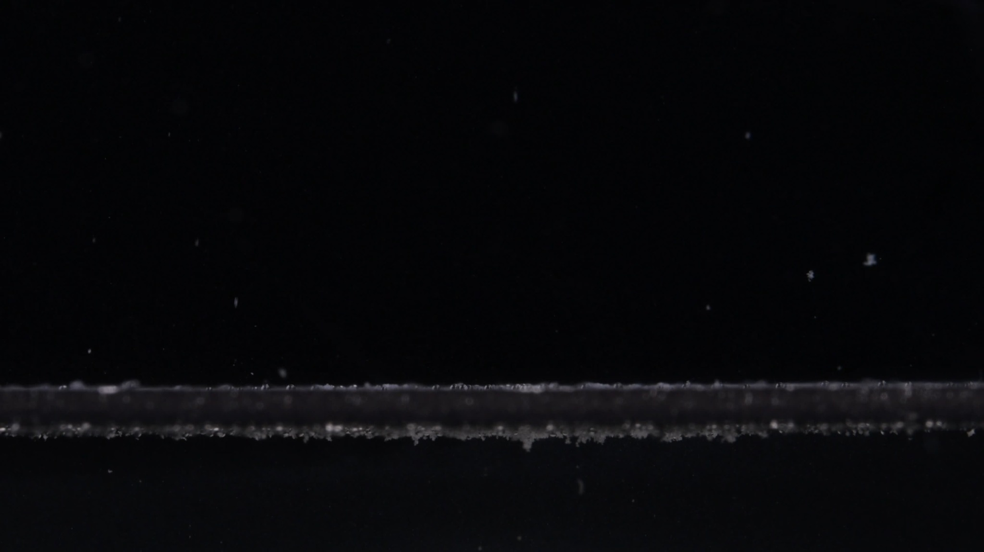
Group B - Picture 5 - 60 minutes
Assistant

Group B - Image 5 - Time: 60 minutes
- Color change: The original pale-yellow tablet body is no longer visible. Only a thin, pale whitish residue remains along the bottom. The yellow color has largely disappeared as a concentrated visible mass.
- Shape change: No recognizable tablet shape remains. The flat cylindrical tablet seen at 0 minutes has completely changed into a discontinuous sediment line. There is no visible mound, core, side wall, or intact fragment.
- Surface texture change: A true tablet surface is no longer present. The remaining material appears as fine powder-like sediment and scattered small particles.
- Volume / size change: The visible tablet volume is extremely reduced. Compared with 0 and 15 minutes, almost the entire tablet body has disappeared from the visible field. Only a very low layer of residue remains.
- Dissolution speed and time: By 60 minutes, Group B is in a near-complete disintegration stage. Most visible structural loss occurred before or around 30 minutes; from 30 to 60 minutes, the change is mainly further thinning of residue.
- Physical state change: The tablet has changed from a solid disk into settled fine particles and sparse suspended particles. No large fragments or compact core are visible.
- Dissolution medium: The liquid appears relatively clear overall, with some scattered suspended specks. The main remaining material is near the bottom surface.
- Fragment distribution and density: Fine fragments are distributed mainly as a thin sediment layer along the bottom. The upper liquid contains only sparse particles. Fragment density is much lower than at 15 minutes.
- Short interpretation: At 60 minutes, Group B appears almost completely disintegrated, leaving only fine bottom residue and scattered particles.

4. Overall Comparison: Group A vs Group B
User
Please compare Groups A and B based on their disintegration characteristics across the eight dimensions to determine if they are from the same drug or not, and explain why you think so.
Assistant
Using the eight-dimension disintegration framework, the two groups are not consistent with the same exact tablet/formulation. Image analysis alone cannot prove chemical identity, but based on visible disintegration behavior, I would judge Group A and Group B as likely different drug products or different formulations/manufacturers, even if both are labeled as Doxycycline Hyclate Tablets.
The comparison is based on the required dimensions: color, shape, surface texture, volume, dissolution speed/time, physical state, medium, and fragment distribution. The knowledge-base framework treats these eight dimensions as the core features for systematic disintegration description, and it also notes that tablet size and shape can help distinguish products.
Dimension | Group A | Group B | Interpretation
1. Color change | Starts white/off-white at 0 min. Yellow material becomes visible after disintegration begins. At 60 min, yellow-white residue remains. | Starts pale yellow at 0 min. By 30-60 min, the yellow tablet body is mostly gone, leaving pale whitish sediment. | Different. Initial color and final residue color pattern are not the same.
2. Shape change | Starts as a smaller, thicker, rounded/biconvex tablet. Becomes an irregular mound and remains mound-like through 60 min. | Starts as a wider, flatter cylindrical tablet. By 30 min, the tablet shape has almost completely disappeared. | Strongly different. Initial geometry and shape-loss pattern differ clearly.
3. Surface texture change | Smooth at 0 min, then becomes rough, porous, fluffy, and granular. The porous surface remains visible for a long time. | Slightly matte/compact at 0 min, powdery and porous at 15 min, but no clear tablet surface remains by 30 min. | Different. Group B loses surface structure much faster.
4. Volume / size change | Large early change by 15 min, but a visible residue mound persists at 30, 45, and 60 min. | Broad tablet at 0 min, still substantial at 15 min, then dramatic volume loss by 30 min. Only a thin sediment layer remains afterward. | Strongly different. Group B shows much faster visible volume disappearance.
5. Dissolution speed and time | Fast from 0-15 min, then slow erosion from 15-60 min. | Moderate to fast from 0-15 min, then very rapid collapse/dispersal from 15-30 min. | Different. Group B has a much faster middle-stage breakdown.
6. Physical state change | Solid tablet -> porous yellow-white mound -> fragile but still localized residue. No complete disappearance by 60 min. | Solid disk -> porous mound at 15 min -> fine particles/sediment by 30 min. No intact core remains. | Different. Group B reaches fine particulate state much earlier.
7. Dissolution medium | Medium remains mostly clear away from the tablet; particles are concentrated near the residue mound. | At 15-30 min, more fine particles are suspended in the field; later the medium clears with sediment along the bottom. | Different. Group B shows broader particle dispersion earlier.
8. Fragment distribution and density | Dense fragments/residue stay concentrated around the original tablet position. A mound remains even at 60 min. | Fine fragments disperse more widely, then settle as a thin bottom layer. No dense central mound remains after 30 min. | Strongly different. Final residue pattern is very different.

Main reasons for the judgment
The strongest evidence is the initial tablet appearance. Group A begins as a mostly white, rounded, thicker biconvex tablet, while Group B begins as a pale-yellow, wider, flatter cylindrical tablet. That difference is important because tablet size and shape are directly relevant to disintegration behavior and product comparison.
The second major difference is the disintegration rate. Group A still has a clear yellow-white residue mound at 60 minutes. Group B loses its main tablet body by around 30 minutes and leaves only a thin sediment line by 45-60 minutes. This suggests different internal structure, excipient composition, compression hardness, coating behavior, or formulation design.
The third major difference is the residue pattern. Group A remains locally concentrated as a porous mound. Group B disperses into fine particles and sediment, with no persistent mound. Fragment distribution and sedimentation behavior are important for comparing disintegration patterns.

Final conclusion
I do not think Groups A and B are from the same exact drug product/formulation.
They may possibly share the same active ingredient, because both show yellow-white material during disintegration, but the images are more consistent with different formulations, different manufacturers, different tablet structures, or different product batches rather than the same tablet. My confidence is moderate to high based on visible disintegration characteristics, especially because the initial shape/color, 30-minute state, and 60-minute residue pattern are clearly different.

