Drug Disintegration Image Analysis Conversation
Doxycycline Hyclate Tablets: Groups A and B
Edited English transcript and comparison report

Scope Note
This document compiles the conversation content through the final drug disintegration discussion and comparison. The content is edited into English and organized for readability. The final document-production request is not included as a transcript item.
The analysis is based on visual characteristics in uploaded images only. It is not a definitive pharmaceutical identity test.

Knowledge Base Framework Used
The discussion used an eight-dimension framework for describing drug disintegration images. Each uploaded image was evaluated according to the following dimensions:
- Color change: tablet color, solution transparency, turbidity, color intensity, and spatial spread of color.
- Shape change: transition from an intact tablet to deformation, cracking, mound formation, collapse, or fragmentation.
- Surface texture change: smoothness, roughness, pores, cracks, peeling, powdery material, and granular or flaky texture.
- Volume change: apparent swelling, spreading, shrinking, height loss, width change, and residual core size.
- Dissolution speed and time: the timing of rapid or slow disintegration stages across 0, 15, 30, 45, and 60 minutes.
- Physical state change: hard solid, softened body, hydrated aggregate, collapse, powder formation, sedimentation, and suspension.
- Dissolution medium: visible clarity, localized haze, suspended particles, and whether the medium appears clear or turbid.
- Fragment distribution with density: fragment size, fragment density, location around the tablet, floating or sinking behavior, and sediment concentration.
Particular attention was given to changes in tablet size and shape because these features are important for comparing whether two image series may represent the same drug or formulation type.

Edited Conversation Transcript

Initial Task
User
I need you to analyze the disintegration images of two groups of Doxycycline Hyclate Tablets, Groups A and B. These may be images of the same drug or different drugs. I need you to determine whether the images are from the same drug or not. For each group, I will upload five images, with each picture taken 15 minutes apart. Please describe the drug disintegration process in English for each image in the group. Finally, determine whether the two sets of images are from the same drug. You may call the Knowledge Base to remember how to describe drug disintegration. As you describe the tablets in English, pay attention to changes in the size and shape of the tablets. If you are prepared, I will upload the picture of Group A, picture 1, at 0 minutes.
Assistant
I am prepared. Please upload Group A, Picture 1, at 0 minutes.
I will analyze every image in English using the eight disintegration dimensions: color change, shape change, surface texture, volume change, dissolution speed and time, physical state, dissolution medium, and fragment distribution with density. I will pay special attention to tablet size and shape changes, then compare Groups A and B after all ten images are uploaded to judge whether they appear to be the same drug formulation or different.
This will be a visual disintegration comparison, not a definitive pharmaceutical identity test.

Knowledge Base Reminder
User
You are not totally prepared. Please call the Knowledge Base to remember how to describe drug disintegration again.
Assistant
You are right. I have called the Knowledge Base again and refreshed the description framework.
For every uploaded image, I will describe the Doxycycline Hyclate Tablet disintegration using these eight fixed dimensions:
- Color Change: solution color, tablet color, transparency, turbidity, and local color diffusion.
- Shape Change: whether the tablet remains intact, becomes deformed, cracks, rounds off, collapses, or fragments.
- Surface Texture Change: smoothness, roughness, pores, cracks, peeling, powdery layer, or fibrous/flaky structures.
- Volume Change: reduction or swelling in tablet size, including height, width, contour, and remaining core size.
- Dissolution Speed and Time: slow/fast stage, liquid penetration, particle formation, and changes every 15 minutes.
- Physical State Change: swelling, cracking, softening, collapse, powder formation, sedimentation, and suspension.
- Dissolution Medium: clarity, viscosity appearance, turbidity, suspended particles, and whether the medium remains clear or becomes cloudy.
- Fragment Distribution with Density: fragment size, density, location, floating/sinking behavior, sediment layer, and particle dispersion.
I will also focus strongly on size and shape, because the Knowledge Base says tablet size and shape are important for judging disintegration behavior and may help compare whether two groups are the same or different formulation.
For each image, I will output: group, picture number, time point, the eight dimensions, and a key observation for the same-or-different drug comparison. After all ten images are uploaded, I will compare Group A and Group B by initial tablet size and shape, disintegration speed, remaining tablet core size, cracking and fragmentation pattern, color and turbidity pattern, fragment density and sediment distribution, and a final visual judgment.
Now I am fully prepared. Please upload Group A, Picture 1, at 0 minutes.

Group A Image Sequence and Analysis
User
Group A pictures were uploaded. Each picture was taken 15 minutes apart. The user requested accurate English descriptions and asked to reduce hallucinations.

Uploaded Image Sequence: Group A
0 min | 15 min | 30 min | 45 min | 60 min
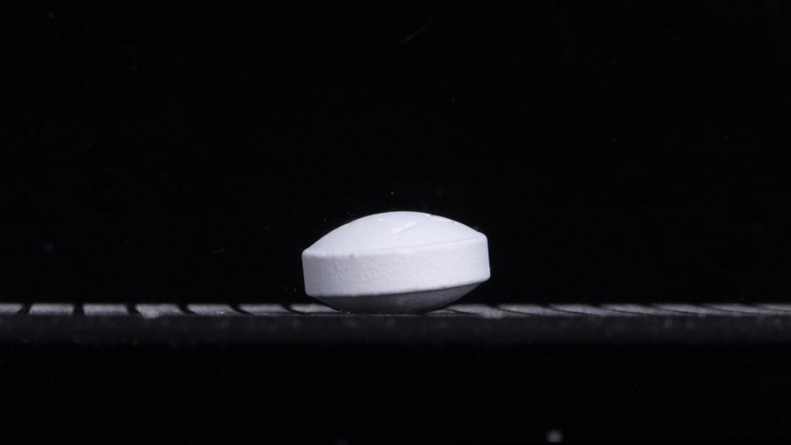 | 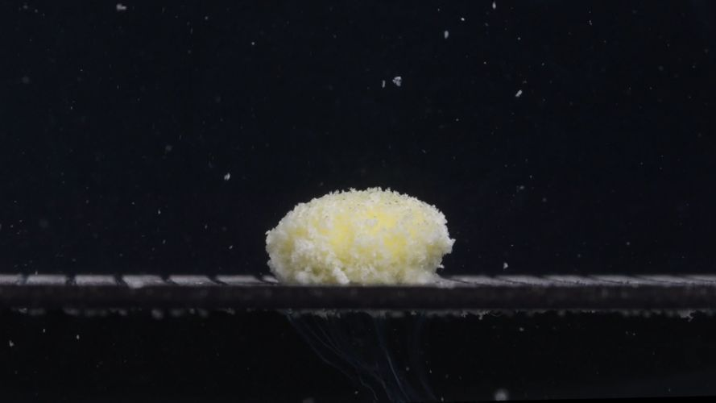 | 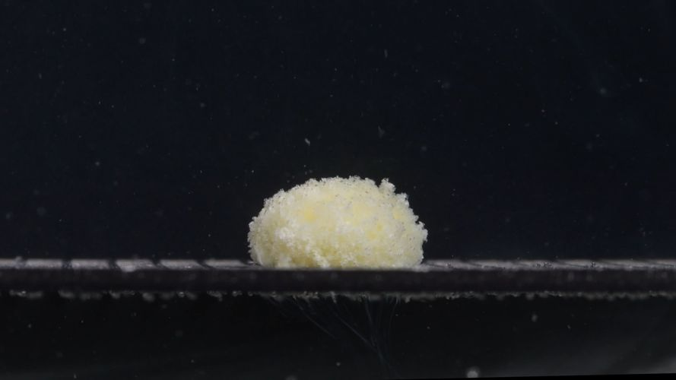 | 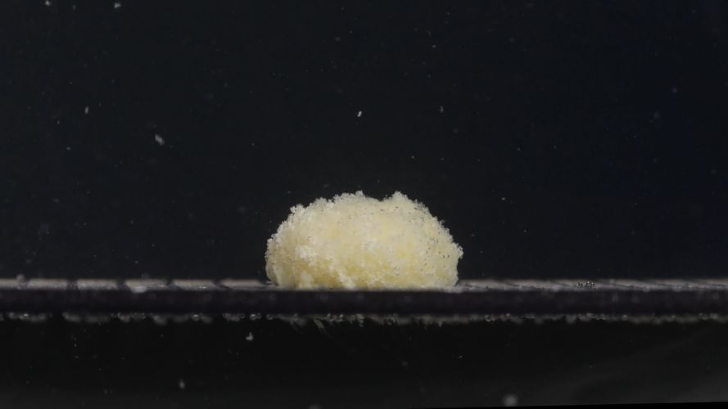 | 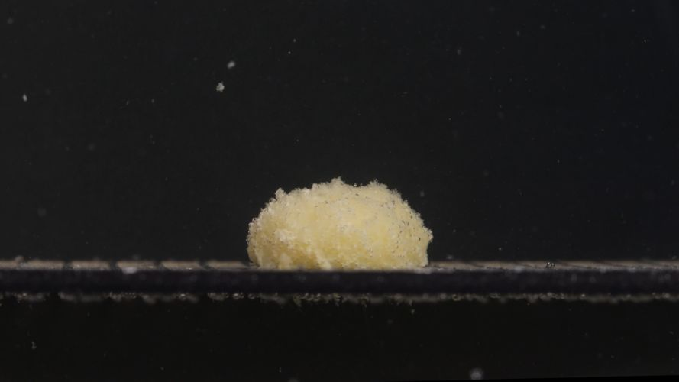
Images were uploaded as a five-stage sequence captured at 15-minute intervals.
Assistant
I reviewed Group A pictures at 0, 15, 30, 45, and 60 minutes using the eight-dimension disintegration framework. I focused carefully on size and shape because those features are important for comparison.

Group A — Picture 1 — 0 min
- Color change: The tablet is mostly white to off-white. No obvious yellow diffusion or clouding is visible yet.
- Shape change: The tablet is still intact, with a thick, rounded, biconvex profile. The side wall is clearly preserved, and the top surface appears smooth and slightly curved.
- Surface texture change: The surface is mostly smooth and compact, with only minor visible roughness or compression marks. No major pores, cracks, or peeling are visible.
- Volume change: The tablet keeps its original compact volume. No visible swelling or collapse is present.
- Dissolution speed and time: At this starting point, disintegration has not visibly begun.
- Physical state change: The tablet remains a solid, coherent body.
- Dissolution medium: The surrounding medium appears visually clear against the dark background; no obvious turbidity is visible.
- Fragment distribution with density: No visible fragments around the tablet.
- Key observation: Group A starts as a relatively large, white, intact, rounded tablet with a stable contour.

Group A — Picture 2 — 15 min
- Color change: A strong change has occurred. The visible mass is now pale yellow to yellow-white, suggesting that the inner material is exposed after hydration or disintegration of the outer layer.
- Shape change: The original tablet outline is largely lost. The tablet has changed from a smooth biconvex tablet into a rounded, swollen, mound-like mass.
- Surface texture change: The surface becomes highly rough, porous, and granular. It looks like many small particles are attached to the surface.
- Volume change: The apparent visible mass becomes wider and fluffier than at 0 min. This may represent swelling and particle expansion rather than true increase in solid tablet volume.
- Dissolution speed and time: Major disintegration has already occurred by 15 min. The change from intact tablet to porous mound is rapid in this interval.
- Physical state change: The tablet has softened and partially collapsed into a wet, granular aggregate. No clear intact core is visible from this side view.
- Dissolution medium: The medium contains visible suspended specks. The background still looks mostly clear, but local particle suspension is obvious.
- Fragment distribution with density: Fine fragments are concentrated around and above the tablet. Most material remains dense near the original tablet position, while small particles disperse upward and outward.
- Key observation: By 15 min, Group A shows rapid surface breakdown and swelling, with a pale yellow granular mound replacing the original smooth tablet.

Group A — Picture 3 — 30 min
- Color change: The mound remains pale yellow or yellow-white. The yellow tone appears more evenly distributed than at 15 min.
- Shape change: The tablet remains a low, rounded mound. The original tablet edge and side wall are no longer identifiable.
- Surface texture change: The surface is still very granular and porous, with a powdery or sponge-like appearance.
- Volume change: Compared with 15 min, the apparent width and height look similar, possibly slightly more spread laterally. The mass has not fully dispersed.
- Dissolution speed and time: Disintegration seems to have slowed after the large early change. From 15 to 30 min, the main mass persists rather than disappearing.
- Physical state change: The material appears as a hydrated, fragile aggregate rather than a solid tablet.
- Dissolution medium: Small particles remain visible in the surrounding medium, but there is no heavy uniform cloudiness across the whole image.
- Fragment distribution with density: Fragment density remains highest at the original tablet location. Fine particles are suspended sparsely around the mound.
- Key observation: At 30 min, the tablet is still not fully dissolved; it has stabilized as a porous yellow mound with persistent central mass.

Group A — Picture 4 — 45 min
- Color change: The mound appears slightly more yellow-beige than earlier, with less pure white visible on the surface.
- Shape change: The mass remains mound-like but looks slightly more irregular, especially along the top contour. The original tablet shape is completely absent.
- Surface texture change: The surface remains coarse, with many small granules and pores. Some areas look more compacted, while others remain loose and powdery.
- Volume change: The mound appears slightly broader and somewhat flattened compared with the original tablet. The height is not dramatically reduced from 30 min, but the contour is less regular.
- Dissolution speed and time: From 30 to 45 min, the process appears gradual. No sudden collapse is visible.
- Physical state change: The mass is now a semi-collapsed granular deposit, not an intact tablet.
- Dissolution medium: Fine particles remain dispersed in the medium. The medium itself does not appear fully opaque.
- Fragment distribution with density: Dense fragments remain around the base and central mound. A few particles are visible above the mass, indicating continuing but slow release.
- Key observation: At 45 min, Group A shows continued erosion, but the central mound remains persistent and dense.

Group A — Picture 5 — 60 min
- Color change: The mass appears deeper yellow-beige, especially compared with the white starting tablet. A lighter whitish area remains on the left/front side.
- Shape change: The tablet remains as a broad, irregular mound. There is still a substantial residual mass, so the tablet has not fully dispersed by 60 min.
- Surface texture change: The surface is still rough and porous, with a granular, crumbly appearance. The edges are uneven rather than sharply defined.
- Volume change: Compared with 0 min, the apparent mass is broader and less tablet-like. Compared with 45 min, the overall size looks similar, suggesting a slower late-stage dissolution phase.
- Dissolution speed and time: The fastest visible change occurred between 0 and 15 min. From 15 to 60 min, the process is slower, mainly involving gradual erosion and particle release.
- Physical state change: The material remains a hydrated granular aggregate with no visible intact tablet shell.
- Dissolution medium: Small suspended particles are still visible. The surrounding medium is not completely clear, but the turbidity appears localized rather than uniformly dense.
- Fragment distribution with density: Most fragments remain densely packed near the original tablet position, with sparse fine particles suspended around it.
- Key observation: At 60 min, Group A still has a large residual mound, indicating incomplete visual disintegration under these observed conditions.

Group A Overall Disintegration Pattern
Group A shows a rapid early transformation: from a smooth white intact tablet at 0 min to a yellow, swollen, porous, granular mound by 15 min. After that, the disintegration becomes much slower. From 15 to 60 min, the mass remains in roughly the same location and keeps a substantial mound-like structure, with gradual surface erosion and fine particle release.
The most important size and shape trend is: intact compact biconvex tablet to swollen yellow granular mound to persistent broad irregular residual mass. Visually, the apparent mound becomes wider than the original tablet, but this likely reflects swelling, hydration, and loosened granules rather than true growth of the solid tablet.
At this stage, a same-or-different decision could not yet be made because Group B had not been analyzed.

Group B Image Sequence and Analysis
User
Group B pictures were uploaded. Each picture was taken 15 minutes apart. The user again requested accurate English descriptions and asked to reduce hallucinations.

Uploaded Image Sequence: Group B
0 min | 15 min | 30 min | 45 min | 60 min
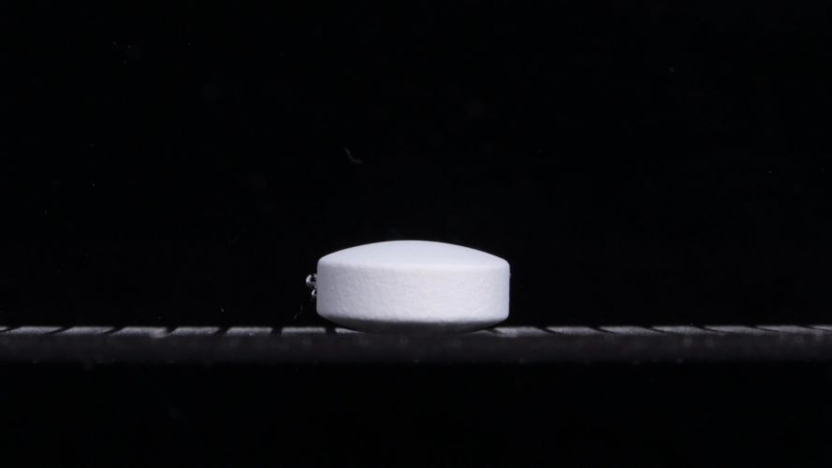 | 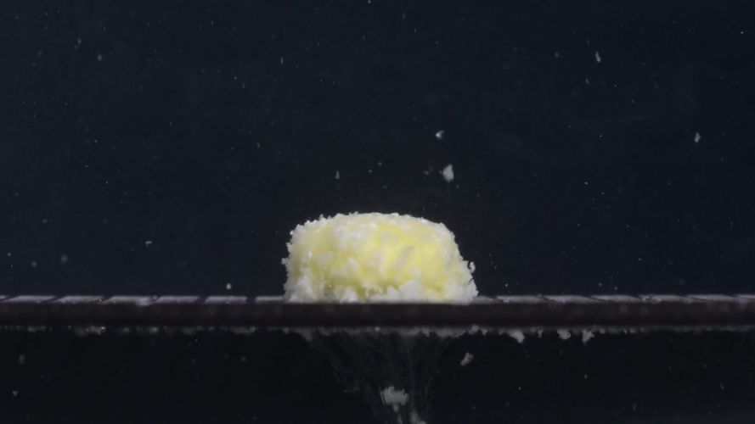 | 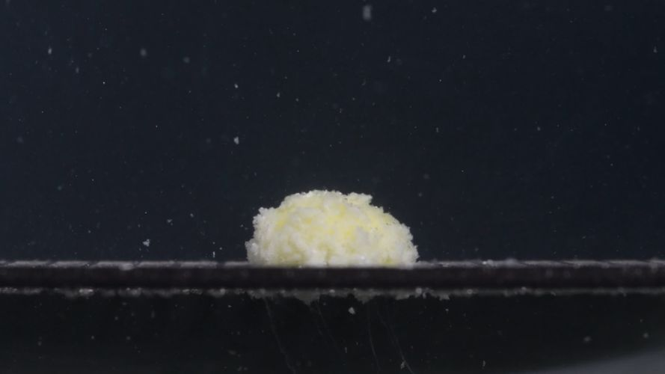 | 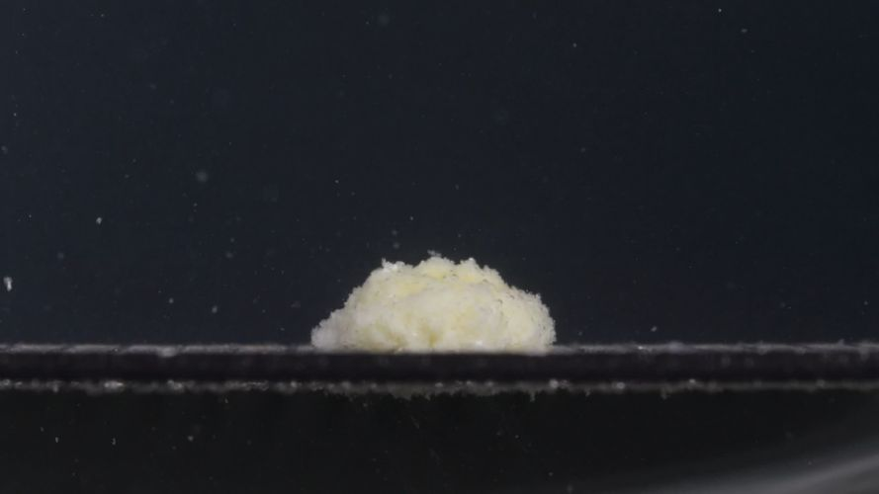 | 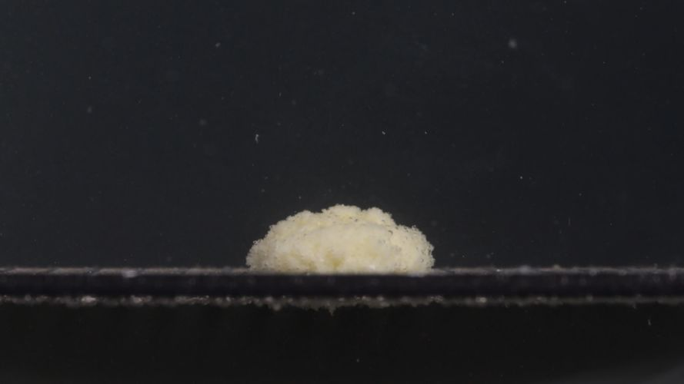
Images were uploaded as a five-stage sequence captured at 15-minute intervals.
Assistant
I analyzed Group B carefully and compared it with Group A. This is a visual disintegration comparison, not a chemical identification test. The comparison is based mainly on the eight Knowledge Base dimensions, especially size, shape, color, surface texture, remaining mass, and fragment distribution.

Group B — Picture 1 — 0 min
- Color change: The tablet is white to off-white, with no visible yellow exposure or color diffusion.
- Shape change: The tablet is intact, with a round, thick, biconvex tablet shape. The side wall is vertical and clear, and the top is smoothly curved.
- Surface texture change: The surface appears mostly smooth and compact, with slight fine roughness on the side wall.
- Volume change: No visible swelling, erosion, or volume reduction is present.
- Dissolution speed and time: At 0 min, disintegration has not visibly started.
- Physical state change: The tablet remains a coherent solid body.
- Dissolution medium: The surrounding medium appears visually clear; no obvious turbidity is present.
- Fragment distribution with density: No fragments are visible around the tablet.
- Key observation: Group B begins as a white, intact, thick round tablet, visually very similar to Group A at 0 min.

Group B — Picture 2 — 15 min
- Color change: The tablet changes from white to yellow-white, with a stronger yellow area visible near the central/front region.
- Shape change: The original tablet outline is mostly lost. It has transformed into a rounded, swollen mound-like mass.
- Surface texture change: The surface becomes rough, porous, granular, and fluffy, with many small particles attached to the outer surface.
- Volume change: The apparent mass becomes wider and softer-looking than the original tablet. This likely reflects swelling and loosening of particles rather than true solid growth.
- Dissolution speed and time: A major change occurs within the first 15 minutes, indicating fast early disintegration.
- Physical state change: The tablet softens and partially collapses into a hydrated granular aggregate.
- Dissolution medium: Many fine particles are visible in the medium. There is also a visible downward stream of material below the tablet support, suggesting active particle release.
- Fragment distribution with density: Fragment density is highest around the tablet and below the support. Some larger flakes or clumps are visible near the underside, while finer particles are suspended around the tablet.
- Key observation: By 15 min, Group B shows rapid transformation into a yellow-white porous mound, very similar to Group A, although Group B appears to show slightly more visible downward particle shedding at this time point.

Group B — Picture 3 — 30 min
- Color change: The mass remains pale yellow to yellow-white. The yellow color is still visible but appears more diffused across the mound.
- Shape change: The remaining tablet material forms a low rounded mound. The original biconvex tablet shape is no longer visible.
- Surface texture change: The surface remains coarse, porous, and granular, with a sponge-like appearance.
- Volume change: Compared with 15 min, the mass appears slightly lower and more spread, but a substantial residual mound remains.
- Dissolution speed and time: After the rapid 0 to 15 min change, the process slows. From 15 to 30 min, the main mass persists.
- Physical state change: The tablet is no longer a solid tablet but a hydrated, fragile, granular mass.
- Dissolution medium: Fine suspended particles are present, but the medium is not uniformly opaque.
- Fragment distribution with density: Most particles remain concentrated near the original tablet position. Sparse particles are visible above and around the mound.
- Key observation: At 30 min, Group B still contains a persistent central mound, similar to Group A at 30 min.

Group B — Picture 4 — 45 min
- Color change: The mass appears pale yellow-beige, with some whitish areas remaining, especially near the lower/front region.
- Shape change: The mound becomes slightly flatter and more irregular. The upper contour is uneven, with small granular protrusions.
- Surface texture change: The surface remains rough and crumbly. The texture looks less compact than a solid tablet and more like a wet powder aggregate.
- Volume change: The height appears slightly reduced compared with earlier images, but the residual mound is still clear and substantial.
- Dissolution speed and time: Dissolution or erosion continues slowly. No sudden collapse is visible between 30 and 45 min.
- Physical state change: The material remains a semi-collapsed granular deposit.
- Dissolution medium: Fine particles remain suspended in the surrounding medium, with localized haze rather than complete cloudiness.
- Fragment distribution with density: Fragments are still densest near the mound and along the base/support area. A few suspended particles are visible farther away.
- Key observation: Group B continues gradual erosion but does not fully disperse by 45 min.

Group B — Picture 5 — 60 min
- Color change: The remaining mass is pale yellow-beige, with a slightly duller, less bright yellow appearance than at 15 min.
- Shape change: A broad, low, irregular mound remains. The original tablet shape is completely absent, but the material has not fully dissolved or dispersed.
- Surface texture change: The surface is still granular and porous. The outer boundary is uneven, with small loose particles attached.
- Volume change: Compared with 0 min, the compact tablet has expanded or loosened into a broader mound. Compared with 45 min, the size appears only slightly changed, indicating slow late-stage erosion.
- Dissolution speed and time: The fastest disintegration occurred from 0 to 15 min. From 15 to 60 min, the remaining material erodes slowly.
- Physical state change: The tablet remains as a hydrated granular residue rather than a solid tablet.
- Dissolution medium: Small particles are still visible in the medium, but the whole medium is not densely opaque.
- Fragment distribution with density: Most fragments remain concentrated near the original tablet location, with sparse suspended particles in the surrounding liquid.
- Key observation: At 60 min, Group B still has a substantial residual mound, closely matching the late-stage appearance of Group A.

Group B Overall Disintegration Pattern
Group B follows this sequence: intact white biconvex tablet to yellow-white swollen porous mound by 15 min to persistent granular mound from 30 to 60 min.
The most important size and shape trend is that the tablet does not simply shrink uniformly. Instead, it first loses its smooth tablet outline, becomes a swollen and loosened granular mass, then slowly erodes while keeping a central mound.

Preliminary Comparison After Group B Analysis

Strong Similarities
- Initial appearance: Both groups start as white, thick, round or biconvex tablets.
- Early disintegration: Both show major transformation by 15 min, changing into a yellow-white, swollen, porous mound.
- Color pattern: Both reveal a pale yellow or yellow-white internal material after disintegration begins.
- Shape pattern: Both lose the original tablet outline quickly and become mound-like rather than breaking into a few large separate chunks.
- Surface texture: Both develop a rough, porous, fluffy, granular surface.
- Late-stage behavior: Both still retain a substantial residual mound at 60 min, meaning neither appears fully dispersed by the final image.
- Fragment distribution: In both groups, fragments remain densest near the original tablet position, with only sparse suspended particles farther away.

Minor Differences
- Group B at 15 min appears to show slightly stronger downward particle shedding beneath the tablet support.
- Group A at 60 min appears slightly more yellow-beige in the visible mound, while Group B remains a little paler in some areas.
- The 0 min tablet angle differs: Group A appears slightly tilted or viewed at a slightly different orientation, while Group B is more horizontally aligned. This may be due to placement rather than drug difference.

Preliminary Judgment
Based on the visual evidence, Group A and Group B are likely from the same drug or the same type of formulation. The full disintegration pathway is highly similar: same initial tablet type, same rapid 0 to 15 min transformation, same yellow-white porous mound, same slow 15 to 60 min erosion, and same persistent residual mass at 60 min.
However, this is not a definitive identity confirmation. Lighting, tablet orientation, medium conditions, batch variation, and camera focus can affect the images. A definitive judgment would require label information or analytical testing.

Final Eight-Dimension Comparison
User
Please compare Groups A and B based on their disintegration characteristics across the eight dimensions to determine if they are from the same drug or not, and explain why you think so.
Assistant
Based on the eight-dimension disintegration framework, the judgment is: Groups A and B are likely from the same drug or the same formulation type, but this cannot be confirmed chemically from images alone.
Dimension | Group A | Group B | Comparison
Color change | Starts white/off-white. By 15 min, the mass becomes pale yellow to yellow-white. By 60 min, it remains yellow-beige. | Starts white/off-white. By 15 min, it also becomes yellow-white, with a visible yellow center. By 60 min, it remains pale yellow-beige. | Very similar. Both groups show the same white-to-yellow transition after wetting and disintegration.
Shape change | 0 min: intact thick biconvex tablet. 15 min: original tablet outline is lost and becomes a swollen rounded mound. 30–60 min: broad irregular mound remains. | 0 min: intact thick biconvex tablet. 15 min: also becomes a swollen rounded mound. 30–60 min: broad irregular mound remains. | Highly similar. Both lose their original tablet shape quickly and do not break into a few large separate chunks.
Surface texture change | Smooth compact surface at 0 min, then rough, porous, fluffy, granular surface from 15 min onward. | Smooth compact surface at 0 min, then rough, porous, fluffy, granular surface from 15 min onward. | Highly similar. Both show the same porous and granular surface texture pattern.
Volume change | Apparent volume increases or expands at 15 min because the tablet swells and loosens into a larger mound. Later, the mound persists with only slow reduction. | Same pattern: compact tablet at 0 min, swollen mound at 15 min, persistent residual mass at 60 min. | Very similar. Neither group shows rapid complete shrinkage or disappearance. Both retain a large residue at 60 min.
Dissolution speed and time | Fastest visible change occurs between 0 and 15 min. From 15 to 60 min, disintegration slows and mainly becomes gradual erosion. | Same: rapid 0 to 15 min transformation, then slower erosion from 15 to 60 min. | Highly similar kinetic profile. This is one of the strongest reasons to think they are the same or very similar formulation.
Physical state change | Solid tablet changes into a hydrated, soft, crumbly granular aggregate. No intact shell remains after 15 min. | Same change: solid tablet becomes a hydrated granular mass, with no clear intact tablet shell after 15 min. | Highly similar. Both show swelling, softening, and collapse rather than clean cracking into large pieces.
Dissolution medium | Medium remains mostly visually clear with local suspended particles and mild local turbidity near the tablet. | Similar medium appearance; at 15 min, Group B shows slightly more visible downward particle shedding. | Mostly similar. Group B may release slightly more visible particles downward at 15 min, but this difference is small and may be due to angle, focus, or local flow.
Fragment distribution and density | Fragments remain densest around the original tablet position. Fine particles are suspended sparsely around the mound. | Same pattern: dense fragments near the mound, sparse suspended particles around it, with some downward shedding. | Very similar. Both retain a central dense mound rather than dispersing uniformly through the medium.

Final Interpretation
The most important shared pattern is: white intact biconvex tablet to rapid yellow-white swelling and granulation by 15 min to persistent porous mound from 30 to 60 min to incomplete visual disintegration at 60 min.
That sequence is very consistent between A and B. The small differences observed, such as Group B's slightly stronger downward particle release at 15 min and minor differences in mound height or color intensity, are not strong enough to suggest a different drug. They could come from tablet positioning, lighting, focus, local fluid movement, or small batch or handling variation.
Final conclusion: Groups A and B are more likely the same drug or same formulation type than different drugs. Visual confidence is moderate to high because the time-dependent disintegration behavior matches across all eight dimensions. However, image analysis alone cannot prove pharmaceutical identity; confirmation would require label information, formulation records, or chemical testing.

