English Transcript and Analysis Report
Doxycycline Hyclate Tablets Disintegration: Groups A and B
Scope: This document edits the conversation into English and includes the drug-disintegration discussion only. The final Chinese request asking for this Word document is intentionally omitted.
Method note: The analysis follows the uploaded Knowledge Base framework for drug-disintegration images, which uses eight dimensions: color change, shape change, surface texture change, volume/size change, dissolution speed and time, physical state change, dissolution medium, and fragment distribution with density.

1. Initial Request and Preparation
User
I need you to try analyzing the disintegration images of two groups of Doxycycline Hyclate Tablets, A and B. These may be images of the same drug or different drugs. I need you to determine whether the images are from the same drug or not.
For each group, I will upload 5 images. Each picture is taken 15 minutes apart. Please describe the drug disintegration process in English for each image in the group, and finally determine whether the two sets of images are from the same drug.
You can call the Knowledge Base to remember how to describe drug disintegration. As you describe the tablets in English, pay attention to changes in the size and shape of the tablets. If you are prepared, I will upload picture 1 of Group A at 0 minutes.
Assistant
I am prepared. Please upload Group A — picture 1 at 0 minutes.
I will describe each image in English using the eight disintegration dimensions: color change, shape change, surface texture, volume/size change, dissolution speed and time, physical state, dissolution medium, and fragment distribution/density. I will pay special attention to tablet size and shape changes, then compare Group A and Group B to judge whether they are likely from the same drug/disintegration behavior pattern.
Note: I can compare the images visually and behaviorally, but I cannot confirm chemical identity with certainty from images alone.
User
You are not fully prepared. Please call the Knowledge Base again to remember how to describe drug disintegration.
Assistant
You are right. I have now called the Knowledge Base again and refreshed the full drug-disintegration description framework.
For every image of Doxycycline Hyclate Tablets, I will describe the disintegration using the eight required dimensions: color change, shape change, surface texture change, volume/size change, dissolution speed and time, physical state change, dissolution medium, and fragment distribution/density. The Knowledge Base says these dimensions are used to capture the full disintegration process clearly and systematically.
For each uploaded image, I will use this structure:
1. Color Change: I will describe tablet color, liquid transparency, turbidity, color intensity, and whether the color spreads locally or uniformly in the medium.
2. Shape Change: I will focus strongly on whether the tablet remains intact, becomes rounded/irregular, cracks, breaks, collapses, or forms fragments.
3. Surface Texture Change: I will describe whether the surface is smooth, rough, porous, cracked, peeling, powdery, flaky, or fibrous.
4. Volume / Size Change: I will carefully compare tablet size, including shrinkage, swelling, reduction in height/diameter, contour loss, and whether the size decreases uniformly or unevenly.
5. Dissolution Speed and Time: Since each picture is taken 15 minutes apart, I will track the disintegration sequence at 0, 15, 30, 45, and 60 minutes, describing whether the process is slow, moderate, or rapid.
6. Physical State Change: I will describe swelling, softening, cracking, internal weakening, collapse, powder formation, or sediment formation.
7. Dissolution Medium: I will describe visible changes in the liquid/medium, such as clarity, cloudiness, suspension, sediment, floating particles, or changes around the tablet.
8. Fragment Distribution with Density: I will describe where fragments are located, whether they are dense near the tablet, dispersed in the liquid, settled at the bottom, or suspended as fine particles.
For the final comparison between Group A and Group B, I will judge whether they are likely the same drug based on the initial tablet size, shape, and appearance; rate of size/volume reduction; pattern of cracking, swelling, erosion, and fragmentation; color and turbidity changes in the medium; fragment amount, density, and sediment behavior; and the overall disintegration timeline from 0 to 60 minutes.
The Knowledge Base also notes that size and shape can help identify disintegration behavior because different tablet forms and sizes may dissolve or break down differently.
I am now fully prepared. Please upload Group A — picture 1 — 0 minutes.

2. Group A Images and Analysis
User
Here are the Group A images. Please make sure the English description is accurate, think carefully, and reduce hallucinations. Each picture is taken 15 minutes apart.

Group A Uploaded Images
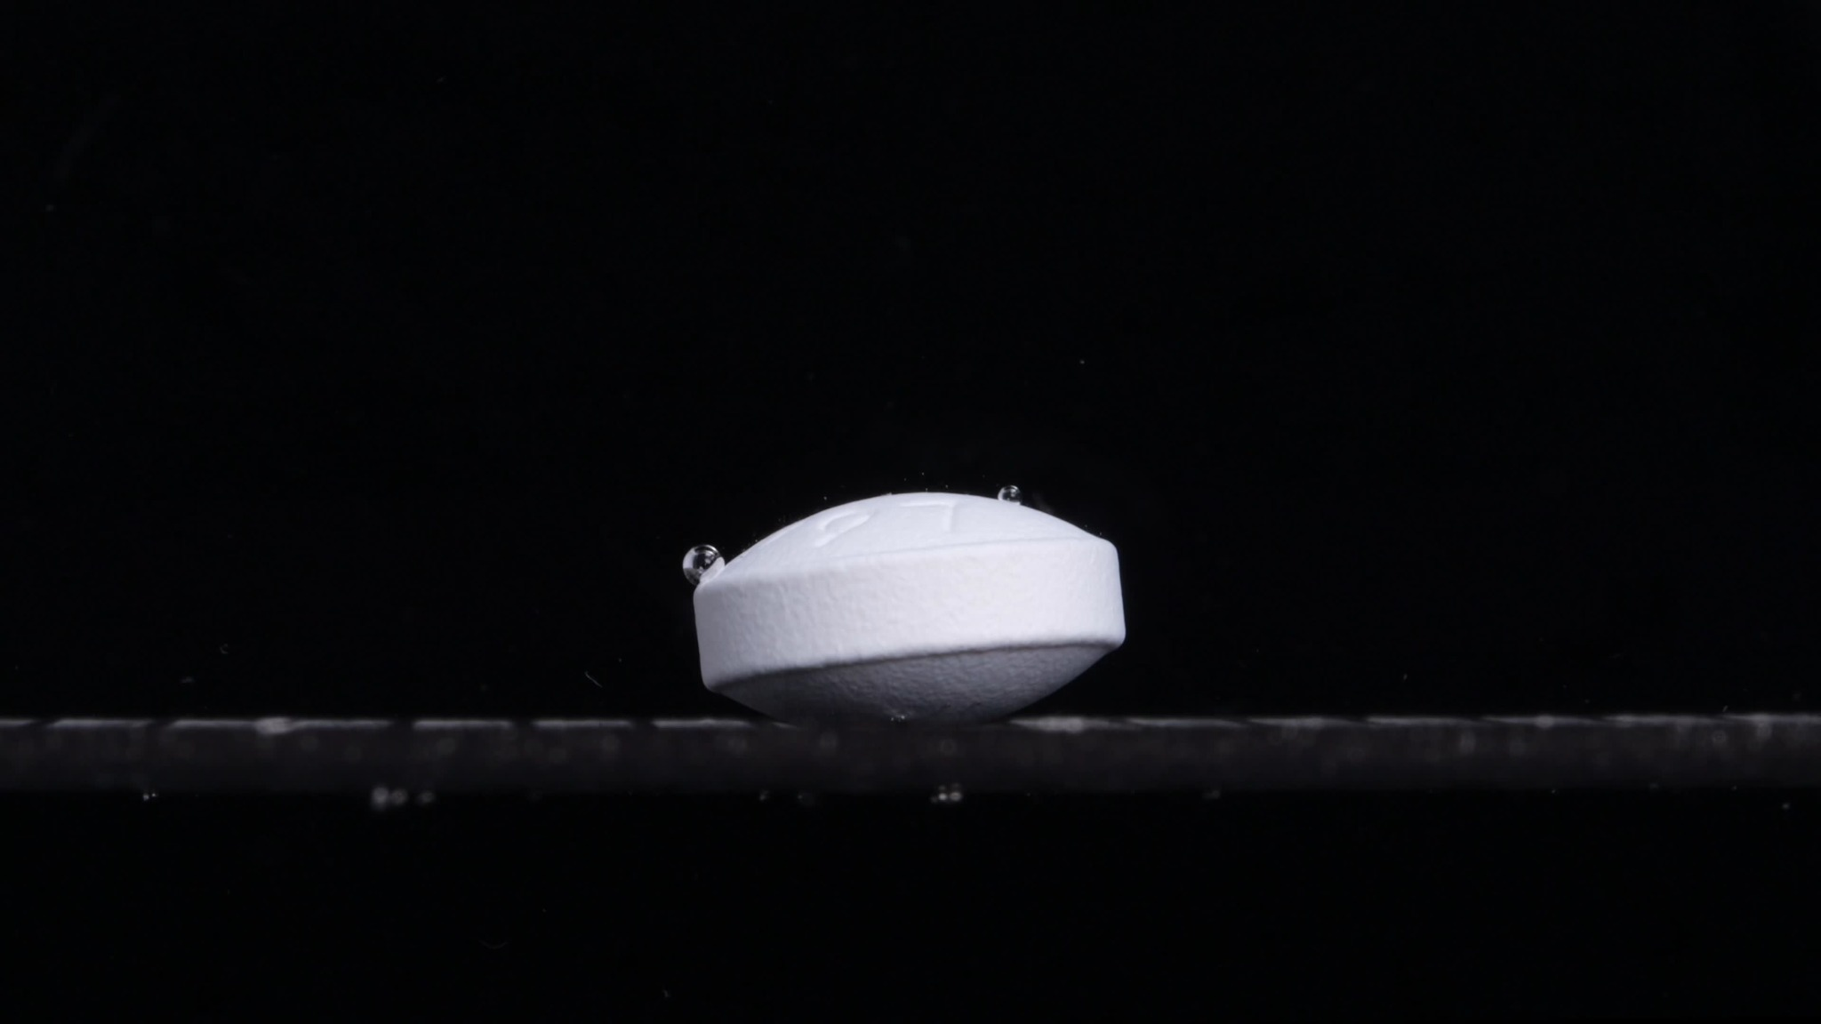
Group A — Picture at 0 minutes
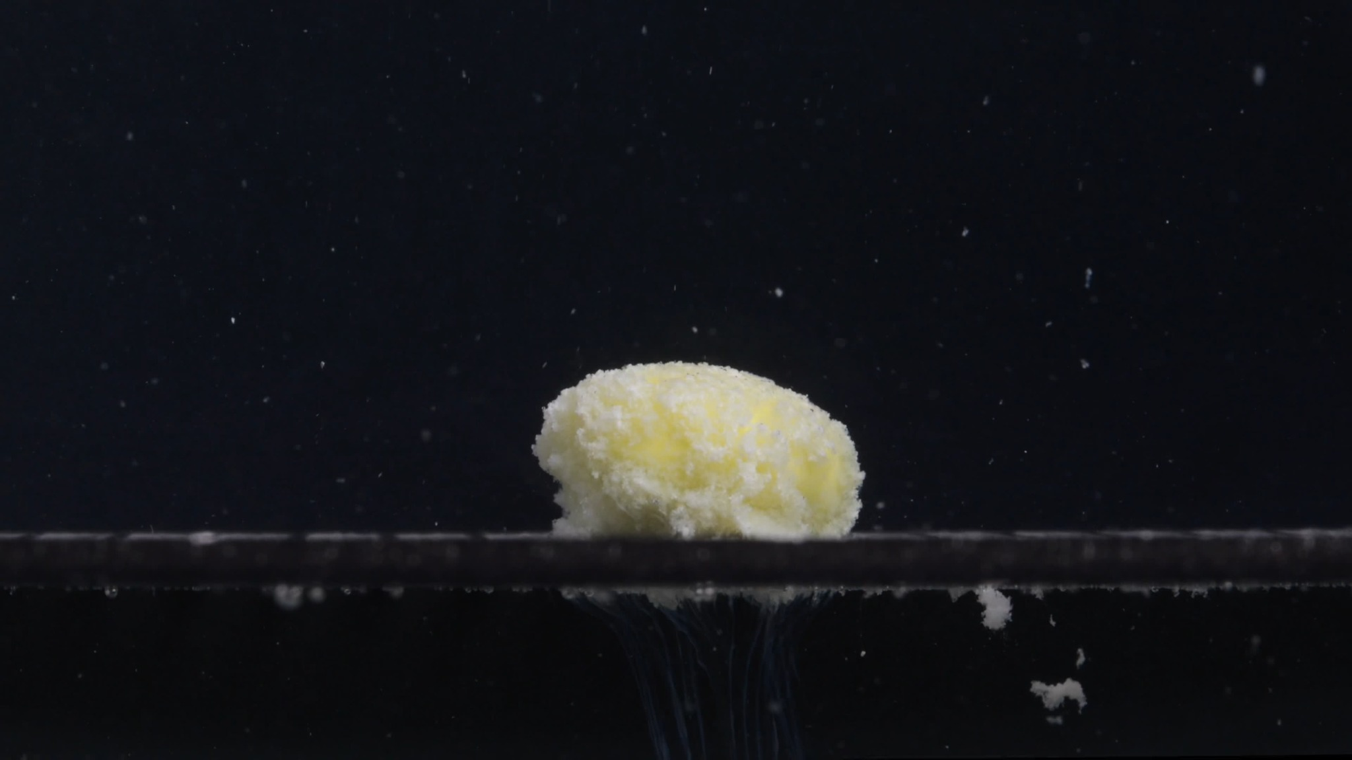
Group A — Picture at 15 minutes
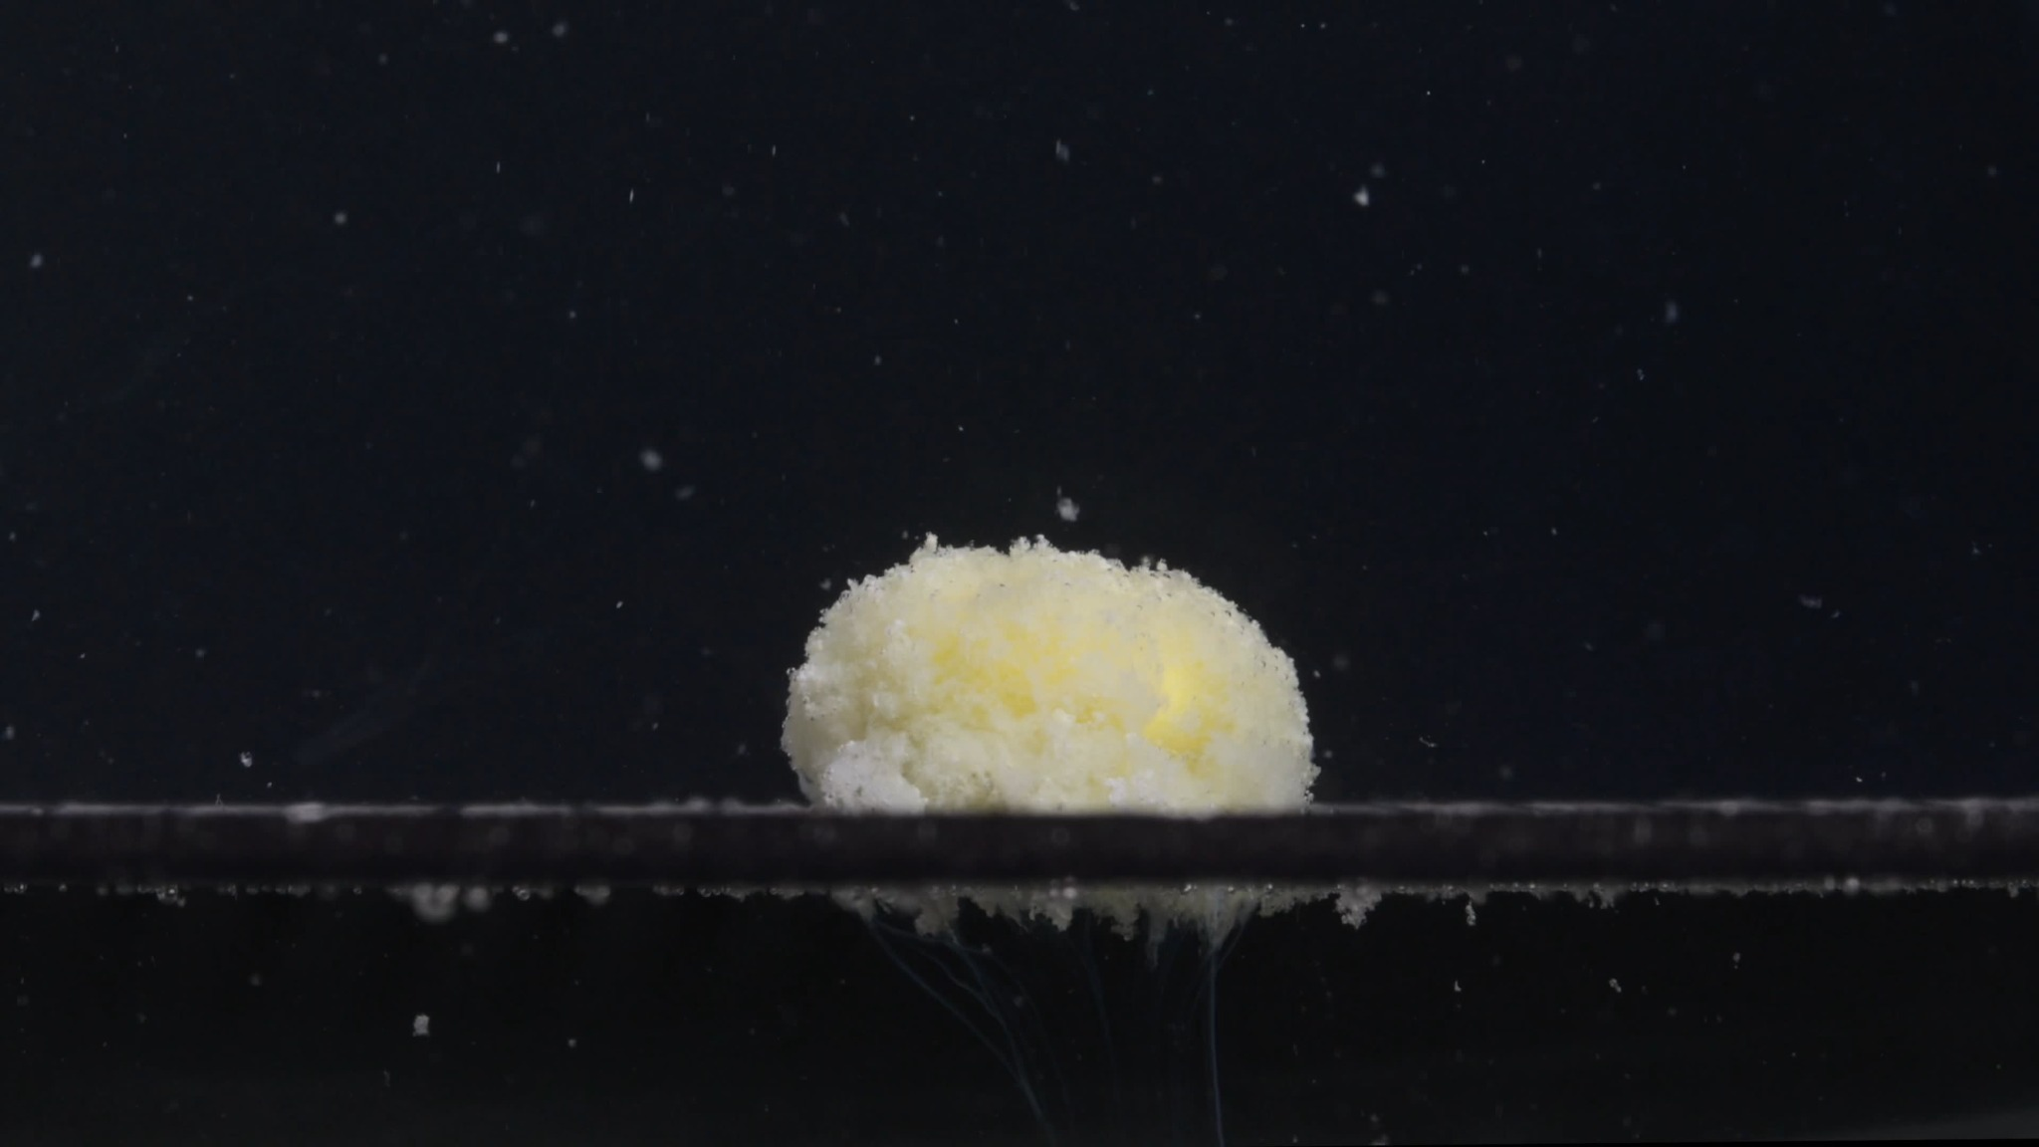
Group A — Picture at 30 minutes
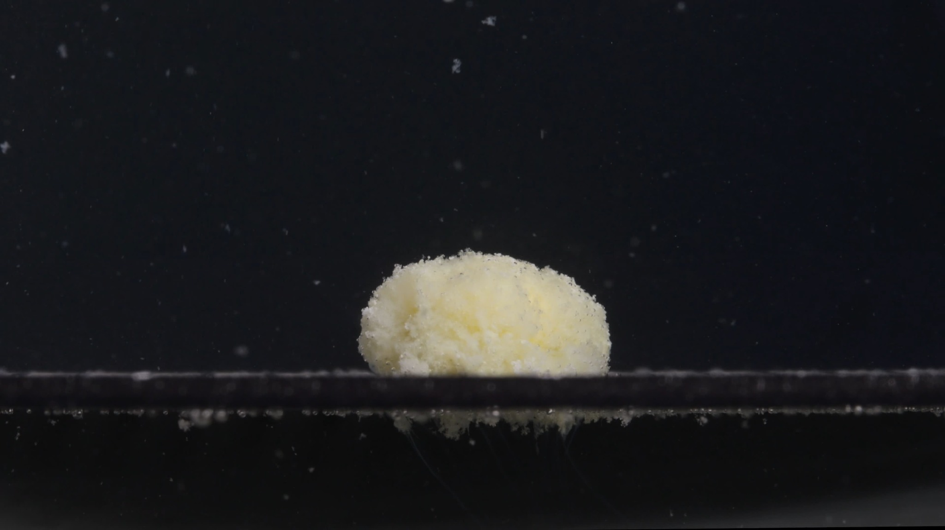
Group A — Picture at 45 minutes
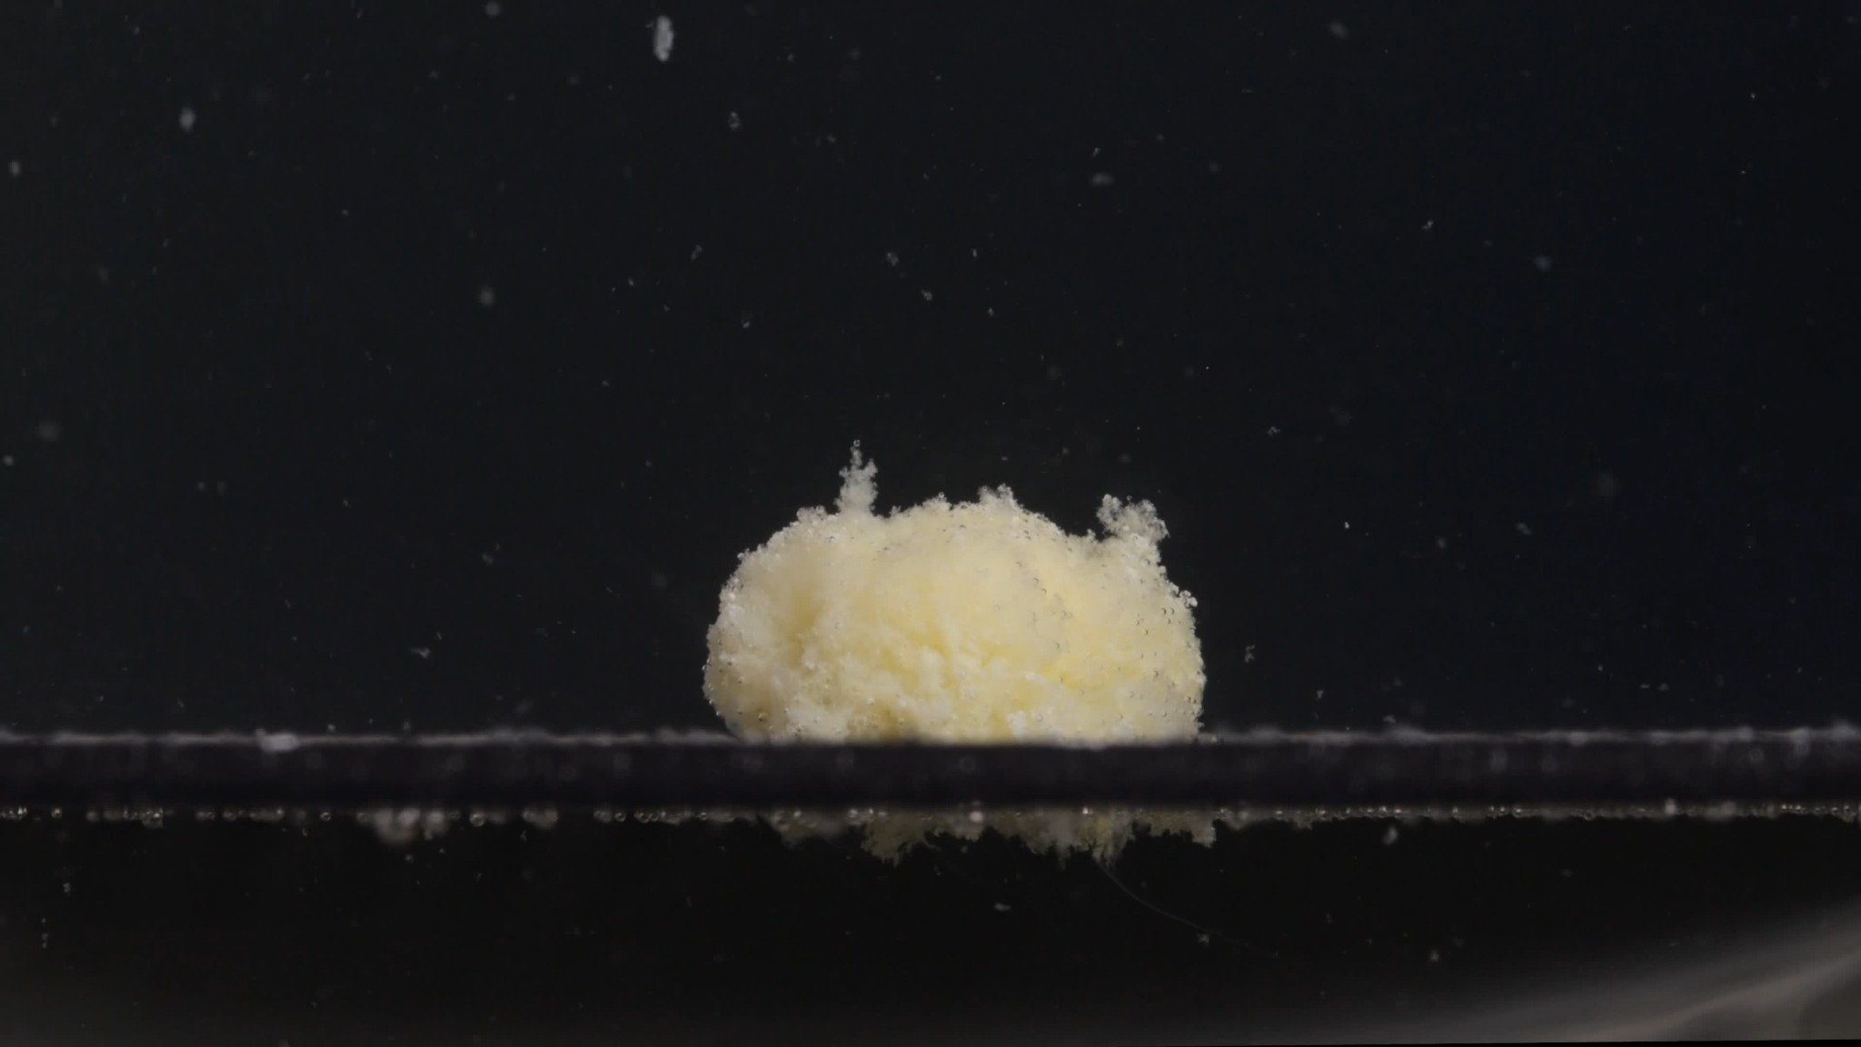
Group A — Picture at 60 minutes
Assistant
I received Group A: 5 images at 0, 15, 30, 45, and 60 minutes. I will describe only what is visible and avoid assuming unseen chemical information. The description follows the eight-dimension disintegration framework from the Knowledge Base: color, shape, surface texture, volume, time/speed, physical state, dissolution medium, and fragment distribution.

Group A — Picture 1 — 0 minutes
Color change: The tablet is mostly white to off-white. No obvious yellow color is exposed yet. The surrounding medium appears clear; the dark background makes the liquid look black, but there is no visible turbidity around the tablet.
Shape change: The tablet is still intact. It has a compact, rounded, biconvex tablet-like shape with a defined side wall and curved upper/lower surfaces. The contour is sharp and regular.
Surface texture change: The surface appears smooth, dense, and slightly wet/glossy. No visible cracks, pores, powdering, peeling, or erosion are present.
Volume / size change: This is the baseline size. The tablet retains its full original volume, with no measurable swelling or shrinkage visible.
Dissolution speed and time: At 0 minutes, disintegration has not visibly started. The rate appears effectively zero or very slow at this stage.
Physical state change: The tablet remains a solid, compact body. A few small bubbles are attached near the upper edge, but the tablet itself has not softened or collapsed.
Dissolution medium: The medium appears visually clear. No cloudy halo or suspended particles are visible near the tablet.
Fragment distribution with density: No fragments are visible. Particle density around the tablet is essentially absent.

Group A — Picture 2 — 15 minutes
Color change: The visible tablet mass has changed from white to a white–pale yellow mixture. Yellow areas are now exposed across the upper surface, suggesting that the outer surface has opened and the inner material is visible. The medium contains many small white particles, creating mild local turbidity.
Shape change: The original smooth tablet shape is lost. The tablet has transformed into an irregular, rounded mound. The side wall and clean biconvex outline are no longer visible. The upper contour is uneven and swollen-looking.
Surface texture change: The surface is now rough, porous, granular, and sponge-like. Many fine particles are attached to the surface, giving it a fuzzy or crumbly appearance.
Volume / size change: The compact tablet body has expanded/loosened into a porous mass. Its original height and side-wall definition are reduced, while the surface appears bulkier because of swelling and particle loosening. The footprint is still relatively large, but the tablet no longer looks dense.
Dissolution speed and time: Between 0 and 15 minutes, the tablet undergoes a major change. This suggests a rapid early disintegration phase, likely caused by liquid penetration and weakening of the outer structure.
Physical state change: The tablet has softened and partially collapsed. It appears to have changed from a hard solid tablet into a fragile, wet, granular mass.
Dissolution medium: The medium now contains suspended particles. The area below the tablet shows a downward plume or sediment-like trail, indicating material falling from the tablet.
Fragment distribution with density: Fragment density is highest near the tablet surface and below the support line. Several larger loose fragments are visible on the right side and below the tablet, while finer particles are dispersed through the surrounding liquid.

Group A — Picture 3 — 30 minutes
Color change: The tablet mass remains pale yellow with white areas, but the yellow color appears more broadly distributed than at 15 minutes. The medium contains visible fine particles, especially around and below the tablet.
Shape change: The remaining mass is still a rounded mound, but it appears more flattened and less structurally defined than at 15 minutes. The original tablet outline is completely absent.
Surface texture change: The surface remains highly granular, porous, and uneven. The top has a powdery, crumbly texture, with small particles continuously separating from the main body.
Volume / size change: Compared with 15 minutes, the mound appears slightly lower and more eroded. The tablet has not fully disappeared, but the compact volume is clearly reduced compared with the original 0-minute tablet.
Dissolution speed and time: From 15 to 30 minutes, disintegration continues but appears less dramatic than the first 15 minutes. The process has shifted from rapid structural failure to slower erosion and particle shedding.
Physical state change: The tablet is now a soft, partially disintegrated mass. It remains cohesive enough to keep a central mound, but its outer regions are fragile and continuously breaking into fine particles.
Dissolution medium: The medium contains a moderate amount of suspended particulate matter. A downward stream of material is visible beneath the tablet, showing continued release and settling.
Fragment distribution with density: Fine particles are dispersed around the image. Denser material is concentrated directly under the tablet, while a few larger fragments remain near the bottom/support region.

Group A — Picture 4 — 45 minutes
Color change: The remaining tablet is still pale yellow to off-white. The yellow tone is visible across the central body, while some white material remains at the edges and lower regions.
Shape change: The tablet is now a low, dome-like mound. It is flatter than the original tablet and has an irregular left-side depression or eroded region. The contour is rounded but no longer smooth.
Surface texture change: The surface remains rough and porous, though it looks slightly more compact than at 15 minutes. Fine granules cover the surface, especially along the upper and side edges.
Volume / size change: The tablet volume is further reduced compared with the initial image. The height is much lower than the 0-minute tablet, and the remaining mass looks less dense and less sharply bounded.
Dissolution speed and time: Between 30 and 45 minutes, the rate appears slow to moderate. The tablet continues to erode, but the central mound remains, indicating incomplete disintegration.
Physical state change: The tablet is in a weakened, semi-collapsed state. It is no longer a hard tablet but has not fully dispersed into the medium.
Dissolution medium: The liquid still shows suspended particles, but the cloudiness is mainly localized around the tablet and below the support line. The background remains mostly clear.
Fragment distribution with density: Most dense fragments and sediment are located below the tablet. Finer particles are scattered upward and outward, but the highest density remains close to the original tablet position.

Group A — Picture 5 — 60 minutes
Color change: The remaining material is still pale yellow with off-white granular regions. The color has not become uniform in the medium; instead, it remains concentrated in the tablet mass and nearby particles.
Shape change: The tablet remains as an irregular, rounded mound, not fully dissolved. The top surface has small protruding granular peaks, and the outline is uneven. Compared with 45 minutes, the general mound shape persists with only slight further erosion.
Surface texture change: The surface is very rough, porous, and powdery. The top edge appears loose and crumbly, with small granules projecting upward.
Volume / size change: The volume is much smaller and less compact than the original tablet. However, a substantial central mass remains after 60 minutes, meaning the tablet has not completely disintegrated within the observed time.
Dissolution speed and time: The disintegration has slowed by 60 minutes. The early stage was much faster, while the later stage shows gradual surface erosion and particle loss.
Physical state change: The tablet is a fragile, hydrated, semi-collapsed granular mass. It is partially disintegrated but still cohesive.
Dissolution medium: The medium contains suspended fine particles and settled material below the tablet. No strong uniform color change of the entire medium is visible.
Fragment distribution with density: Fine particles are scattered throughout the field, with the densest material still concentrated around the tablet and below it. Some sediment-like material remains under the support line.

Group A Overall Disintegration Pattern
Group A shows a clear sequence. At 0 minutes, the tablet is intact, white, smooth, and compact. By 15 minutes, it undergoes major structural failure: the smooth surface disappears, yellow inner material is exposed, and the tablet becomes a porous granular mound. From 30 to 60 minutes, the tablet continues to erode slowly, but a central pale-yellow/off-white mass remains.
The main size reduction occurs early, while later changes are mostly surface erosion, particle shedding, and sediment formation.
Key visual features of Group A: The tablet starts as a white, intact, rounded tablet and changes into a pale-yellow, porous, crumbly mound. It does not completely dissolve by 60 minutes. The most important size/shape change is the loss of the original smooth biconvex tablet form by 15 minutes, followed by gradual flattening and erosion.
Please upload Group B — picture 1 to picture 5 when ready. After I analyze Group B in the same format, I will compare the two groups and judge whether they are likely from the same drug or different drugs based on the visual disintegration pattern.

3. Group B Images and Analysis
User
Here are the Group B images. Please make sure the English description is accurate, think carefully, and reduce hallucinations. Each picture is taken 15 minutes apart.

Group B Uploaded Images
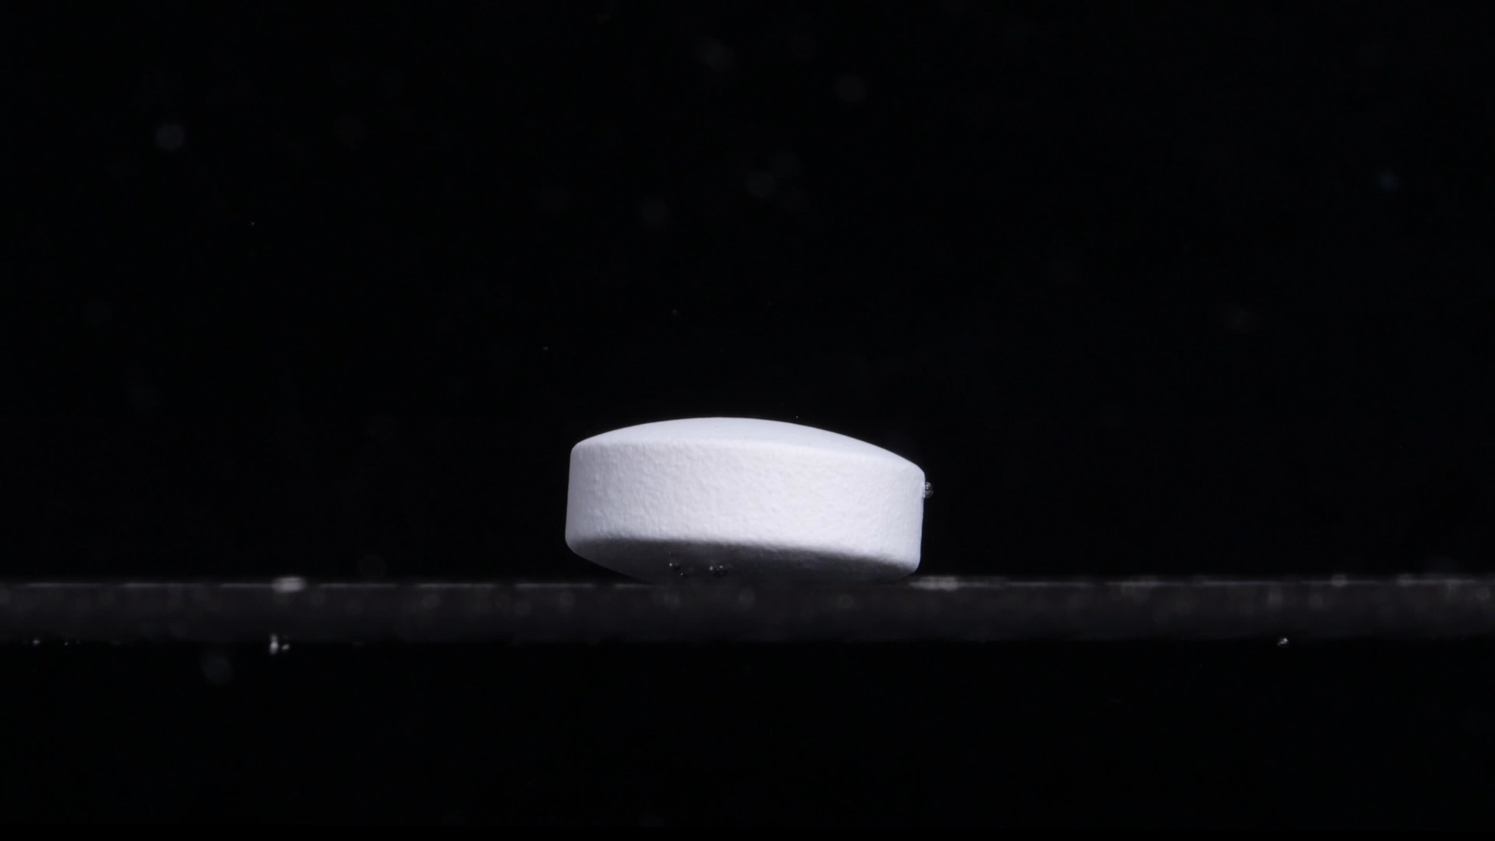
Group B — Picture at 0 minutes
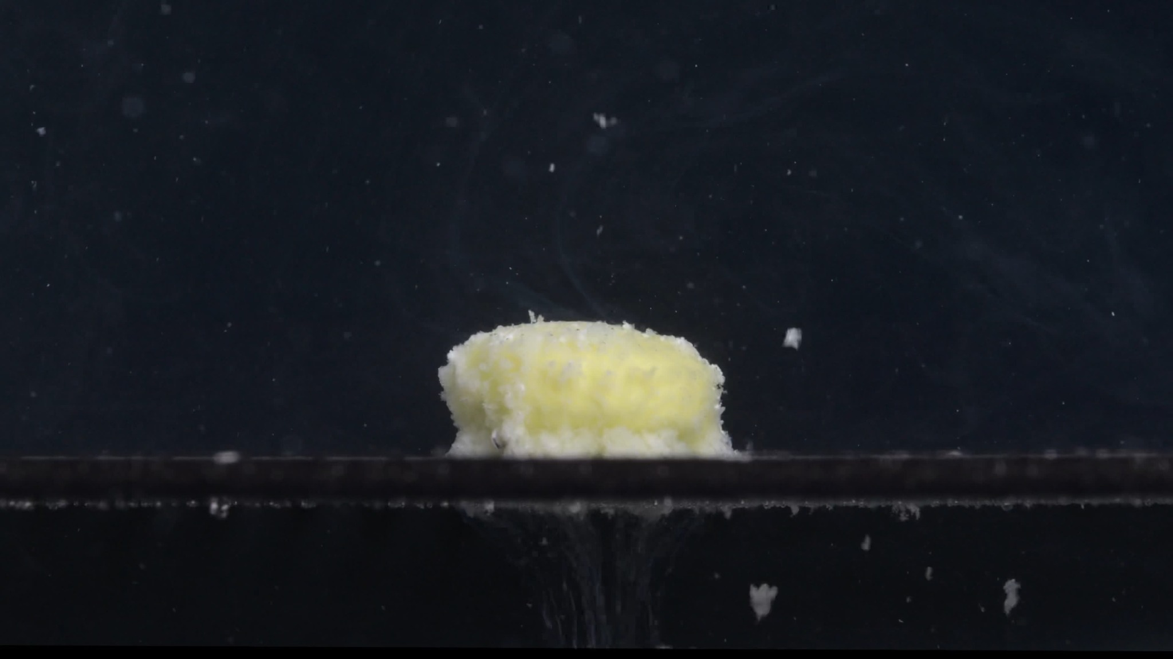
Group B — Picture at 15 minutes
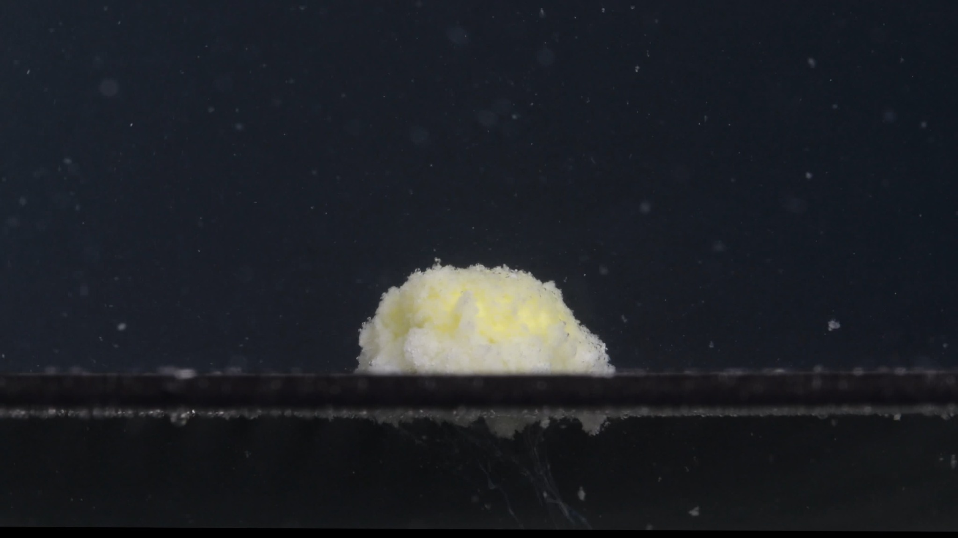
Group B — Picture at 30 minutes
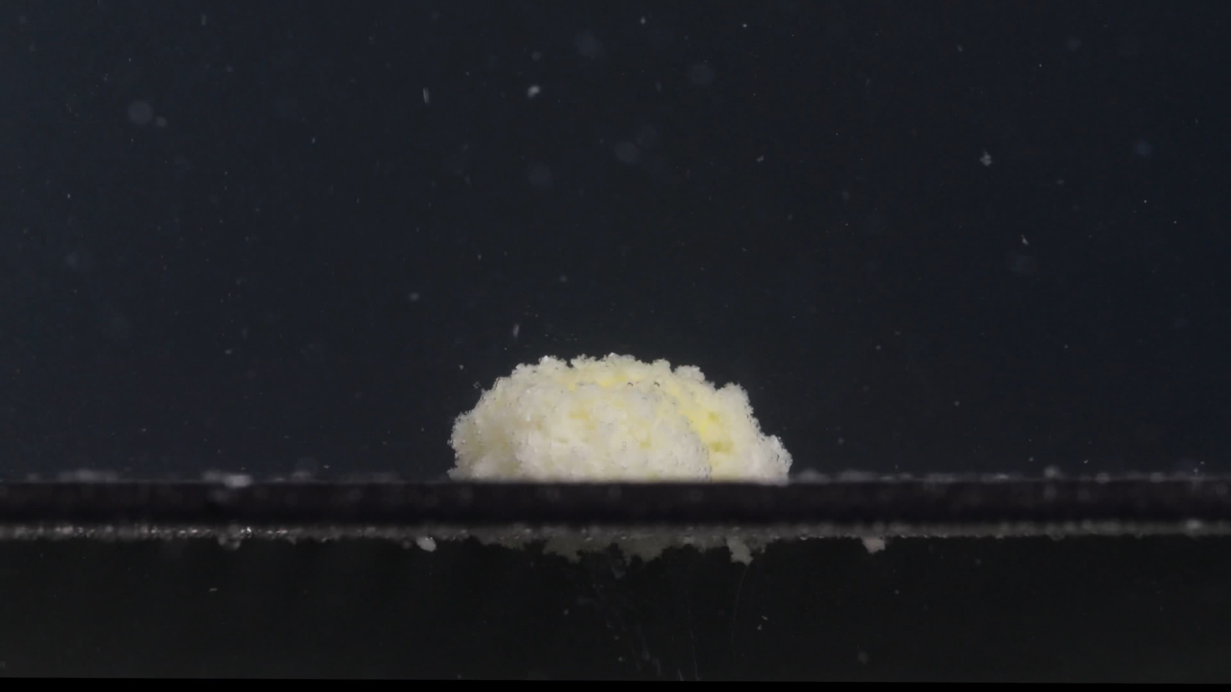
Group B — Picture at 45 minutes
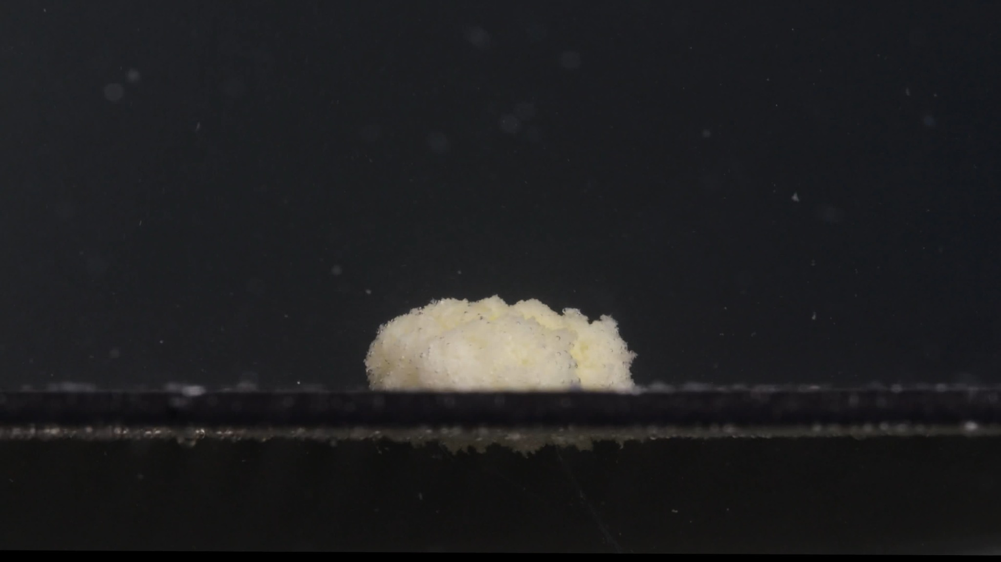
Group B — Picture at 60 minutes
Assistant
I analyzed Group B using the same eight-dimension framework: color, shape, surface texture, volume/size, dissolution speed/time, physical state, dissolution medium, and fragment distribution. This framework is appropriate because the Knowledge Base emphasizes that drug disintegration images should be described through these eight dimensions and with time-sequenced changes.
I will describe only visible features from the images. I will not infer the exact pH, formulation, coating material, or chemical identity from the images alone.

Group B — Picture 1 — 0 minutes
Color change: The tablet is uniformly white to off-white. No yellow internal material is visible yet. The surrounding medium appears clear, with no obvious cloudiness around the tablet.
Shape change: The tablet is intact and regular. It appears as a round, short cylindrical tablet with a relatively flat vertical side wall and slightly curved upper and lower faces.
Surface texture change: The surface appears mostly smooth and compact. There is slight visible surface roughness on the side wall, but no cracking, peeling, swelling, or powder shedding is visible.
Volume / size change: This is the baseline condition. The tablet keeps its original height, width, and compact volume.
Dissolution speed and time: At 0 minutes, no visible disintegration has started. The dissolution/disintegration rate appears very slow or not yet observable.
Physical state change: The tablet remains a hard, cohesive solid body. A small bubble is visible near the right edge, but this does not indicate tablet breakdown.
Dissolution medium: The medium is visually clear. No obvious suspended powder or sediment is visible.
Fragment distribution with density: No fragments are visible. Fragment density is essentially zero.

Group B — Picture 2 — 15 minutes
Color change: The tablet has changed strongly from white to a white–pale yellow mass. Yellow material is exposed across much of the upper surface, especially in the central region. The surrounding medium contains scattered white particles, producing mild local turbidity.
Shape change: The original clean cylindrical shape is mostly lost. The tablet has become a low, irregular, sponge-like mound. Some side-wall-like structure remains, but the original smooth tablet outline is no longer intact.
Surface texture change: The surface is now rough, porous, granular, and powdery. The top looks like a loose, wet, crumbly structure rather than a smooth compressed tablet surface.
Volume / size change: The compact tablet volume has loosened and partially collapsed. The remaining mass still occupies a similar horizontal footprint, but the original dense tablet body has changed into a porous swollen/crumbled mound.
Dissolution speed and time: Most visible structural change occurs between 0 and 15 minutes. This indicates a rapid early disintegration stage, likely after liquid penetration weakened the tablet structure.
Physical state change: The tablet has softened and partially broken down. It is no longer a hard solid tablet; it appears hydrated, fragile, and granular.
Dissolution medium: Fine particles are suspended around the tablet. A downward plume is visible below the tablet, showing material release and settling.
Fragment distribution with density: Fragments are densest near the tablet and directly below it. A few larger detached pieces are visible away from the main mass, especially on the right/lower side. Fine particles are dispersed through the nearby medium.

Group B — Picture 3 — 30 minutes
Color change: The mass remains pale yellow mixed with off-white. The yellow region is still mainly concentrated in the central upper part, while white material remains around the edges.
Shape change: The tablet has become a lower, irregular dome. The original vertical side wall is no longer clearly visible. The mass is more flattened than at 15 minutes.
Surface texture change: The surface remains highly granular and porous. Small crumb-like particles are visible along the top and outer edge.
Volume / size change: Compared with 15 minutes, the mound appears slightly lower and less sharply defined. The tablet has lost much of its original compact height, but a central mass remains.
Dissolution speed and time: From 15 to 30 minutes, the change is slower than the first 15 minutes. The process appears to shift from rapid collapse to gradual erosion and particle shedding.
Physical state change: The tablet is now a softened, partially collapsed granular mass. It still holds together as one main body, but its edges are fragile.
Dissolution medium: Fine suspended particles are visible. A faint downward sediment trail remains below the tablet.
Fragment distribution with density: The densest fragments are located directly beneath the tablet and along the lower support line. Smaller particles are scattered more widely in the medium.

Group B — Picture 4 — 45 minutes
Color change: The remaining mass is still off-white with pale yellow patches. The yellow color is less sharply concentrated than at 15 minutes and appears mixed into the softened body.
Shape change: The tablet is now a low, flattened mound. Its outline is uneven, and the original tablet geometry is completely absent.
Surface texture change: The surface remains rough and porous, with a fine powdery/granular texture. The top edge is irregular but not dramatically breaking into large pieces at this moment.
Volume / size change: The height is clearly reduced compared with the original tablet. The remaining material is spread more horizontally and looks less compact.
Dissolution speed and time: Between 30 and 45 minutes, disintegration continues slowly. The main body persists, so the process is incomplete.
Physical state change: The tablet remains in a hydrated, weakened, semi-collapsed state. It behaves visually like a soft residue rather than a solid tablet.
Dissolution medium: The surrounding medium remains mostly clear away from the tablet, but there are fine particles near and below the mass.
Fragment distribution with density: Fragment density is highest below the tablet and along the bottom/support region. Fine particles are dispersed in the nearby medium, but there is no large cloud spreading through the entire image.

Group B — Picture 5 — 60 minutes
Color change: The remaining mass is mainly off-white to pale yellow. Yellow areas are still visible but appear less intense than at 15 minutes. The color remains localized in the residual tablet mass rather than uniformly coloring the medium.
Shape change: The tablet has become a flattened, irregular mound. The upper contour is uneven, with small granular protrusions. The original round tablet shape is no longer recognizable.
Surface texture change: The surface is rough, powdery, and porous. The outer edges look fragile and crumbly.
Volume / size change: The tablet volume is much reduced compared with 0 minutes, especially in height. However, a substantial residual mound remains after 60 minutes, so the tablet has not fully disintegrated or disappeared.
Dissolution speed and time: By 60 minutes, the process appears slow. Most major breakdown happened early, especially between 0 and 15 minutes, followed by gradual erosion from 15 to 60 minutes.
Physical state change: The tablet is a soft, hydrated, semi-collapsed granular residue. It remains partially cohesive.
Dissolution medium: The medium contains some fine particles and sediment below the tablet. There is no strong uniform turbidity throughout the whole liquid.
Fragment distribution with density: Most particles are concentrated below and around the remaining mound. The highest density is near the original tablet position, with only scattered fine particles farther away.

Group B Overall Disintegration Pattern
Group B shows a clear disintegration sequence. At 0 minutes, the tablet is white, intact, compact, and cylindrical. At 15 minutes, it undergoes major structural breakdown: yellow inner material becomes visible, the surface becomes porous and granular, and particles begin to detach. From 30 to 60 minutes, the tablet continues to erode slowly, becoming flatter and more irregular, but a central residual mound remains.
The most important size and shape change is the rapid transformation from a compact cylindrical tablet into a low porous mound within the first 15 minutes, followed by slower height reduction and surface erosion.

4. Final Comparison Across the Eight Dimensions
User
Please compare Groups A and B based on their disintegration characteristics across the eight dimensions to determine if they are from the same drug or not, and explain why you think so.
Assistant
Based on the visible disintegration characteristics across the eight dimensions, I judge that Group A and Group B are likely from the same drug, or at least from a highly similar formulation of Doxycycline Hyclate Tablets. This is an image-based judgment only; it cannot prove chemical identity without analytical testing.
The eight-dimension framework is appropriate here because drug disintegration should be compared by color, shape, surface texture, volume, dissolution time, physical state, medium appearance, and fragment distribution.

Eight-Dimension Comparison
Dimension | Group A | Group B | Similarity Assessment
1. Color change | Starts white/off-white. By 15 minutes, pale yellow internal material appears. From 30–60 minutes, yellow-white residue remains. | Also starts white/off-white. By 15 minutes, pale yellow internal material appears. From 30–60 minutes, yellow-white residue remains. | Highly similar.
2. Shape change | 0 minutes: intact rounded tablet. 15 minutes: original shape collapses into an irregular porous mound. 30–60 minutes: low rounded mound remains. | 0 minutes: intact short cylindrical tablet. 15 minutes: collapses into an irregular porous mound. 30–60 minutes: flattened mound remains. | Highly similar, with minor initial shape/orientation difference.
3. Surface texture change | Smooth at 0 minutes; rough, granular, porous, and sponge-like after 15 minutes. | Smooth at 0 minutes; rough, granular, porous, and sponge-like after 15 minutes. | Very similar.
4. Volume / size change | Major loss of compact tablet structure occurs by 15 minutes. Later, volume decreases slowly, but a residual mass remains at 60 minutes. | Same pattern: major early collapse by 15 minutes, then slower erosion; residual mass remains at 60 minutes. | Very similar.
5. Dissolution speed and time | Fastest visible change occurs between 0–15 minutes. After that, disintegration slows. | Same: fastest change between 0–15 minutes, then slow erosion from 30–60 minutes. | Very similar.
6. Physical state change | Hard tablet becomes hydrated, softened, crumbly, and semi-collapsed. | Hard tablet becomes hydrated, softened, crumbly, and semi-collapsed. | Very similar.
7. Dissolution medium | Medium remains mostly clear away from the tablet; local turbidity and particles appear near/below the tablet. | Same: mostly clear background with local particles near/below the tablet. | Very similar.
8. Fragment distribution and density | Fragments and sediment are densest near the tablet and beneath the support line; fine particles scatter outward. | Same distribution: high density near/below tablet, scattered fine particles farther away. | Very similar.

Why They Are Likely the Same Drug
The strongest evidence is the time sequence. In both groups, the tablets behave almost the same way:
At 0 minutes, both are intact, white, compact tablets with smooth surfaces.
At 15 minutes, both rapidly lose their original tablet shape, expose pale yellow internal material, and become rough, porous, granular mounds.
At 30–60 minutes, both continue to erode slowly rather than fully disappear. In both groups, a pale yellow/off-white residual mound remains at 60 minutes.
This pattern is not just one similar feature; it is a combination of similar color transition, shape collapse, surface roughening, volume reduction, erosion speed, residue formation, and fragment distribution. That multi-dimensional similarity strongly supports that Group A and Group B are from the same drug or a very similar formulation.

Minor Differences
There are small differences, but they do not look large enough to indicate a different drug.
Group A at 0 minutes appears slightly more tilted or biconvex in view, while Group B looks more like a short cylinder. This may be due to camera angle, tablet orientation, or how the tablet sits on the support.
Group A shows slightly more irregular protrusions and visible scattered material at later times, especially around 60 minutes. Group B appears a little flatter and more horizontally spread. These differences could come from small experimental variation, liquid movement, lighting, or tablet positioning.

Final Conclusion
Image-based conclusion: Group A and Group B are likely the same drug or the same type of Doxycycline Hyclate Tablet formulation.
I would not classify them as clearly different drugs because the disintegration pattern is too similar across all eight dimensions. The only responsible limitation is that image analysis can compare behavior and appearance, but it cannot chemically confirm identity.

