Drug Disintegration Image Analysis Conversation
Doxycycline Hyclate Tablets | Groups A and B | Edited English Version
This Word document presents the complete English-edited content of the drug-disintegration discussion up to and including the final comparison of Groups A and B. The final Chinese request asking for this document is intentionally omitted.
The image-based conclusions are visual observations only. They do not constitute chemical identification or laboratory confirmation of the active ingredient.

1. Initial User Request
The user requested an analysis of disintegration images for two groups of Doxycycline Hyclate Tablets, Group A and Group B. Each group contains five images taken 15 minutes apart. The goal was to describe the drug disintegration process in English for each image and finally determine whether the two groups appear to come from the same drug or from different drugs.
The user emphasized that descriptions should be accurate, carefully reasoned, and should minimize hallucinations. The user also asked the assistant to call the Knowledge Base to remember how to describe drug disintegration, with special attention to changes in tablet size and shape.

2. Knowledge Base Preparation
The assistant first confirmed preparation, then the user requested that the Knowledge Base be called again. The assistant refreshed the drug-disintegration description framework.
The Knowledge Base framework requires the analysis to cover eight dimensions:
- Color change: solution transparency, turbidity, color intensity, and local or uniform color spread.
- Shape change: whether the tablet remains intact, becomes rounded or eroded, cracks, collapses, or fragments.
- Surface texture change: smoothness, roughness, pores, cracks, peeling, flakes, or fibrous structures.
- Volume / size change: reduction in diameter, height, thickness, contour, swelling, shrinkage, or collapse.
- Dissolution speed and time: whether disintegration is slow, moderate, or rapid at each 15-minute interval, and whether the rate changes over time.
- Physical state change: swelling, softening, cracking, pore expansion, internal weakening, collapse, and particle formation.
- Dissolution medium: clarity, cloudiness, sediment, suspended particles, and visible interaction between the tablet and liquid.
- Fragment distribution and density: whether fragments stay near the tablet, spread outward, settle at the bottom, or form dense suspended clouds.
For determining whether Group A and Group B are the same drug, the assistant stated that the comparison would focus on the whole time sequence, including initial tablet size, shape, color, coating appearance, edge erosion, swelling, cracking, fragment type, turbidity, and final residual tablet mass.

3. Group A Image-by-Image Analysis

Group A - Pic 1 - 0 minutes
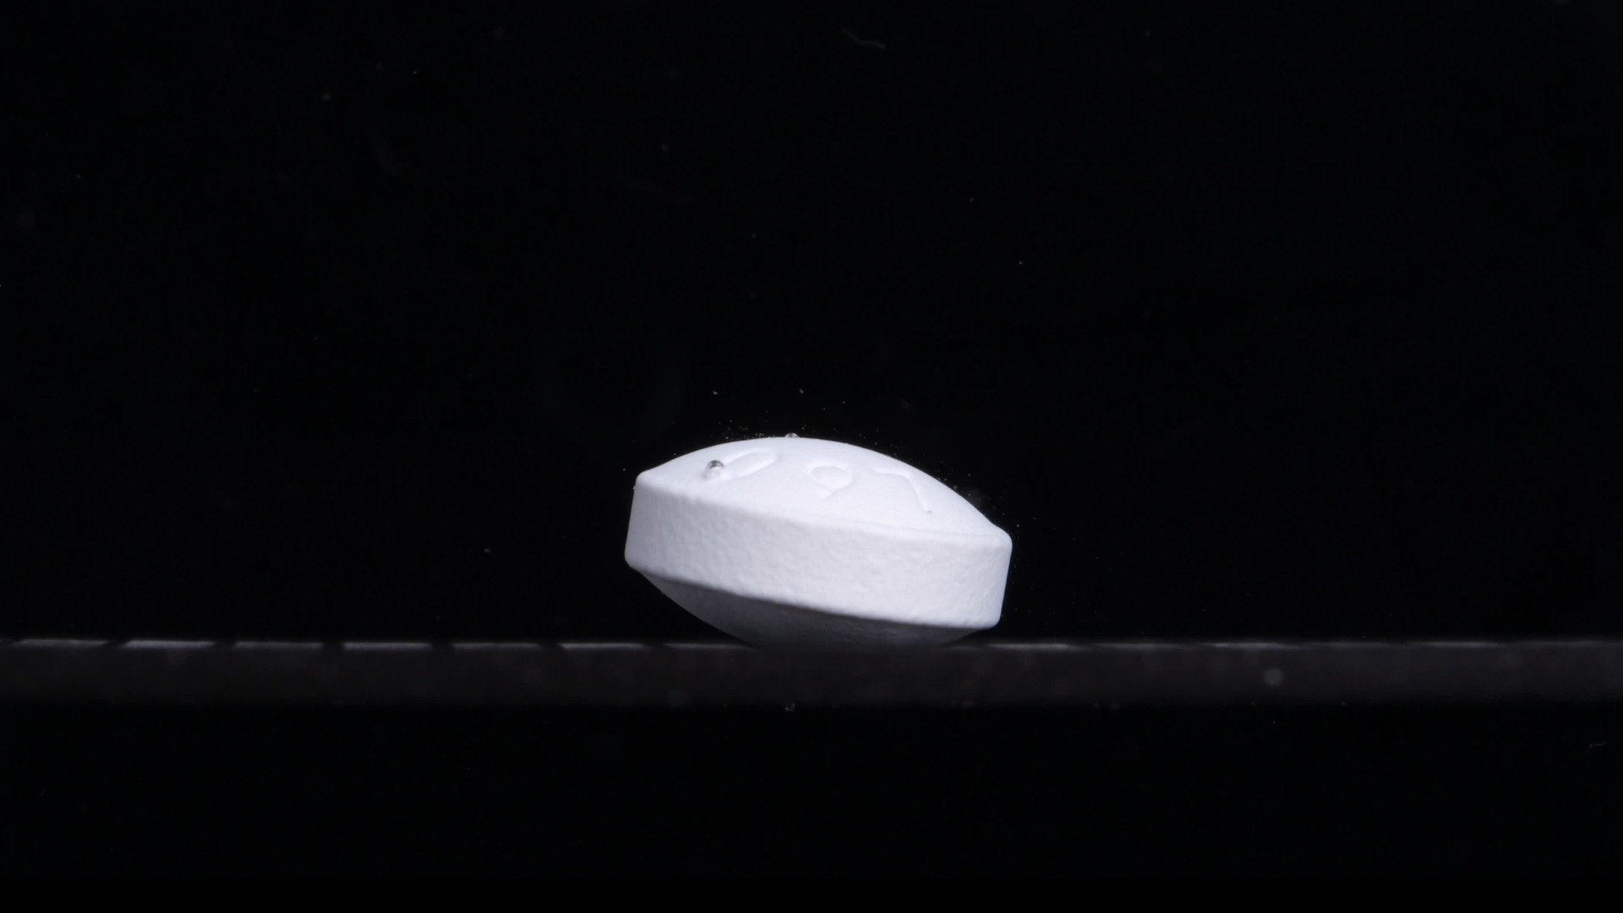
Group A - Pic 1 - 0 minutes
1. Color change: The tablet is uniformly white to off-white. No visible yellowing, staining, or color diffusion is seen in the surrounding medium. The medium/background appears dark and visually clear, with no obvious cloudiness or suspended powder around the tablet.
2. Shape change: The tablet remains intact. It appears to be a round, thick, biconvex tablet viewed from the side, with a raised curved upper face and lower face. The side wall is still continuous, and the tablet outline is well defined. No splitting, cracking, edge collapse, or large deformation is visible.
3. Surface texture change: The upper surface looks relatively smooth, with several visible liquid droplets on top. The side surface appears slightly matte or fine-grained, but this may be the original tablet texture rather than disintegration. No obvious pores, peeling, flakes, or surface erosion are visible at this stage.
4. Volume / size change: This image represents the initial tablet size. The tablet still has full thickness and a complete body. No measurable reduction in diameter, height, or volume is visible.
5. Dissolution speed and time: At 0 minutes, there is no visible active disintegration. The dissolution/disintegration rate appears minimal or not yet observable. Later images should be compared against this baseline to judge whether the tablet erodes slowly from the edge, swells, cracks, or breaks into fragments.
6. Physical state change: The tablet appears solid and structurally stable. No swelling, softening, cracking, internal collapse, or powder shedding is visible. The visible droplets suggest surface wetting may have begun, but there is not enough evidence yet to say that liquid has penetrated the tablet core.
7. Dissolution medium: The surrounding medium is not clearly visible as a transparent liquid layer, but the environment around the tablet appears clear and non-turbid. No obvious sediment, cloudy halo, or dispersed particles are present near the tablet.
8. Fragment distribution and density: No fragments are visible. No powder cloud or sediment layer is seen around the tablet. Fragment density is therefore zero or negligible at this time point.
Overall observation: The tablet is still whole, white, thick, and sharply contoured, with no clear disintegration. This image should be used as the baseline morphology for Group A. The most important baseline features are: white color, thick biconvex round shape, intact edges, smooth-to-matte surface, and absence of fragments or turbidity.

Group A - Pic 2 - 15 minutes
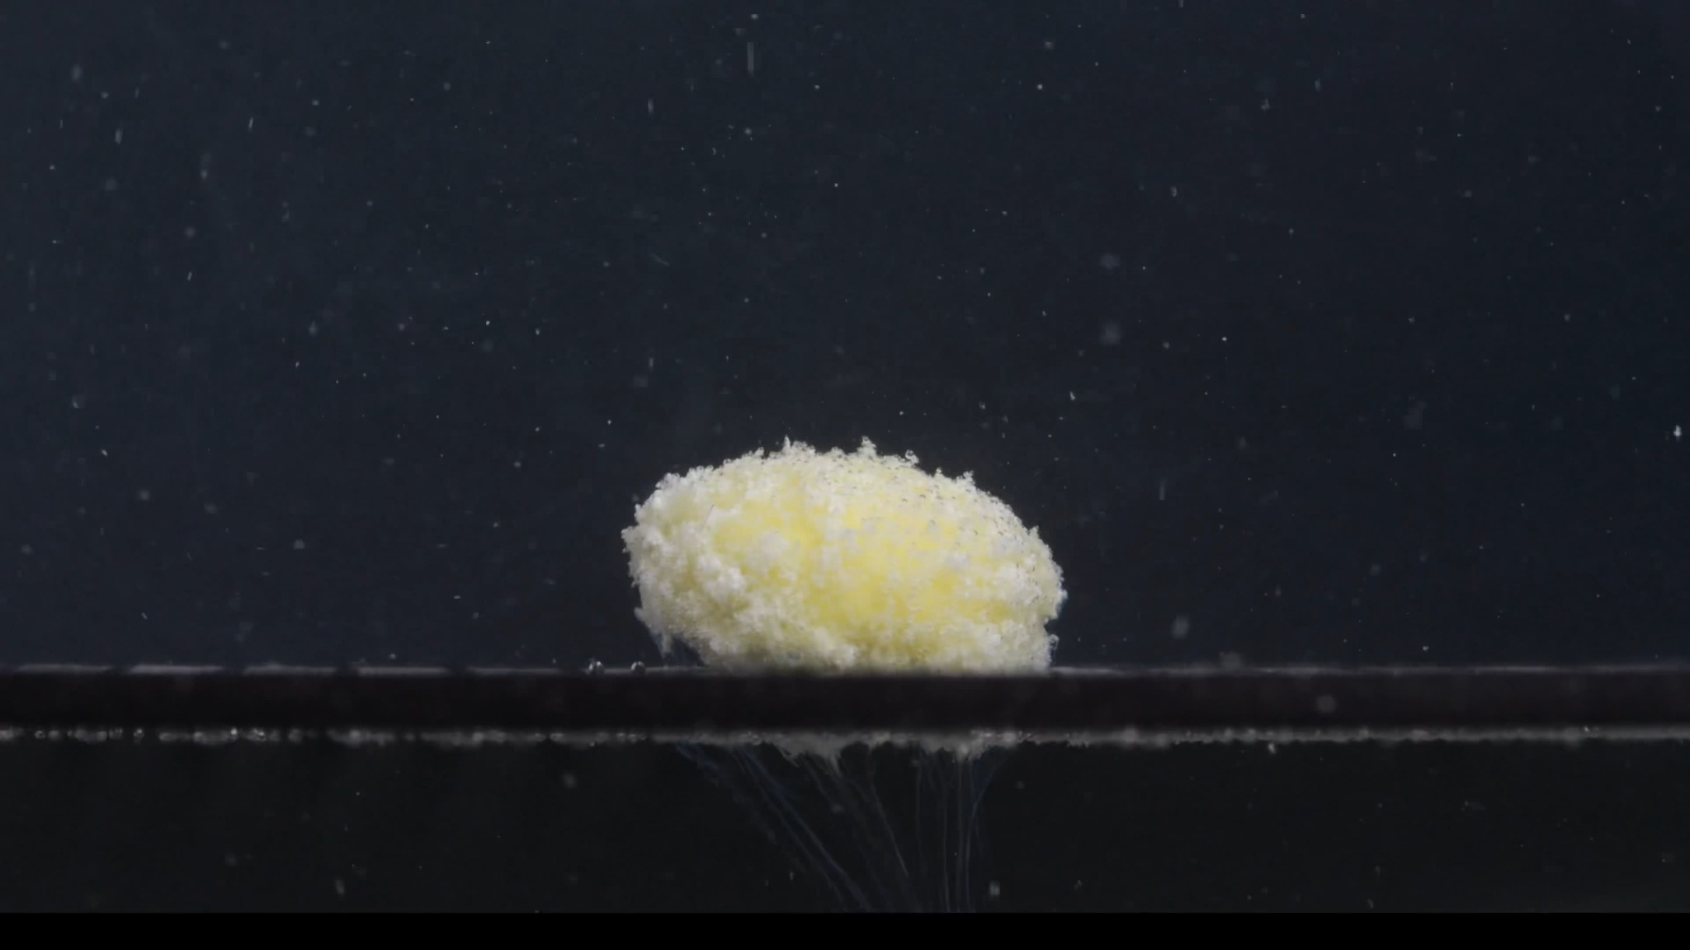
Group A - Pic 2 - 15 minutes
1. Color change: The tablet is no longer uniformly white. A yellow region is now clearly visible in the central upper area, while the outer region remains mostly white. This suggests that the outer white layer has loosened or eroded enough to expose the inner material. The surrounding liquid/background contains many small bright specks, indicating increased suspended particles or turbidity compared with 0 minutes.
2. Shape change: The original sharp, thick, biconvex tablet outline has changed into a rounded, swollen-looking mound. The side wall is no longer smooth or sharply vertical. The edges appear softened, irregular, and crumbly. The tablet still remains as one main mass, but its original manufactured shape has been largely lost.
3. Surface texture change: The surface has changed from relatively smooth to rough, porous, and granular. The outer white material appears fluffy or powdery, especially along the upper and side edges. No clean crack line is visible, but the whole surface looks loosened, as if the tablet matrix is breaking into fine particles.
4. Volume / size change: The tablet's original height and side-wall definition have decreased. The mass appears lower and more rounded, with some lateral spreading at the base. Because the camera scale may not be perfectly identical, this should be described as a qualitative size/shape reduction rather than a precise volume measurement. Overall, the tablet has not fully disappeared, but the intact tablet volume has clearly reduced.
5. Dissolution speed and time: Between 0 and 15 minutes, the disintegration speed appears moderate to relatively active. The tablet did not simply dissolve uniformly; instead, it first softened and broke down at the surface, producing a powdery layer. The exposed yellow center suggests that the outer layer disintegrated faster than the inner core.
6. Physical state change: The tablet has changed from a hard, intact solid into a softened, partially collapsed, porous mass. The internal structure appears weakened. The top and edges show clear signs of material loss and loosening. The yellow central area may represent exposed inner tablet material, but its chemical identity cannot be assumed from the image alone.
7. Dissolution medium: The medium now contains many visible suspended particles. The background is still mostly dark, but compared with 0 minutes, there is more particulate matter throughout the field. A faint cloudy or particulate zone is visible around the tablet, especially near the base.
8. Fragment distribution and density: Fine particles are distributed around and above the tablet. A denser white particulate layer is visible along the bottom surface near the tablet. Under the tablet, there are downward, thread-like or plume-like trails, suggesting small particles or dissolved material moving downward from the tablet area. No large separated fragments are clearly visible; the disintegration products are mainly fine granules or powder-like particles.
Overall observation: At 15 minutes, Group A shows substantial disintegration: the tablet has changed from a white, intact biconvex form into a rounded, crumbly, porous mass with a yellow exposed center. The edges are softened, the surface is granular, and fine particles are dispersed into the medium. The tablet is not fully dissolved yet, but the original shape and surface integrity have been strongly disrupted.

Group A - Pic 3 - 30 minutes
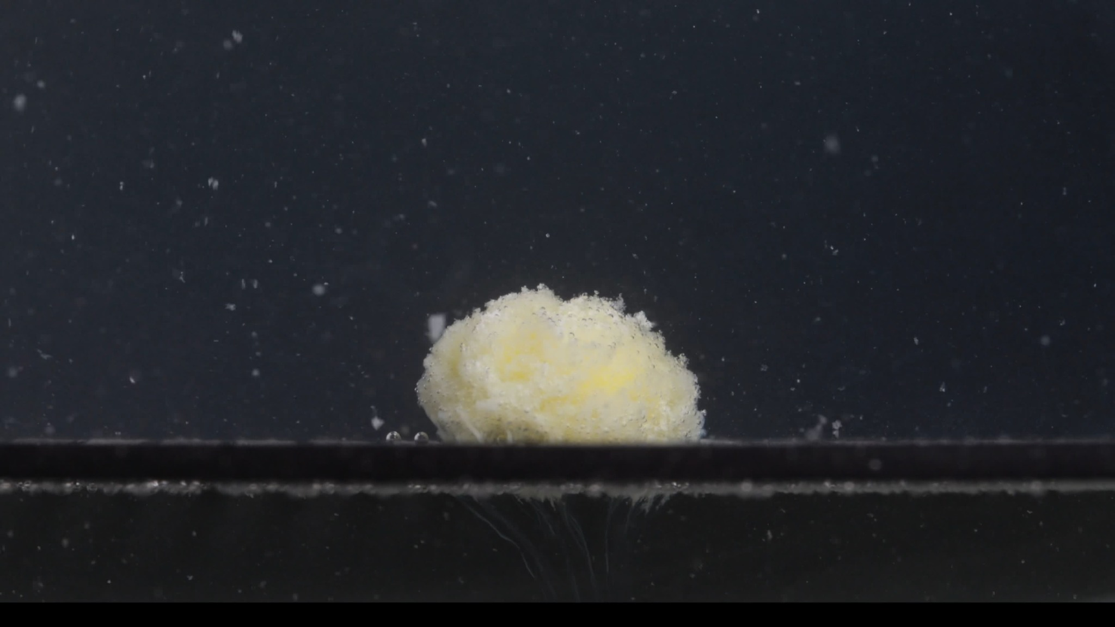
Group A - Pic 3 - 30 minutes
1. Color change: The tablet still shows a yellow central region surrounded by a white/off-white outer material. The yellow area appears more diffuse than at 15 minutes, suggesting more exposure of the inner material. The surrounding medium contains many scattered light particles, indicating persistent particulate turbidity.
2. Shape change: The tablet has lost the original biconvex tablet shape seen at 0 minutes. It now appears as a low, rounded, irregular mound. The top contour is uneven, and the edges are no longer sharply defined. No large separate tablet fragments are clearly visible.
3. Surface texture change: The surface is rough, porous, and granular. The outer surface looks loosened and powdery, especially along the upper edge and side margins. The surface does not show a clean fracture line; instead, it appears to be crumbling gradually into fine particles.
4. Volume / size change: The visible tablet mass is still present, but its recognizable intact-tablet volume has clearly decreased compared with 0 minutes. Compared with 15 minutes, the change is moderate rather than dramatic: the mound appears slightly more eroded and less compact. Because the camera view and lighting may affect apparent size, a precise percentage reduction should not be assigned from the image alone.
5. Dissolution speed and time: From 15 to 30 minutes, the disintegration appears continuing but not extremely rapid. The main process seems to be progressive erosion of the surface and release of fine particles. The tablet has not fully dispersed by 30 minutes, indicating a relatively sustained disintegration process.
6. Physical state change: The tablet appears softened and structurally weakened. The residual mass looks porous and partially collapsed, but it still retains a central body. The yellow inner area suggests that the outer layer has been substantially disrupted, while the remaining core is still present.
7. Dissolution medium: The surrounding medium is visibly populated with fine particles. A faint particulate cloud is present around the tablet, especially near the base. The background remains dark, but the numerous suspended specks show that material has been released into the medium.
8. Fragment distribution and density: Fragmentation is mainly in the form of fine powder-like particles, not large chunks. Particles are scattered above and around the tablet. A denser line of sediment-like material is visible near the bottom/support surface. Downward plume-like traces beneath the tablet suggest fine material moving or settling downward from the main mass.
Overall observation: At 30 minutes, Group A shows continued disintegration into a soft, rough, yellow-white granular mound. The tablet remains as one main body, but its original shape, smooth surface, and sharp edges are gone. The main visual signs are surface erosion, exposed yellow interior, fine particle shedding, and suspended/sedimented powder.

Group A - Pic 4 - 45 minutes
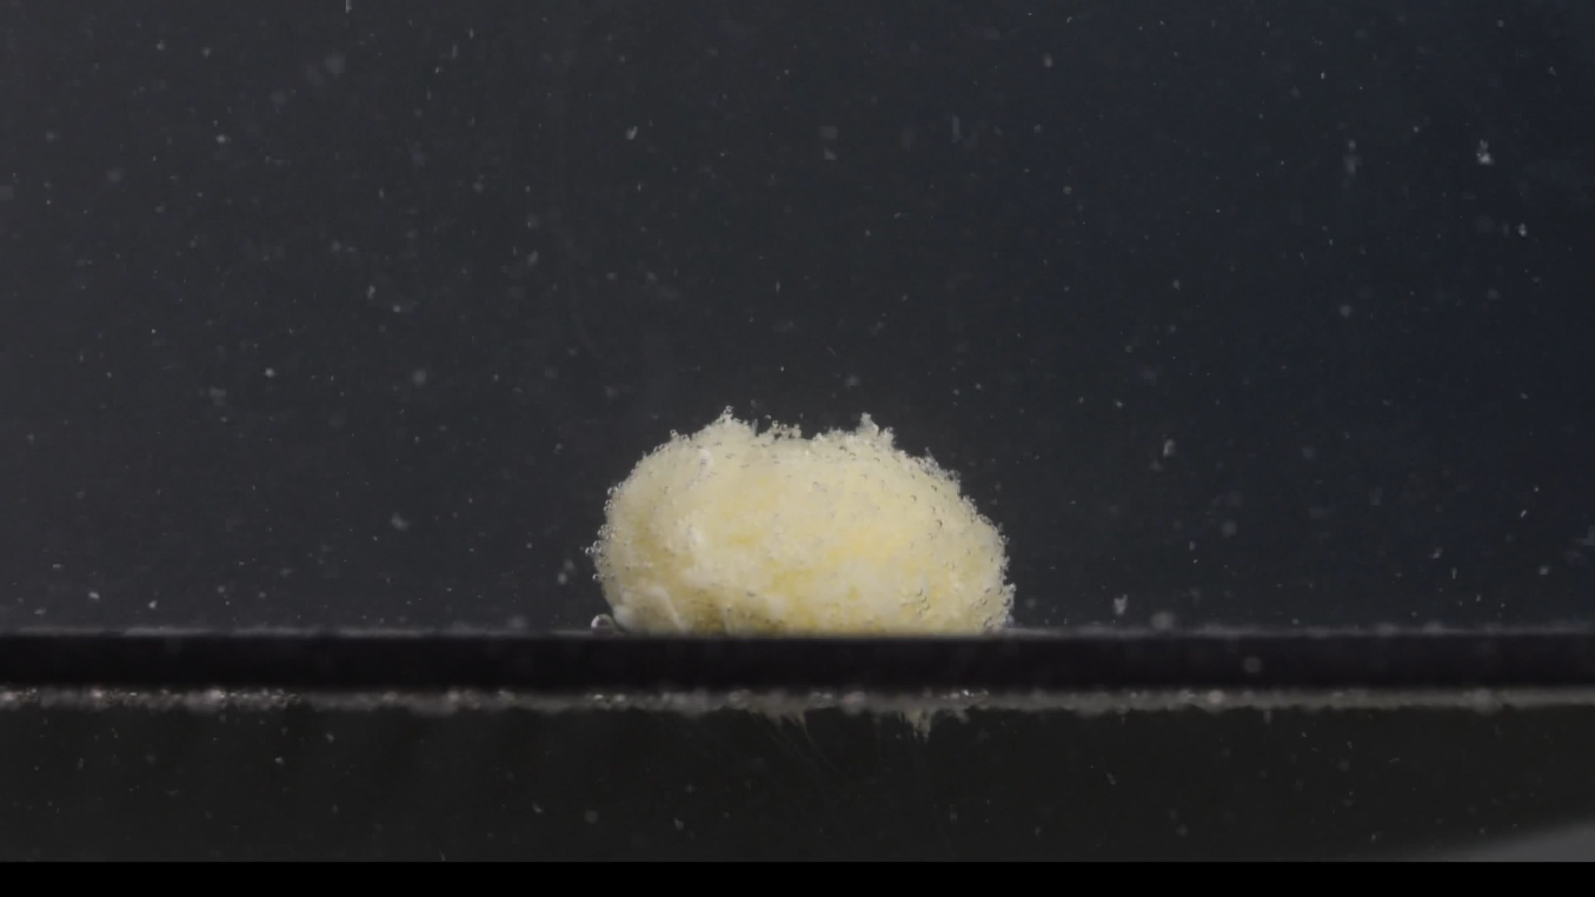
Group A - Pic 4 - 45 minutes
1. Color change: The residual tablet mass remains yellow-white. The central region is pale yellow, while the outer surface is mostly off-white to light cream. The yellow color appears more blended and diffuse than at 15 minutes, suggesting continued exposure and mixing of the inner material with the outer layer. The surrounding medium contains many small bright particles, but there is no strong uniform color spread through the whole liquid.
2. Shape change: The original round, biconvex tablet shape is no longer visible. The tablet is now a low, dome-like, irregular mound. Its top surface is uneven, with a rough raised region near the upper edge. The bottom part appears flattened against the support surface, while the side edges are softened and poorly defined.
3. Surface texture change: The surface is clearly granular, rough, and porous. The upper and side edges look loose and crumbly, with small powder-like material detaching from the main body. There are no clear long cracks, but the surface appears weakened across the whole mass. The texture suggests progressive erosion rather than clean fracture.
4. Volume / size change: Relative to the 0-minute image, the tablet has lost its original thickness, side-wall shape, and compact outline. Compared with the 30-minute image, the visible mass appears only slightly reduced or similarly sized, so the disintegration rate between 30 and 45 minutes seems slower. The residual body still has a substantial central volume, meaning the tablet has not fully disintegrated by 45 minutes.
5. Dissolution speed and time: From 0 to 15 minutes, the tablet changed rapidly from intact to porous and yellow-exposed. From 15 to 45 minutes, the process appears more gradual. At 45 minutes, disintegration is still ongoing, but the speed looks slow to moderate, dominated by surface erosion and fine-particle shedding rather than major collapse.
6. Physical state change: The tablet appears softened, swollen or loosened, and structurally weakened. It has not collapsed into separate large fragments. The remaining mass looks cohesive but fragile, with a powdery outer layer and exposed yellow inner material. The bottom contact area appears compressed or flattened, indicating loss of the original rigid tablet geometry.
7. Dissolution medium: The medium remains dark in the image, but many fine suspended particles are visible throughout the field. The area near the tablet and support surface shows more particulate material than the upper background. No large floating chunks are clearly visible.
8. Fragment distribution and density: Fragmentation is mostly in the form of fine particles and powder-like debris. The highest fragment density is near the tablet surface and along the bottom/support line. Some particles are dispersed upward and outward into the surrounding medium. Faint downward plume-like traces are still visible below the tablet area, suggesting settling or movement of fine material.
Overall observation: At 45 minutes, Group A remains as a yellow-white, rough, porous, low mound. The tablet has lost its original manufactured shape, but it has not fully separated into large fragments. The main disintegration pattern is slow continuing erosion with fine-particle release, while a substantial central residual mass remains.

Group A - Pic 5 - 60 minutes
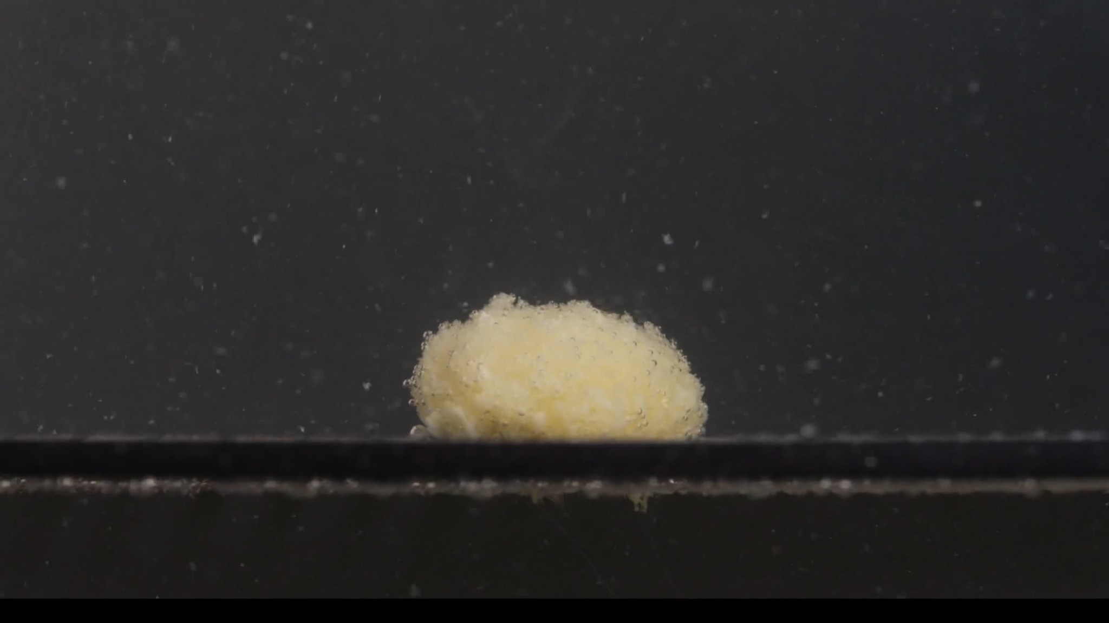
Group A - Pic 5 - 60 minutes
1. Color change: The remaining mass is mainly pale yellow to yellow-white. The yellow tone is more dominant than in the initial 0-minute image, where the tablet was uniformly white. The outer surface still has some whitish material, but the central and upper areas appear more yellow, suggesting continued exposure of the inner tablet material. The surrounding medium contains many small light particles, but there is no strong uniform yellow coloration throughout the whole liquid.
2. Shape change: The tablet no longer has the original round, biconvex manufactured shape. It now appears as a low, irregular, dome-like mound resting on the bottom/support surface. The upper outline is uneven and fluffy, while the side boundaries are soft and poorly defined. No large separated fragments are visible; the tablet remains mostly as one eroded body.
3. Surface texture change: The surface is rough, porous, granular, and powdery. The upper edge looks loose, with fine material appearing to detach from the surface. The texture is not smooth or compact anymore. The visible disintegration pattern is mainly surface erosion and powder shedding, rather than clean cracking into large pieces.
4. Volume / size change: Compared with 0 minutes, the tablet has clearly lost its original height, edge sharpness, and compact tablet geometry. Compared with 45 minutes, the residual mass appears slightly lower and more eroded, but the difference is not dramatic. A substantial central body still remains, so the tablet has not completely disintegrated by 60 minutes. Because the image scale and lighting may vary slightly, the size change should be described qualitatively rather than as an exact percentage.
5. Dissolution speed and time: The early stage from 0 to 15 minutes showed the most obvious transformation: loss of the intact tablet shape and exposure of yellow material. From 15 to 60 minutes, the disintegration appears slower and more progressive. At 60 minutes, the process is still ongoing at a slow-to-moderate erosion rate, mainly releasing fine particles from the surface.
6. Physical state change: The tablet appears softened, weakened, porous, and partially collapsed. It remains cohesive enough to keep a central mound, but it no longer looks structurally firm. The lower part appears compressed against the support surface, while the upper portion looks fragile and powdery. There is no visible complete breakup into large chunks.
7. Dissolution medium: The surrounding medium shows numerous suspended particles, especially visible against the dark background. The area near the support surface contains more particulate material than the upper background. The medium appears particle-rich, but not uniformly opaque.
8. Fragment distribution and density: Fragments are mainly fine powder-like particles, not large pieces. The highest particle density is around the tablet surface and along the bottom/support line. Fine particles are scattered upward and outward into the medium. Some sediment-like material is visible near the bottom, suggesting gradual settling of disintegrated particles.
Overall observation: At 60 minutes, Group A remains as a yellow-white, rough, porous, low residual mound. The original tablet shape is completely lost, but a central mass still persists. The disintegration behavior is characterized by gradual erosion, yellow inner-material exposure, powder shedding, fine suspended particles, and bottom sedimentation.

4. Group B Image-by-Image Analysis

Group B - Pic 1 - 0 minutes
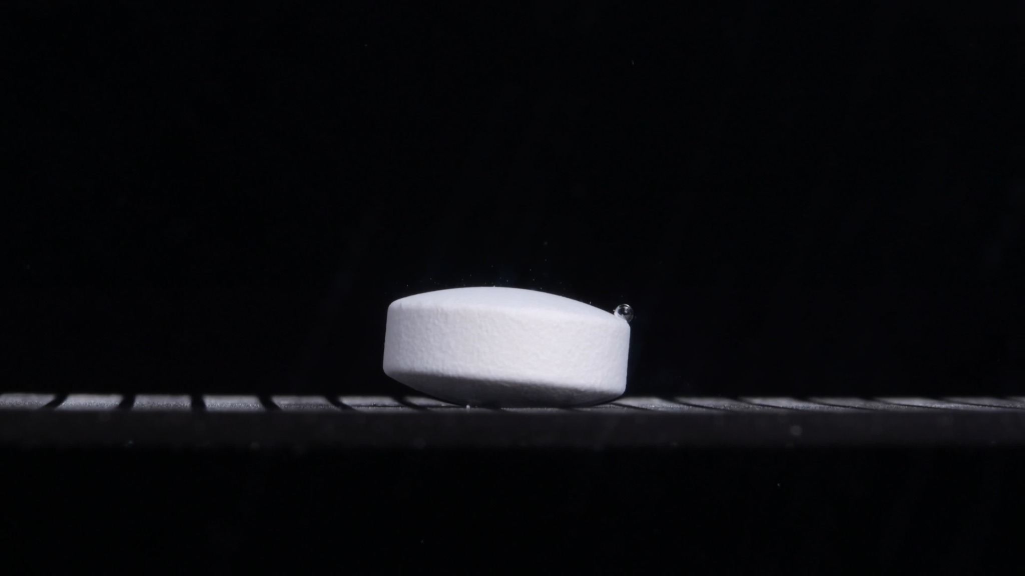
Group B - Pic 1 - 0 minutes
1. Color change: The tablet is uniformly white to off-white. No yellow inner region is visible at this time point. The surrounding medium/background appears dark and visually clear, with no obvious turbidity, powder cloud, or color diffusion around the tablet.
2. Shape change: The tablet is still intact. It appears to be a round, thick, biconvex tablet viewed from the side. The side wall is fairly vertical and continuous, while the top and bottom surfaces are curved. No cracking, splitting, collapse, or fragmentation is visible.
3. Surface texture change: The surface appears mostly smooth to slightly matte. The side surface shows very fine texture, but this may be the original compressed-tablet surface rather than disintegration. A small droplet or bubble is visible near the right upper edge, but there is no clear surface erosion or peeling.
4. Volume / size change: This is the initial full-size reference for Group B. The tablet retains its original height, thickness, and compact outline. No visible size reduction has occurred.
5. Dissolution speed and time: At 0 minutes, no active disintegration is visible. The dissolution/disintegration rate cannot yet be judged from this single image, except that the tablet remains structurally intact at the starting point.
6. Physical state change: The tablet appears solid, firm, and structurally stable. No swelling, softening, cracking, pore expansion, or collapse is visible. There is no evidence yet of internal material exposure.
7. Dissolution medium: The visible medium appears clear and non-turbid. There are no visible clouds of fine particles around the tablet. The bottom/support surface is visible beneath the tablet.
8. Fragment distribution and density: No fragments are visible. No sediment layer or suspended powder cloud is present. Fragment density is therefore absent or negligible at this stage.
Overall observation: At 0 minutes, Group B shows an intact, white, thick biconvex tablet with a smooth-to-matte surface and no visible disintegration. Visually, its starting state is broadly similar to Group A at 0 minutes: both are white, thick, round/biconvex tablets with clear outlines and no fragments. A final decision requires the complete sequence.

Group B - Pic 2 - 15 minutes
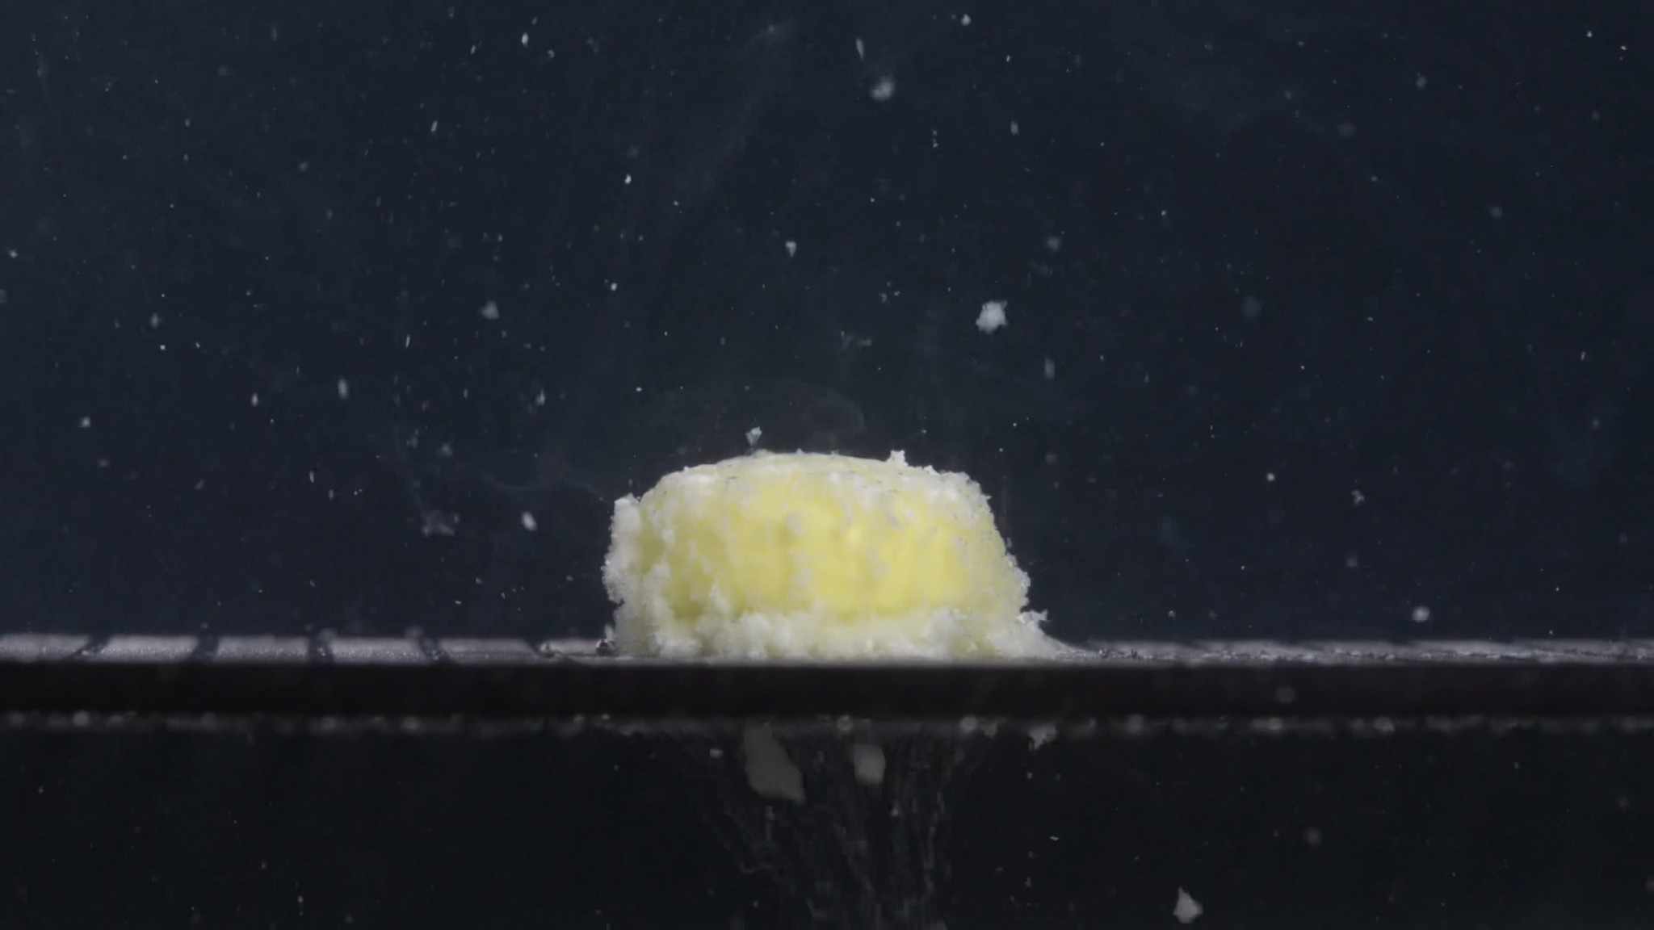
Group B - Pic 2 - 15 minutes
1. Color change: The tablet is no longer uniformly white. A large yellow inner area is visible across the central body of the tablet. White/off-white material remains mainly around the outer edges and lower border. The surrounding medium contains many visible white particles, indicating increased turbidity and particle release.
2. Shape change: The original biconvex shape has been strongly altered. Unlike the 0-minute tablet, the residual mass now looks more like a short, block-like or low cylindrical mound with softened edges. The top remains relatively broad and flattened compared with Group A at 15 minutes, but the side edges are clearly eroded. The tablet still remains mostly as one main body; it has not split into large separate fragments.
3. Surface texture change: The surface has become rough, porous, granular, and powdery. The outer white layer appears loosened and fluffy, especially along the left edge, right edge, and bottom contact area. The yellow central region looks exposed and uneven rather than smooth. No single major crack line is clearly visible; the damage appears mainly as surface erosion and crumbling.
4. Volume / size change: The tablet has lost part of its original height and edge definition. The original smooth side wall is no longer preserved. The residual body is still relatively large, but the visible tablet volume has clearly decreased compared with 0 minutes. There is some spreading or accumulation of loosened material near the base.
5. Dissolution speed and time: By 15 minutes, disintegration is already active and obvious. The outer layer appears to have broken down enough to expose a broad yellow inner region. The process seems moderately fast in the first 15 minutes, with erosion from the surface and edges rather than complete breakup.
6. Physical state change: The tablet has changed from a firm compact solid into a softened, weakened, partially collapsed mass. The matrix appears porous and fragile. The white outer portion is losing cohesion, while the yellow inner material remains as a central residual body.
7. Dissolution medium: The medium contains numerous suspended particles around the tablet. The area near the bottom/support surface has a visible layer of particulate material. Beneath the tablet, faint downward plume-like material is visible, suggesting settling or downward movement of fine particles.
8. Fragment distribution and density: Most fragments are fine powder-like particles, not large chunks. Particle density is highest around the tablet edges, along the bottom support line, and directly below the tablet. Several particles are also scattered throughout the surrounding medium. A few larger flakes or small clumps appear suspended above or near the tablet, but the main tablet body remains cohesive.
Overall observation: At 15 minutes, Group B shows strong early disintegration: the tablet has lost its original smooth white exterior, a broad yellow inner core is exposed, and the outer white material has become loose, granular, and powdery. The tablet remains mainly as one central mass, with fine particles released into the surrounding medium.

Group B - Pic 3 - 30 minutes
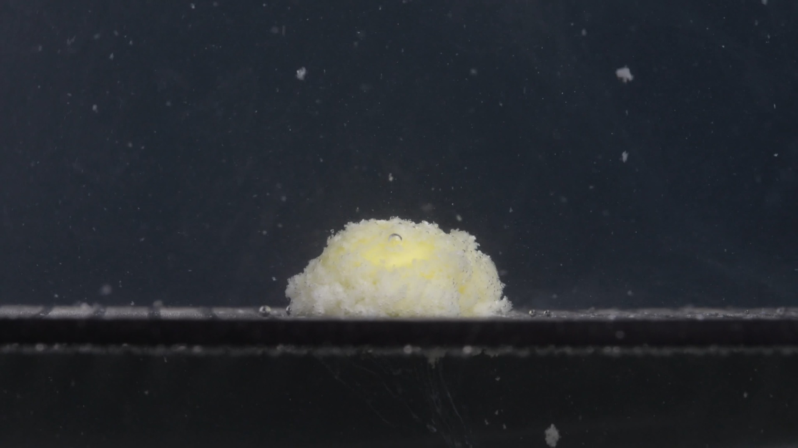
Group B - Pic 3 - 30 minutes
1. Color change: The residual tablet mass remains yellow-white. The yellow inner material is still visible, especially in the central and upper areas. White/off-white material remains around the outer surface and lower edges. The surrounding medium contains many scattered light particles, showing continued release of tablet material.
2. Shape change: The tablet no longer resembles the original intact biconvex tablet. Compared with the 15-minute image, the body appears lower, more rounded, and less block-like. The edges are softened and irregular. The tablet still remains mainly as one cohesive residual mass, without obvious large separated fragments.
3. Surface texture change: The surface is rough, porous, granular, and powdery. The upper surface looks uneven, with loose material around the top and sides. A small droplet or bubble is visible on the top surface, but this should not be interpreted as a crack or tablet fragment. No long, clear fracture line is visible; the main process appears to be surface erosion.
4. Volume / size change: The tablet has clearly lost part of its original height and compact outline compared with 0 minutes. Compared with 15 minutes, the visible residual mass appears slightly lower and more collapsed. A substantial central body still remains, so disintegration is incomplete at 30 minutes. The apparent volume change is qualitative only; the image does not allow a precise percentage estimate.
5. Dissolution speed and time: From 0 to 15 minutes, Group B showed rapid visible change: the white exterior opened and the yellow inner material became exposed. From 15 to 30 minutes, the process continues but appears more gradual. At 30 minutes, the dominant mechanism is slow-to-moderate erosion with fine powder release, not sudden breakup.
6. Physical state change: The tablet appears softened, porous, weakened, and partially collapsed. The structure still holds together as one mound, but the surface looks fragile. The lower part appears flattened against the support surface, suggesting loss of the original rigid tablet geometry.
7. Dissolution medium: The medium contains many fine suspended particles visible against the dark background. Particle density is higher near the tablet and near the bottom/support surface. The medium is particle-rich, but not completely opaque.
8. Fragment distribution and density: Fragments are mainly fine powder-like particles, with a few small flakes or clumps visible in the surrounding field. The densest fragment accumulation is around the tablet base and along the bottom/support line. A faint downward plume-like zone is visible below the tablet, suggesting settling or downward movement of fine material.
Overall observation: At 30 minutes, Group B appears as a yellow-white, rough, porous, low mound. The tablet remains as one main residual body, but the original white biconvex form has disappeared. The disintegration pattern is dominated by surface erosion, yellow inner-material exposure, fine-particle shedding, and bottom sedimentation.

Group B - Pic 4 - 45 minutes
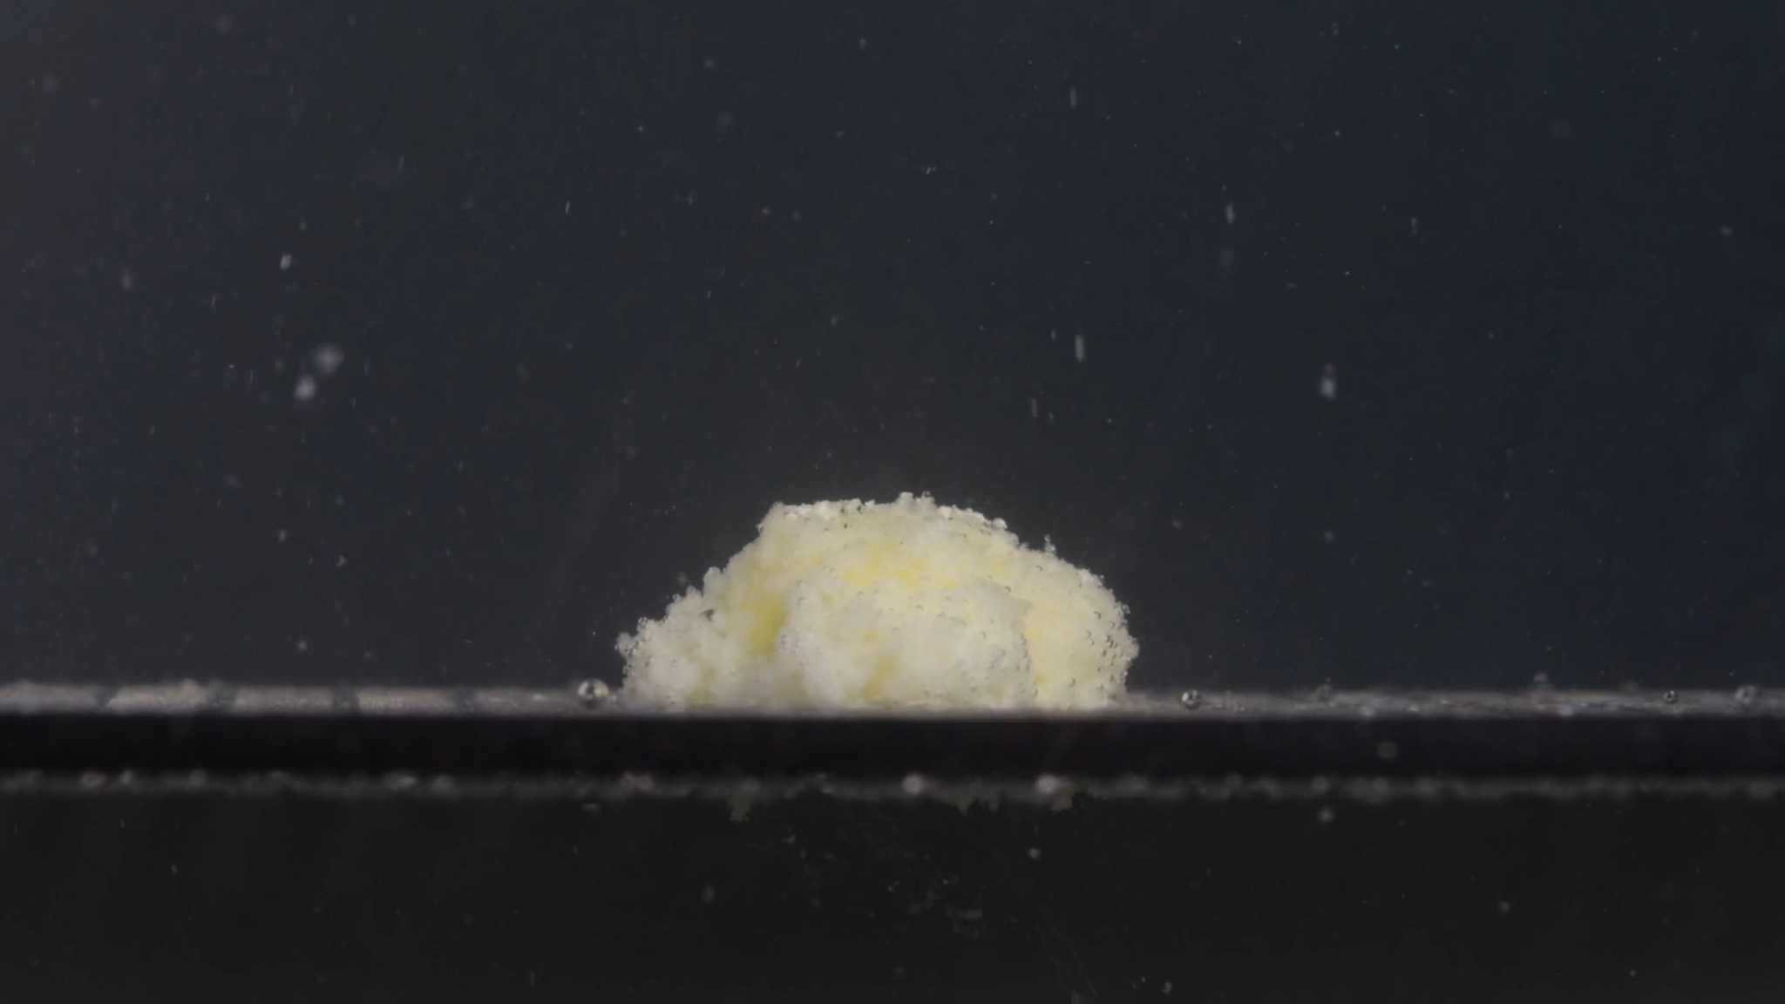
Group B - Pic 4 - 45 minutes
1. Color change: The residual tablet mass is still yellow-white. The yellow color is visible inside the main body, especially in the central and left-middle areas. White/off-white material remains on the outer surface and around the lower edges. The medium contains scattered bright particles, but the whole liquid is not uniformly yellow or fully opaque.
2. Shape change: The original intact biconvex tablet shape is no longer visible. The remaining body is a low, irregular mound resting on the support surface. Compared with 30 minutes, the mound appears slightly flatter and more spread along the base. The edges are soft and uneven rather than sharply defined.
3. Surface texture change: The surface is rough, porous, and powdery. The upper surface has a loose granular appearance. The front and side edges look crumbly, with fine material detaching from the main body. No clear large crack or clean fracture plane is visible; the breakdown appears erosive rather than split-like.
4. Volume / size change: Compared with the 0-minute tablet, the residual mass has clearly lost height, compactness, and the original tablet contour. Compared with the 30-minute image, the volume reduction appears modest. A central residual body is still present, so the tablet is not fully disintegrated at 45 minutes. The apparent size change should be interpreted qualitatively because the image does not provide a fixed measurement scale.
5. Dissolution speed and time: The strongest visible change occurred during the first 15 minutes, when the white exterior opened and the yellow inner material became exposed. From 30 to 45 minutes, the disintegration rate appears slower, with continued powder release but no major collapse. The process is still ongoing at 45 minutes.
6. Physical state change: The tablet appears softened, weakened, porous, and partially collapsed. It remains cohesive as one mound, but its outer structure looks fragile. The lower part appears flattened against the support surface, consistent with loss of the original rigid tablet form.
7. Dissolution medium: Fine particles are visible throughout the surrounding medium. Particle density appears higher near the tablet and along the bottom/support line. The medium is particle-rich, but it does not appear completely clouded.
8. Fragment distribution and density: Fragmentation is mostly in the form of fine powder-like particles. The densest material is concentrated around the base of the tablet and along the support surface. Some particles are suspended above and around the residual mass. No large detached tablet fragments are clearly visible in this image.
Overall observation: At 45 minutes, Group B remains as a yellow-white, low, rough, porous mound. The tablet has lost its original shape, but it has not fully dispersed. The dominant disintegration pattern is gradual erosion, powder shedding, fine suspended particles, and sediment-like accumulation near the bottom.

Group B - Pic 5 - 60 minutes
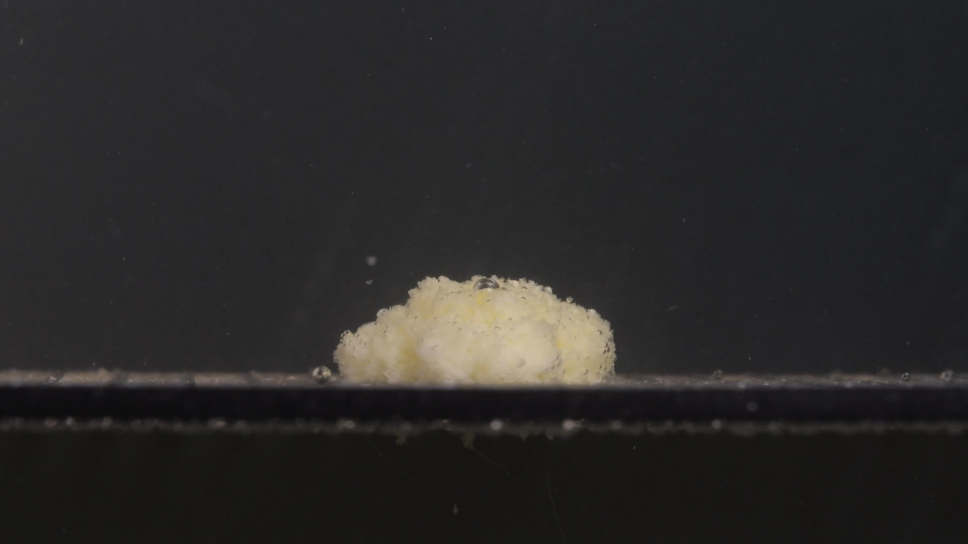
Group B - Pic 5 - 60 minutes
1. Color change: The residual mass is mainly pale yellow to yellow-white. Yellow material is visible within the body, while some whitish material remains on the outer surface. The surrounding medium contains scattered light particles, but the whole liquid does not appear uniformly yellow or completely opaque.
2. Shape change: The original biconvex tablet shape has disappeared. The remaining material forms a low, irregular mound resting on the support surface. The outline is soft and uneven, with no sharp manufactured edges remaining. No large separated chunks are clearly visible.
3. Surface texture change: The surface is rough, granular, porous, and powdery. The upper surface appears loose and fragile. A small droplet or bubble is visible on the upper surface, but it should not be interpreted as a tablet fragment. The texture suggests erosion and crumbling rather than clean splitting.
4. Volume / size change: Compared with the 0-minute image, the tablet has lost much of its original height, side-wall definition, and compact geometry. Compared with 45 minutes, the residual mass appears slightly more eroded, but the change is not dramatic. A substantial central body remains at 60 minutes, so disintegration is incomplete.
5. Dissolution speed and time: The most obvious change occurred within the first 15 minutes, when the white exterior broke down and yellow inner material became exposed. From 15 to 60 minutes, the process became slower and more gradual. At 60 minutes, the dominant process is slow-to-moderate surface erosion with fine powder release.
6. Physical state change: The tablet appears softened, weakened, porous, and partially collapsed. It remains cohesive enough to form one mound, but the surface looks fragile and easily detachable. The bottom is flattened against the support surface, showing loss of the original rigid tablet shape.
7. Dissolution medium: Fine particles are visible in the medium, especially near the tablet and along the bottom/support line. The medium is particle-rich but not fully opaque. There is no obvious large floating fragment cloud.
8. Fragment distribution and density: Fragments are mostly fine powder-like particles. The highest fragment density is near the tablet base and support surface. Some small particles are suspended above and around the residual mass. No major large detached tablet pieces are clearly seen.
Overall observation: At 60 minutes, Group B remains as a yellow-white, low, rough, porous residual mound. The tablet has lost its original shape but has not completely dispersed. The disintegration pattern is mainly surface erosion, powder shedding, yellow inner-material exposure, fine suspended particles, and sediment-like accumulation near the bottom.

5. Final Comparison of Group A and Group B Across the Eight Dimensions
The following comparison is based on the eight-dimensional framework and on visible image features only. It is not chemical confirmation.

1. Color change
Group A: Group A starts as a white/off-white tablet at 0 minutes. By 15 minutes, a yellow inner region appears, and from 30 to 60 minutes the residue remains yellow-white.
Group B: Group B also starts white/off-white. By 15 minutes, a broad yellow inner region is exposed, and from 30 to 60 minutes the residue remains yellow-white.
Comparison: The color change is very similar. Both show the same transition: white exterior to yellow inner material exposure, then to a yellow-white residual mound. This is one of the strongest similarities.

2. Shape change
Group A: Group A is initially an intact thick biconvex tablet. By 15 minutes, it becomes a rounded, irregular mound. From 30 to 60 minutes, it remains as a low dome-like residual mass.
Group B: Group B is also initially an intact thick biconvex tablet. By 15 minutes, it becomes a softened block-like/yellow-white mass, then gradually becomes a low mound by 30 to 60 minutes.
Comparison: The shape-change pattern is highly similar, although Group B looks slightly more block-like at 15 minutes. This difference may come from tablet orientation, contact with the bottom surface, or local wetting differences.

3. Surface texture change
Group A: Group A changes from smooth/matte at 0 minutes to rough, porous, fluffy, and granular by 15 minutes. It remains powdery and porous through 60 minutes.
Group B: Group B changes from smooth/matte at 0 minutes to rough, porous, granular, and powdery by 15 minutes. The same rough porous texture remains through 60 minutes.
Comparison: The surface texture behavior is very similar. Both tablets show surface loosening and powder-like erosion rather than clean cracking or large-piece fracture.

4. Volume / size change
Group A: Group A loses its original height and biconvex shape by 15 minutes. From 30 to 60 minutes, the residual mass becomes only gradually smaller or lower.
Group B: Group B shows a similar loss of original height and compact outline by 15 minutes. From 30 to 60 minutes, gradual reduction continues, but a central mass remains.
Comparison: The overall volume-change pattern is similar. In both groups, most visible size/shape change happens in the first 15 minutes, and both retain a visible residual body at 60 minutes.

5. Dissolution speed and time
Group A: Group A shows rapid visible change from 0 to 15 minutes, followed by slower erosion from 15 to 60 minutes. It is not fully disintegrated by 60 minutes.
Group B: Group B also shows rapid visible change from 0 to 15 minutes, followed by slower erosion from 15 to 60 minutes. It is not fully disintegrated by 60 minutes.
Comparison: The dissolution-time pattern is very similar. Both follow early rapid surface breakdown followed by prolonged slow-to-moderate erosion.

6. Physical state change
Group A: Group A changes from a firm intact tablet to a softened, porous, weakened residual mound, without complete collapse into large fragments.
Group B: Group B changes in the same way: a firm intact tablet becomes a softened, porous, weakened mound, without major large-fragment collapse.
Comparison: The physical-state transition is very similar. Both appear to soften and erode progressively while the remaining body stays cohesive throughout the observed 60 minutes.

7. Dissolution medium
Group A: Group A is initially clear/dark in the surrounding field. Later, it contains many fine suspended particles, especially around the tablet and near the bottom.
Group B: Group B is similarly initially clear/dark, then becomes particle-rich with fine suspended material and bottom accumulation.
Comparison: The dissolution-medium appearance is similar. Both sequences show particle release into the surrounding medium, but not complete uniform opacity.

8. Fragment distribution and density
Group A: Group A mainly produces fine powder-like particles. The highest density is near the tablet surface and bottom/support line, with no obvious large detached fragments.
Group B: Group B also mainly produces fine powder-like particles. The highest density is near the tablet base and support line, with no obvious large detached fragments.
Comparison: The fragment distribution is very similar. Both groups produce fine particulate debris rather than large broken pieces.

6. Key Similarities Supporting Same Drug or Very Similar Formulation
- Same initial morphology: both begin as white/off-white, thick, round, biconvex tablets.
- Same early color transition: both expose yellow inner material by 15 minutes.
- Same disintegration route: both change from intact tablet to rough, porous, yellow-white mound.
- Same fragmentation style: both mainly release fine powder-like particles, not large fragments.
- Same time pattern: rapid change in the first 15 minutes, then slower erosion from 15 to 60 minutes.
- Same final state at 60 minutes: both still have a central residual mound and are not fully dissolved or disintegrated within the observed hour.

7. Minor Differences
- At 15 minutes, Group B appears slightly more block-like and upright, while Group A appears more rounded and dome-like.
- Group B seems to have a broader yellow exposed area at 15 minutes.
- Group A's mound appears slightly smoother and more rounded in some later frames.
- These differences are not large enough to strongly suggest a different drug. They could be caused by tablet orientation, camera angle, local wetting, lighting, or normal tablet-to-tablet variation.

8. Final Determination
Based on the full 0- to 60-minute visual sequence, Group A and Group B are likely from the same drug, or at least from a very similar formulation.
This should not be considered chemical proof, because image analysis alone cannot confirm the active ingredient. However, the full disintegration behavior across all eight dimensions is visually highly consistent between the two groups.
The strongest evidence is the matching pattern: white intact biconvex tablet -> yellow inner material exposure by 15 minutes -> rough porous yellow-white mound -> gradual surface erosion -> fine powder release -> residual central mass still present at 60 minutes.
Therefore, the visual evidence supports that Group A and Group B are more likely the same drug or the same/similar formulation than clearly different drugs.

