Doxycycline Hyclate Tablets: Disintegration Image Analysis
Edited English Record of the Drug-Disintegration Discussion

Scope Note
This Word document is an edited English version of the conversation related to the analysis of two groups of Doxycycline Hyclate Tablet disintegration images. It includes the preparation framework, the image-by-image descriptions for Group A and Group B, and the final comparison across eight disintegration dimensions. The final Chinese request to create this document is intentionally omitted. The image-based conclusions are visual assessments only and cannot chemically confirm drug identity.

User Objective
The user requested an analysis of two image groups, Group A and Group B. Each group contains five images taken 15 minutes apart, at 0, 15, 30, 45, and 60 minutes. The goal was to describe the disintegration process of each group in English and determine whether the two sets of images appear to be from the same drug.

Knowledge Base Framework Used for the Analysis
The analysis was structured according to the Knowledge Base guidance for describing drug disintegration images. Every image was considered through the following eight fixed dimensions:
- Color change: Color intensity, turbidity, transparency, and spatial distribution of color in the liquid.
- Shape change: Whether the tablet remains intact, becomes rounded or eroded, cracks, collapses, or breaks into irregular fragments.
- Surface texture change: Smoothness, roughness, pores, cracks, peeling, flakes, powdery surface, or fibrous/fluffy structures.
- Volume / size change: Reduction in diameter or height, swelling, shrinkage, flattening, collapse, and contour clarity.
- Dissolution speed and time: How quickly visible changes occur at each time point, including acceleration or slowing.
- Physical state change: Liquid penetration, swelling, internal weakening, cracking, particle formation, and collapse.
- Dissolution medium: Clarity, cloudiness, sediment, bubbles, suspended particles, and visible medium changes.
- Fragment distribution and density: Particle number, size, position, suspension, sedimentation, and density around or below the tablet.

Group A Image Sequence
The following images were provided as a time sequence for visual disintegration analysis.
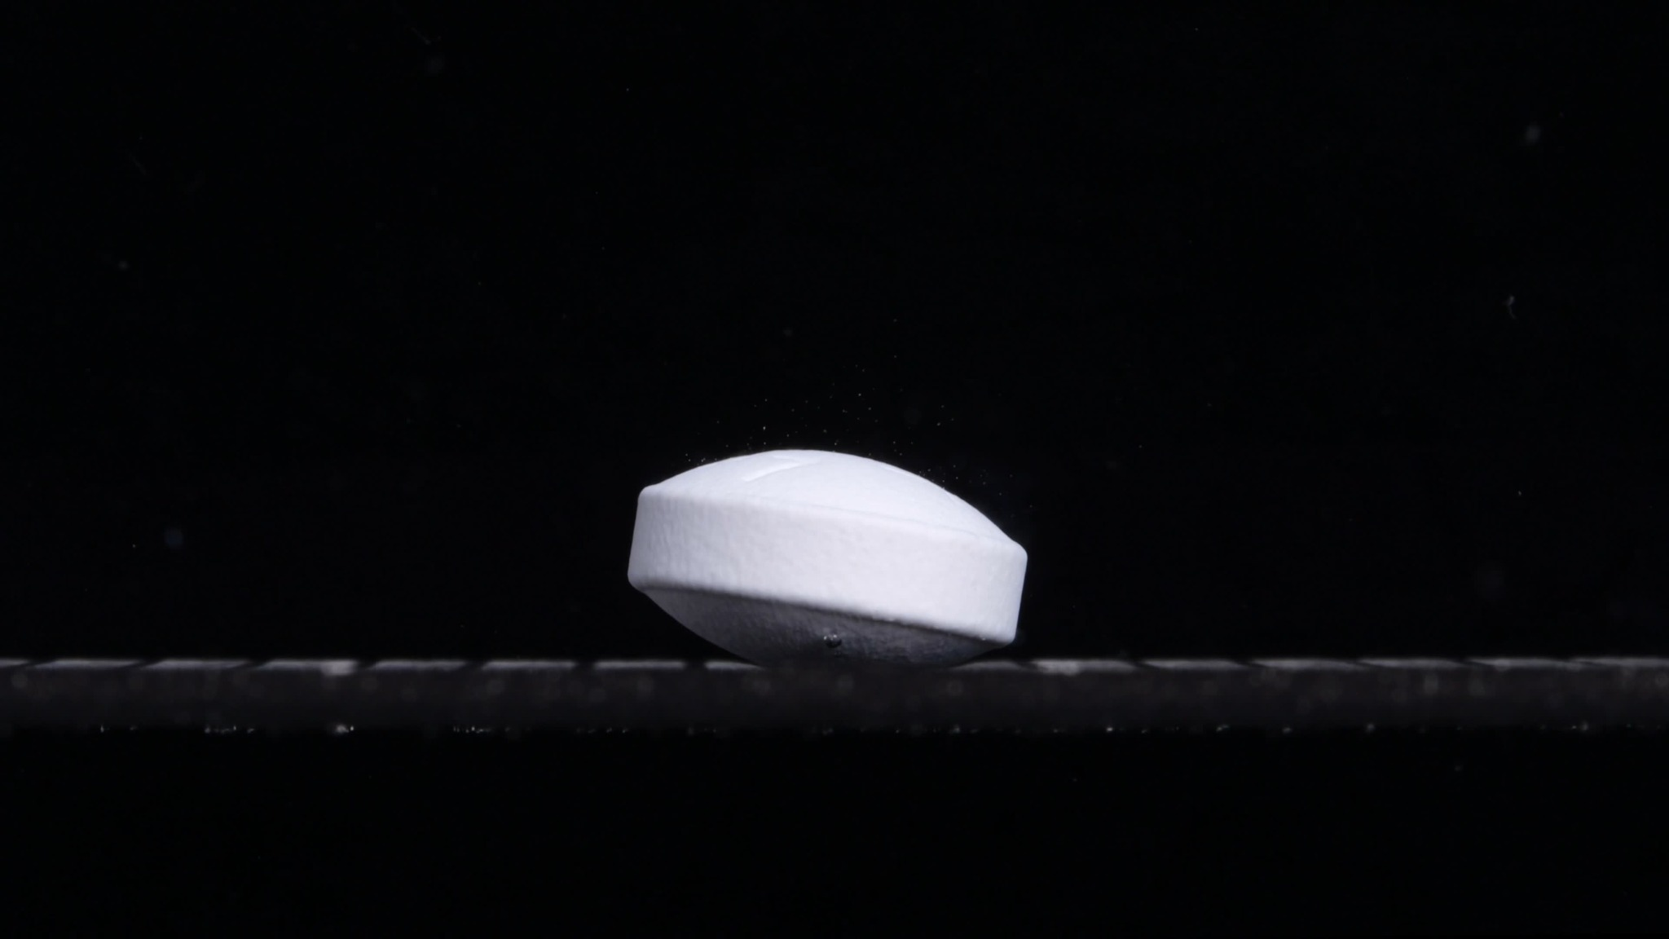  Group A - 0 minutes | 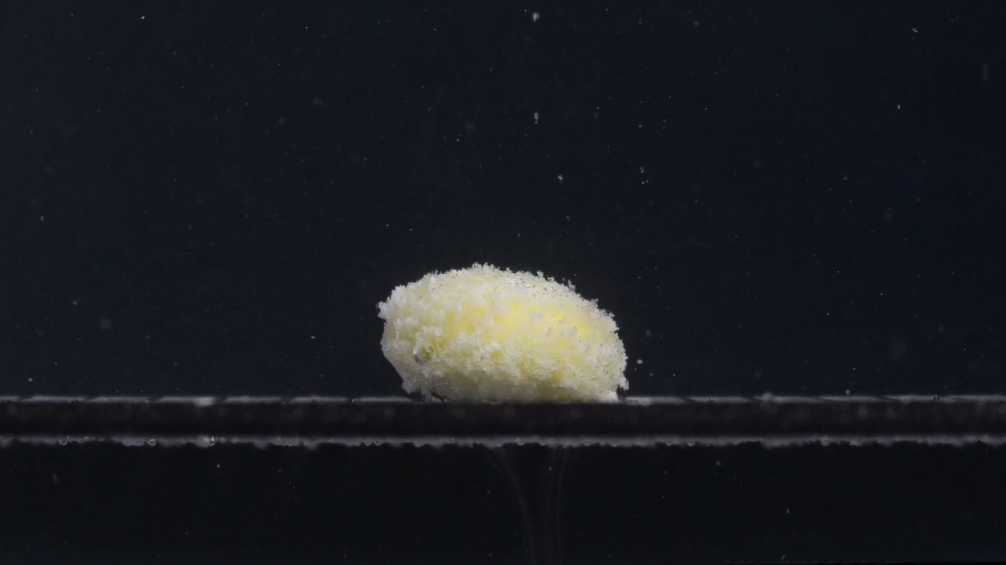  Group A - 15 minutes
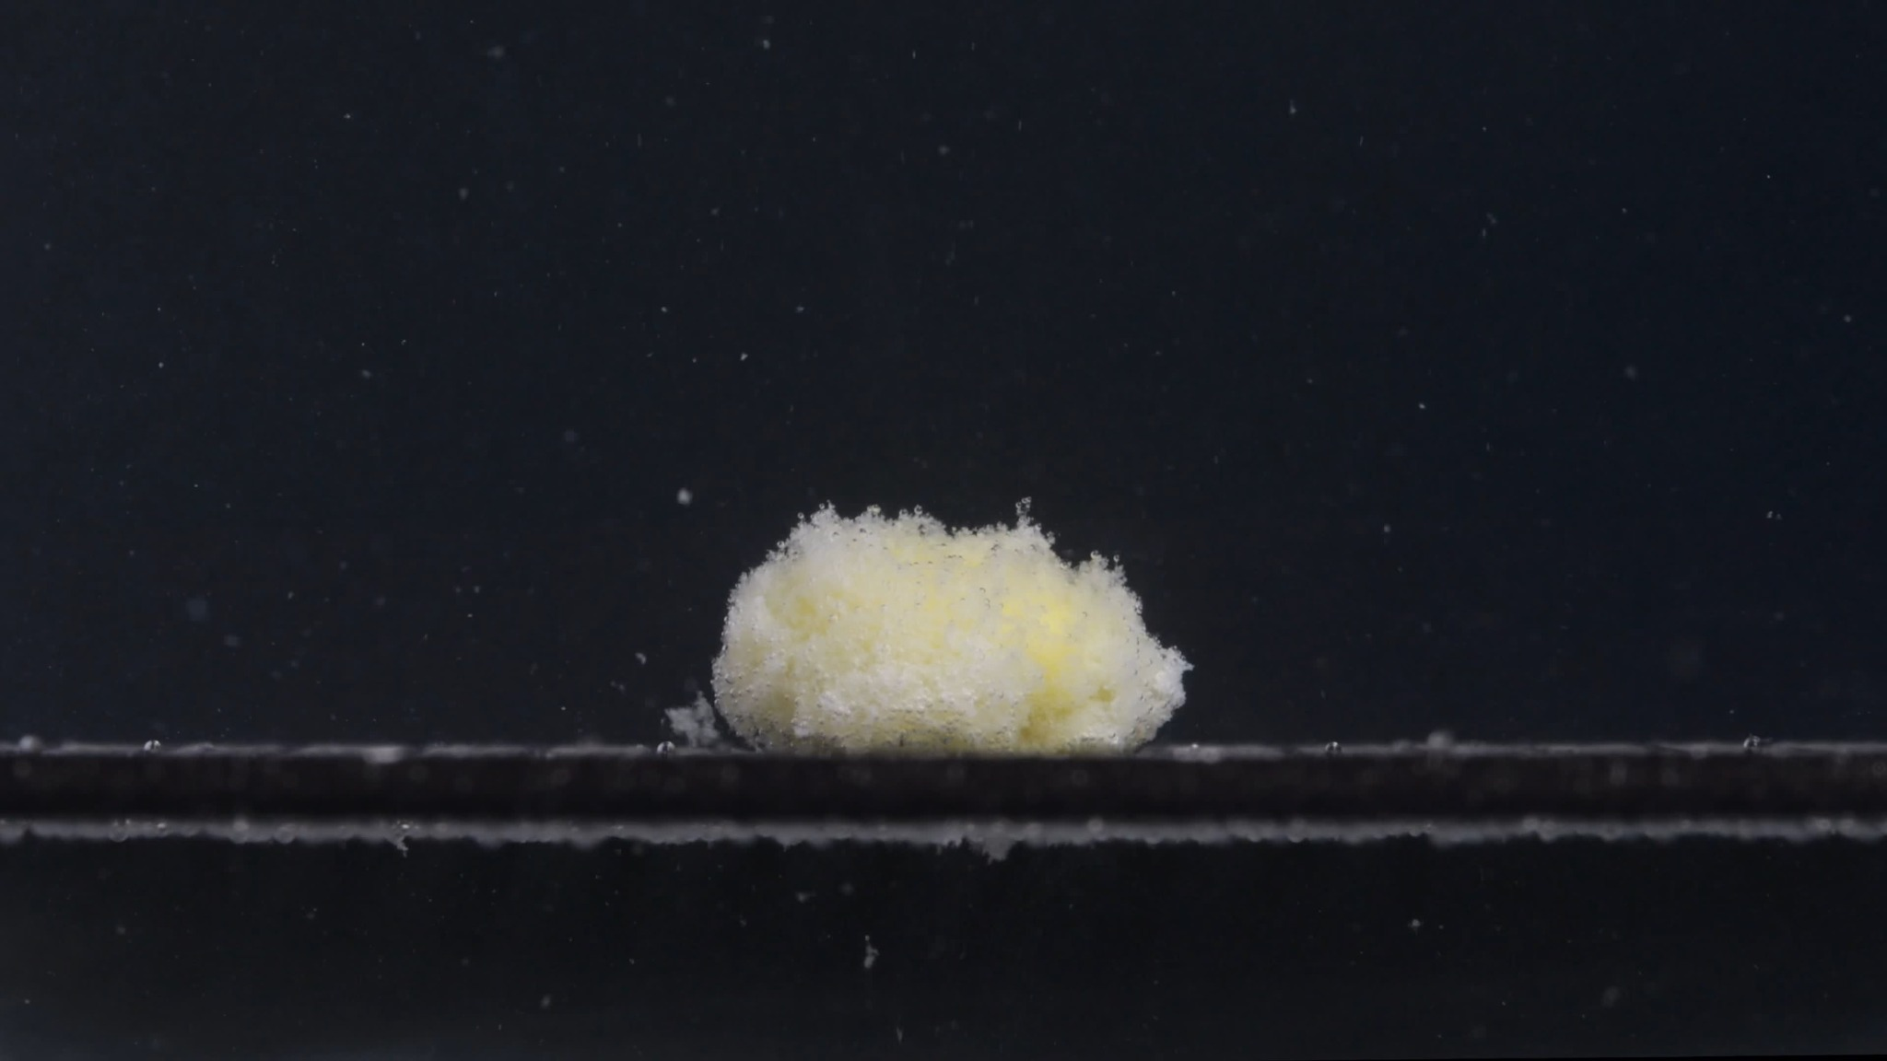  Group A - 30 minutes | 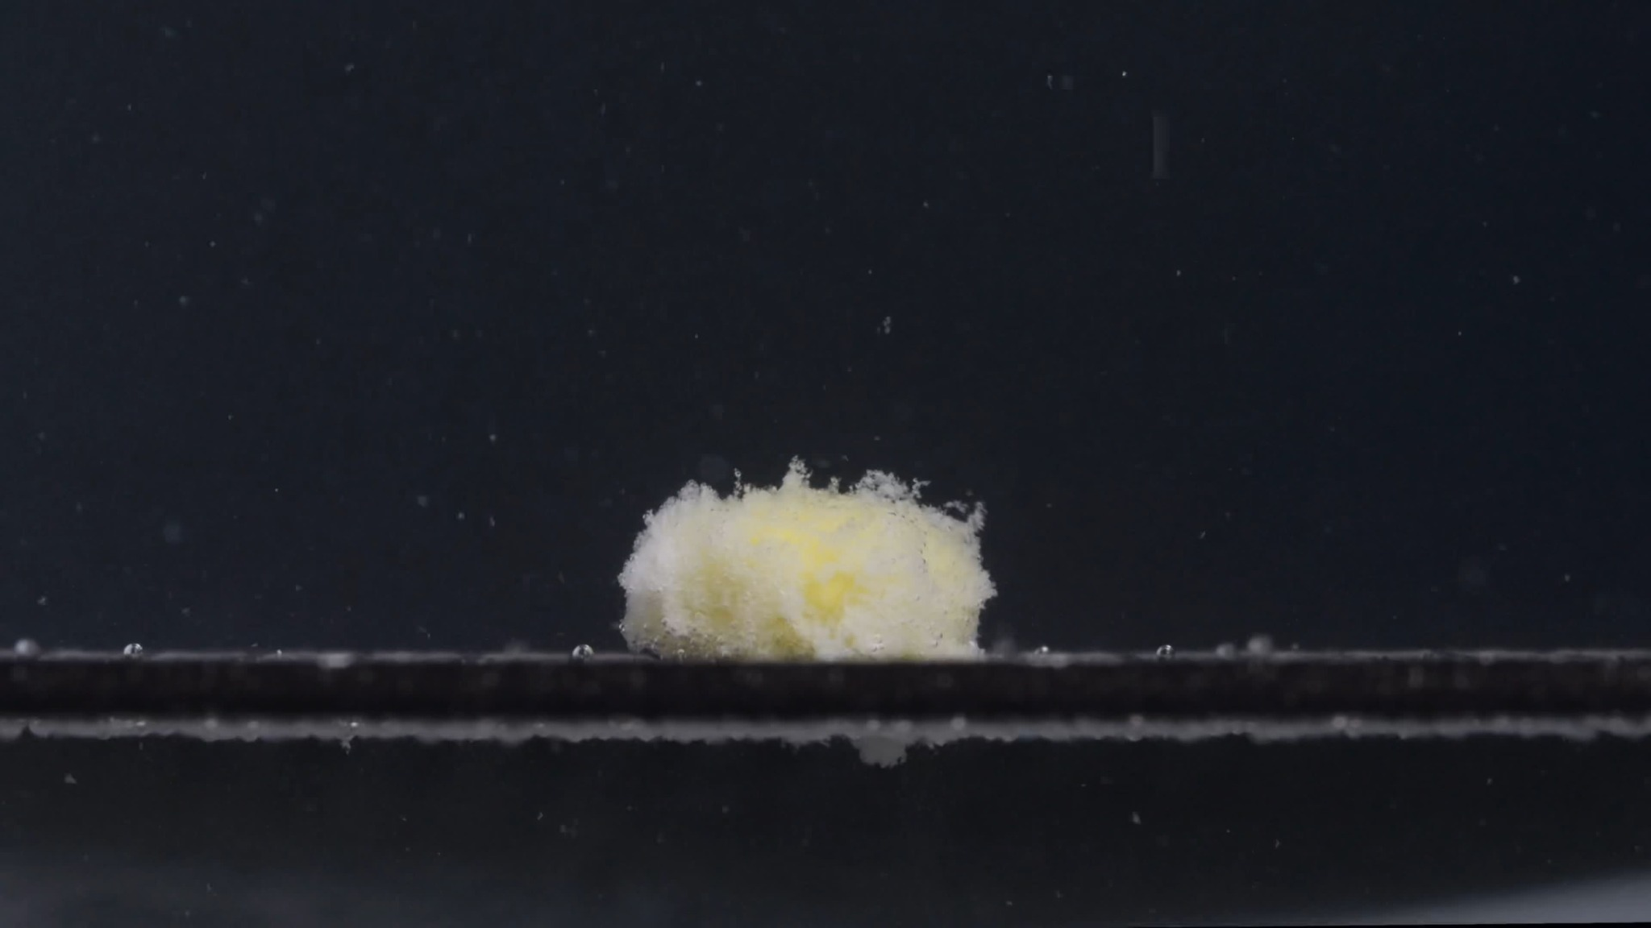  Group A - 45 minutes
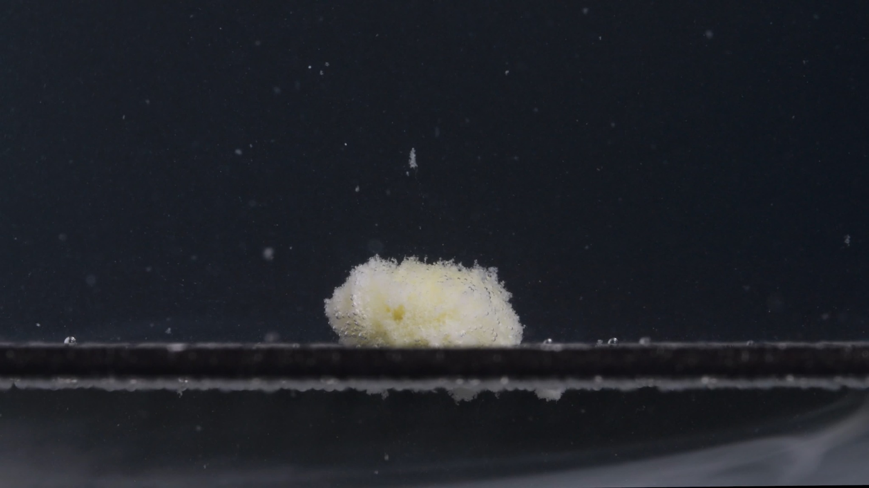
Group A - 60 minutes

Group A: Image-by-Image Disintegration Description

Group A - 0 minutes
Dimension | Description
Color change | The tablet is mostly white to off-white. No obvious yellow core is visible yet. The surrounding medium appears dark and visually clear, with no visible clouding around the tablet.
Shape change | The tablet remains intact. It has an oblong, biconvex or caplet-like form with a clear beveled side edge. The outline is still sharp and regular.
Surface texture change | The surface appears relatively smooth and compact, with only slight fine texture visible on the side. No obvious cracks, peeling, or powder shedding are seen.
Volume / size change | This is the baseline size. The tablet still has its full height and width, with a well-defined raised upper surface and a solid side wall.
Dissolution speed and time | At 0 minutes, there is no visible disintegration. Liquid penetration has not yet produced visible swelling, erosion, or fragmentation.
Physical state change | The tablet appears solid and structurally stable. No collapse or internal exposure is visible.
Dissolution medium | The medium remains visually clear and dark. There is no obvious suspended powder cloud near the tablet.
Fragment distribution and density | No detached fragments are visible. The tablet mass is concentrated entirely in the original intact body.

Group A - 15 minutes
Dimension | Description
Color change | A clear yellow coloration appears inside the tablet mass, especially in the central region. The outer material remains whitish, suggesting that the surface layer has hydrated or opened while the yellow inner material becomes exposed.
Shape change | The original smooth caplet shape is no longer preserved. The tablet has changed into a rounded, swollen mound with an irregular contour. The sharp beveled edge from 0 minutes has disappeared.
Surface texture change | The surface is now rough, porous, and sponge-like. Fine granules or softened particles cover the exterior. The surface looks loosened rather than compact.
Volume / size change | Compared with 0 minutes, the apparent tablet body looks expanded and puffed, especially vertically and around the upper surface, because of swelling and porous particle formation. However, the original solid outline has been lost.
Dissolution speed and time | Between 0 and 15 minutes, the major visible transition occurs: the tablet changes from intact to strongly hydrated and partially disintegrated. This suggests a relatively fast initial breakdown after liquid penetration.
Physical state change | The tablet appears to have absorbed liquid, swollen, and softened. The inner yellow material is exposed, while the outer white structure has become loose and friable.
Dissolution medium | The medium contains small suspended specks around the tablet, but it is not heavily turbid. Most material remains attached to the tablet mound.
Fragment distribution and density | Small particles are visible near the surface and immediately around the tablet. Fragment density is highest close to the tablet, with little wide dispersion.

Group A - 30 minutes
Dimension | Description
Color change | The yellow coloration is still visible but partly covered by white, fluffy disintegrated material. The tablet appears pale yellow-white overall.
Shape change | The tablet is now a larger, irregular, fluffy mound. The top boundary is uneven, with small protrusions and loose particle clusters. The original caplet geometry is completely gone.
Surface texture change | The surface is highly granular, porous, and wool-like. It looks less like a solid tablet and more like a mass of hydrated powder and soft fragments.
Volume / size change | The apparent width looks slightly more spread out than at 15 minutes, likely due to loosening and outward expansion of the disintegrated material. The height is still substantial, but the structure is less compact.
Dissolution speed and time | From 15 to 30 minutes, disintegration continues mainly through surface loosening and particle generation rather than complete dissolution. The breakdown remains active, but the mass still holds together.
Physical state change | The tablet has transitioned into a semi-cohesive wet particulate mass. The surface appears weakened and unstable, but no large separate chunks are clearly detached.
Dissolution medium | Fine particles are visible in the medium around the tablet. The liquid is slightly populated with suspended specks, but most disintegrated matter remains close to the original tablet position.
Fragment distribution and density | Fragment density is concentrated around the mound and along the bottom support. A few particles appear suspended above and around the tablet, while heavier material stays near the base.

Group A - 45 minutes
Dimension | Description
Color change | The tablet mass remains pale yellow-white. The yellow regions are less sharply defined and appear more diffused within the softened mass.
Shape change | The mound becomes lower and more compact than at 30 minutes. The top is still irregular, but the overall height appears reduced. The tablet is no longer expanding; it is beginning to settle and collapse.
Surface texture change | The surface remains rough and porous, but it looks slightly denser than at 30 minutes. Some fluffy protrusions persist along the top edge.
Volume / size change | A visible reduction in height occurs compared with 30 minutes. The mass appears to have partially collapsed downward, with less vertical expansion.
Dissolution speed and time | The disintegration rate appears to slow after the strong initial breakdown. By 45 minutes, the process is dominated by gradual erosion, settling, and compaction rather than rapid shape change.
Physical state change | The tablet has become a softened aggregate. Internal structure is likely weakened, and the mass is settling under its own weight.
Dissolution medium | The surrounding medium contains scattered fine particles. There is no dense cloud spreading far from the tablet.
Fragment distribution and density | Fragments remain densest near the base of the mound. The distribution is still localized, with limited outward movement.

Group A - 60 minutes
Dimension | Description
Color change | The remaining mass is pale yellow-white, with yellow areas still visible inside. The color looks more muted and mixed than earlier.
Shape change | The tablet is now a flattened, irregular residue mound. The height is clearly lower than at 15 to 30 minutes, and the upper contour is less raised.
Surface texture change | The surface remains rough and granular. It looks like a compacted wet powder mass rather than a coherent tablet.
Volume / size change | The visible height has decreased further. The residue appears smaller and flatter, suggesting continued erosion and collapse after the earlier swelling stage.
Dissolution speed and time | By 60 minutes, disintegration is incomplete but advanced. The process has slowed, with the remaining material persisting as a cohesive residue rather than fully dispersing.
Physical state change | The original tablet structure has been destroyed. The remaining material is a softened, porous, partially collapsed aggregate.
Dissolution medium | The medium still shows scattered particles, but the bulk of the drug residue remains settled at the original location.
Fragment distribution and density | Most fragments are concentrated at the bottom around the tablet residue. Fine particles are sparsely suspended, while denser material has settled.

Group A Overall Interpretation
Group A shows a clear sequence: at 0 minutes, an intact white caplet-like tablet is visible; at 15 minutes, rapid swelling, yellow core exposure, and loss of the original shape occur; at 30 minutes, the tablet reaches a maximum fluffy or porous disintegration appearance; at 45 minutes, the mass partially collapses and compacts; and by 60 minutes, a flattened yellow-white residue remains. The key identifying features for comparison are the white intact starting tablet, the yellow inner material appearing after hydration, the rapid transformation into a fluffy porous mound by 15 to 30 minutes, and the gradual flattening and settling by 45 to 60 minutes.

Group B Image Sequence
The following images were provided as a time sequence for visual disintegration analysis.
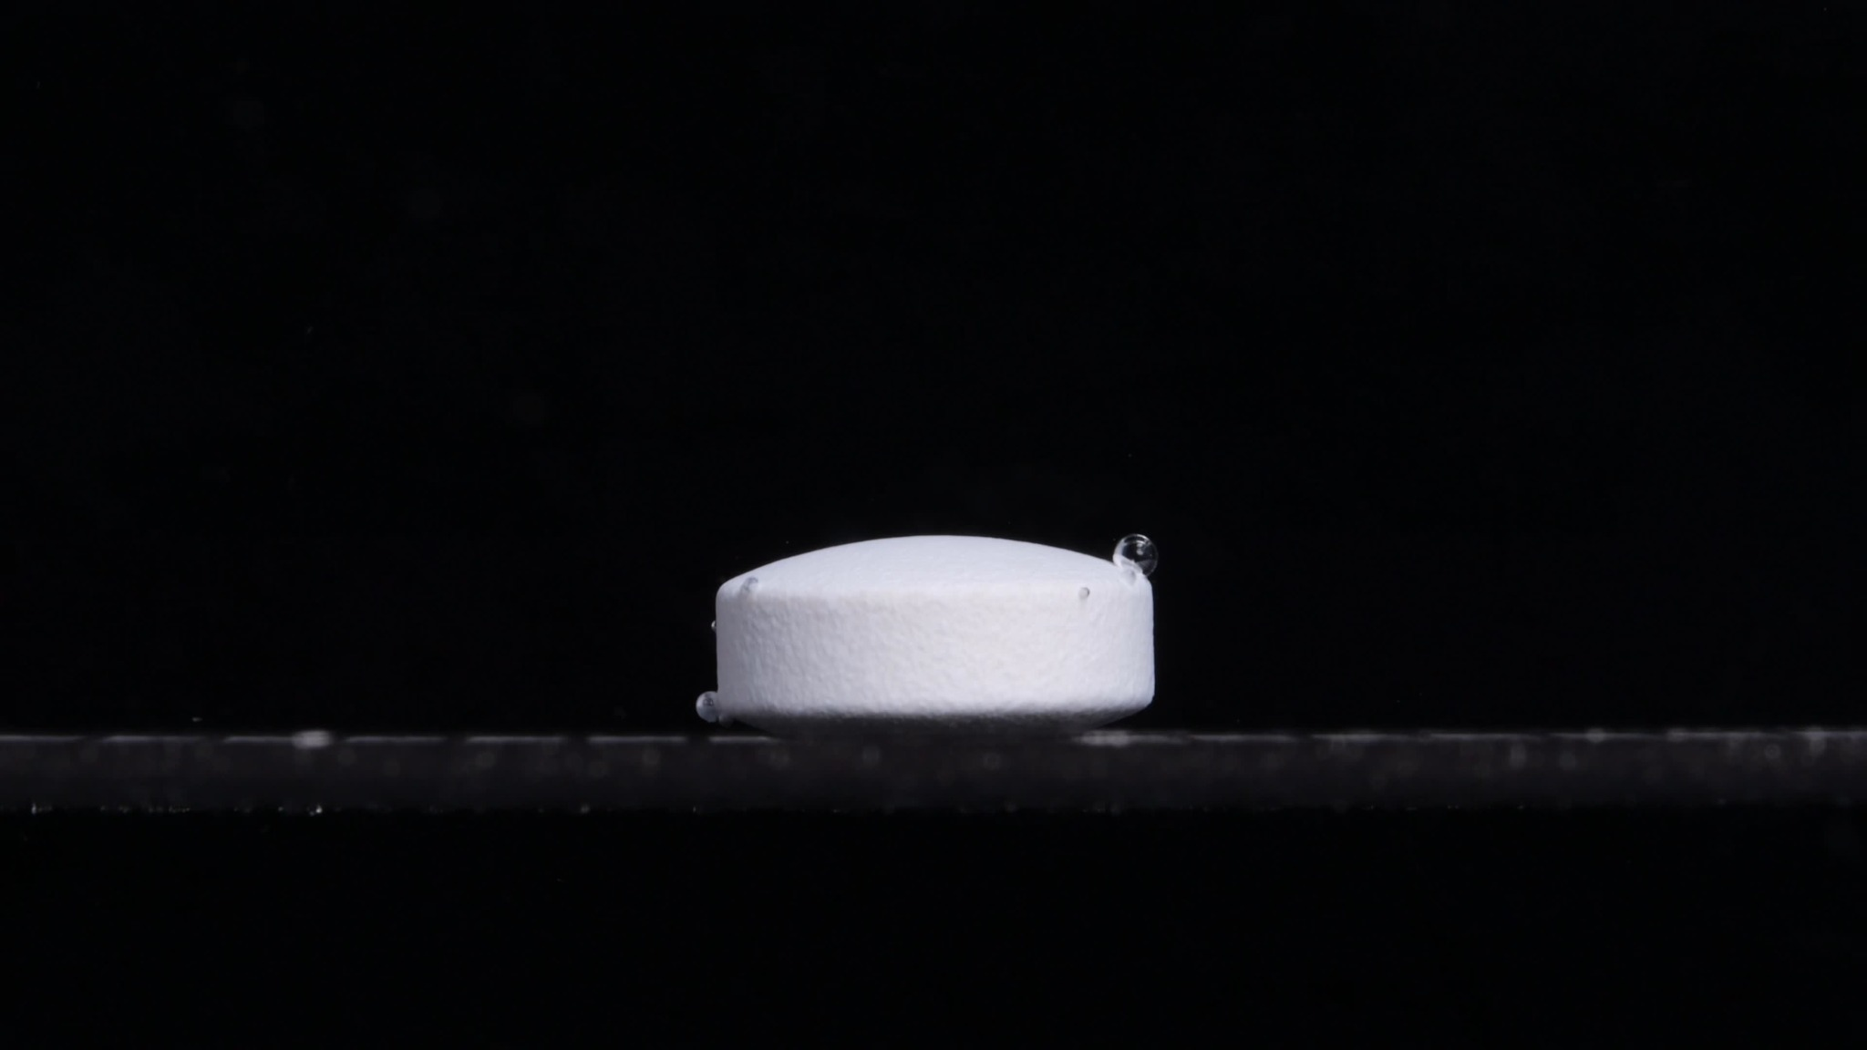  Group B - 0 minutes | 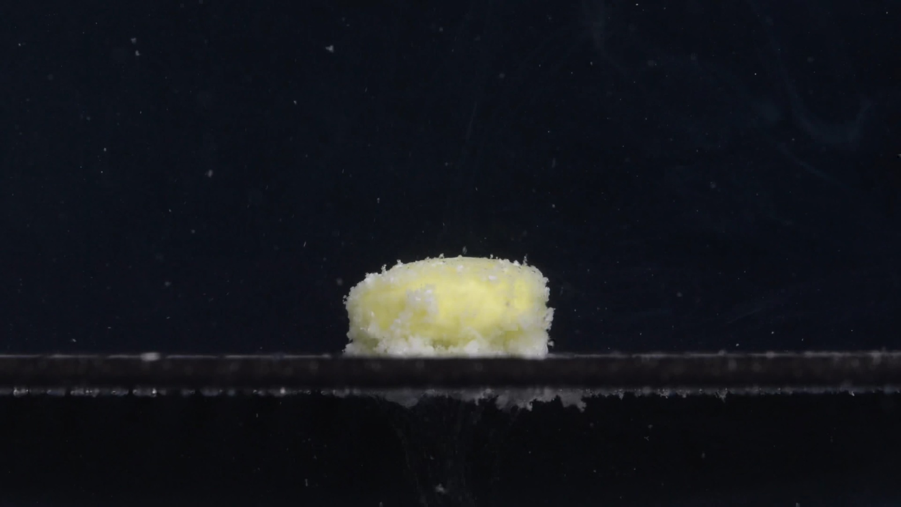  Group B - 15 minutes
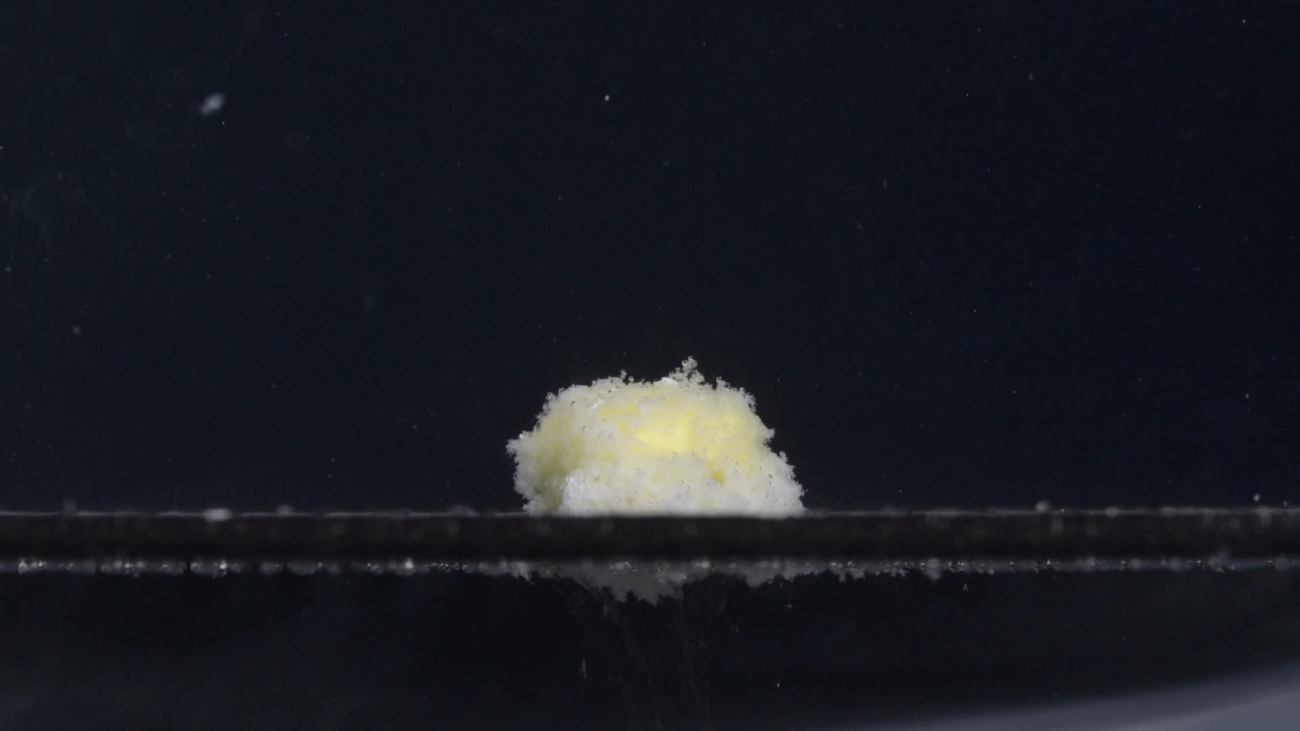  Group B - 30 minutes | 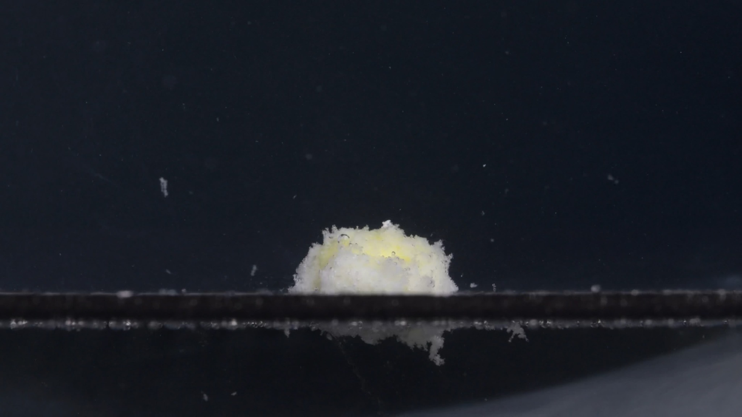  Group B - 45 minutes
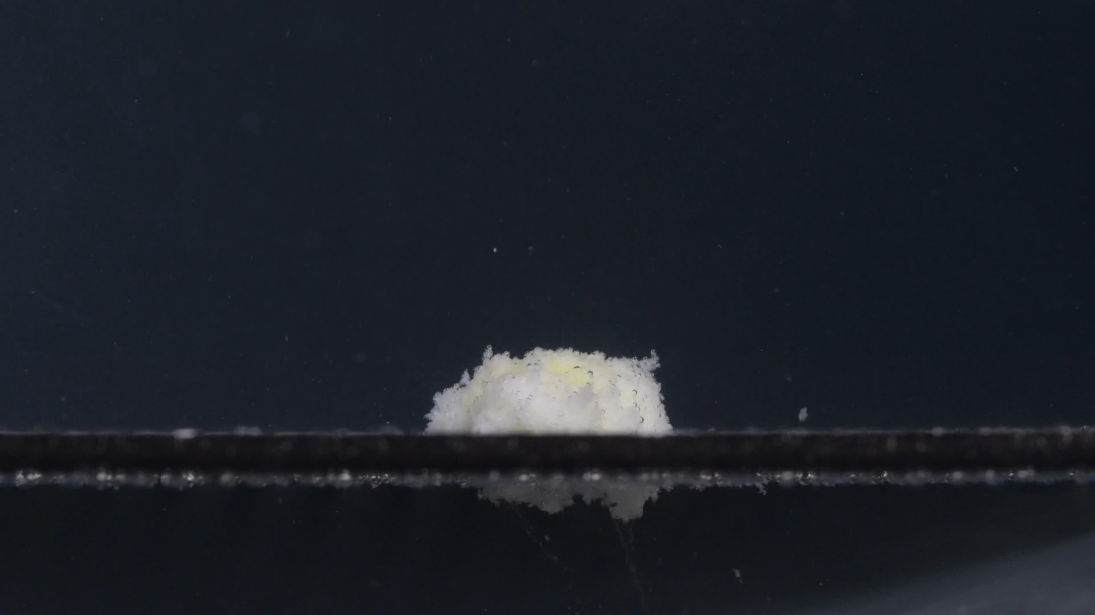
Group B - 60 minutes

Group B: Image-by-Image Disintegration Description

Group B - 0 minutes
Dimension | Description
Color change | The tablet is uniformly white to off-white. No yellow inner material is visible at this stage. The surrounding medium appears visually clear and dark, without obvious turbidity.
Shape change | The tablet is still intact. It appears as a round, short cylindrical tablet with a flat upper surface and a vertical side wall. The outline is regular and sharply defined.
Surface texture change | The surface looks compact and mostly smooth, with slight fine roughness on the side wall. No visible cracking, peeling, or powder shedding is present.
Volume / size change | This is the baseline size. The tablet has full height and width, and the contour remains complete.
Dissolution speed and time | At 0 minutes, no visible disintegration has occurred.
Physical state change | The tablet remains solid and mechanically stable. There is no visible swelling or collapse.
Dissolution medium | The surrounding medium is clear, with a few bubbles attached to the tablet surface.
Fragment distribution and density | No drug fragments are visible. All material remains in the intact tablet body.

Group B - 15 minutes
Dimension | Description
Color change | A yellow inner region becomes clearly visible across the upper and central tablet mass. White material remains around the lower edge and outer surface.
Shape change | The tablet loses its original sharp cylindrical shape. Compared with Group A at 15 minutes, Group B still keeps a slightly more compact, block-like mound. The side boundary is softened but not completely dispersed.
Surface texture change | The surface becomes rough, porous, and granular. Fine white particles appear around the outer edge, especially near the base.
Volume / size change | The tablet appears swollen and loosened. Its height is still substantial, but the original smooth side wall has changed into a hydrated, irregular surface.
Dissolution speed and time | The main transformation between 0 and 15 minutes is rapid hydration and exposure of the yellow internal material. This suggests active early disintegration.
Physical state change | Liquid penetration appears to have weakened the tablet internally. The outer white layer becomes friable, while the yellow inner material is exposed.
Dissolution medium | The medium contains scattered fine particles, but most material remains attached to the tablet mound.
Fragment distribution and density | Fragments are concentrated close to the tablet base. There is limited outward dispersion.

Group B - 30 minutes
Dimension | Description
Color change | The tablet remains pale yellow-white. The yellow region is still visible near the center and upper part, but it is partly covered by white granular material.
Shape change | The tablet becomes a rounded, irregular mound. The top is uneven and fluffy, and the original cylindrical outline is no longer present.
Surface texture change | The surface is highly porous and powdery, with small raised granules. The edge is no longer smooth and appears eroded.
Volume / size change | The apparent height is similar or slightly increased compared with 15 minutes because the hydrated material has expanded into a loose mound. The solid compact volume is reduced, even though the visible fluffy mass occupies space.
Dissolution speed and time | From 15 to 30 minutes, the process continues through surface erosion and particle formation. The disintegration remains active but not explosive; the mass still stays localized.
Physical state change | The original tablet has become a semi-cohesive wet powder aggregate. It has not fully dissolved or dispersed.
Dissolution medium | Fine particles are visible in the surrounding medium. Turbidity remains relatively mild and localized.
Fragment distribution and density | Most fragments remain near the original tablet position, especially at the bottom. Small particles are suspended sparsely above and around the mound.

Group B - 45 minutes
Dimension | Description
Color change | The yellow color becomes less dominant and more hidden within the white disintegrated material. The overall appearance is pale yellow-white.
Shape change | The mound becomes lower and more collapsed than at 30 minutes. Its upper surface remains irregular, but the overall height is reduced.
Surface texture change | The surface is still rough and fluffy, but the structure appears more compacted. Some loose particles are visible at the top and edges.
Volume / size change | There is a clear reduction in height compared with the earlier swollen stage. The tablet residue settles downward.
Dissolution speed and time | The disintegration rate appears to slow after 30 minutes. The dominant process is now gradual collapse, erosion, and sedimentation rather than rapid expansion.
Physical state change | The tablet is no longer a coherent solid. It is a softened, partially collapsed aggregate of hydrated particles.
Dissolution medium | There are visible suspended particles and some sediment-like material below the tablet area. The main residue remains localized.
Fragment distribution and density | Fragment density is highest at the base and immediately below the tablet. Some fine particles are dispersed in the surrounding liquid, but there is no broad cloud covering the whole field.

Group B - 60 minutes
Dimension | Description
Color change | The residue is mainly white to pale yellow-white. Only faint yellow areas remain visible.
Shape change | The tablet has become a low, flattened, irregular residue mound. The original tablet shape is completely lost.
Surface texture change | The surface remains granular and porous, but it appears more compact and settled than at 30 minutes.
Volume / size change | The height is further reduced compared with 45 minutes. The residue is flatter and smaller, indicating continued collapse and erosion.
Dissolution speed and time | By 60 minutes, disintegration is advanced but not complete. A visible residue remains, so the tablet has not fully dissolved into the medium.
Physical state change | The tablet has changed from a solid compact body into a wet, fragmented, partially compacted residue.
Dissolution medium | The surrounding medium contains fine suspended particles and settled material near the bottom or support surface.
Fragment distribution and density | Most fragments remain close to the original tablet position, with the highest density below and around the residue. Fine particles are only sparsely dispersed farther away.

Comparison Between Group A and Group B

Strong Similarities
Both groups show the same major disintegration pattern: at 0 minutes, an intact white or off-white tablet is present; at 15 minutes, yellow internal material becomes exposed and the outer white layer becomes loose and granular; at 30 minutes, the tablet forms a fluffy, porous yellow-white mound; at 45 minutes, the mound begins to collapse and compact; and by 60 minutes, a flattened residue remains, with disintegration advanced but incomplete.
The most important shared features are the white exterior, yellow inner region, rapid early swelling, porous/fluffy surface, localized fragment distribution, and gradual collapse after 30 minutes.

Visible Differences
Group A at 0 minutes appears more tilted or obliquely positioned, with a more biconvex-looking profile. Group B at 0 minutes appears more upright and cylindrical, with a flatter top and clearer vertical side wall. Group A at 15 to 30 minutes looks slightly more expanded and fluffy. Group B looks a little more compact at 15 minutes and appears to collapse somewhat more by 60 minutes. At 60 minutes, Group A retains a slightly taller and more yellow-visible residue, while Group B appears flatter and whiter with less obvious yellow exposure.

Eight-Dimension Comparison
Dimension | Group A | Group B | Comparison
Color change | Starts white/off-white at 0 minutes. By 15 minutes, yellow internal material appears. From 30 to 60 minutes, the residue remains pale yellow-white. | Also starts white/off-white. Yellow internal material appears clearly by 15 minutes, then becomes mixed with white porous residue. | Highly similar. Both show the same white exterior and yellow inner exposure pattern. This is one of the strongest signs that the two groups may be the same or very similar.
Shape change | At 0 minutes, the tablet appears intact but slightly tilted or oblique, with a biconvex or caplet-like profile. By 15 minutes, the original shape is lost and becomes a swollen mound. | At 0 minutes, the tablet appears more upright and cylindrical, with a flatter top. By 15 minutes, the original shape is also lost and becomes a swollen mound. | Mostly similar after disintegration begins. The initial 0-minute shape looks different, but this may be due to tablet orientation and imaging angle. The later shape-change pathway is very similar.
Surface texture change | Smooth compact surface at 0 minutes; rough, porous, fluffy, granular surface after 15 to 30 minutes. | Smooth compact surface at 0 minutes; rough, porous, granular/fluffy surface after 15 to 30 minutes. | Highly similar. Both tablets develop a sponge-like, wet powder surface.
Volume / size change | Appears to swell strongly by 15 to 30 minutes, then gradually collapses and flattens by 45 to 60 minutes. | Also swells by 15 to 30 minutes, then collapses and becomes flatter by 45 to 60 minutes. | Highly similar. Both show the same sequence: initial swelling/expansion followed by settling and volume reduction.
Dissolution speed and time | Major transformation occurs between 0 and 15 minutes. Maximum fluffy porous mass is around 15 to 30 minutes. Slower collapse occurs from 45 to 60 minutes. | Same general timing: rapid change between 0 and 15 minutes, strong porous disintegration by 30 minutes, slower collapse afterward. | Highly similar. The disintegration timeline almost matches across the two groups.
Physical state change | Changes from solid compact tablet to hydrated, softened, porous aggregate. Internal yellow material becomes exposed. | Same transition from solid tablet to hydrated, softened, porous aggregate with exposed yellow material. | Highly similar. The internal and external structural breakdown pattern is consistent.
Dissolution medium | Medium remains relatively clear/dark, with scattered particles. No large dense cloud spreads throughout the whole field. | Medium also remains relatively clear/dark, with scattered fine particles and localized residue. | Similar. Both show localized particle release rather than strong whole-medium turbidity.
Fragment distribution and density | Fragments mostly stay near the original tablet position and base. Fine particles are sparse in the surrounding medium. | Fragments also remain concentrated near the base, with limited outward dispersion. | Highly similar. Both show localized sediment or residue rather than wide fragment dispersal.

Final Determination
Based on the visible disintegration characteristics across the eight dimensions, Group A and Group B are most likely from the same drug or from a highly similar formulation, rather than clearly different drugs.
The reasoning is that both groups share the same overall disintegration sequence: white intact tablet -> yellow inner material exposed by 15 minutes -> fluffy porous yellow-white mound by 15 to 30 minutes -> gradual collapse and flattening by 45 to 60 minutes -> localized residue remains. The shared yellow internal exposure, porous swollen mound formation, slow later collapse, and localized fragment distribution are strong visual similarities.
The main difference is the 0-minute appearance. Group A looks more tilted or biconvex from the side, while Group B looks more upright and cylindrical. Because the later disintegration behavior is highly similar, this difference is more plausibly explained by tablet orientation, camera angle, placement on the support surface, bubble attachment, or ordinary sample-to-sample variation, rather than by a clearly different drug identity.
Final visual judgment: Group A and Group B are likely the same Doxycycline Hyclate Tablet or a very similar formulation. The confidence is moderate to moderately high visually, but not absolute, because image analysis alone cannot chemically confirm drug identity. Confirmation would require label information, imprint comparison, or analytical testing.

