Drug Disintegration Image Analysis
Doxycycline Hyclate Tablets: Group A vs Group B
Edited English-only record of the drug-image discussion. The later Chinese instruction requesting this file is excluded.

1. Scope and Analytical Framework
Study context: Two sets of images, Group A and Group B, were reviewed for Doxycycline Hyclate Tablets. Each group contained five images taken 15 minutes apart, at 0, 15, 30, 45, and 60 minutes. The purpose was to describe the disintegration process in English for each image and determine whether the two image sets likely represented the same drug or different drugs.
Method: The description followed an eight-dimension drug-disintegration framework, with special attention to tablet size and shape changes. Observations were limited to visible image features; composition, pH, viscosity, manufacturer, strength, and chemical identity were not inferred from the images.
Dimension | Description Focus
Color change | Tablet color, yellowing, solution turbidity, and any visible color diffusion.
Shape change | Loss of original tablet contour, cracking, deformation, fragmentation, and mound formation.
Surface texture change | Changes from smooth or compact surface to rough, porous, powdery, fluffy, or granular texture.
Volume / size change | Changes in height, width, compactness, swelling, flattening, collapse, or spreading.
Dissolution speed and time | Time-based progression at 15-minute intervals and whether disintegration is slow, moderate, or rapid.
Physical state change | Transition from solid intact tablet to softened, friable, porous, collapsed, or residual mass.
Dissolution medium | Visible clarity, suspended particles, sediment, or turbidity in the medium.
Fragment distribution and density | Presence, location, and density of fine particles, sediment, clusters, or large fragments.

2. Group A Image-by-Image Analysis

Group A - Pic 1 - 0 minutes
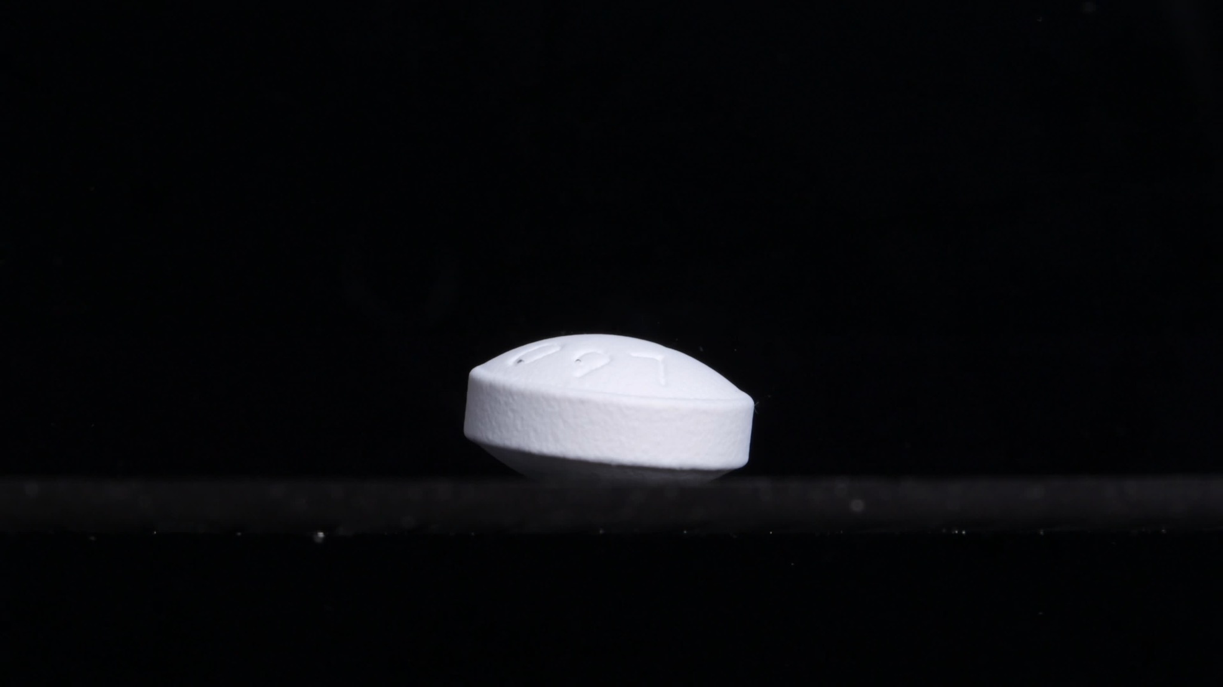
Group A - Pic 1 - 0 minutes image.
Color change: The tablet appears white to off-white. No obvious color diffusion, staining, yellowing, or cloud-like color spread is visible around the tablet at this starting point. The surrounding field remains dark/clear in the image, with no visible turbidity caused by tablet material.
Shape change: The tablet is still intact. It appears as a round, compressed tablet viewed from the side, with a flat vertical side wall and a slightly domed or curved upper face. The lower edge appears slightly beveled or angled. No visible cracking, splitting, edge collapse, or fragmentation is present at 0 minutes.
Surface texture change: The side surface looks slightly rough or granular, which may reflect the compressed powder structure. The upper surface appears smoother but has a few shallow irregular marks or depressions. These are not clearly identifiable as cracks; they may be surface marks, lighting effects, or early wetting marks. No peeling, flaking, pore expansion, or fibrous structures are visible.
Volume / size change: This image is the baseline size and volume for Group A. The tablet maintains its original compact body, with no visible swelling or shrinkage. The contour is still well-defined, especially along the side wall and upper edge.
Dissolution speed and time: At 0 minutes, there is no visible active disintegration. The dissolution/disintegration rate appears minimal or not yet observable in this frame. Later images at 15-minute intervals are needed to determine the time course.
Physical state change: The tablet remains in a solid, intact physical state. No clear liquid-penetration effects such as swelling, cracking, softening, collapse, or particle shedding are visible yet. The surface does not show obvious structural failure.
Dissolution medium: The medium or background appears dark in the image, and the visible area around the tablet does not show obvious cloudiness. No suspended particles or dissolved plume can be seen. The exact medium composition cannot be determined from the image alone.
Fragment distribution and density: No fragments are visible around the tablet. No sediment layer, powder cloud, or dispersed particle field is apparent. Fragment density is none or not detectable at this starting time point.
Interim interpretation: This is an intact white/off-white tablet at the initial stage, with a stable round compressed shape, clearly preserved size, and no visible disintegration products. It serves as the baseline for judging later changes in tablet size, shape, edge integrity, surface roughness, and fragment formation.

Group A - Pic 2 - 15 minutes
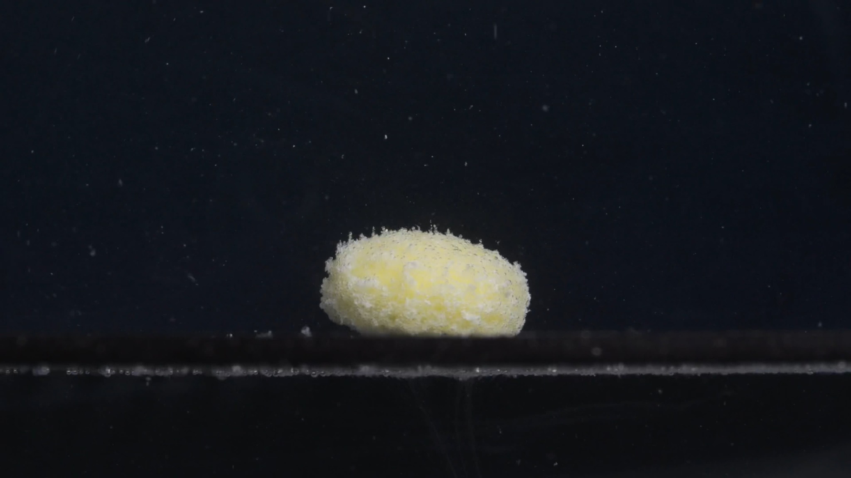
Group A - Pic 2 - 15 minutes image.
Color change: The tablet has changed from the earlier white/off-white appearance to a more pale yellow to yellow-white appearance. The yellow color is concentrated mainly on the tablet body, especially the upper and central regions. Some surrounding fine particles also appear light-colored, but the medium itself is not uniformly yellow.
Shape change: The tablet is no longer a clean, sharply defined compressed cylinder. It now appears as a rounded, softened mound with a domed upper surface. The original straight side wall and clear beveled lower edge are much less distinct. No large fracture splitting the tablet into separate pieces is visible, but the outer contour has become irregular and eroded.
Surface texture change: The surface has changed from relatively smooth/compact to rough, fuzzy, and granular. A layer of fine powder-like material appears to cover the tablet surface. The upper edge and side surface show many small protrusions or loose particles, suggesting surface erosion and particle shedding. No clear deep crack is visible, but the surface is visibly weakened and porous-looking.
Volume / size change: The tablet still remains as one main body. Compared with 0 minutes, the outline appears less compact and less sharply bounded. The apparent height seems reduced or visually softened, while the footprint may look slightly broader because the outer layer has swollen or loosened. No precise percentage change is assigned because image scale and angle may vary.
Dissolution speed and time: By 15 minutes, visible disintegration has clearly begun. The process appears moderate rather than complete: the tablet has not collapsed into many large fragments, but active surface erosion and particle release are present. The formation of fine particles suggests that disintegration has accelerated compared with the 0-minute image.
Physical state change: The tablet appears to have softened after liquid penetration. The outer layer seems porous and friable, with fine material detaching from the surface. The main core still remains, so this is not a complete collapse stage. The visible state is partially swollen or softened with active surface erosion.
Dissolution medium: The background medium remains mostly dark, but many small suspended particles are visible throughout the image. The medium is not fully opaque, but it shows increased particulate contamination compared with the 0-minute image. The exact medium composition, pH, or viscosity cannot be determined from the image alone.
Fragment distribution and density: Fine particles are visible around the tablet and suspended above it. A thin, pale sediment-like line is visible along the lower horizontal surface near the tablet. Fragment density is highest immediately around the tablet surface and lower farther away. No large detached tablet fragments are clearly visible.
Interim interpretation: At 15 minutes, Group A shows clear early-to-middle disintegration: the tablet has turned yellowish, the surface has become rough and powdery, the original cylindrical contour has softened, and many fine particles have been released into the surrounding medium. The tablet still retains one main body, so disintegration is incomplete.

Group A - Pic 3 - 30 minutes
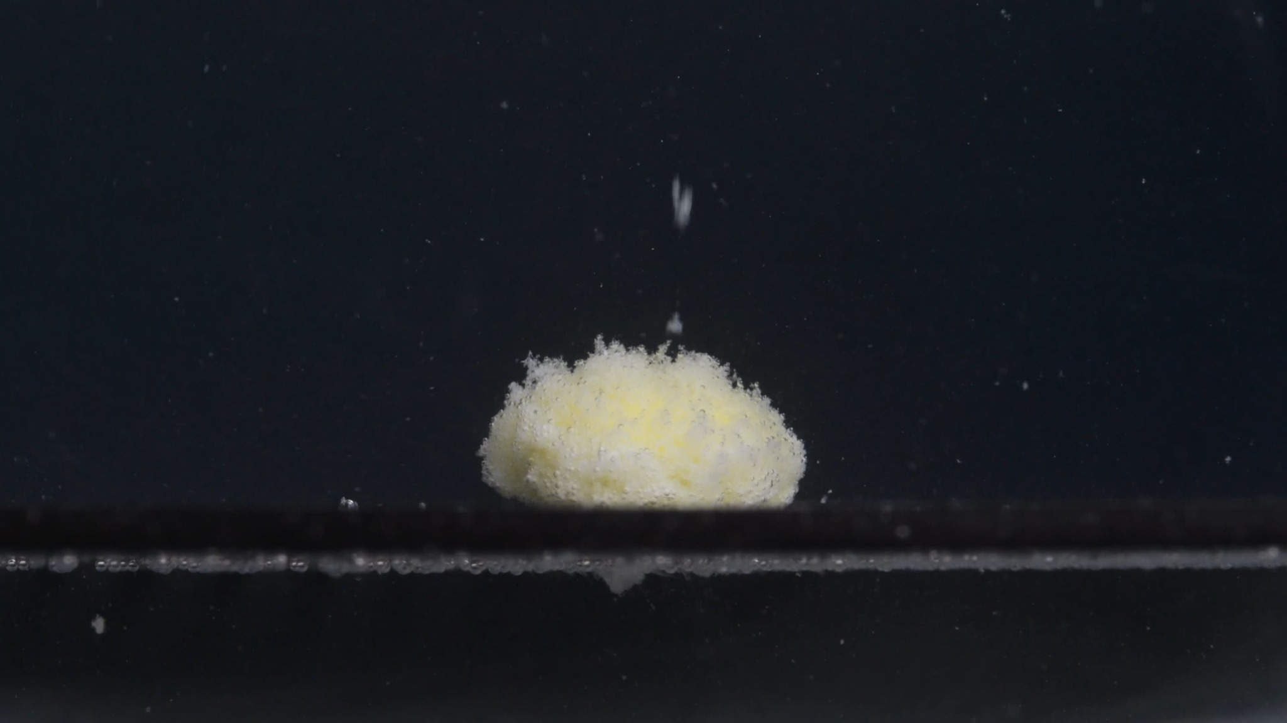
Group A - Pic 3 - 30 minutes image.
Color change: The tablet remains pale yellow to yellow-white. Compared with 0 minutes, the white tablet body has clearly developed a yellowish appearance. Compared with 15 minutes, the yellow tone is still present, but the surface also appears more covered by whitish powder-like material. The surrounding medium does not appear uniformly yellow, although small light particles are visible in the liquid.
Shape change: The original compressed tablet shape is no longer clearly preserved. The tablet now appears as a soft, rounded mound rather than a sharply edged cylinder. The upper contour is dome-like and uneven. The side edges are blurred by loose particles, and the original vertical side wall is difficult to distinguish. No large separated fragments are visible; the tablet still exists mainly as one central mass.
Surface texture change: The surface is highly rough, granular, and fuzzy. Many tiny particles are attached to or lifting from the surface, especially along the upper and side edges. The surface looks more porous and friable than at 0 minutes. No clear deep crack crosses the tablet, but the surface layer appears loosened and weakened.
Volume / size change: The tablet still retains a central bulk, so it has not fully collapsed. Compared with the initial image, it appears less compact and less sharply bounded. Its apparent height seems lower and more mound-like than the original intact tablet, while the outline looks slightly spread or softened because of surface erosion. No exact percentage is estimated because scale and angle may differ.
Dissolution speed and time: At 30 minutes, disintegration has progressed beyond the initial wetting stage. The dominant process appears to be continued surface erosion and fine-particle shedding, rather than sudden breakage into large pieces. The rate appears gradual to moderate: the tablet is clearly disintegrating, but it has not dispersed completely after 30 minutes.
Physical state change: The tablet appears softened, porous, and partially eroded. The outer layer seems unstable and powdery, suggesting liquid penetration and weakening of the compressed structure. The core still remains, indicating incomplete disintegration. The physical state is partially disintegrated with a remaining softened central mass.
Dissolution medium: Numerous small particles are visible in the surrounding medium. The liquid is not completely opaque, but it contains more suspended material than the 0-minute image. A pale line or sediment-like accumulation is visible near the lower horizontal surface. The exact medium composition, pH, or viscosity cannot be determined from the image alone.
Fragment distribution and density: Fragmentation is mainly in the form of fine particles, not large chunks. Particle density is highest around the tablet and along the bottom surface. Some particles are suspended above and around the tablet, while others appear to have settled below. The debris field appears slightly more developed than at 15 minutes, but the central tablet mass is still dominant.
Interim interpretation: By 30 minutes, Group A shows progressive but incomplete disintegration. The tablet has changed from a white intact cylinder into a pale yellow-white, rough, powdery mound. The main body remains, but its edges and surface are visibly eroded, with fine particles dispersed into the surrounding medium. The pattern suggests gradual surface erosion with softening rather than rapid splitting into large fragments.

Group A - Pic 4 - 45 minutes
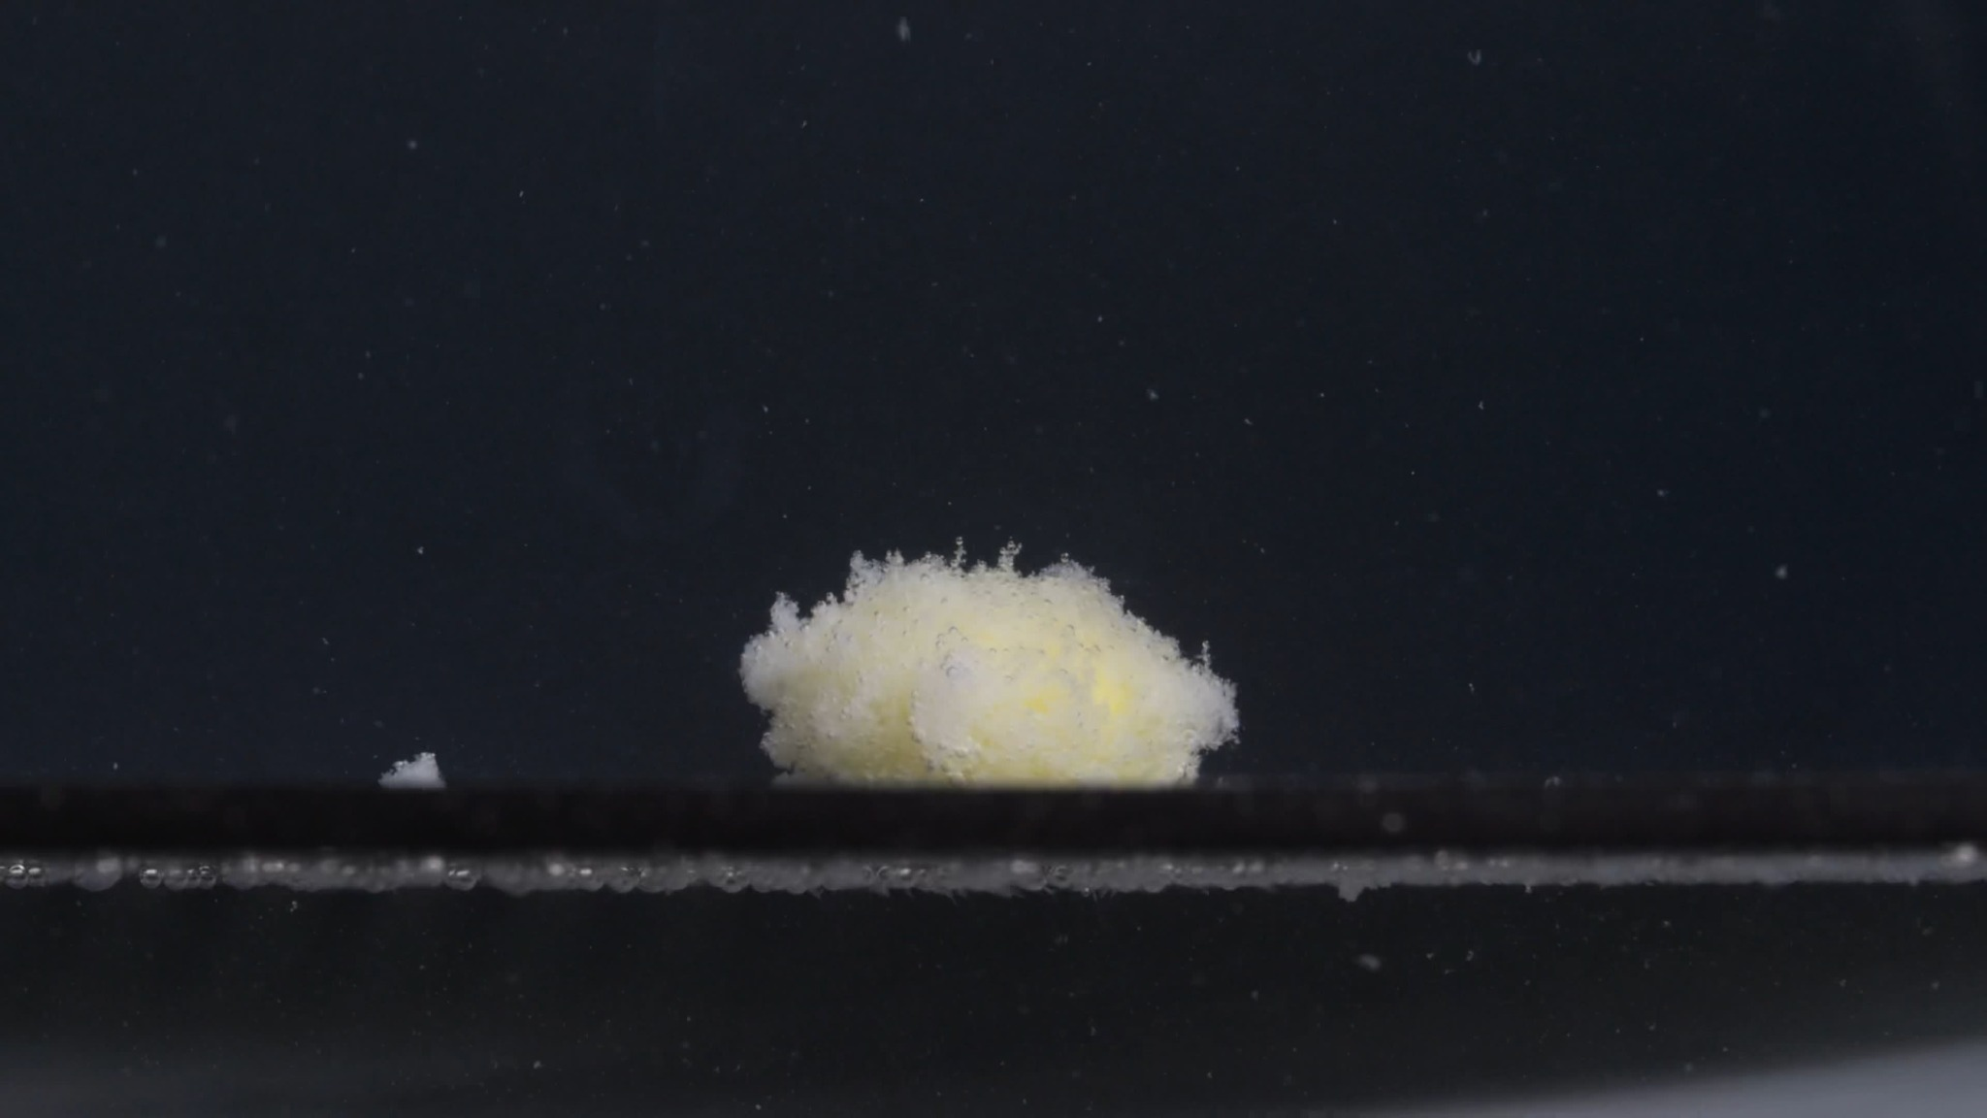
Group A - Pic 4 - 45 minutes image.
Color change: The remaining tablet mass is still mainly pale yellow to yellow-white. The yellow coloration is visible inside the central mound, while the outer surface is partly covered by whitish, powder-like material. The surrounding medium does not look uniformly yellow, but many small bright particles are visible in the liquid.
Shape change: The original round compressed-tablet shape is no longer recognizable. The tablet has become a low, irregular, softened mound. The upper outline is uneven and fuzzy, with loose material projecting from the surface. A small separate piece or compact particle cluster is visible to the left of the main mound, suggesting that some material has detached from the main tablet body. There is still one dominant central mass, so the tablet has not fully dispersed.
Surface texture change: The surface is strongly rough, porous-looking, and powdery. The edges are no longer smooth; they appear frayed and granular. The left and upper portions show a fluffy, eroded texture, consistent with surface loosening and fine-particle shedding. No single clear deep crack is visible, but the entire outer layer appears weakened and fragmented.
Volume / size change: Compared with the 0-minute image, the tablet has clearly lost its compact cylindrical form. Compared with 30 minutes, the main body appears lower, less defined, and more spread out, especially along the base. The tablet volume appears reduced or structurally collapsed, but no reliable percentage is given. The main change is not just shrinkage; it is loss of contour and conversion into a loose mound.
Dissolution speed and time: By 45 minutes, disintegration has progressed further but is still incomplete. The process appears dominated by gradual erosion, softening, and release of fine particles, rather than rapid splitting into several large hard fragments. Compared with 15 and 30 minutes, the tablet shows more advanced weakening and more visible detached material.
Physical state change: The tablet has changed from a solid intact tablet into a softened, partially collapsed, friable mass. The core is still present, but the surface and edges appear loose and unstable. The visible state is advanced partial disintegration with a remaining central residue.
Dissolution medium: The surrounding medium contains many small suspended particles. The liquid is not completely opaque, but it appears more particle-loaded than at 0 minutes. A light sediment-like layer is visible along the lower horizontal surface. The pH, composition, or viscosity of the medium cannot be determined from this image.
Fragment distribution and density: Fine particles are distributed around the tablet and through the surrounding field. Particle density is highest near the tablet surface and along the lower base area. A small detached white fragment or sediment cluster is visible to the left of the main mass. The main tablet remains as one larger mound, while most released material appears as fine debris rather than large fragments.
Interim interpretation: At 45 minutes, Group A shows advanced but incomplete disintegration. The tablet has lost its original cylindrical shape and has become a pale yellow-white, soft, powdery mound with an irregular outline. The size and shape changes are substantial: the mass is lower, more spread out, and less compact than at the beginning. Fine particles and at least one small detached cluster are visible, but a central residue still remains.

Group A - Pic 5 - 60 minutes
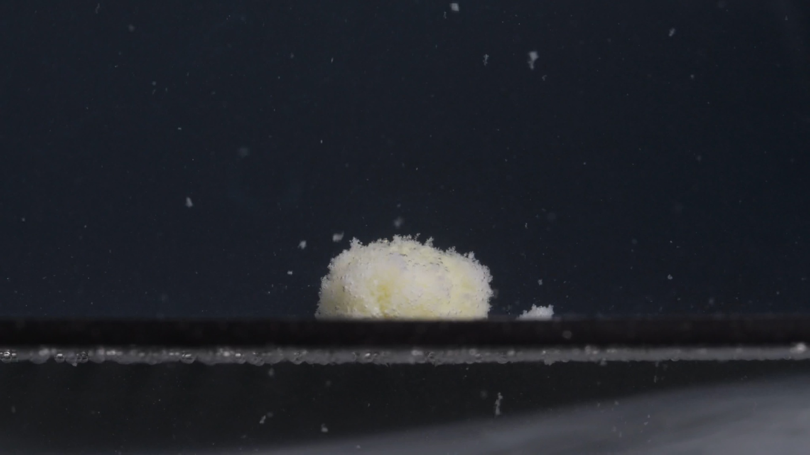
Group A - Pic 5 - 60 minutes image.
Color change: The remaining tablet mass is still mainly pale yellow to yellow-white. The central region shows a faint yellow tone, while the outer surface appears more whitish because of the powdery surface layer. The surrounding liquid does not appear uniformly colored, but light-colored particles are visible in the medium.
Shape change: The original intact tablet shape is completely lost. The tablet remains as a low, rounded, irregular mound rather than a defined cylinder. The top and side edges are fuzzy and uneven. A small detached powdery cluster is visible to the right of the main mass. No clear large crack or clean split is visible; the tablet appears to disintegrate mainly by erosion and shedding.
Surface texture change: The surface is very rough, granular, and fluffy/powdery. Fine particles appear attached to the surface and also suspended nearby. The outer layer looks loose and friable, especially along the upper edge. The surface is no longer compact or smooth.
Volume / size change: Compared with the 0-minute tablet, the size and shape have changed substantially. The tablet appears lower, softer, and less compact, with a blurred outline. Compared with 45 minutes, the main mound still persists; there is not a dramatic additional collapse in this single frame, but the surface remains heavily eroded. No precise percentage of volume loss is determined.
Dissolution speed and time: By 60 minutes, disintegration is still incomplete. The process appears slow to moderate, with continued surface erosion rather than rapid full dispersion. The tablet has released many fine particles, but a central residue remains after one hour.
Physical state change: The tablet has changed from a solid compact tablet into a softened, partially collapsed, porous-looking residue. The remaining mass appears weak and friable. The core or central residue is still present, so the tablet has not fully dissolved or fully dispersed. The dominant physical change is progressive softening, erosion, and particle shedding.
Dissolution medium: The surrounding medium contains many small suspended particles. The liquid is not completely opaque, but it is visibly particle-loaded. A pale sediment-like line is visible along the bottom/horizontal surface. The medium composition, pH, and viscosity cannot be confirmed from the image alone.
Fragment distribution and density: Fine particles are distributed around the tablet and throughout the visible liquid. Particle density is greatest near the tablet and along the lower surface. A small detached cluster is present to the right of the main mound. Most fragments are fine powder-like particles rather than large solid pieces.
Interim interpretation: Group A shows a gradual erosion-dominated disintegration pattern from 0 to 60 minutes: intact white/off-white tablet at 0 minutes; yellowing and rough powdery surface by 15 minutes; softened pale yellow-white mound by 30 minutes; advanced partial disintegration at 45 minutes; and a central mound still remaining at 60 minutes. Overall, Group A does not fully disintegrate within 60 minutes in these images.

3. Group B Image-by-Image Analysis

Group B - Pic 1 - 0 minutes
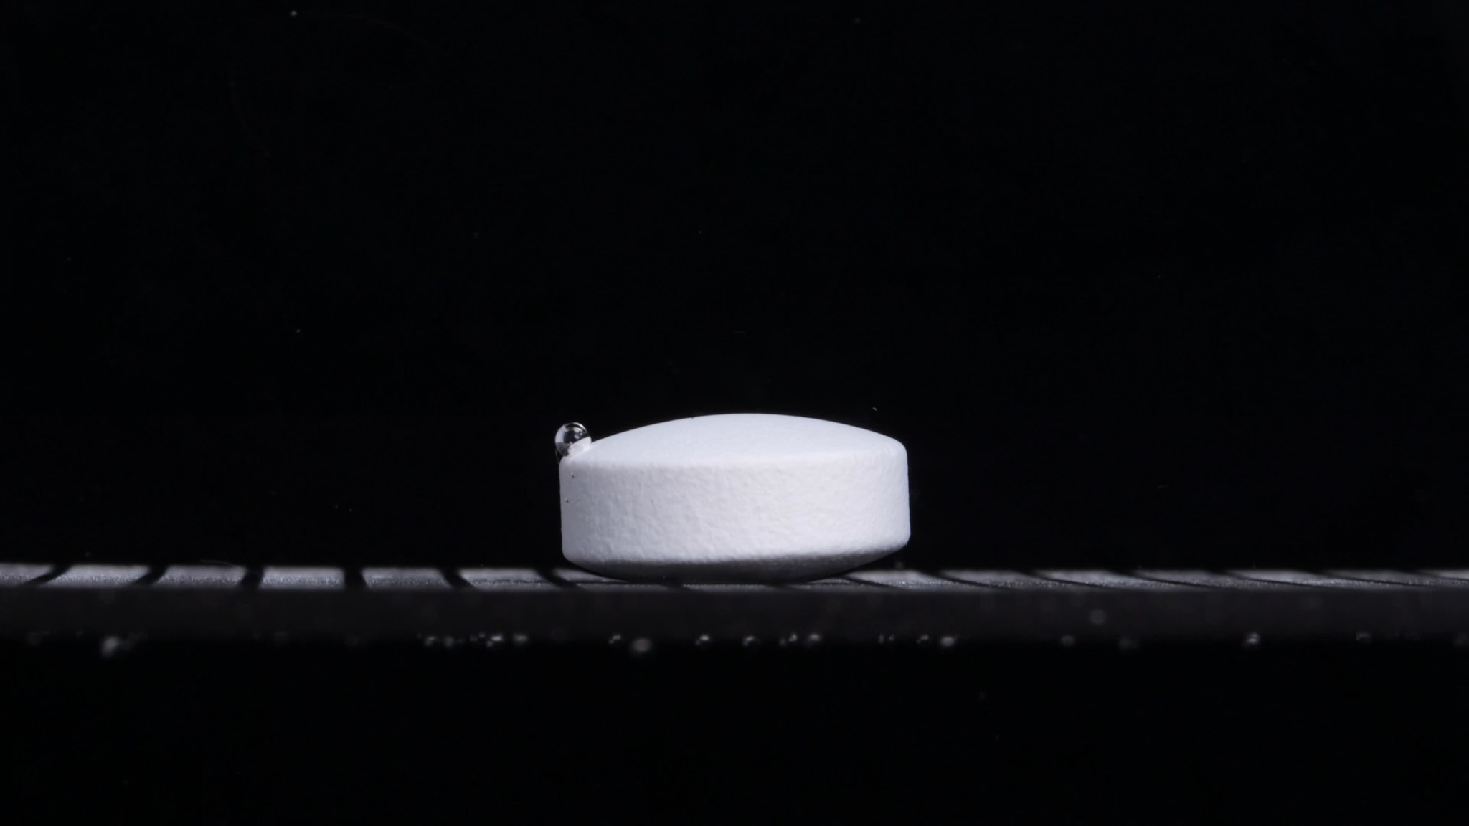
Group B - Pic 1 - 0 minutes image.
Color change: The tablet appears white to off-white. No yellowing, discoloration, color diffusion, or cloudy color plume is visible at this starting point. The surrounding medium/background remains dark and clear in the visible region.
Shape change: The tablet is intact and keeps a regular compressed-tablet shape. It appears cylindrical from the side, with a relatively straight vertical side wall and a slightly curved or gently convex upper face. The lower edge appears slightly beveled or shadowed. No cracks, splitting, deformation, or fragmentation are visible.
Surface texture change: The side surface looks slightly matte and finely rough, consistent with a compressed powder tablet surface. The top surface appears smoother than the side wall. A small round bubble or droplet-like object is visible near the upper-left edge of the tablet; it is not treated as tablet damage because it looks more like attached air/liquid than a crack. No pore expansion, peeling, flaking, or powder shedding is visible.
Volume / size change: This image is the initial size and volume reference for Group B. The tablet appears compact, with a clearly preserved height and diameter. No visible swelling, shrinkage, collapse, or spreading is present.
Dissolution speed and time: At 0 minutes, no active disintegration is visible. The dissolution/disintegration rate appears not yet observable in this frame. Later 15-minute interval images are needed to judge whether Group B erodes slowly, fragments rapidly, swells, or collapses.
Physical state change: The tablet remains in a solid, intact physical state. There is no visible softening, cracking, swelling, collapse, or particle generation. The internal condition cannot be assessed from the image.
Dissolution medium: The medium composition cannot be determined from the image. The visible surrounding area does not show obvious turbidity or suspended tablet material. No color plume or sediment from the tablet is visible at this time point.
Fragment distribution and density: No tablet fragments are visible around the main tablet body. No powder cloud, sediment pile, or detached particles can be confidently attributed to tablet disintegration. Fragment density is none or not detectable at 0 minutes.
Interim interpretation: Group B at 0 minutes is broadly similar to Group A at 0 minutes: both show an intact white/off-white compressed tablet with no visible disintegration. Group B appears slightly more regular and smooth on the top surface, while Group A showed a more domed top with shallow surface marks. This difference alone is not enough to determine identity.

Group B - Pic 2 - 15 minutes
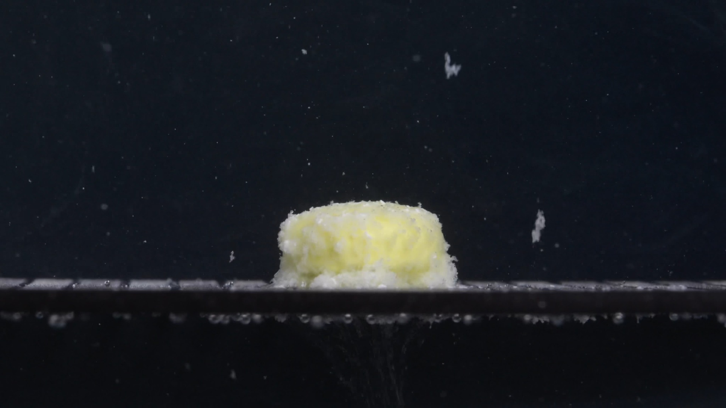
Group B - Pic 2 - 15 minutes image.
Color change: The tablet has changed from white/off-white at 0 minutes to a visible pale yellow to yellow-white appearance. The yellow color is strongest in the central body of the tablet. The outer loose material appears more whitish, especially around the lower edge and side regions. The surrounding medium does not appear uniformly yellow, although there are scattered light particles in the liquid.
Shape change: The tablet is no longer a clean, sharply edged cylinder. It still retains a single main tablet body, but the edge has become irregular and softened. The upper surface appears flatter than Group A at the same time point, but the outline is already fuzzy because of surface erosion. No clear full-depth crack or large split is visible.
Surface texture change: The surface has become rough, granular, and powdery. The side wall and upper edge show loose, fine material attached to the tablet. The lower margin appears surrounded by a whitish eroded layer or sediment-like material. The original smooth compact surface seen at 0 minutes is no longer preserved.
Volume / size change: The tablet still has a substantial central mass. Compared with the 0-minute image, the tablet looks less compact and less sharply bounded, especially along the base and side edges. The height appears somewhat reduced or softened, but the tablet has not collapsed completely. No reliable percentage of volume loss is given because image angle, lighting, and boundary definition may affect apparent size.
Dissolution speed and time: By 15 minutes, Group B shows clear active disintegration. The disintegration appears moderate: the tablet has not broken into large separate fragments, but fine-particle shedding and surface erosion are obvious. The process appears similar to an early-to-middle erosion stage, where liquid penetration weakens the outer layer and increases loose particle formation.
Physical state change: The tablet appears to have softened after exposure to the medium. The outer layer is friable and porous-looking, while the central body remains intact. The visible physical state is partially softened with active surface erosion, not fully dispersed.
Dissolution medium: The visible medium contains scattered suspended particles. Some bright specks are present throughout the frame; these may include tablet particles, bubbles, or imaging artifacts, so not every speck is attributed to tablet disintegration. The medium is not fully opaque, but it is visibly more particle-loaded than at 0 minutes. The exact medium composition, pH, or viscosity cannot be determined from the image alone.
Fragment distribution and density: Most visible fragments are fine powder-like particles, not large chunks. Fragment density is highest close to the tablet surface, especially along the base. A pale sediment-like accumulation is visible near the lower contact area. No large detached tablet fragment is clearly visible.
Interim interpretation: At 15 minutes, Group B shows clear but incomplete disintegration. The tablet has turned pale yellow-white, its surface has become rough and powdery, and fine particles have begun to spread into the surrounding medium. The tablet still retains one main central body, so the dominant pattern at this stage is surface erosion and softening, not complete fragmentation.

Group B - Pic 3 - 30 minutes
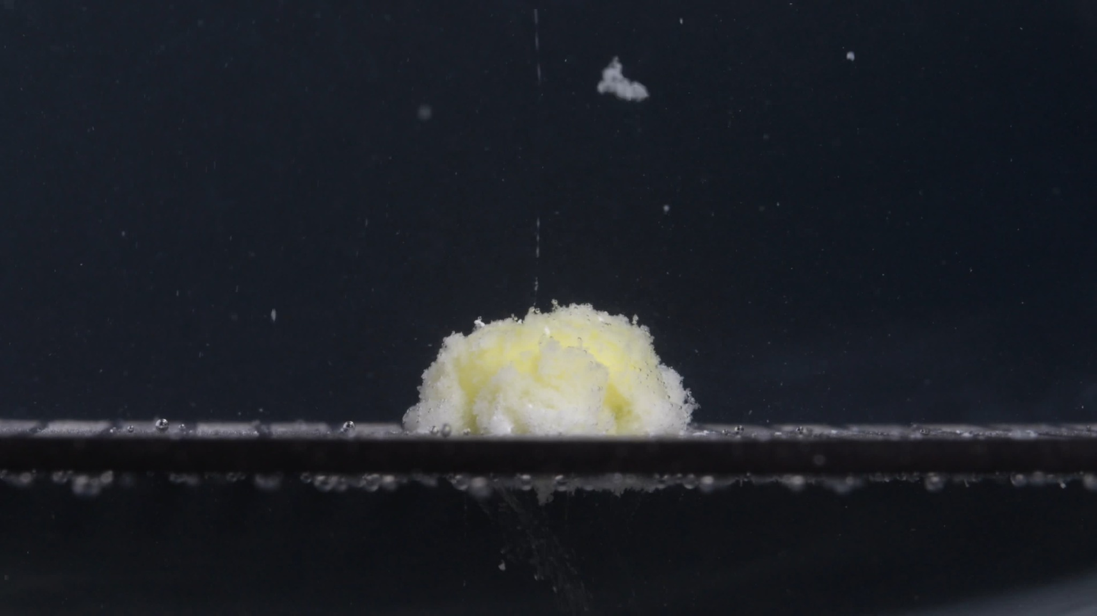
Group B - Pic 3 - 30 minutes image.
Color change: The remaining tablet mass is pale yellow to yellow-white. The yellow color is more visible in the inner and central areas, while the outer loose material appears more whitish. The medium itself does not appear uniformly yellow, but scattered bright particles are visible around the tablet.
Shape change: The original cylindrical tablet shape is no longer preserved. The tablet has become an irregular mound with uneven height and a rough contour. Compared with the 15-minute image, the top is less flat and more broken-looking, with several uneven raised and depressed areas. No clean large split is visible, but the body appears structurally weakened and partially collapsed.
Surface texture change: The surface is strongly granular, powdery, and friable. The edges are fuzzy and irregular, especially on the left and right sides. The central surface appears clumpy, with soft-looking loose material rather than a compact solid face. No smooth original tablet surface is still visible.
Volume / size change: Compared with 0 minutes, the tablet has clearly lost its compact shape and sharp boundary. Compared with 15 minutes, the main mass appears more uneven and partially collapsed, although a central residue still remains. The apparent height is reduced and the base appears spread or surrounded by eroded material. No accurate percentage of volume loss is estimated from the image alone.
Dissolution speed and time: By 30 minutes, Group B shows progressive but incomplete disintegration. The disintegration appears to have advanced from surface erosion into a more collapsed, mound-like stage. The dominant process is still erosion and fine-particle shedding rather than complete breakup into large separate pieces.
Physical state change: The tablet has changed from a solid intact tablet into a softened, porous-looking, partially collapsed mass. The outer and upper regions look weak and powdery. The central material is still present, so the tablet has not fully dispersed. The visible state suggests substantial liquid penetration and weakening, but the internal core cannot be directly confirmed.
Dissolution medium: The surrounding medium contains many small suspended particles. A larger bright cluster is visible above the tablet, but from this single image it cannot be determined whether it is a detached tablet fragment, a floating particle aggregate, or an imaging artifact. The medium is not fully opaque, but it is clearly more particle-loaded than at 0 minutes. The medium composition, pH, and viscosity cannot be determined visually.
Fragment distribution and density: Fine powder-like fragments are distributed around the tablet, especially near the base. Fragment density is highest immediately around the main mound and along the lower surface. A pale sediment-like accumulation is visible near the contact area. Most visible disintegration products are fine particles or soft aggregates rather than large solid fragments.
Interim interpretation: At 30 minutes, Group B has entered a more advanced partial-disintegration stage. The original tablet shape has changed into a pale yellow-white, irregular, powdery mound. The tablet is still not fully dispersed, but its surface and contour are much more degraded than at 15 minutes. The main visible pattern is softening, collapse of the compact form, and fine-particle shedding.

Group B - Pic 4 - 45 minutes
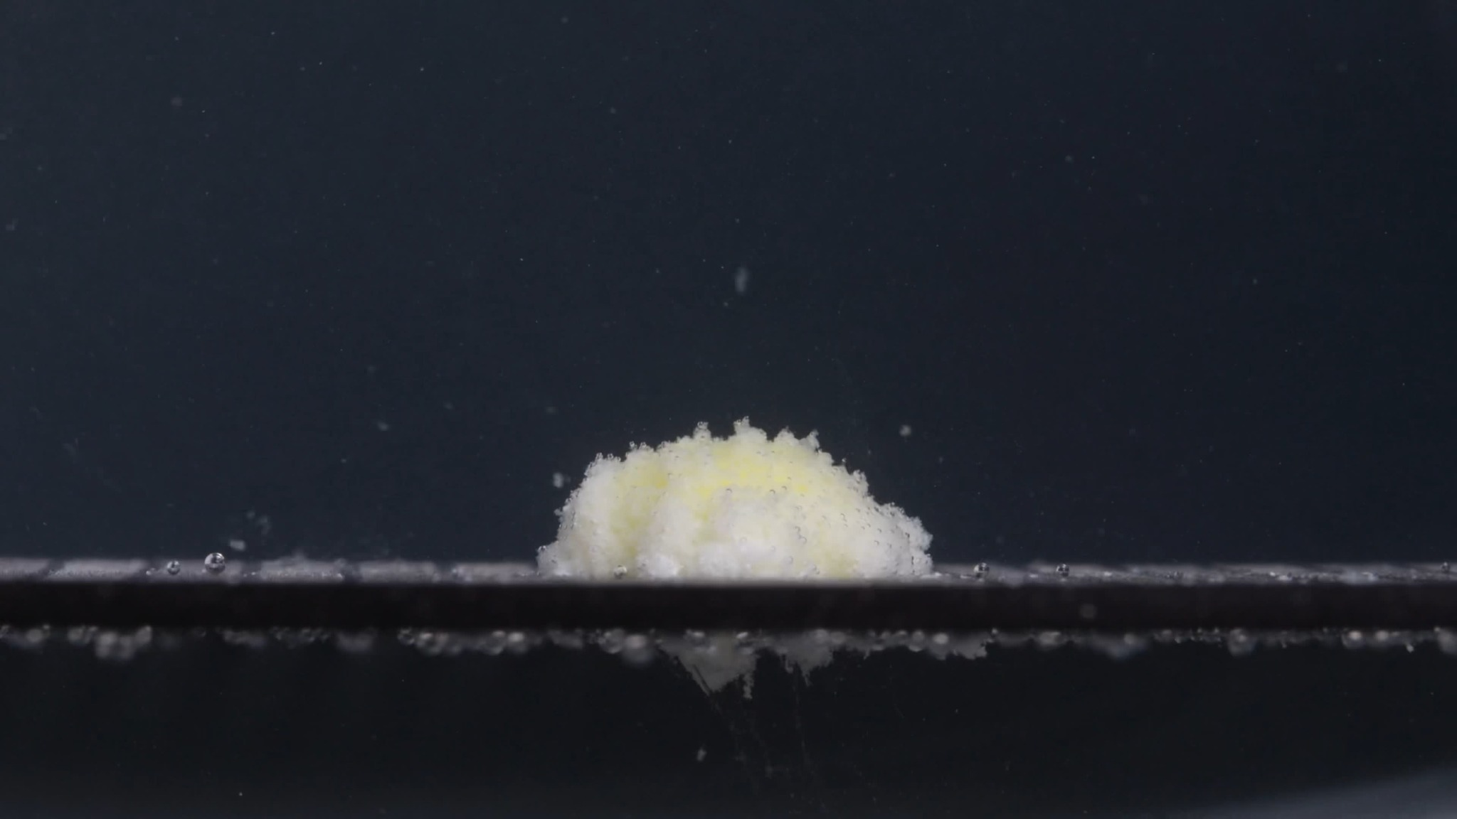
Group B - Pic 4 - 45 minutes image.
Color change: The remaining tablet mass is still pale yellow to yellow-white. The yellow color is mainly visible in the inner or central parts of the mound. The outer surface appears more whitish because it is covered by loose powder-like material. The surrounding medium is not uniformly yellow, but small light-colored particles are visible.
Shape change: The original cylindrical tablet shape is no longer visible. The tablet has become a low, irregular mound with a rough and uneven upper outline. Compared with the 30-minute image, the mound appears slightly more flattened and less structurally defined. No large clean split or large separated solid fragment is clearly visible.
Surface texture change: The surface is very rough, granular, and fluffy/powdery. The top edge has many small projections, giving it a frayed appearance. The sides are blurred by loose material, showing that the compact tablet surface has broken down. The surface appears friable rather than smooth or hard.
Volume / size change: Compared with the 0-minute tablet, the original height and sharp side wall have been substantially lost. Compared with 30 minutes, the main body appears lower and more spread into a mound-like residue. The tablet still has a central remaining mass, so it is not fully dispersed. No precise percentage of size loss is determined from the image alone.
Dissolution speed and time: By 45 minutes, Group B shows advanced but incomplete disintegration. The process appears to continue mainly through surface erosion, softening, and fine-particle release, rather than sudden breakup into large fragments. The remaining central mound indicates that disintegration has not finished within 45 minutes.
Physical state change: The tablet has changed from a solid compact form into a softened, porous-looking, partially collapsed residue. The outer region appears weak and loose. The core or central residue still persists, but it is no longer sharply bounded. The visible physical state suggests progressive weakening and collapse of the compressed tablet structure.
Dissolution medium: The surrounding medium contains many small suspended particles. The liquid remains partially clear rather than completely opaque. A pale sediment-like accumulation is visible along the lower horizontal surface. The exact medium composition, pH, and viscosity cannot be determined from the image.
Fragment distribution and density: Most visible fragments are fine powder-like particles. Particle density is highest around the tablet mound and along the lower contact surface. Some particles are suspended in the liquid above the tablet. No obvious large detached tablet chunk is visible at this time point.
Interim interpretation: At 45 minutes, Group B shows continued erosion-dominated disintegration. The tablet has lost its original cylindrical shape and has become a pale yellow-white, low, powdery mound. The size and contour have changed substantially, but a central residue remains, indicating incomplete disintegration.

Group B - Pic 5 - 60 minutes
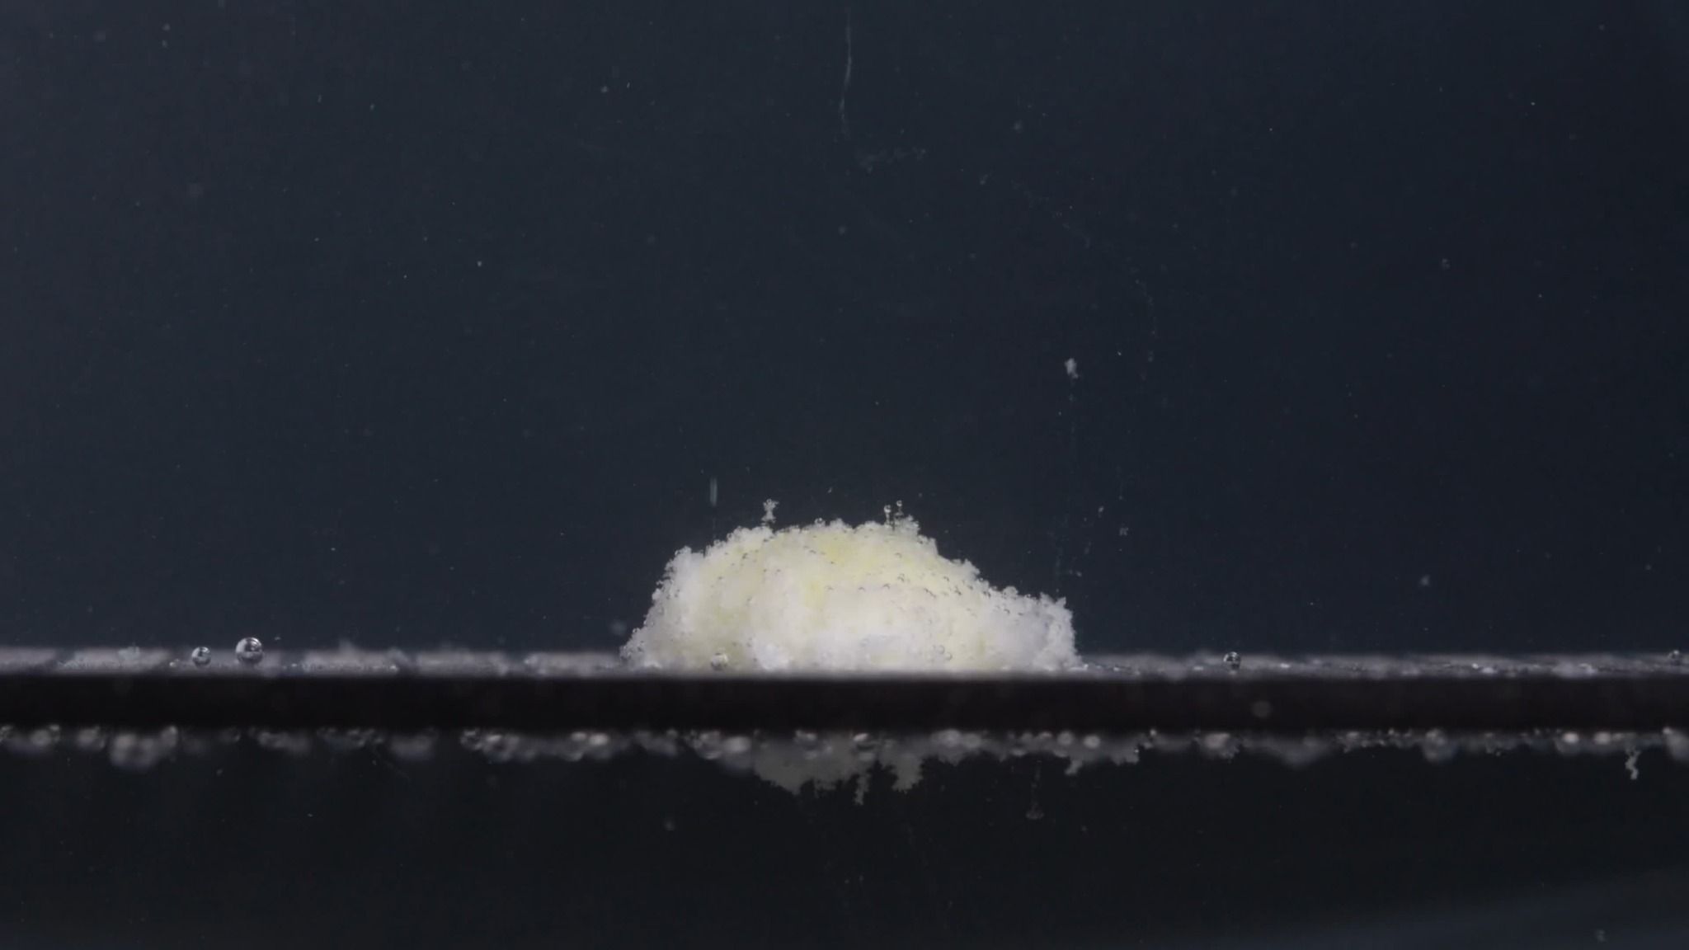
Group B - Pic 5 - 60 minutes image.
Color change: The remaining tablet mass is still pale yellow to yellow-white. The central area has a faint yellow tone, while the outer eroded material appears more whitish. The surrounding medium is not uniformly yellow, but small light particles are visible.
Shape change: The original cylindrical tablet shape is fully lost. The tablet is now a low, irregular, mound-like residue. The top contour is uneven and fuzzy, with no sharp tablet edge remaining. No large clean split or large solid fragment is clearly visible.
Surface texture change: The surface is rough, porous-looking, granular, and powdery. The edge appears frayed, especially along the upper and side margins. The original compact surface has disappeared.
Volume / size change: Compared with 0 minutes, the tablet has undergone major size and shape degradation. It appears lower, flatter, and more spread out than the original tablet. Compared with 45 minutes, the main mound still remains, but it looks slightly more flattened and loosely dispersed.
Dissolution speed and time: At 60 minutes, Group B still shows incomplete disintegration. The process appears gradual and erosion-dominated, with continued fine-particle release rather than rapid full breakup.
Physical state change: The tablet has changed from a solid compact tablet into a softened, friable, partially collapsed residue. A central mass still persists, so it has not fully dissolved or fully dispersed.
Dissolution medium: The surrounding medium contains many small suspended particles. A pale sediment-like accumulation is visible along the lower horizontal surface. The medium composition, pH, and viscosity cannot be determined from the image alone.
Fragment distribution and density: Most fragments are fine powder-like particles, not large chunks. Particle density is highest around the remaining mound and along the bottom surface. Some particles are suspended above the tablet, but the dominant residue remains near the base.
Interim interpretation: Group B shows a gradual erosion and softening process from 0 to 60 minutes: intact white/off-white cylindrical tablet at 0 minutes; yellowing and rough powdery surface by 15 minutes; irregular mound formation by 30 minutes; lower porous-looking mound by 45 minutes; and central residue still present at 60 minutes.

4. Group-Level Summary

Group A Overall Pattern, 0-60 Minutes
- 0 min: Intact white/off-white compressed tablet with clear cylindrical form.
- 15 min: Surface becomes yellowish, rough, and powdery; tablet remains one main body.
- 30 min: Tablet becomes a softened pale yellow-white mound with more fine particles.
- 45 min: Advanced partial disintegration; original shape lost, small detached cluster appears.
- 60 min: Central mound still remains; surface is highly powdery, with fine suspended particles and sediment.
Overall Group A interpretation: Group A does not fully disintegrate within 60 minutes in these images. The key features are loss of the original cylindrical shape, yellowish discoloration, gradual reduction of structural integrity, rough powdery surface formation, and fine-particle shedding.

Group B Overall Pattern, 0-60 Minutes
- 0 min: Intact white/off-white cylindrical tablet.
- 15 min: Yellowing appears; surface becomes rough and powdery.
- 30 min: Original shape mostly lost; tablet becomes an irregular mound.
- 45 min: Mound becomes lower and more porous-looking.
- 60 min: Central residue remains, with fine particles and sediment around it.
Overall Group B interpretation: Group B also shows gradual erosion and softening. It does not fully disperse within 60 minutes and remains as a pale yellow-white powdery mound with fine particles and localized sediment.

5. Final Comparison Across the Eight Dimensions
Final visual judgment: Group A and Group B are likely from the same drug or from a very similar formulation. This is not chemical confirmation; images alone cannot prove active ingredient, manufacturer, strength, or excipient composition. However, the visible disintegration sequences show a highly similar disintegration fingerprint.
Dimension | Group A | Group B | Comparison
Color change | Starts white/off-white; by 15 minutes, pale yellow material becomes visible; from 30-60 minutes, the residue remains yellow-white. | Starts white/off-white; by 15 minutes, pale yellow material also appears; from 30-60 minutes, the remaining mass is also yellow-white. | Highly similar. Both show localized yellow exposure inside the tablet residue, not strong yellow diffusion through the whole medium.
Shape change | Starts as an intact compressed tablet; by 15-30 minutes, becomes a rounded, irregular mound; at 60 minutes, no original tablet outline remains. | Same pattern: intact at 0 minutes, mound-like by 15-30 minutes, original shape gone by 60 minutes. | Highly similar. Both lose their original shape early and remain as one main mound instead of splitting into many large pieces.
Surface texture change | Smooth/matte at 0 minutes; becomes rough, fuzzy, granular, porous-looking, and powdery after 15 minutes. | Same: smooth at 0 minutes, then rough, powdery, granular, and porous-looking. | Highly similar. Both disintegrate mainly by surface erosion and powder shedding, not by clean cracking.
Volume / size change | Major loss of sharp contour and height after 15 minutes; later becomes lower and less compact, but a central mound remains at 60 minutes. | Same major early height loss and gradual later flattening; a central mound also remains at 60 minutes. | Highly similar. Both show vertical collapse or softening rather than complete disappearance.
Dissolution speed and time | No visible disintegration at 0 minutes; clear disintegration by 15 minutes; slower erosion from 30-60 minutes; incomplete at 60 minutes. | Same time course: no visible start at 0 minutes, obvious change by 15 minutes, gradual erosion afterward, incomplete at 60 minutes. | Highly similar. The timing pattern is one of the strongest reasons to think they are the same or very similar.
Physical state change | Solid tablet becomes softened, friable, porous-looking, and partially collapsed. | Same physical transition: solid tablet to softened porous aggregate to residual powdery mound. | Highly similar. Neither group fully disperses into only fine sediment within 60 minutes.
Dissolution medium | Medium remains mostly dark/clear, with scattered suspended particles and some sediment near the bottom. | Similar: mostly clear/dark medium, scattered particles, localized sediment. | Similar. No obvious strong whole-medium turbidity difference is visible.
Fragment distribution and density | Mostly fine powder-like particles near the tablet; limited suspended particles; small localized sediment; no large fragments dominant. | Same: fine particles concentrated around the mound and bottom surface; no large-fragment breakup. | Highly similar. Fragment size and distribution pattern match closely.

6. Reasoning for the Final Determination
Reason for likely same-drug judgment: The strongest evidence is that both groups follow the same time-sequenced pattern: intact white/off-white tablet at 0 minutes; rapid visible surface erosion and yellow inner material exposed by 15 minutes; original tablet shape mostly lost and rough yellow-white mound remaining by 30 minutes; further powdery erosion by 45 minutes; and a central powdery mound still remaining at 60 minutes.
Why this matters: The similarity is not limited to one feature. It appears across color exposure, shape loss, surface roughening, height reduction, erosion speed, physical softening, medium clarity, and fine-particle distribution. The sequence is therefore more informative than any single image.
Minor differences: Group B looks slightly flatter and more regular at 0 minutes, while Group A appears slightly more domed or tilted. Group B also appears a little flatter at 60 minutes. These differences could be caused by camera angle, lighting, tablet orientation, wetting condition, or small tablet-to-tablet variability.
Final determination: Group A and Group B are likely the same drug or very similar formulations, with moderate-to-high visual confidence. Laboratory testing or packaging/manufacturer information would be required for certainty.

