Edited English Record
Doxycycline Hyclate Tablet Disintegration Image Analysis
Groups A and B | Five images per group | 15-minute intervals

Scope of This Document
This document is an edited English version of the drug-disintegration discussion. It includes the preparation, Knowledge Base framework, Group A image analysis, Group B image analysis, and the final comparison used to judge whether the two image sets are likely from the same drug or formulation.
The document stops at the final determination about Groups A and B. Non-drug-related conversation after that point is not included.

Knowledge Base Description Framework
The analysis follows the eight fixed dimensions used in the Knowledge Base for describing drug disintegration images:
- Color change: tablet color, medium color, transparency, turbidity, and spatial distribution of color.
- Shape change: preservation or loss of original tablet contour, cracking, deformation, collapse, and fragmentation.
- Surface texture change: smoothness, roughness, pores, cracks, peeling, powdering, flakes, or fibrous structures.
- Volume / size change: swelling, shrinkage, height loss, diameter loss, collapse, or uneven reduction.
- Dissolution speed and time: slow, moderate, or rapid disintegration at each timestamp.
- Physical state change: liquid penetration, swelling, softening, internal weakening, cracking, particle generation, and collapse.
- Dissolution medium: clarity, cloudiness, suspended particles, sediment, bubbles, color plumes, and visible interaction between liquid and tablet.
- Fragment distribution and density: number, size, density, location, spreading, suspension, and settling of fragments.
The final comparison focuses especially on tablet size, shape, edge contour, shape retention, swelling, cracking, collapse, residue, and fragment distribution.

1. Initial Preparation
User: I need you to try analyzing the disintegration images of two groups of Doxycycline Hyclate Tablets, A and B. These may be images of the same drug or different drugs. I need you to determine whether the images are from the same drug or not. For each group, I will upload five images. Each picture is taken 15 minutes apart. Please describe the drug disintegration process in English for each image in the group, and finally determine whether the two sets of images are from the same drug. You can call the Knowledge Base to remember how to describe drug disintegration. As you describe the tablets in English, pay attention to changes in the size and shape of the tablets. If you are prepared, I will upload Group A, picture 1 at 0 minutes.
Assistant: I am prepared. Please upload Group A, picture 1 at 0 minutes. I will analyze each image using the eight disintegration dimensions: color change, shape change, surface texture, volume change, dissolution speed/time, physical state, dissolution medium, and fragment distribution/density. I will pay special attention to tablet size, contour, shape retention, edge erosion, swelling, cracking, and fragmentation, because these are key indicators for comparing whether Group A and Group B may be the same drug.
User: You are not fully prepared. Please call the Knowledge Base to remember how to describe drug disintegration again.
Assistant: I re-checked the Knowledge Base and restated the exact description framework before image analysis. The recalled framework requires analysis of every uploaded image using eight fixed dimensions.
- Color change: tablet color, liquid color, transparency, turbidity, and whether color spreads locally or uniformly.
- Shape change: whether the tablet remains intact, cracks, deforms, collapses, rounds off, flattens, or breaks into fragments.
- Surface texture change: smoothness, roughness, pores, cracks, peeling, powdering, flakes, or fibrous structures.
- Volume / size change: swelling, shrinkage, height loss, diameter loss, collapse, or uneven reduction.
- Dissolution speed and time: slow, moderate, or rapid disintegration at 0, 15, 30, 45, and 60 minutes.
- Physical state change: liquid penetration, swelling, softening, internal weakening, cracking, breaking, particle generation, and collapse.
- Dissolution medium: clarity, cloudiness, suspended particles, sediment, bubbles, color plume, and visible interaction between liquid and tablet.
- Fragment distribution and density: number, size, density, location, spreading, suspension, and settling of fragments.
For the final comparison between Group A and Group B, the analysis would focus on the initial tablet size, shape, thickness, edge contour, and surface markings; whether the tablet swells, shrinks, cracks, flattens, collapses, or keeps its shape; whether the disintegration speed is similar at each 15-minute interval; whether the residue, sediment, turbidity, and fragment distribution look similar; and whether the differences are large enough to suggest different formulations or different drugs.
The analysis would describe only what is visible in the images and avoid unsupported assumptions. Image analysis can suggest whether the two groups are visually consistent with the same drug or formulation, but it cannot chemically confirm identity without packaging, imprint, manufacturer information, or laboratory testing.

2. Group A Image Set and Analysis
User: These are Group A images. Each picture is taken 15 minutes apart. When you describe the drug, please make sure the English description is accurate, think carefully, and reduce hallucinations.
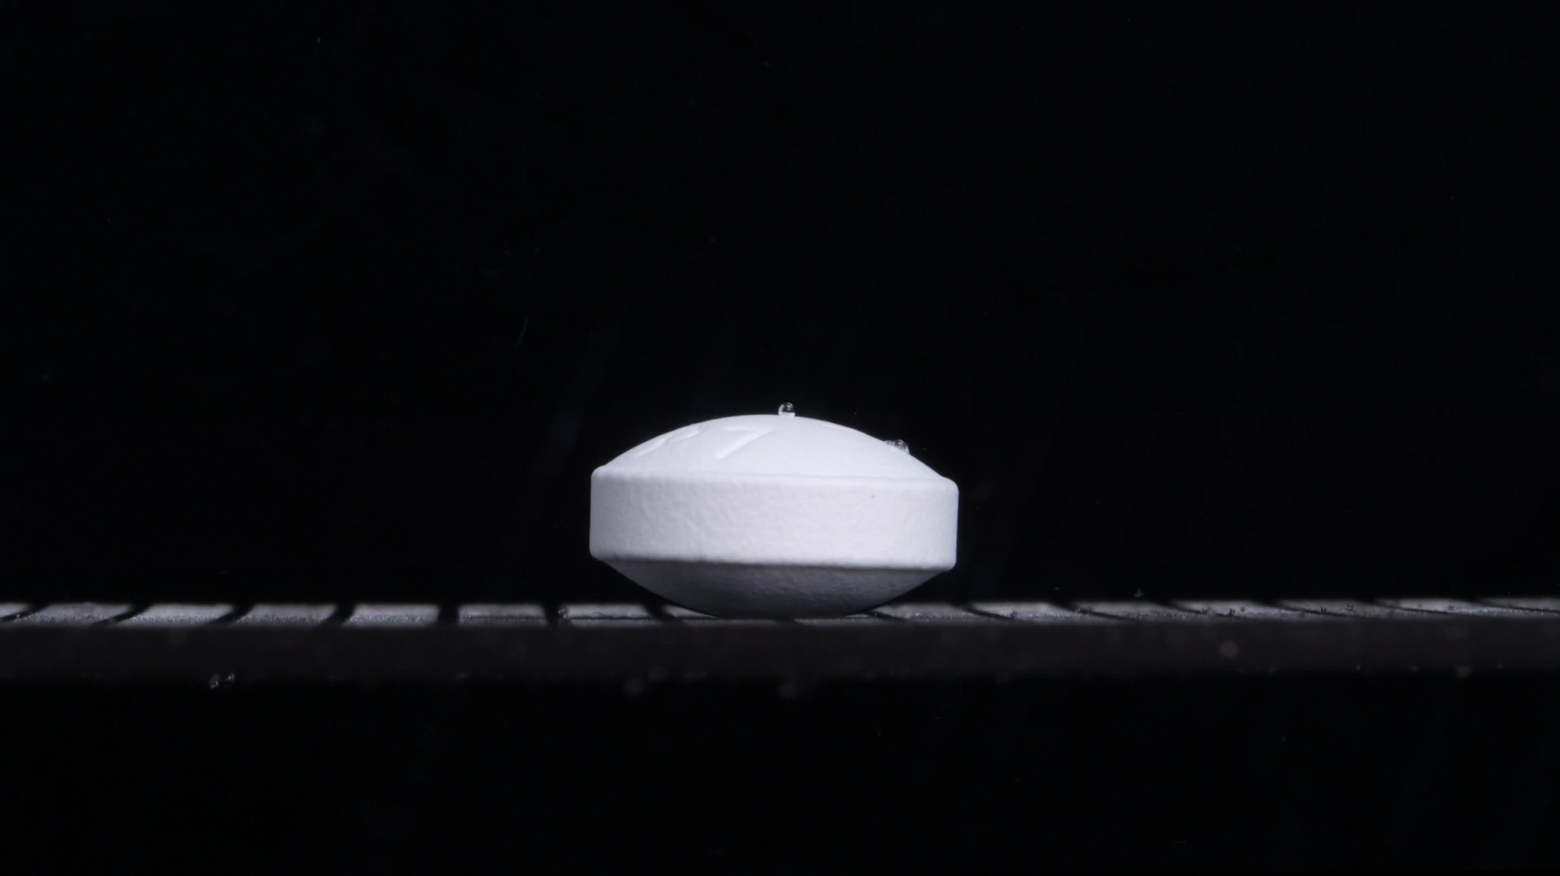
Group A — 0 min
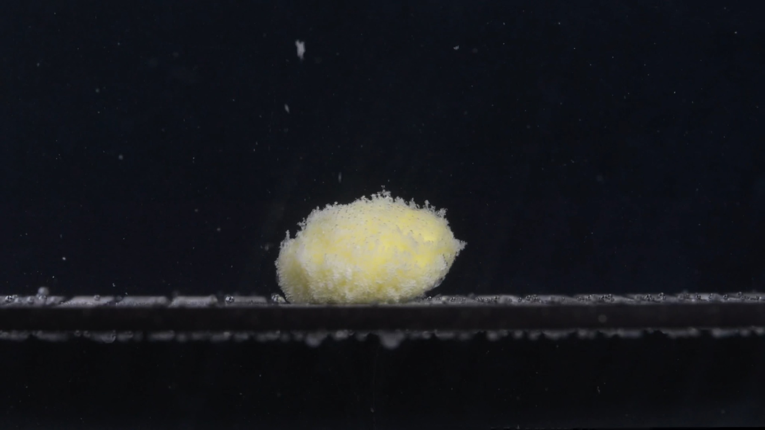
Group A — 15 min
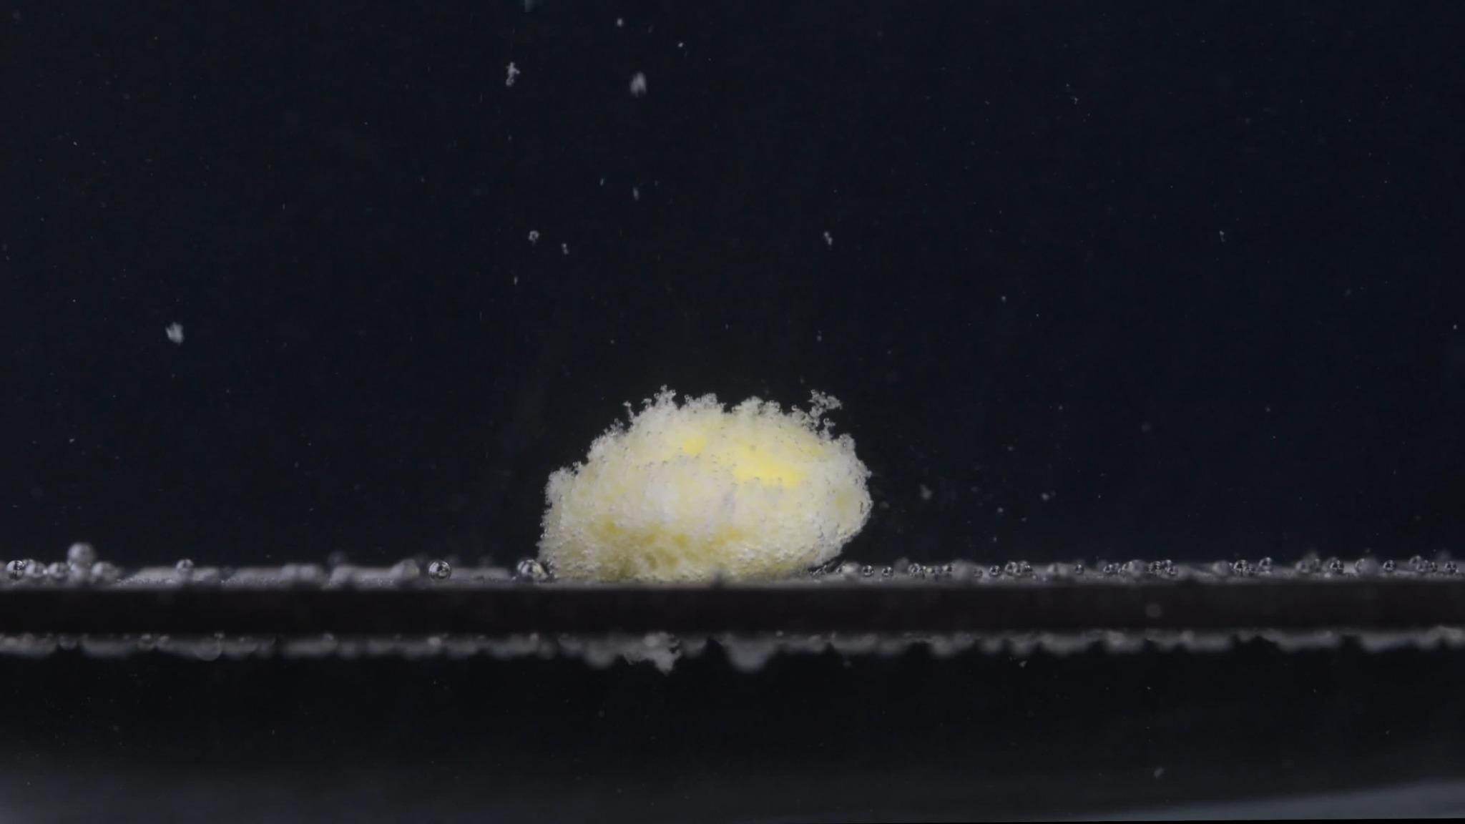
Group A — 30 min
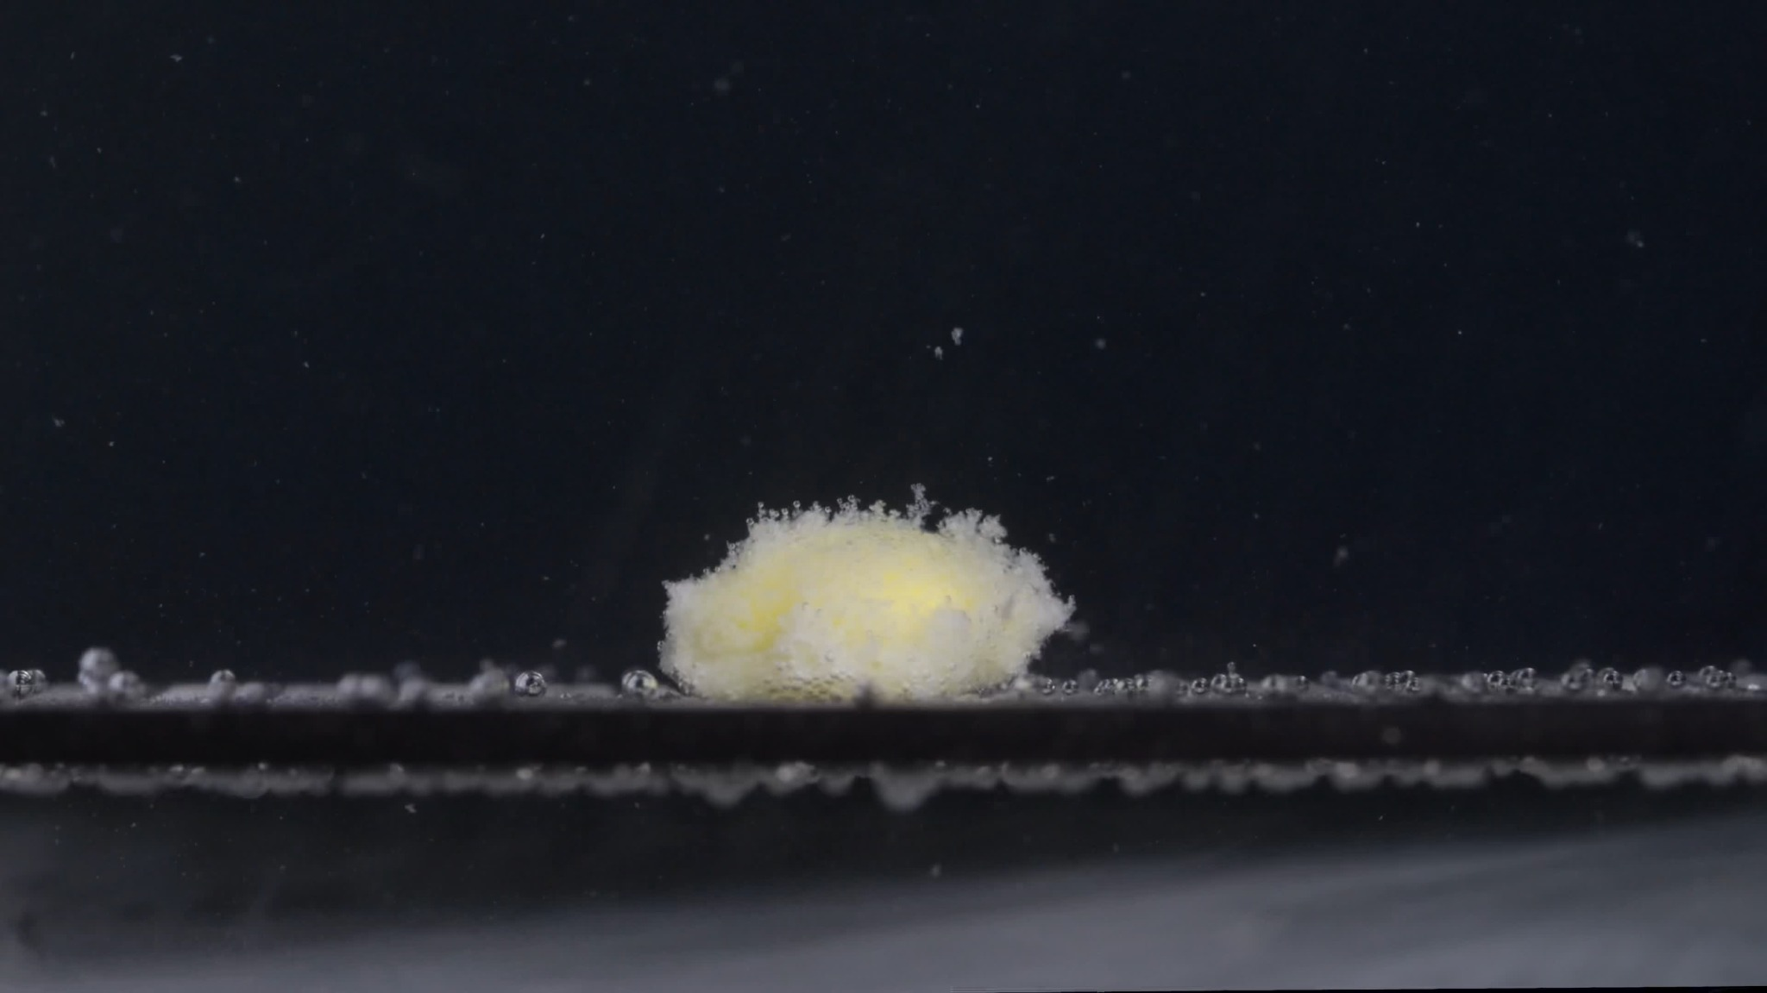
Group A — 45 min
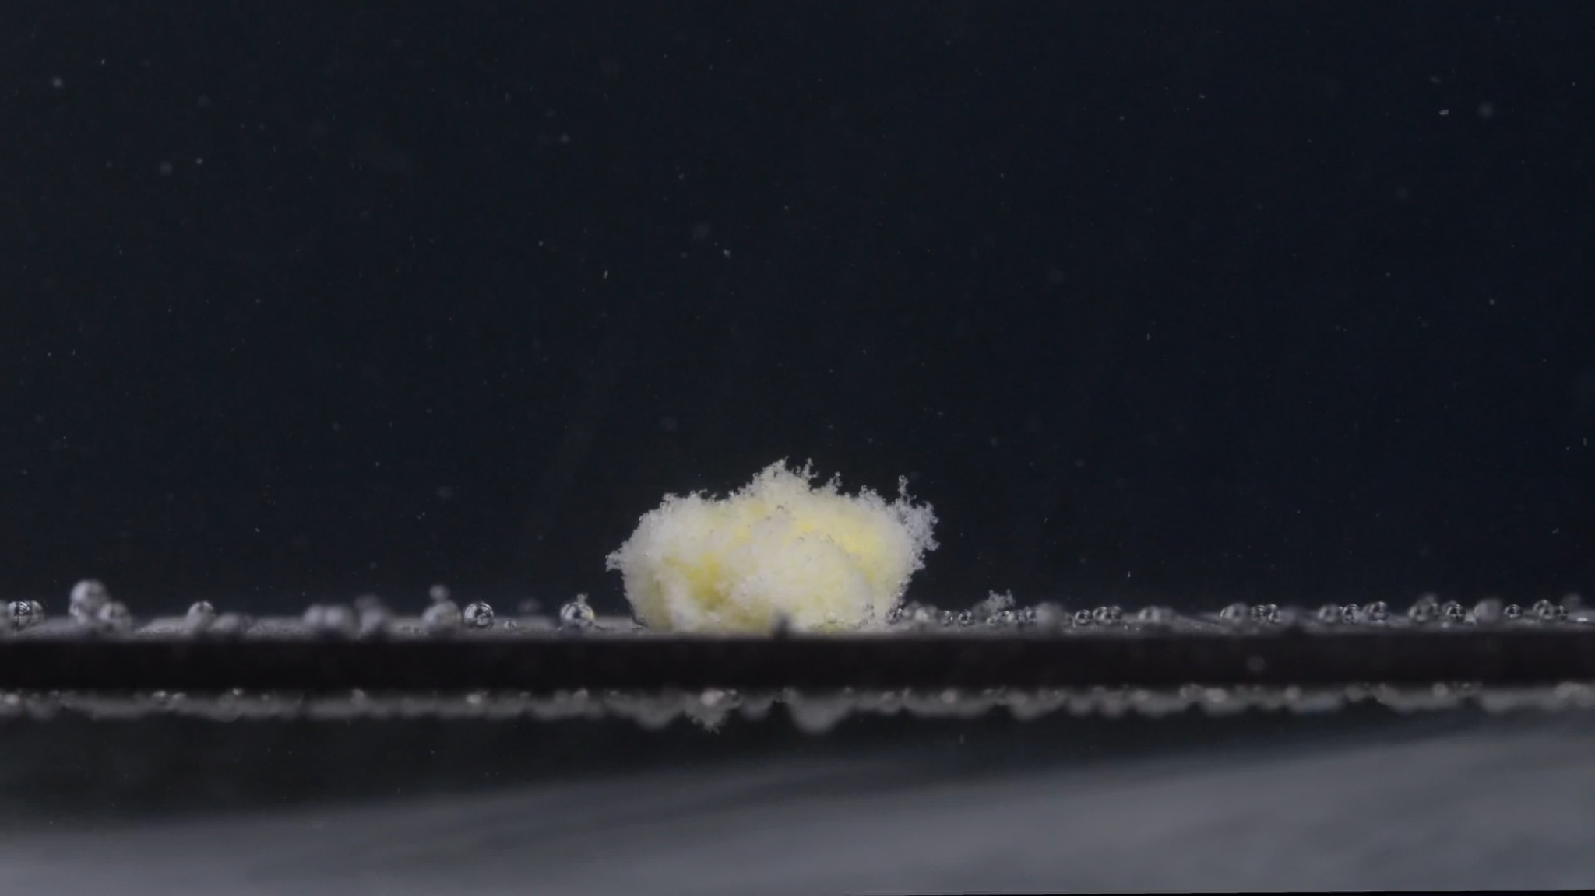
Group A — 60 min

Assistant Analysis of Group A
The assistant described only the visible image features and avoided chemical identification from images alone.

A1 — 0 min
Color change: The tablet is uniformly white. No yellow core or colored residue is visible yet. The surrounding medium appears mostly clear against the dark background.
Shape change: The tablet is still intact. It has a regular compressed-tablet shape with a flat cylindrical side band and beveled or biconvex upper and lower surfaces. The edge contour is sharp and well defined.
Surface texture change: The surface appears smooth and compact. No visible pores, cracks, peeling, or powder shedding are present.
Volume / size change: This is the baseline state. The tablet keeps its original full size and height. No swelling or shrinkage is visible.
Dissolution speed and time: At 0 minutes, no visible disintegration has started.
Physical state change: The tablet remains solid and structurally stable. No collapse, softening, or fragmentation is visible.
Dissolution medium: The medium looks visually clear. Small bubbles or droplets are visible near the tablet and platform, but they do not appear to be tablet fragments.
Fragment distribution and density: No fragments are visible around the tablet.

A2 — 15 min
Color change: A clear color transition has occurred. The tablet is no longer uniformly white; a pale yellow inner region is exposed, while whitish material remains around the outside.
Shape change: The original sharp tablet outline has disappeared. The tablet has become an irregular, swollen mound. It is still mainly one coherent mass, but the original cylindrical form is no longer preserved.
Surface texture change: The surface has become rough, fluffy, and porous. The outer layer looks loosened, with fine fibrous or powdery material projecting outward.
Volume / size change: The compact tablet has expanded into a softer-looking mass. The apparent height is lower and less geometrically defined than the original tablet, while the surface area appears more diffuse because of swelling and loosening.
Dissolution speed and time: Between 0 and 15 minutes, disintegration is obvious and relatively fast. The coating or outer compact layer appears to have broken down substantially during this interval.
Physical state change: The tablet has softened and partly collapsed. Liquid penetration appears to have reached the inner yellow material, causing the tablet to lose rigidity.
Dissolution medium: The medium remains mostly transparent, but fine suspended particles are visible around the tablet.
Fragment distribution and density: Fragments are concentrated close to the original tablet position. Most material remains attached to the central mound; only fine particles are dispersed nearby.

A3 — 30 min
Color change: The pale yellow color remains visible inside the central mass, but it is partially covered by whitish, loosened material. The color is unevenly distributed rather than uniform.
Shape change: The mass remains mound-like but becomes less compact. The edges are more irregular and feathered than at 15 minutes.
Surface texture change: The surface appears increasingly granular and flocculent. Fine particles are detaching from the top and edges.
Volume / size change: Compared with 15 minutes, the structure appears slightly more eroded and less dense. The original tablet volume is no longer visually recoverable; the remaining mass is a softened residue.
Dissolution speed and time: Disintegration continues after 15 minutes, but the change from 15 to 30 minutes appears more gradual than the initial 0–15 minute change.
Physical state change: The tablet is no longer a hard solid. It behaves visually like a wet, porous, partially collapsed aggregate.
Dissolution medium: More suspended fine particles are visible in the surrounding liquid, especially above and around the tablet.
Fragment distribution and density: Fragment density remains highest near the central mass. Small particles are dispersed upward and outward, but no large detached chunks are clearly visible.

A4 — 45 min
Color change: Yellow regions are still visible but appear more muted and partly buried under white disintegrated material. The mass shows a mixed white-yellow appearance.
Shape change: The mound has become flatter and more irregular. The original tablet shape is completely lost. The upper surface looks uneven, with a loose, crumb-like outline.
Surface texture change: The surface is highly rough and powdery. The outer material appears fragile, with small flakes or fine particles separating from the main body.
Volume / size change: The visible compact mass has reduced further. It appears lower and less dense than before, suggesting continued erosion and collapse.
Dissolution speed and time: From 30 to 45 minutes, the process appears to continue at a moderate but slower rate. The main change is gradual breakdown and thinning rather than sudden fragmentation.
Physical state change: The structure appears weak and partially collapsed. It is now mostly a soft residue rather than a tablet.
Dissolution medium: The liquid still appears relatively clear overall, but scattered particles are visible in suspension.
Fragment distribution and density: Fine fragments are distributed near the platform and around the mound. The highest density remains at the tablet’s original location.

A5 — 60 min
Color change: The remaining material is still a mixture of white and pale yellow. Yellow areas are visible inside the residue, while the outer disintegrated material appears mostly whitish.
Shape change: The tablet has become an irregular loose aggregate. There is no remaining recognizable original tablet contour.
Surface texture change: The residue looks very rough, fluffy, and porous. The surface has a fibrous or flocculent appearance, with small projections and detached particles.
Volume / size change: The compact tablet volume has greatly decreased in structural integrity. The remaining visible material is a smaller, collapsed residue pile rather than a solid tablet.
Dissolution speed and time: By 60 minutes, disintegration is advanced but not visually complete. Some central material remains, so the tablet has not fully disappeared.
Physical state change: The tablet has transitioned from a hard compressed solid into a soft, fragmented, partially suspended residue.
Dissolution medium: The medium contains visible fine particles, but it is not completely opaque. The disintegration remains localized around the tablet position.
Fragment distribution and density: Fragments are densest near the central residue and platform. Fine particles are dispersed above and around the mass, while heavier material appears to remain settled near the original tablet site.

Group A Overall Disintegration Pattern
Group A shows a rapid early transformation between 0 and 15 minutes: the intact white tablet loses its original shape, exposes a pale yellow inner region, and becomes a swollen, fluffy mound. From 15 to 60 minutes, the process becomes more gradual: the mass erodes, collapses, and sheds fine particles, but a visible central residue remains at 60 minutes.
The most important visual features for later comparison with Group B are:
- The intact tablet at 0 minutes is white, compact, beveled or biconvex, and sharply contoured.
- By 15 minutes, the tablet rapidly changes into a yellow-white swollen porous mound.
- Disintegration is mainly softening, swelling, surface loosening, and gradual collapse, not large-piece splitting.
- Fragments are mostly fine, fluffy, and locally concentrated, with no obvious large hard fragments.
- At 60 minutes, residual material remains, so dissolution or disintegration is not visually complete.

3. Group B Image Set and Analysis
User: These are Group B images. Each picture is taken 15 minutes apart. When you describe the drug, please make sure the English description is accurate, think carefully, and reduce hallucinations.
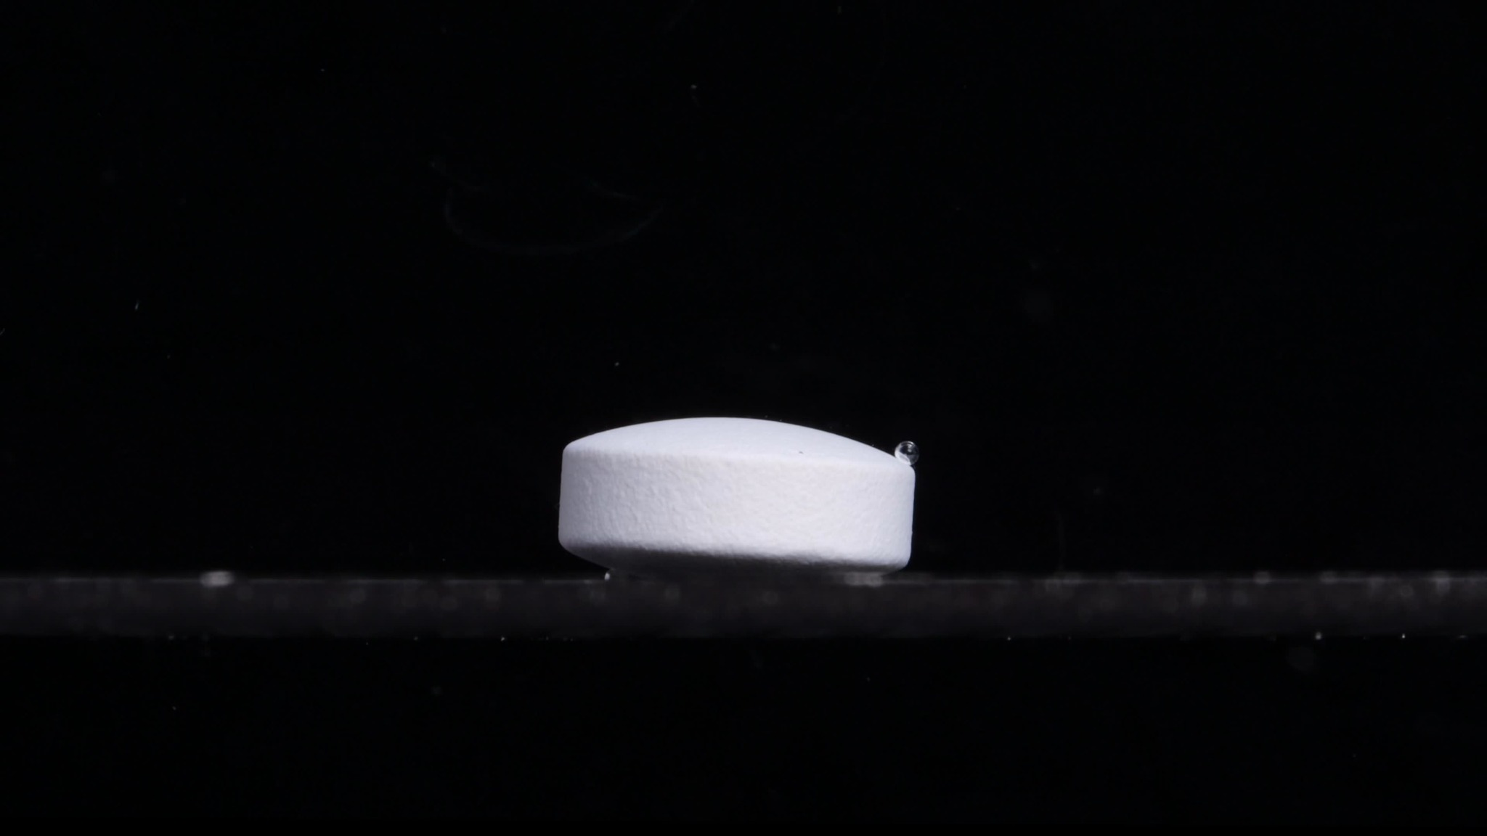
Group B — 0 min
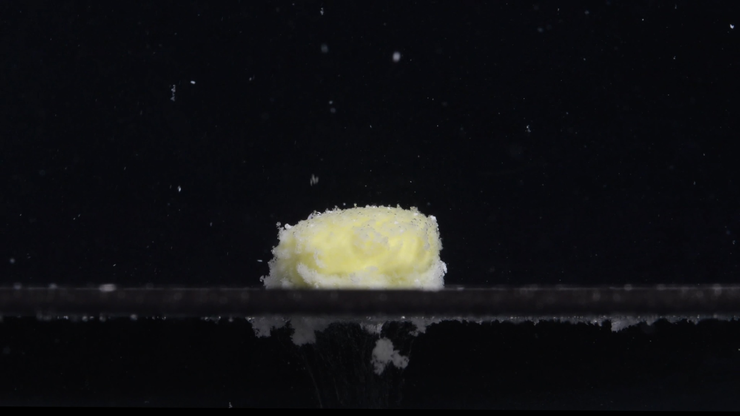
Group B — 15 min
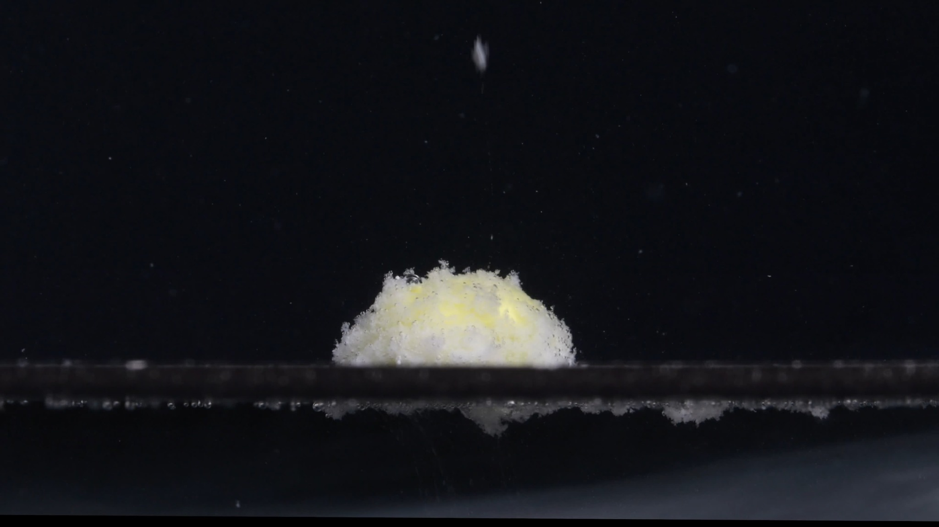
Group B — 30 min
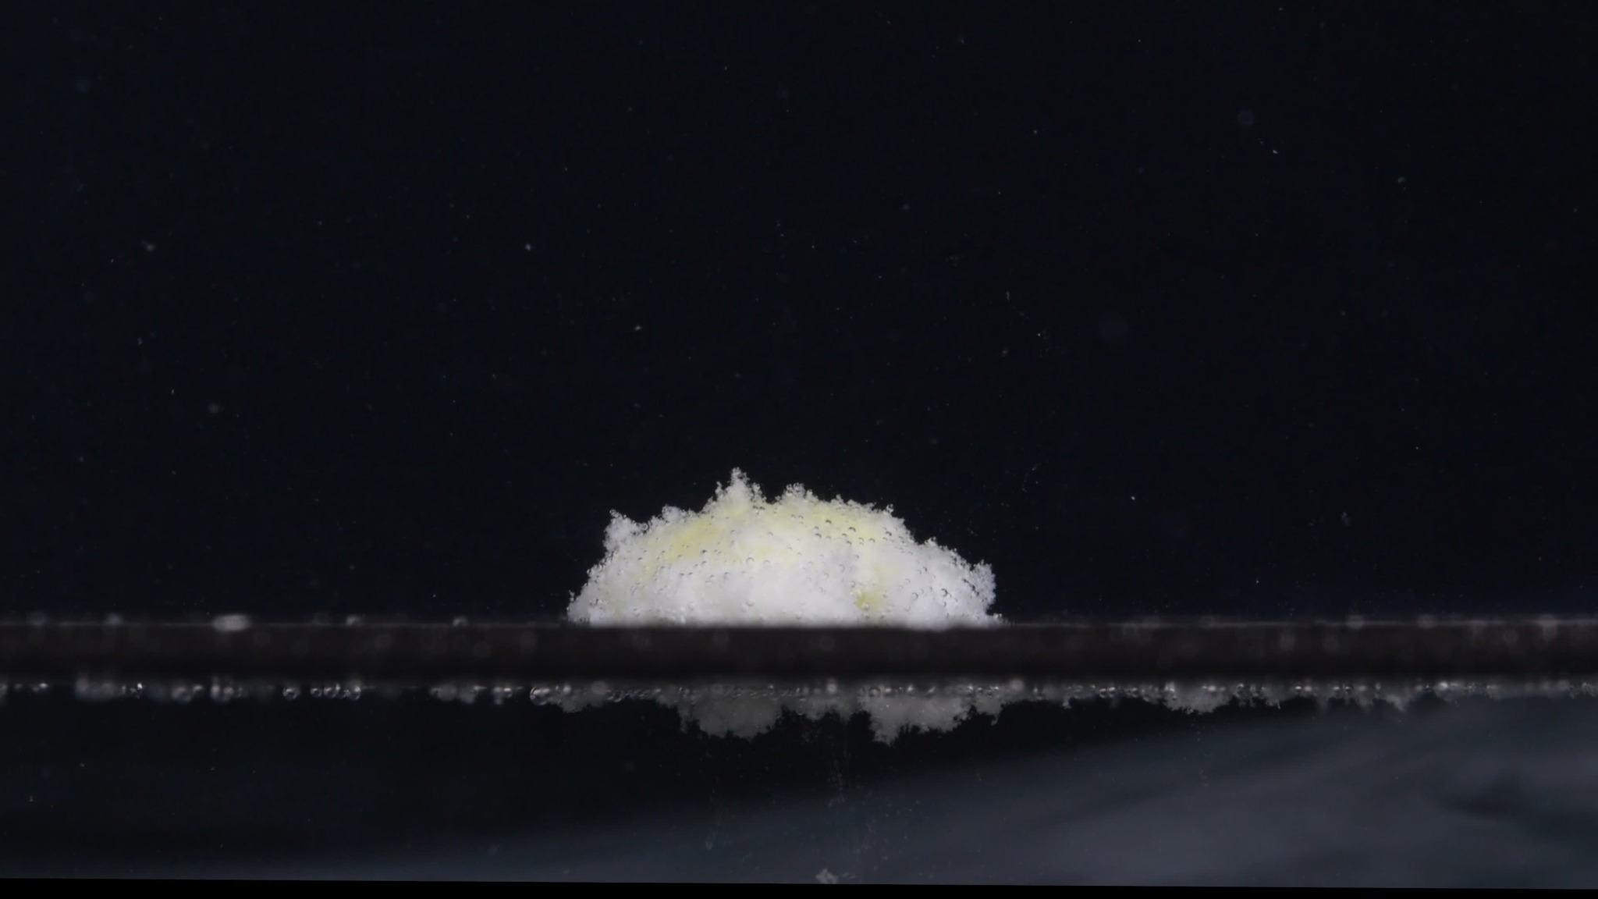
Group B — 45 min
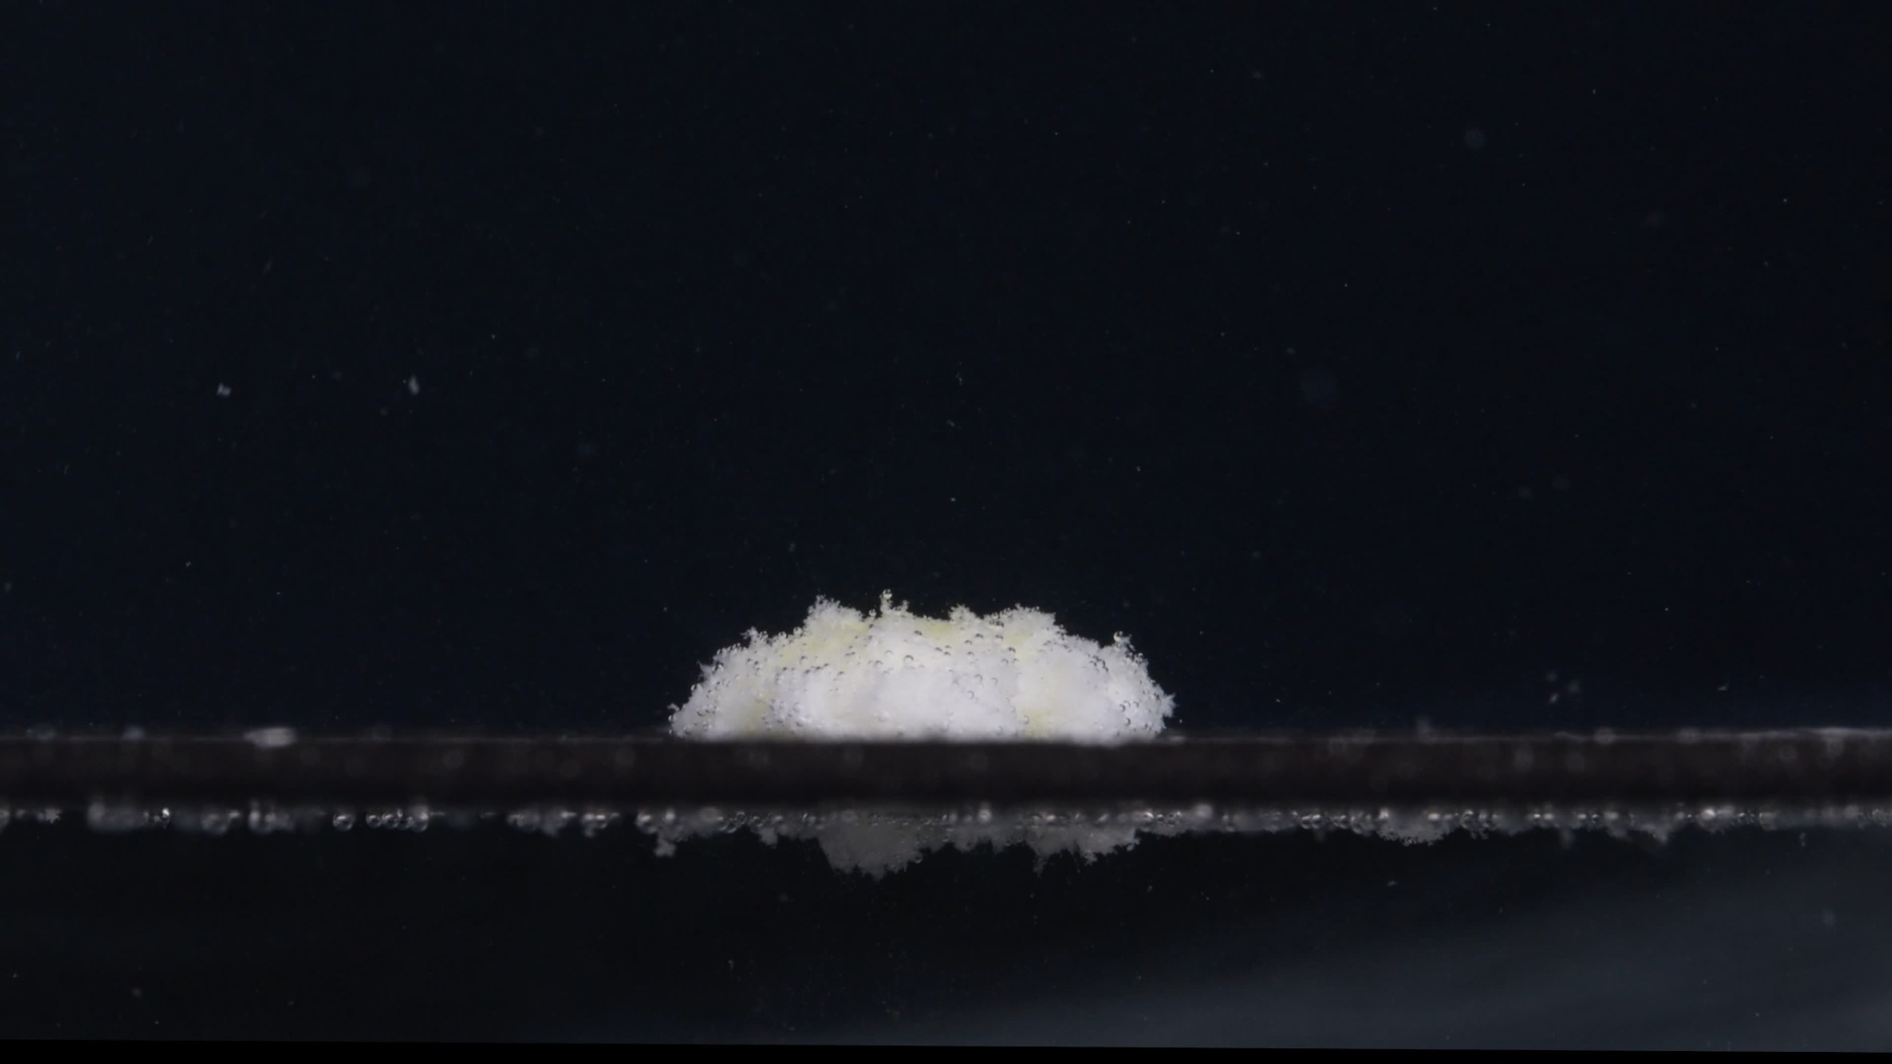
Group B — 60 min

Assistant Analysis of Group B
The judgment remained visual-only: the images can show whether disintegration behavior is consistent, but they cannot chemically prove the identity of the tablets.

B1 — 0 min
Color change: The tablet is uniformly white. No yellow inner material or colored residue is visible.
Shape change: The tablet is intact, round, and compressed, with a flat cylindrical side wall and slightly curved upper surface. The outline is regular and sharply defined.
Surface texture change: The visible surface is smooth to slightly matte. No cracks, pores, peeling, or powder shedding are visible.
Volume / size change: This is the baseline state. The tablet keeps its full original size and thickness.
Dissolution speed and time: At 0 minutes, no visible disintegration has started.
Physical state change: The tablet remains a hard, coherent solid. No swelling or collapse is visible.
Dissolution medium: The surrounding medium appears mostly clear. A bubble is visible near the right upper edge of the tablet, but it does not appear to be drug material.
Fragment distribution and density: No tablet fragments are visible.

B2 — 15 min
Color change: A pale yellow region becomes clearly visible in the center of the tablet mass. White material remains around the outer region, producing a yellow-white appearance.
Shape change: The original cylindrical tablet shape is mostly lost. The tablet has become a swollen, softened mound, although it still remains mainly as one central mass.
Surface texture change: The surface becomes rough, porous, and fluffy. Fine powder-like or fibrous material appears around the top and edges.
Volume / size change: The compact tablet has expanded and loosened. The mass appears wider and more diffuse than the original tablet, but less geometrically defined.
Dissolution speed and time: A major change occurs between 0 and 15 minutes. This indicates relatively rapid early liquid penetration and surface breakdown.
Physical state change: The tablet has softened and partly collapsed. The yellow core or inner material appears exposed, suggesting that the outer white layer has opened or eroded.
Dissolution medium: The medium remains mostly transparent, but fine particles are visible around the tablet. Some residue is also visible below the platform or reflection area, but this region is partly obscured.
Fragment distribution and density: Fragments are concentrated near the original tablet position. Most material remains attached to the central mound; only fine particles are dispersed nearby.

B3 — 30 min
Color change: The yellow area remains visible but is partly covered by white, loosened material. The color distribution is uneven, with yellow mostly inside and white material more dominant at the surface.
Shape change: The tablet remains as a low, irregular mound. The original sharp tablet contour is no longer visible.
Surface texture change: The surface is strongly granular and flocculent. The top and sides look porous, with fine particles detaching from the mass.
Volume / size change: Compared with 15 minutes, the mound appears slightly lower and more spread out. The compact volume has continued to weaken.
Dissolution speed and time: From 15 to 30 minutes, disintegration continues but appears slower than the first 15 minutes. The main process is gradual erosion rather than sudden splitting.
Physical state change: The tablet is now a wet, softened aggregate rather than a solid tablet. It appears structurally weak but not fully dissolved.
Dissolution medium: The medium still looks relatively clear overall, with scattered suspended particles visible.
Fragment distribution and density: The highest density of fragments remains around the central mound. Fine particles are visible above and near the tablet, while heavier material appears to stay close to the platform.

B4 — 45 min
Color change: The visible yellow color becomes less dominant. White disintegrated material covers much of the remaining mound, with only pale yellow patches still visible.
Shape change: The mound becomes flatter and more irregular. No original tablet shape remains.
Surface texture change: The surface is rough, powdery, and fragile-looking. The top edge is uneven, with small loose projections.
Volume / size change: The remaining visible mass is lower than at 30 minutes. The tablet residue has collapsed further and lost more structural height.
Dissolution speed and time: The process continues gradually. Compared with the 0–15 minute stage, the 30–45 minute change is slower and mainly involves thinning, erosion, and soft residue breakdown.
Physical state change: The tablet has become a soft, partially collapsed residue pile. There is no evidence of a hard intact core from this view.
Dissolution medium: The medium remains mostly transparent rather than fully cloudy. Fine particles are present but not dense enough to obscure the whole field.
Fragment distribution and density: Residue is still localized around the original tablet position. Fine material appears distributed near the mound and along the platform.

B5 — 60 min
Color change: The remaining mass is mainly white with faint pale yellow regions. Yellow is still present but less visually dominant than at 15–30 minutes.
Shape change: The tablet has become a low, irregular residue mound. The original round compressed-tablet form is completely absent.
Surface texture change: The surface remains fluffy, porous, and powder-like. The top edge is uneven, suggesting ongoing erosion.
Volume / size change: The mass is visibly reduced in height compared with the earlier swollen state. It has not disappeared completely; a residual pile remains.
Dissolution speed and time: By 60 minutes, disintegration is advanced but incomplete. The tablet has not fully dissolved or dispersed.
Physical state change: The tablet has changed from a solid compressed form into a soft, fragmented, partially dispersed residue.
Dissolution medium: The medium is still not completely opaque. Suspended fine particles are visible, but the residue remains mostly localized.
Fragment distribution and density: Fragments are densest near the original tablet site. There is some fine particulate material around the mass, but no large detached hard fragments are clearly visible.

4. Comparison and Final Determination
User: Please compare Groups A and B based on their disintegration characteristics across the eight dimensions to determine whether they are from the same drug or not, and explain why you think so.

Assistant Comparison Across the Eight Dimensions
Dimension | Group A | Group B | Similarity judgment
Color change | Starts as a white intact tablet. By 15 minutes, a pale yellow inner region appears, surrounded by white loosened material. From 30–60 minutes, the residue remains white-yellow. | Same pattern: white at 0 minutes, yellow core exposed by 15 minutes, mixed white-yellow residue afterward. Yellow becomes less dominant by 45–60 minutes. | Highly similar. Both show the same white-to-yellow exposure pattern.
Shape change | 0 minutes: regular compressed tablet with clear edges. 15 minutes: original shape largely lost, becoming a swollen mound. 30–60 minutes: irregular flattened residue. | 0 minutes: regular compressed tablet with similar side-wall shape. 15 minutes: swollen mound. 30–60 minutes: low irregular mound. | Highly similar. Both lose their original tablet contour at almost the same time.
Surface texture change | Smooth at 0 minutes. Becomes rough, fluffy, porous, and powder-like after 15 minutes. | Smooth at 0 minutes. Also becomes rough, porous, fluffy, and granular after 15 minutes. | Highly similar. Both show the same surface loosening and flocculent texture.
Volume / size change | Intact full-size tablet at 0 minutes. Apparent swelling and loosening by 15 minutes, followed by gradual collapse and height reduction through 60 minutes. | Same trend: compact tablet to swollen loose mound to lower collapsed residue by 60 minutes. | Highly similar. Both show early expansion and softening followed by gradual collapse.
Dissolution speed and time | Fast visible change between 0 and 15 minutes. Slower gradual erosion from 15–60 minutes. Residue remains at 60 minutes. | Same timing: major change by 15 minutes, then slower breakdown. Residue remains at 60 minutes. | Highly similar. The time course is almost the same.
Physical state change | Hard solid to softened swollen aggregate to weak collapsed residue. No large hard fragments are obvious. | Same physical transition: hard tablet to soft yellow-white mound to collapsed residue. | Highly similar. The mechanism appears to be softening, swelling, and erosion rather than splitting into large pieces.
Dissolution medium | Medium remains mostly clear, with visible fine suspended particles near the tablet. No strong full-field turbidity. | Medium also remains mostly clear, with local fine particles and residue near the tablet. | Similar. Both show localized disintegration rather than heavy uniform clouding.
Fragment distribution and density | Fragments are mainly fine, fluffy, and concentrated near the original tablet location. Little long-range dispersion. | Same: fine particles and residue remain densest around the tablet site. | Highly similar. Fragment size and distribution are visually consistent.

Key Reasons Supporting the Same-Drug / Similar-Formulation Judgment
The strongest evidence is the matching time sequence. In both groups, the tablet is intact and white at 0 minutes, then undergoes a major transformation by 15 minutes. At that point, both expose a pale yellow internal region and form a white-yellow swollen, porous mound. This is a very specific pattern.
The second important reason is the similar disintegration mechanism. Neither group mainly breaks into large hard pieces. Instead, both appear to soften, swell, loosen at the surface, become fluffy or granular, and then gradually collapse into a localized residue.
The third reason is the similar final state at 60 minutes. Both groups still have remaining material. The tablets are not completely dissolved, and the residue remains mostly near the original tablet position. This suggests comparable dissolution speed, matrix behavior, and fragment-density pattern.

Differences Observed
- Group A appears slightly more irregular and fluffy in some later images.
- Group B appears slightly flatter and more white-dominant by 45–60 minutes.
- At 0 minutes, Group A looks slightly more beveled or biconvex, while Group B looks slightly flatter from the visible angle.
However, these differences are not strong enough to conclude that the groups are different drugs. They could result from camera angle, tablet orientation, lighting, liquid contact, bubble position, or small sample variation.

Final Determination
Conclusion: Groups A and B are likely the same drug or a very similar formulation.
Confidence level: moderate to moderately high.
The visual disintegration profiles match across all eight dimensions, especially in color exposure, shape loss, swelling/collapse behavior, dissolution timing, and localized fragment distribution. Still, image analysis alone cannot prove chemical identity. For a definitive answer, imprint, manufacturer, batch information, or analytical testing would be required.

