Complete English Dialogue Record
Doxycycline Hyclate Tablet Disintegration Analysis: Groups A and B
This Word document edits the conversation into English and includes the drug-disintegration discussion only. The final Chinese request to create this document is intentionally excluded.
Important note: The image-based conclusion is a visual comparison of disintegration behavior, not a definitive chemical identification. Confirmation would require imprint/package information, manufacturer records, or laboratory testing.

Knowledge-base framework used in the discussion
The analysis used the uploaded drug-disintegration knowledge base and followed eight dimensions for each image:
- Color change: tablet color, medium clarity or turbidity, and spatial color distribution.
- Shape change: preservation or loss of the original tablet outline, cracking, rounding, collapse, and fragmentation.
- Surface texture change: smoothness, roughness, pores, peeling, cracks, flakes, and powdery or fibrous surfaces.
- Volume / size change: swelling, shrinkage, height and width changes, and loss of compact structure.
- Dissolution speed and time: timing of visible disintegration and whether the process accelerates or slows.
- Physical state change: liquid penetration, softening, internal weakening, breaking, and collapse.
- Dissolution medium: visible clarity, cloudiness, suspended particles, bubbles, and sedimentation.
- Fragment distribution and density: location, size, concentration, suspension, and settling of fragments.

Edited English dialogue and image analysis
User
I need you to analyze the disintegration images of two groups of Doxycycline Hyclate Tablets, Group A and Group B. These may be images of the same drug or of different drugs. I need you to determine whether the images are from the same drug or not.
For each group, I will upload five images. Each image is taken 15 minutes apart. Please describe the drug disintegration process in English for each image in the group. Finally, determine whether the two sets of images are from the same drug.
You can call the knowledge base to remember how to describe drug disintegration. As you describe the tablets in English, please pay attention to changes in the size and shape of the tablets. If you are prepared, I will upload Group A, picture 1 at 0 minutes.
Assistant
I am ready. Please upload Group A, picture 1 at 0 minutes.
I will describe each image in English using the eight disintegration dimensions: color change, shape change, surface texture, volume/size change, dissolution speed and time, physical state change, dissolution medium, and fragment distribution/density. I will especially track tablet size, outline, cracking, swelling, fragmentation, and shape retention, because these are important for judging whether Group A and Group B are likely the same drug.
User
You are not fully prepared. Please call the knowledge base again to remember how to describe drug disintegration.
Assistant
I have refreshed the knowledge-base framework and am now prepared.
I will analyze every uploaded disintegration image using the eight required dimensions: color change, shape change, surface texture change, volume/size change, dissolution speed and time, physical state change, dissolution medium, and fragment distribution/density.
For each image, I will describe the tablet in English, with special attention to tablet size and shape, because the knowledge base indicates that size and shape can help identify and compare tablets during disintegration.
Please upload Group A, picture 1 at 0 minutes.

Group A image sequence
User
Group A, picture 1 at 0 minutes was uploaded. The user asked for an accurate English description and requested that hallucinations be minimized.
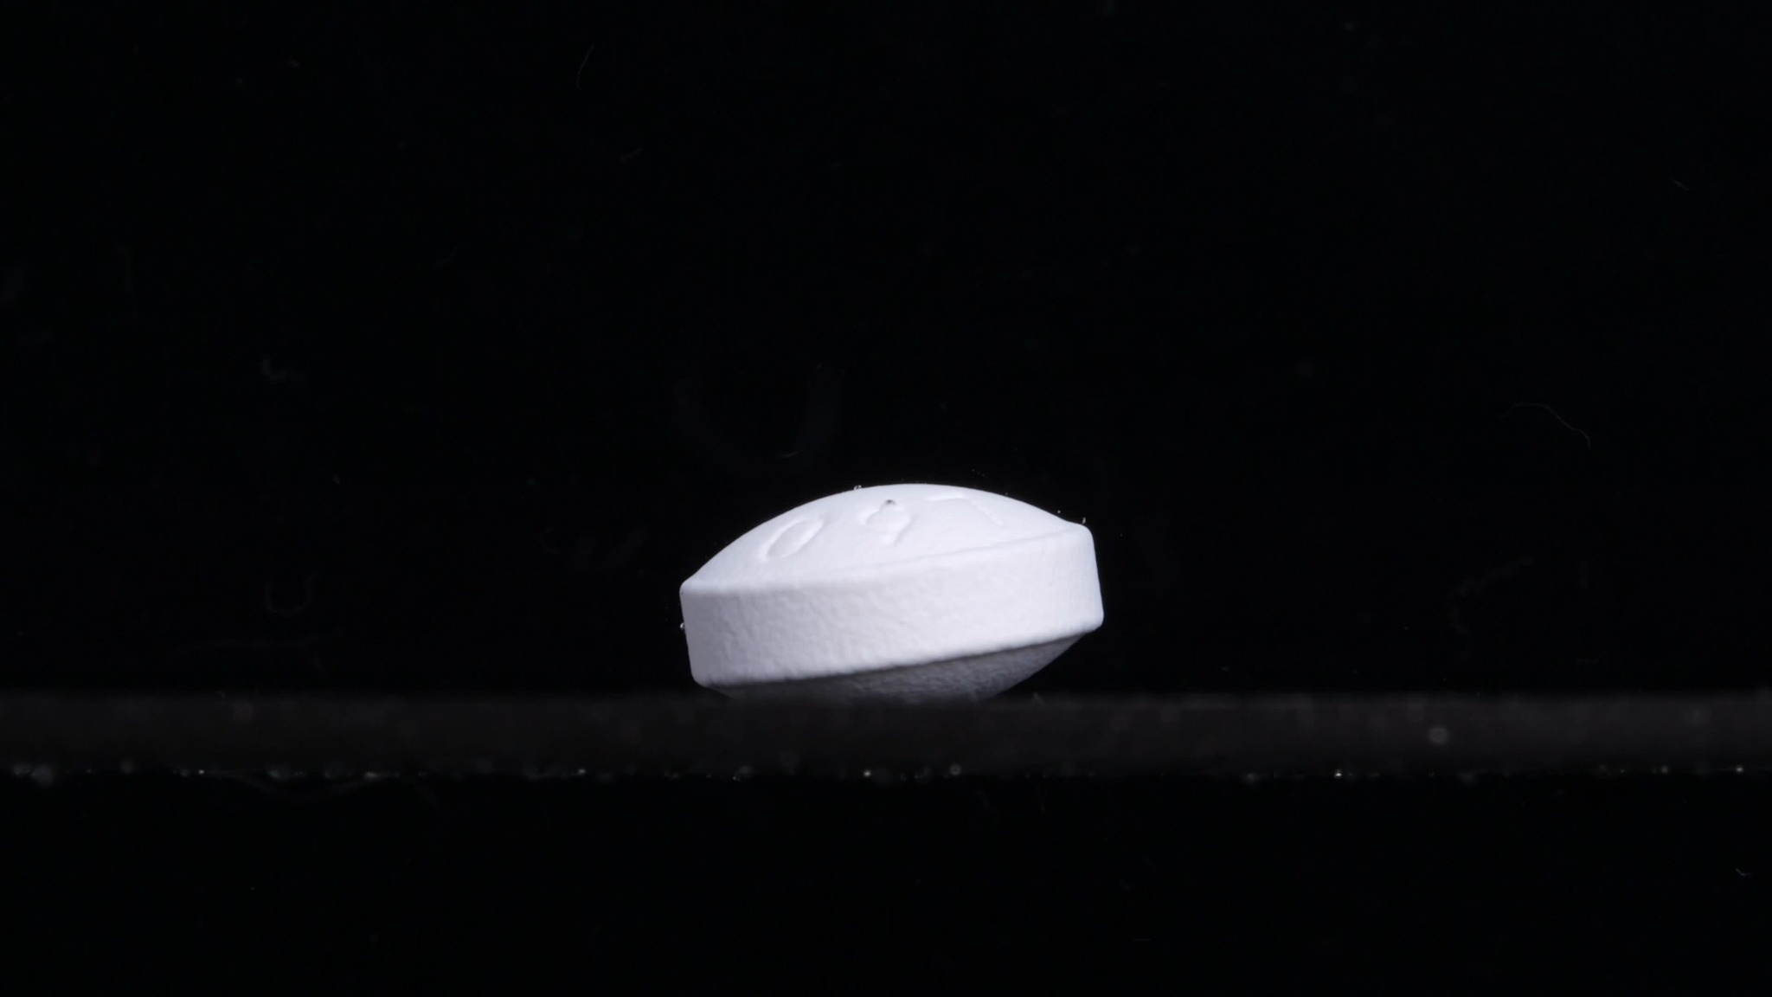
Group A - Picture 1 - 0 minutes

Group A - Picture 1 - 0 minutes
Overall observation:
The tablet appears intact at the initial time point. It is a white to off-white, oblong/oval, biconvex tablet with rounded ends and a relatively thick side wall. The tablet is lying slightly tilted on a dark surface/background. No clear disintegration, cracking, swelling, or fragment release is visible yet.
1. Color change: The tablet remains uniformly white/off-white. No obvious yellowing, darkening, dye diffusion, or cloudy plume is visible around the tablet. The surrounding field appears dark; no visible color spread into the medium can be confirmed from this image.
2. Shape change: The tablet keeps its original solid oblong/caplet-like shape. The contour is still well defined, with rounded ends and a slightly convex upper surface. No visible breakage, edge erosion, or collapse is present.
3. Surface texture change: The upper surface looks mostly smooth, with a shallow embossed or indented marking visible on top. The side surface appears slightly matte or fine-grained, but this looks like the original tablet texture rather than disintegration damage. No obvious pores, peeling, deep cracks, or flaking are seen.
4. Volume / size change: This image should be treated as the baseline size and volume for Group A. The tablet appears full-sized, with no visible swelling, shrinkage, thinning, or volume loss. Its height and width are still preserved.
5. Dissolution speed and time: At 0 minutes, there is no visible evidence of active dissolution. The disintegration speed cannot yet be judged from this single image, but the tablet appears stable at the starting point.
6. Physical state change: The tablet remains in a solid, intact physical state. No internal weakening is visible externally. No cracking, splitting, softening, or collapse can be confirmed.
7. Dissolution medium: The medium or container background appears dark and visually clear in this frame. No suspended particles, cloudiness, sediment layer, or visible diffusion zone is apparent.
8. Fragment distribution and density: No detached fragments are visible around the tablet. Fragment density is essentially zero at this time point. The surrounding area appears clean, without powder clouds or settled debris.
Preliminary comparison note:
This first Group A image establishes a baseline: a white/off-white, intact oblong biconvex tablet with clear shape retention. Later Group A images should be compared against this baseline for changes in size, edge definition, surface roughening, cracking, swelling, and fragment release.
User
Group A, picture 2 at 15 minutes was uploaded.
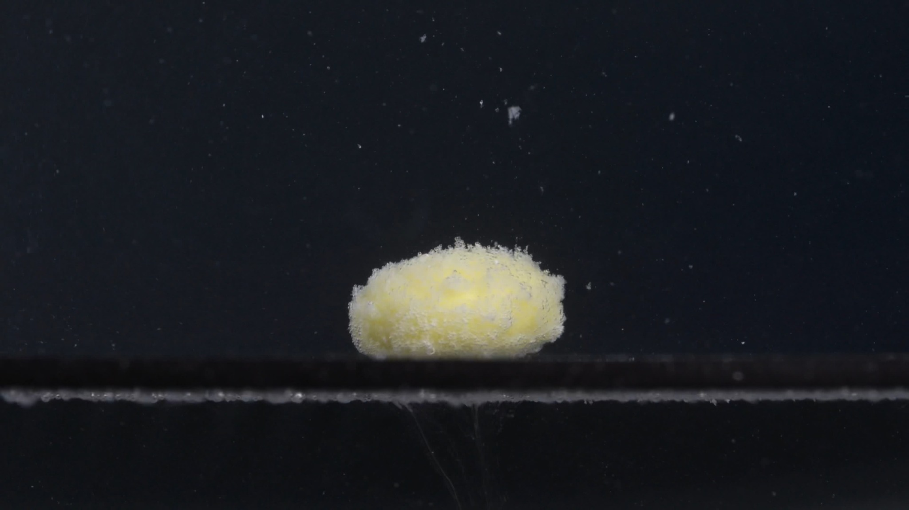
Group A - Picture 2 - 15 minutes

Group A - Picture 2 - 15 minutes
Overall observation:
At 15 minutes, the tablet is still present as one main body, but it no longer looks like the intact, smooth white tablet seen at 0 minutes. It now appears yellow to pale yellow in the central exposed area, with a white, rough, powdery outer layer. The original oblong/caplet-like shape is still recognizable, but the surface and edges have become visibly eroded.
1. Color change: The tablet has changed from mostly uniform white/off-white to a yellow-centered appearance. The yellow color is strongest in the central upper region, while the outer rim remains whitish. The surrounding medium does not show a strong yellow diffusion plume, but many small light particles are visible around the tablet.
2. Shape change: The tablet still keeps an overall rounded oblong or dome-like shape. Compared with 0 minutes, the contour is less sharp and more irregular. The edges appear softened and eroded, especially along the upper and side margins. No complete splitting into large pieces is visible yet.
3. Surface texture change: The surface has changed from smooth to rough, granular, and powdery. A loose, fuzzy-looking layer covers much of the tablet surface. Small particles appear to be detaching from the outer surface, especially around the top and edges. No deep single crack is clearly visible, but the surface looks weakened and porous.
4. Volume / size change: The main tablet body remains relatively large, suggesting that major volume loss has not yet occurred. However, the outer boundary is expanded or blurred by a powdery disintegrating layer, making the tablet look slightly swollen or loosened. The original clean side wall seen at 0 minutes is no longer distinct.
5. Dissolution speed and time: Between 0 and 15 minutes, disintegration has clearly begun. The process appears moderate rather than complete: the tablet has surface erosion and particle release, but the central body remains intact. The exposed yellow region suggests that the outer coating or outer compacted layer has been penetrated or removed.
6. Physical state change: The tablet has shifted from a hard intact solid to a partially softened, porous, eroding solid mass. Liquid penetration appears to have weakened the outer layer first. The core has not collapsed yet, but the surface structure is visibly breaking down.
7. Dissolution medium: The surrounding medium/background remains mostly dark and visually transparent. Fine white particles are visible in the field, especially above and around the tablet. There is no dense cloud covering the whole medium, so turbidity appears localized rather than uniform.
8. Fragment distribution and density: Small detached particles are scattered around the tablet, with a noticeable number suspended above it. Fragment density is highest close to the tablet surface and decreases farther away. No large fragments are visible; the released material is mainly fine powder or tiny granules.
Comparison with Group A at 0 minutes:
The tablet has changed from a smooth, white, sharply contoured oblong tablet into a rough, pale-yellow-centered, powder-coated mass. The overall shape is still retained, but surface erosion, color exposure, and fine particle release are now evident.
User
Group A, picture 3 at 30 minutes was uploaded.
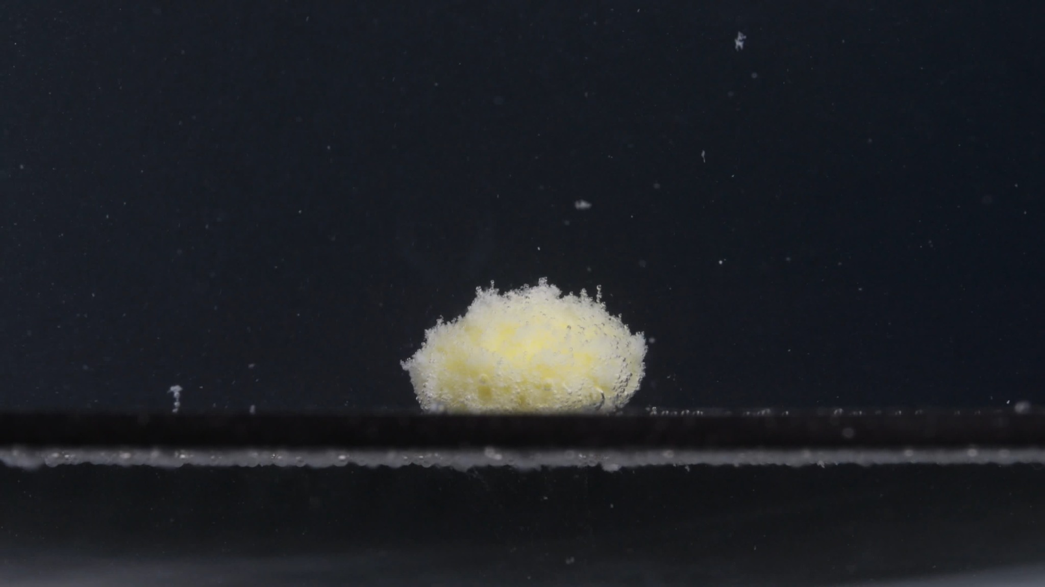
Group A - Picture 3 - 30 minutes

Group A - Picture 3 - 30 minutes
Overall observation:
At 30 minutes, the tablet has progressed from a partially eroded tablet into a loose, irregular, powdery mound. The original oblong tablet outline is now much less clear. A pale yellow inner material is visible through a white granular outer layer, and fine particles are present around the tablet.
1. Color change: The tablet is no longer uniformly white. A pale yellow to light yellow region is visible through the center and lower areas of the mass. The white outer layer remains, but it appears more fragmented and powder-like than at 15 minutes. The surrounding medium still does not show a strong uniform yellow coloration; color change is mainly localized around the tablet body.
2. Shape change: The original oblong/caplet-like shape is now largely lost. The tablet appears as an irregular dome-shaped mound rather than a sharply defined tablet. The side wall seen at 0 minutes is no longer visible. The edges are uneven and crumbly, suggesting progressive erosion and structural collapse.
3. Surface texture change: The surface is highly rough, porous, and granular. The top and edges look fluffy or powder-coated, with many small particles protruding from the surface. No single large crack is obvious, but the entire surface appears weakened and broken into fine granules.
4. Volume / size change: The compact tablet body appears reduced and less structurally defined. The visible footprint remains relatively broad because loosened powder surrounds the remaining mass. Compared with 0 minutes, the tablet no longer has a clean height and width; its volume is now distributed into a soft, irregular mound.
5. Dissolution speed and time: Between 15 and 30 minutes, disintegration has clearly advanced. The process appears to be dominated by surface erosion and powder shedding rather than sudden splitting into large pieces. The increasing amount of fine material suggests that dissolution/disintegration has accelerated as the surface area increased.
6. Physical state change: The tablet has changed from a solid intact unit into a partially collapsed, softened, porous mass. The structure appears internally weakened, with the outer region breaking into fine particles. The core still seems present, but it is no longer enclosed by a stable, smooth surface.
7. Dissolution medium: The medium/background remains mostly dark and relatively clear. Some suspended or floating light particles are visible above and around the tablet. A faint layer of small material is visible near the bottom surface, suggesting particle settling.
8. Fragment distribution and density: Fragment density is highest immediately around the remaining tablet mound. Most fragments appear to be fine white or pale particles, not large broken chunks. A few particles are dispersed upward in the field, while some material appears settled along the bottom line. The distribution is still localized rather than evenly spread throughout the entire visible medium.
Comparison with Group A at 15 minutes:
At 15 minutes, the tablet still retained a recognizable oblong body. By 30 minutes, the tablet has become more mound-like, more granular, and less geometrically defined. The yellow inner material remains visible, while the white outer material has become increasingly loose and powdery. The main change is loss of shape definition and increased fine-particle release.
User
Group A, picture 4 at 45 minutes was uploaded.
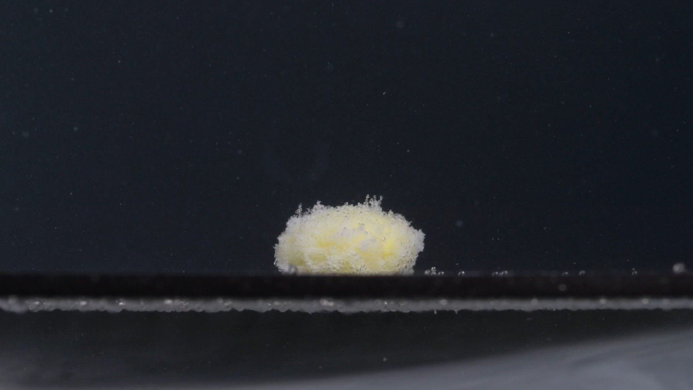
Group A - Picture 4 - 45 minutes

Group A - Picture 4 - 45 minutes
Overall observation:
At 45 minutes, the tablet remains as a low, irregular, mound-like mass rather than a recognizable intact tablet. The original oblong/caplet shape is essentially lost. The visible material is mainly white to off-white granular material, with pale yellow areas still present inside the mound. Compared with 30 minutes, the mass appears slightly flatter and more eroded, but it has not completely dispersed.
1. Color change: The tablet mass shows a mixed white/off-white and pale yellow appearance. The yellow color is visible mainly in the central and lower internal regions, while the outer granular layer remains whitish. There is still no strong, uniform yellow coloration throughout the surrounding medium; the color change remains mostly localized around the tablet residue.
2. Shape change: The original tablet shape is no longer clearly identifiable. The remaining material forms a soft, uneven dome or mound with an irregular outline. The top surface is ragged, with small protruding particles, and the side boundary is blurred. No large separated tablet pieces are visible; the shape change appears driven by gradual erosion and crumbling rather than a clean split.
3. Surface texture change: The surface is very rough, porous, and granular. The upper edge has a loose, fuzzy appearance, suggesting fine particle detachment. The surface no longer looks compact or smooth; it appears weakened and powder-like over nearly the entire visible mass.
4. Volume / size change: Compared with the 0-minute image, the tablet has lost its original height, side wall, and clear solid contour. Compared with 30 minutes, the overall mound appears similar in width but slightly more flattened and less compact. The apparent volume is now distributed as a loose powdery mound rather than a solid tablet body.
5. Dissolution speed and time: From 30 to 45 minutes, the disintegration continues but appears gradual rather than abrupt. The tablet has not fully disappeared; the remaining mound indicates incomplete disintegration at this time point. The main ongoing process appears to be slow surface erosion, fine-particle release, and weakening of the residual core.
6. Physical state change: The tablet has changed into a softened, partially collapsed, porous residue. The internal structure appears weakened, but a central residual mass is still present. No firm tablet wall or intact core outline is visible externally.
7. Dissolution medium: The surrounding medium/background remains mostly dark and relatively clear in the visible field. Fine suspended particles are present, but there is no dense, uniform cloudiness across the whole image. A thin line of settled material is visible near the bottom surface, suggesting sedimentation of released particles.
8. Fragment distribution and density: Fragment density is highest immediately around the remaining mound. The fragments are mostly fine granules or powder-like particles, not large chunks. Some small particles are suspended above and around the tablet, while some appear settled along the bottom. The distribution remains localized, with limited spread into the wider medium.
Comparison with Group A at 30 minutes:
At 30 minutes, the tablet was already a rough, yellow-white mound. At 45 minutes, the same pattern continues: the mound appears slightly flatter, more eroded, and still granular, but the disintegration is not complete. The most important features are loss of original oblong shape, persistent pale yellow inner material, rough powdery texture, and localized fine-particle release.
User
Group A, picture 5 at 60 minutes was uploaded.
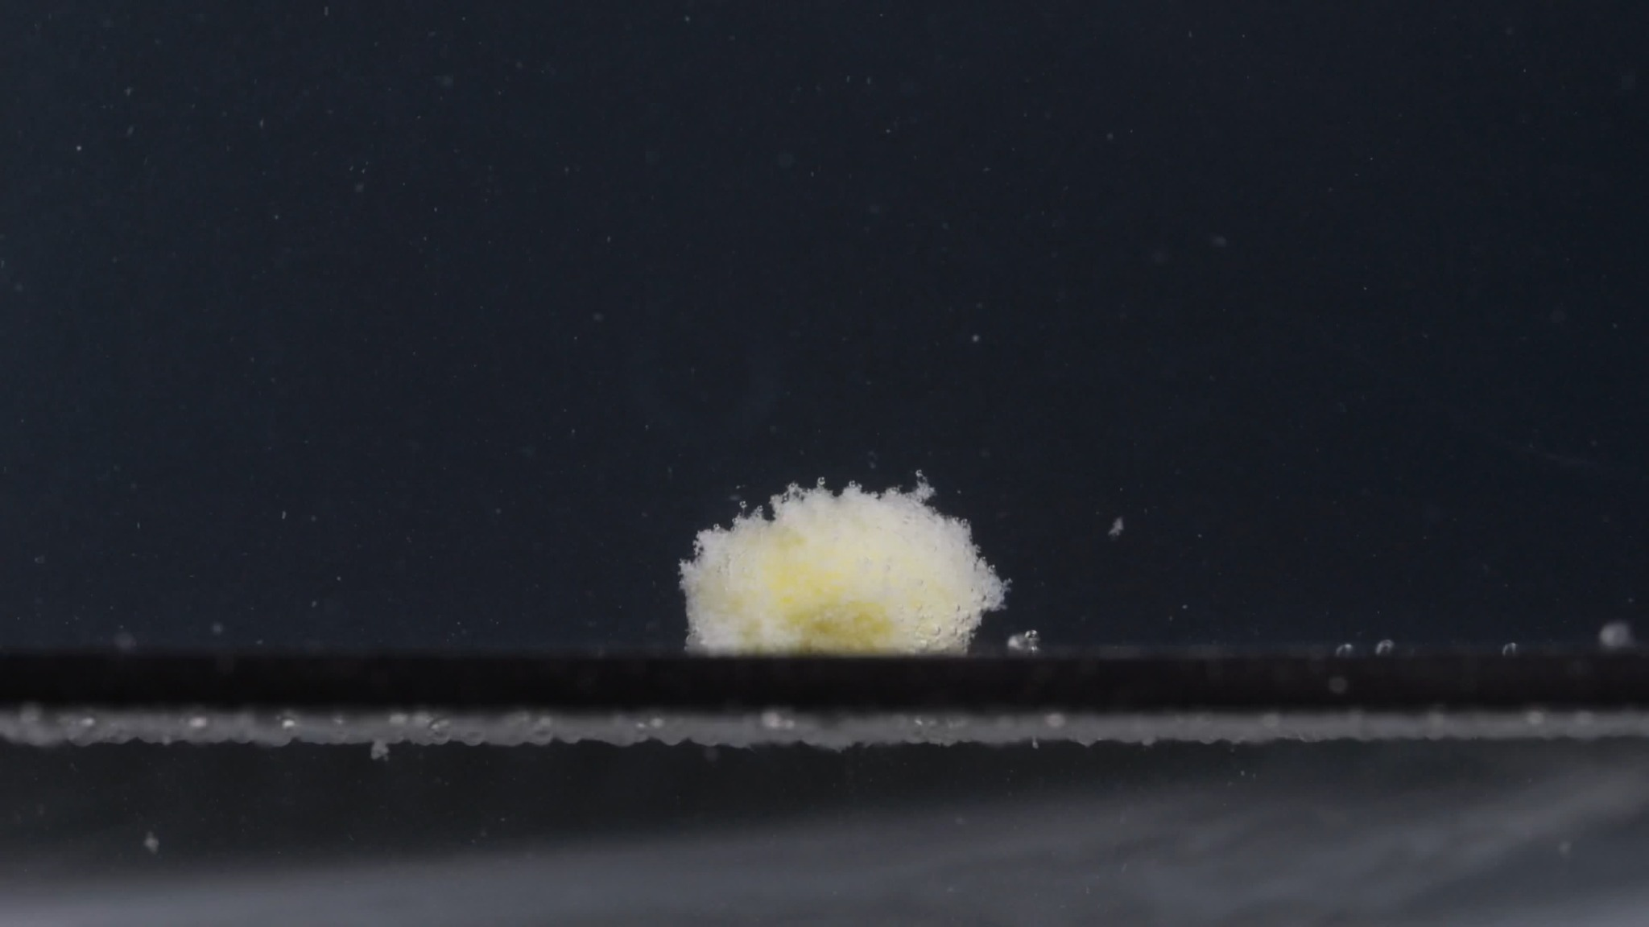
Group A - Picture 5 - 60 minutes

Group A - Picture 5 - 60 minutes
Overall observation:
At 60 minutes, the tablet remains visible as a small, loose, irregular powdery mound. The original intact oblong tablet shape seen at 0 minutes is no longer recognizable. The residue is mainly white/off-white granular material, with a pale yellow area still visible near the lower central part. The tablet has not fully dissolved or dispersed within the visible field.
1. Color change: The tablet residue shows a mixed white/off-white and pale yellow appearance. The yellow color is weaker and more localized than the white outer granular material. There is no obvious strong yellow diffusion throughout the surrounding medium; the color remains concentrated in the residual mound.
2. Shape change: The original oblong biconvex tablet shape has disappeared. The remaining structure is an irregular, low mound with a rough, uneven outline. The edges are no longer sharp or tablet-like; they appear soft, loose, and crumbly. No large separate fragments are visible.
3. Surface texture change: The surface is extremely rough, porous, and powder-like. Fine granules are visible along the top and side margins. The mound has a fluffy or friable appearance, suggesting that the tablet matrix has weakened substantially.
4. Volume / size change: Compared with the 0-minute image, the tablet has undergone major apparent volume loss and loss of structural height. The remaining mass is much less compact than the original tablet. Compared with 45 minutes, the mound appears similar in general size but slightly more loosened and eroded. The tablet is still not completely gone, indicating incomplete disintegration or incomplete dispersion by 60 minutes.
5. Dissolution speed and time: From 0 to 15 minutes, the tablet began surface erosion and yellow core exposure. From 15 to 45 minutes, it progressively lost its original shape and became a granular mound. By 60 minutes, the process appears to have slowed: a residual powdery mass is still present rather than being fully dispersed. The disintegration pattern appears mainly gradual erosion and powder shedding, not rapid breakup into large fragments.
6. Physical state change: The tablet has changed from a solid, intact caplet-like form into a softened, collapsed, porous residue. The remaining material appears weak and friable. No intact core wall or firm tablet boundary is visible externally.
7. Dissolution medium: The visible medium/background remains mostly dark and relatively clear. Some fine particles are visible in the surrounding field, but the whole medium is not densely turbid. The medium composition, pH, and viscosity cannot be determined from the image alone.
8. Fragment distribution and density: Fragment density is highest within and immediately around the residual mound. The fragments are predominantly fine powder-like particles, not large tablet pieces. Some small particles appear suspended above the mound, while some material appears settled along the bottom surface. The distribution remains localized rather than widely dispersed.

Group A - 0 to 60 minute sequence summary
Across the five Group A images, the tablet changes from a white/off-white intact oblong biconvex tablet into a yellow-white, loose, granular mound.
- 0 min: intact, smooth, sharply contoured oblong tablet.
- 15 min: surface erosion begins; pale yellow core becomes visible; outer layer becomes rough and powdery.
- 30 min: original tablet outline is mostly lost; residue becomes an irregular granular mound.
- 45 min: mound persists, slightly flatter and more eroded; fine particles remain localized.
- 60 min: residual powdery mass remains; no complete disappearance is visible.
Key Group A features for later comparison: white outer layer, pale yellow internal material, gradual surface erosion, loss of oblong shape by 30 minutes, persistent localized powdery mound through 60 minutes, and limited medium-wide turbidity.

Group B image sequence
User
Group B pictures 1 through 5 were uploaded together. Each picture was taken 15 minutes apart: 0, 15, 30, 45, and 60 minutes. The user again requested accurate English descriptions and minimal hallucination.
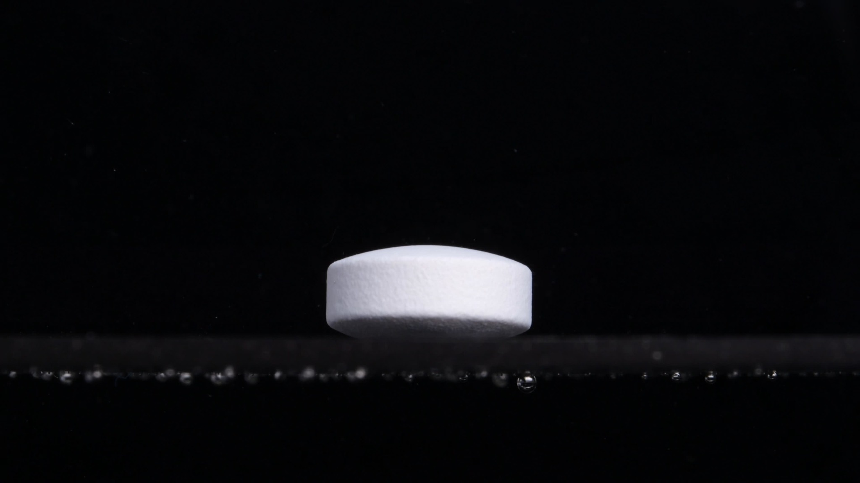
Group B - Picture 1 - 0 minutes
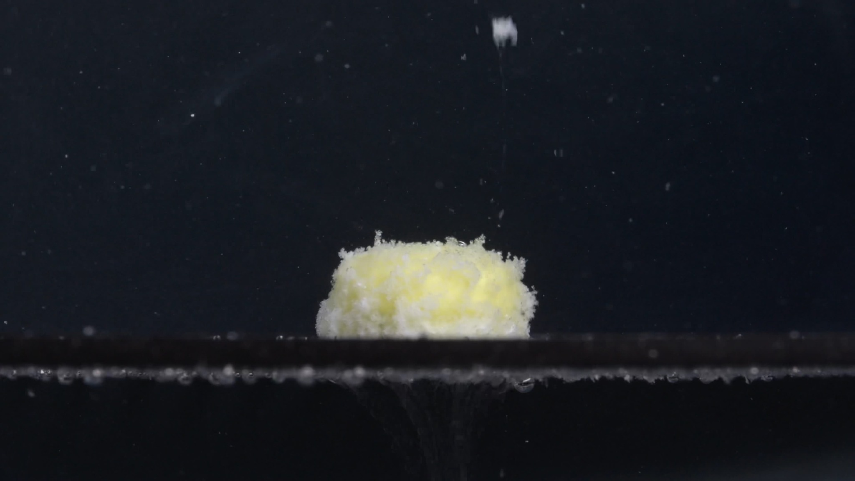
Group B - Picture 2 - 15 minutes
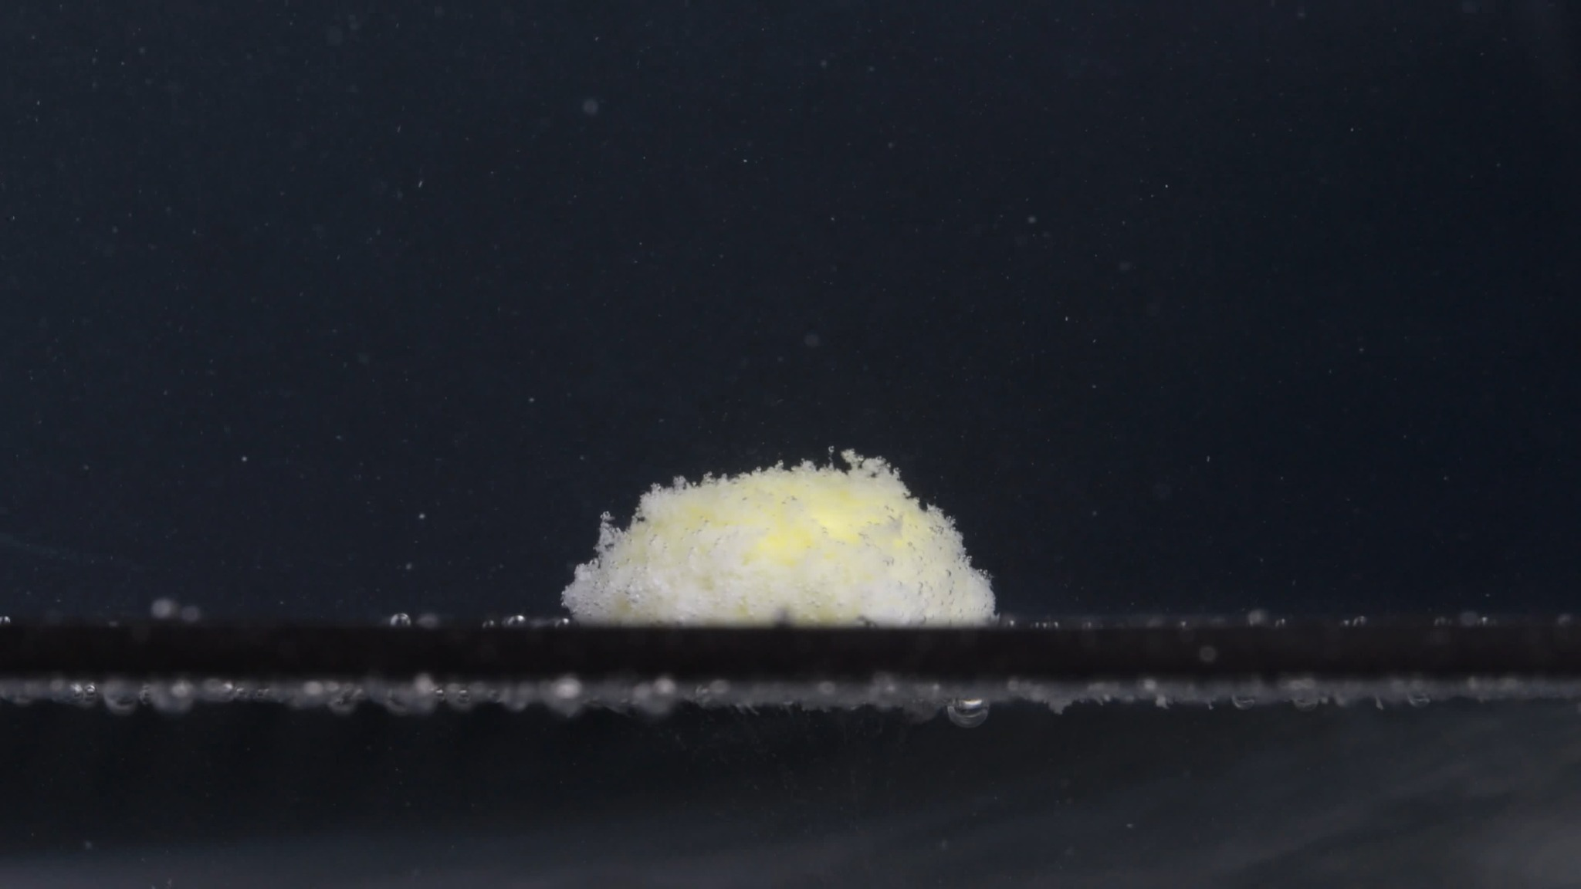
Group B - Picture 3 - 30 minutes
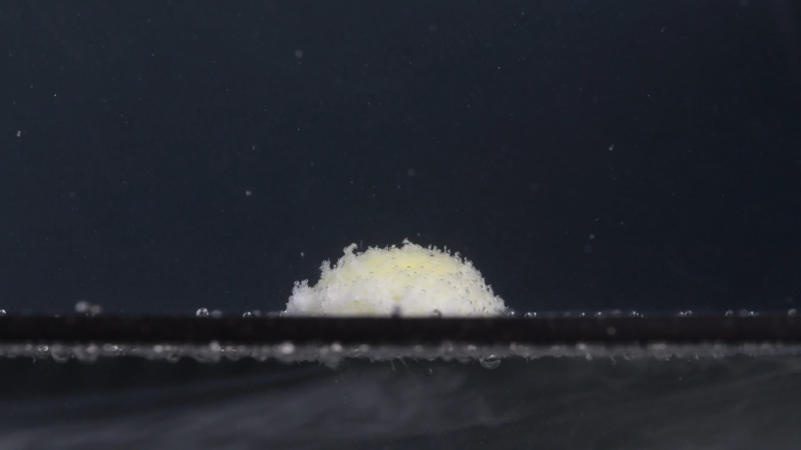
Group B - Picture 4 - 45 minutes
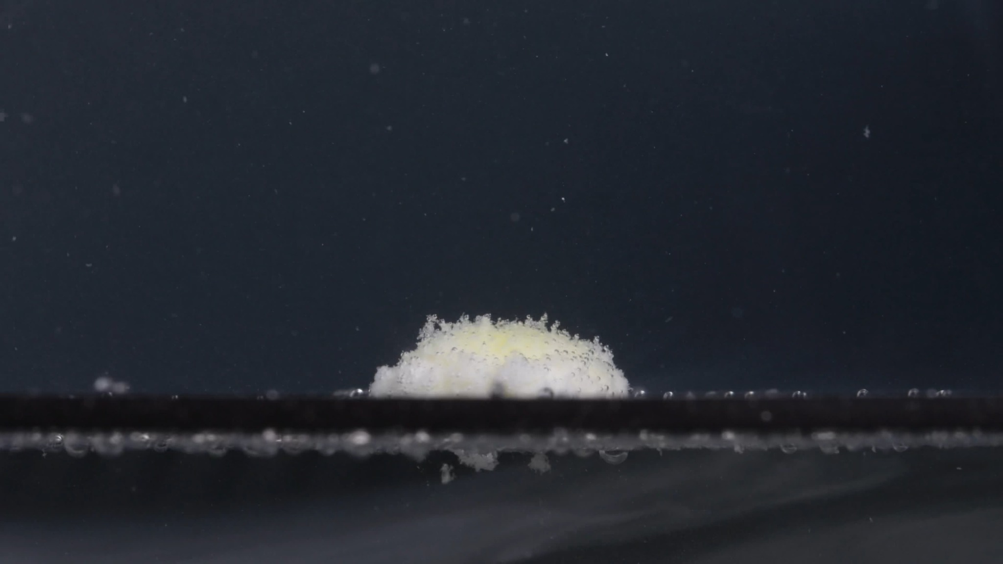
Group B - Picture 5 - 60 minutes

Group B - Picture 1 - 0 minutes
Overall observation:
The tablet is intact, white/off-white, and appears as an oblong or caplet-like biconvex tablet viewed from the side. The side wall is smooth and continuous, and no disintegration is visible yet.
1. Color change: Uniform white/off-white; no yellow exposure or color diffusion is visible.
2. Shape change: The original tablet shape is fully preserved, with a rounded upper surface and clear side wall.
3. Surface texture change: The surface appears mostly smooth and compact, with only slight matte texture.
4. Volume / size change: This is the baseline for Group B; no swelling, shrinkage, or erosion is visible.
5. Dissolution speed and time: At 0 minutes, there is no visible active disintegration.
6. Physical state change: The tablet remains a hard, intact solid.
7. Dissolution medium: The visible medium/background is mostly clear and dark; small bubbles or reflections are present near the bottom line.
8. Fragment distribution and density: No tablet fragments are visible.

Group B - Picture 2 - 15 minutes
Overall observation:
At 15 minutes, the tablet has changed into a yellow-white, rough, granular mound. The original smooth tablet surface is gone, but the remaining mass is still localized and compact.
1. Color change: A pale yellow internal region is clearly exposed, surrounded by white/off-white granular material.
2. Shape change: The original oblong tablet shape is mostly lost; the residue now forms a rounded mound.
3. Surface texture change: The surface is rough, porous, and fluffy, with many fine particles protruding from the surface.
4. Volume / size change: The tablet has lost its clean side wall and compact contour; the visible volume is now distributed as a loose mound.
5. Dissolution speed and time: Disintegration has advanced substantially during the first 15 minutes, mainly through surface erosion and loosening.
6. Physical state change: The tablet has softened and partially collapsed into a friable mass.
7. Dissolution medium: The surrounding medium remains mostly clear; fine suspended particles are visible but not dense throughout the whole field.
8. Fragment distribution and density: Fragment density is highest around the mound, with fine particles suspended nearby and some material settling near the bottom.

Group B - Picture 3 - 30 minutes
Overall observation:
At 30 minutes, the residue remains as a low, irregular mound. The white granular outer material still dominates, with pale yellow areas visible inside.
1. Color change: Mixed white/off-white and pale yellow coloration persists; yellow is mainly internal and localized.
2. Shape change: No recognizable intact tablet outline remains. The residue is mound-like, with an uneven surface and blurred edges.
3. Surface texture change: The surface remains highly granular and porous, with a powdery, friable appearance.
4. Volume / size change: Compared with 15 minutes, the mound appears slightly lower and more spread out. The compact tablet volume has clearly decreased.
5. Dissolution speed and time: Disintegration continues gradually rather than through sudden large-fragment breakage.
6. Physical state change: The remaining mass appears weakened, softened, and partially collapsed.
7. Dissolution medium: The visible medium is still not uniformly turbid; particles remain mostly localized.
8. Fragment distribution and density: Fine particles remain concentrated around the residue, with limited wider dispersion.

Group B - Picture 4 - 45 minutes
Overall observation:
At 45 minutes, the mound becomes flatter and more eroded. The pale yellow region is still visible but less sharply defined, and the white granular material remains around the surface and edges.
1. Color change: The residue remains yellow-white, with yellow mainly in the central area and white powder-like material at the outer surface.
2. Shape change: The residue is now a flattened irregular mound; the original tablet shape is completely absent.
3. Surface texture change: The surface remains rough, loose, and granular, with a powdery fringe especially near the left and upper edges.
4. Volume / size change: The height appears reduced compared with earlier time points, while the base remains locally spread along the bottom surface.
5. Dissolution speed and time: The process appears slower after the main structural collapse; residue remains rather than fully dispersing.
6. Physical state change: The tablet has become a soft, porous, partially collapsed residue.
7. Dissolution medium: The medium remains mostly clear in the wider field, with some suspended particles and bottom sediment.
8. Fragment distribution and density: Fragments are still mostly fine and localized, not large separate chunks.

Group B - Picture 5 - 60 minutes
Overall observation:
At 60 minutes, the tablet residue is still visible as a small, flattened, yellow-white powdery mound. It has not fully dissolved or dispersed.
1. Color change: The residue remains pale yellow internally with white/off-white granular material externally.
2. Shape change: No intact tablet shape remains; only an irregular low mound is visible.
3. Surface texture change: The surface is very rough, porous, and powder-like.
4. Volume / size change: The remaining volume is much smaller and less compact than the original tablet. Compared with 45 minutes, the mound appears slightly lower and more eroded.
5. Dissolution speed and time: Disintegration has slowed by 60 minutes, because a visible residue still persists.
6. Physical state change: The tablet has transformed from a solid caplet-like body into a friable, softened residue.
7. Dissolution medium: The medium is not heavily clouded; most visible material remains near the tablet location.
8. Fragment distribution and density: Fine particles are concentrated around the remaining mound and along the bottom; widespread dispersion is limited.

Initial comparison of Group A and Group B
Strong similarities:
- 0 min: Both begin as white/off-white, oblong, biconvex tablets with compact solid structures.
- 15 min: Both show rapid exposure of a pale yellow internal material and development of a white, rough, powdery outer layer.
- 30 min: Both lose the original oblong tablet outline and become irregular yellow-white granular mounds.
- 45-60 min: Both retain a localized powdery mound rather than fully dissolving. Both show limited medium-wide turbidity and mainly fine-particle shedding rather than large fragment separation.
Minor differences:
Group A at 0 minutes shows a visible upper marking or indentation, while Group B at 0 minutes does not clearly show one. However, this may be due to tablet orientation, viewing angle, lighting, or focus, because Group A is tilted and Group B is more side-on. Group B appears slightly more flattened from 30 minutes onward, but the difference is not large enough to suggest a different drug by itself.
Initial judgment:
The two image sets are likely from the same drug or the same type of doxycycline hyclate tablet. This is not definitively proven by images alone. The visual evidence strongly supports similarity because both groups share the same initial tablet appearance, pale yellow core exposure, white powdery surface erosion, gradual mound formation, localized fragment distribution, and persistent residue at 60 minutes. A definitive identity judgment would still require packaging, imprint information, chemical testing, or controlled dissolution data.

Final eight-dimension comparison and determination
User
Please compare Groups A and B based on their disintegration characteristics across the eight dimensions to determine if they are from the same drug or not, and explain why you think so.
Assistant
Based on the 0-60 minute image sequences, Groups A and B are visually very likely from the same drug or a very similar doxycycline hyclate tablet formulation. This is not a definitive chemical identification, but the disintegration behavior is highly consistent across the two groups.

1. Color change
Group A:
Starts as a white/off-white tablet. By 15 minutes, a pale yellow inner region appears, surrounded by a white powdery outer layer. From 30 to 60 minutes, the residue remains yellow-white, with yellow mostly localized inside the mound.
Group B:
Shows the same pattern: white/off-white at 0 minutes, then clear exposure of pale yellow internal material by 15 minutes, with a white granular outer layer persisting through 60 minutes.
Comparison:
This is one of the strongest similarities. Both groups show the same white exterior to yellow internal exposure to yellow-white residue pattern. This supports the idea that they are the same drug or very similar formulations.

2. Shape change
Group A:
At 0 minutes, the tablet is an intact oblong/biconvex caplet-like shape. By 15 minutes, the original shape is still partly recognizable but softened. By 30 minutes, the original tablet shape is mostly lost and becomes a granular mound.
Group B:
Also starts as an intact oblong/biconvex tablet. By 15 minutes, it has already become a rough mound. From 30 to 60 minutes, the original tablet shape is completely absent.
Comparison:
Both groups follow the same shape pathway: intact oblong tablet to softened/eroded body to irregular mound to flattened residual mound. Group B may appear slightly more collapsed at 15 minutes, but the difference is small and could be caused by viewing angle, tablet orientation, or small batch-to-batch variation.

3. Surface texture change
Group A:
The surface changes from smooth and compact at 0 minutes to rough, porous, fluffy, and powder-like after 15 minutes. From 30 to 60 minutes, the surface remains granular and friable.
Group B:
Shows nearly the same surface evolution: initially smooth, then rough, porous, powdery, and fluffy after disintegration begins.
Comparison:
The surface texture behavior is highly similar. Both groups show fine powder shedding, not large plate-like peeling or sharp fracture into big chunks. This strongly supports similarity.

4. Volume / size change
Group A:
The tablet loses its clear side wall and original height. It becomes a lower, looser mound but remains locally visible even at 60 minutes.
Group B:
Also loses height and compact structure, forming a low mound that persists through 60 minutes.
Comparison:
Both groups show partial volume loss and structural collapse, but neither fully disappears by 60 minutes. This similar persistence of a residual mound is important evidence that the disintegration profiles match.

5. Dissolution speed and time
Group A:
Disintegration begins clearly by 15 minutes, advances substantially by 30 minutes, then slows between 45 and 60 minutes with residue still present.
Group B:
Follows the same timing: obvious disintegration by 15 minutes, mound formation by 30 minutes, and residual material still present at 60 minutes.
Comparison:
The timing is very close. Both groups show a moderate, gradual disintegration process, not rapid complete dissolution and not delayed intact-tablet persistence. The shared 15-30 minute transition is especially similar.

6. Physical state change
Group A:
Changes from a hard intact tablet into a softened, porous, partially collapsed mass. No large solid core remains clearly defined at the end.
Group B:
Shows the same transformation from intact solid to softened friable residue.
Comparison:
Both groups appear to undergo the same physical mechanism: liquid penetration, surface weakening, granular erosion, and collapse into a powdery mound. There is no major difference in the physical breakdown mode.

7. Dissolution medium
Group A:
The surrounding medium remains mostly visually clear/dark. There are fine suspended particles, but no dense yellow cloud spreading throughout the field.
Group B:
Also shows mostly localized particles and limited medium-wide turbidity.
Comparison:
Both groups show localized disintegration rather than strong whole-medium clouding. This similarity suggests comparable solubility, particle release, and sedimentation behavior.

8. Fragment distribution and density
Group A:
Fragments are mainly fine powder-like particles concentrated around the remaining mound, with some suspended particles and some settled material along the bottom.
Group B:
The fragment distribution is almost the same: fine particles remain concentrated near the mound, with limited wider dispersion.
Comparison:
Both groups produce fine granular/powdery fragments, not large broken pieces. The fragment density remains highest near the original tablet location in both sequences.

Final determination
Judgment: likely the same drug or a highly similar formulation.
Groups A and B are likely from the same drug because they match across the most important visual disintegration characteristics:
- Same initial appearance: white/off-white oblong biconvex tablet.
- Same color behavior: pale yellow internal material exposed after wetting.
- Same shape pathway: intact tablet to eroded body to granular mound.
- Same texture change: smooth surface becomes rough, porous, fluffy, and powdery.
- Same time course: clear disintegration by 15 minutes, major shape loss by 30 minutes, and residue still present at 60 minutes.
- Same fragment behavior: mainly fine localized particles, not large fragments.
- Same medium behavior: limited overall turbidity, with particles mostly near the tablet.
The main visible difference is that Group A at 0 minutes shows a possible upper marking/indentation, while Group B's 0-minute image does not clearly show one. However, this could be due to orientation, lighting, or viewing angle, because Group A is slightly tilted and Group B is more side-on. Group B also appears slightly more collapsed at 15 minutes, but not enough to conclude it is a different drug.
Final conclusion:
Groups A and B are likely the same drug, or at minimum very similar doxycycline hyclate tablet formulations. A definitive answer would require imprint comparison, manufacturer information, or chemical/dissolution testing, but visually their disintegration profiles are strongly consistent.

