Edited English Transcript: Drug Disintegration Image Analysis
Doxycycline Hyclate Tablets — Groups A and B. The final Chinese document request is intentionally omitted.
This Word document presents the edited English version of the conversation up to the end of the drug-disintegration discussion. The content has been organized for readability while preserving the substance of the user’s requests, the knowledge-base preparation, the image-based descriptions, and the final comparison between Groups A and B.

1. Initial Request and Preparation
User
I need you to try analyzing the disintegration images of two groups of Doxycycline Hyclate Tablets, A and B. These may be images of the same drug or different drugs. I need you to determine whether the images are from the same drug or not.
For each group, I will upload five images. Each picture is taken 15 minutes apart. Please describe the drug disintegration process in English for each image in the group, and finally determine whether the two sets of images are from the same drug.
You can call the Knowledge Base to remember how to describe drug disintegration. As you describe the tablets in English, pay attention to the changes in the size and shape of the tablets. If you are prepared, I will upload Group A, picture 1 at 0 minutes.
Assistant
I am prepared. Please upload Group A, picture 1 at 0 minutes.
I will describe each image in English using the eight disintegration dimensions: color change, shape change, surface texture, volume/size change, dissolution speed and time, physical state, dissolution medium, and fragment distribution/density.
After all ten images are uploaded, I will compare Group A and Group B and judge whether they are visually consistent with the same drug formulation or likely different, while noting that image-based analysis cannot chemically confirm drug identity.
User
You are not totally prepared. Please call the Knowledge Base again to remember how to describe drug disintegration.
Assistant
I will reload the disintegration-description Knowledge Base and use it as the fixed scoring framework before any image analysis. I will especially focus on tablet size and shape changes, as requested.

2. Knowledge Base Framework Reloaded
Assistant
The Knowledge Base has been called again, and the full disintegration-description framework has been reloaded.
Every uploaded image will be analyzed using these fixed eight dimensions:
- Color change — color intensity, transparency, turbidity, and where color spreads in the medium.
- Shape change — whether the tablet remains whole, cracks, fragments, loses contour, or becomes irregular.
- Surface texture change — smoothness, roughness, pores, cracks, peeling, and flaky or fibrous structures.
- Volume / size change — reduction in tablet height, width, contour, swelling, collapse, and overall size decrease.
- Dissolution speed and time — how fast disintegration progresses at each 15-minute interval and whether the rate accelerates after fragmentation.
- Physical state change — swelling, internal weakening, cracking, particle generation, collapse, and sedimentation.
- Dissolution medium — turbidity, viscosity impression, suspension behavior, and visible interaction between tablet and liquid.
- Fragment distribution and density — where fragments are located, how dense they are, and whether large pieces settle while fine particles remain suspended.
The drug-identification guide also emphasizes that tablet size and shape are important comparison markers, because different forms or coatings may disintegrate at different speeds and show different transparency or turbidity patterns.

3. Group A Images and Analysis
User
When you describe the drug, please make sure your English description is accurate, think carefully, and reduce the occurrence of hallucinations. Each picture is taken 15 minutes apart. This is Group A.

Group A Uploaded Images
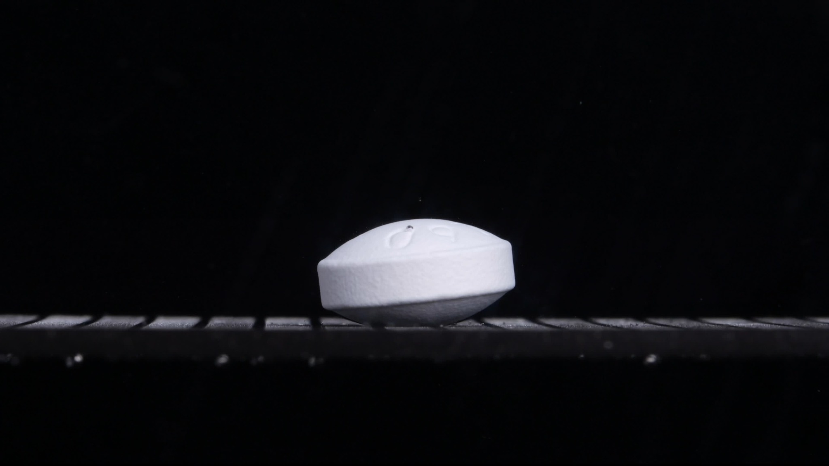  Group A — 0 min | 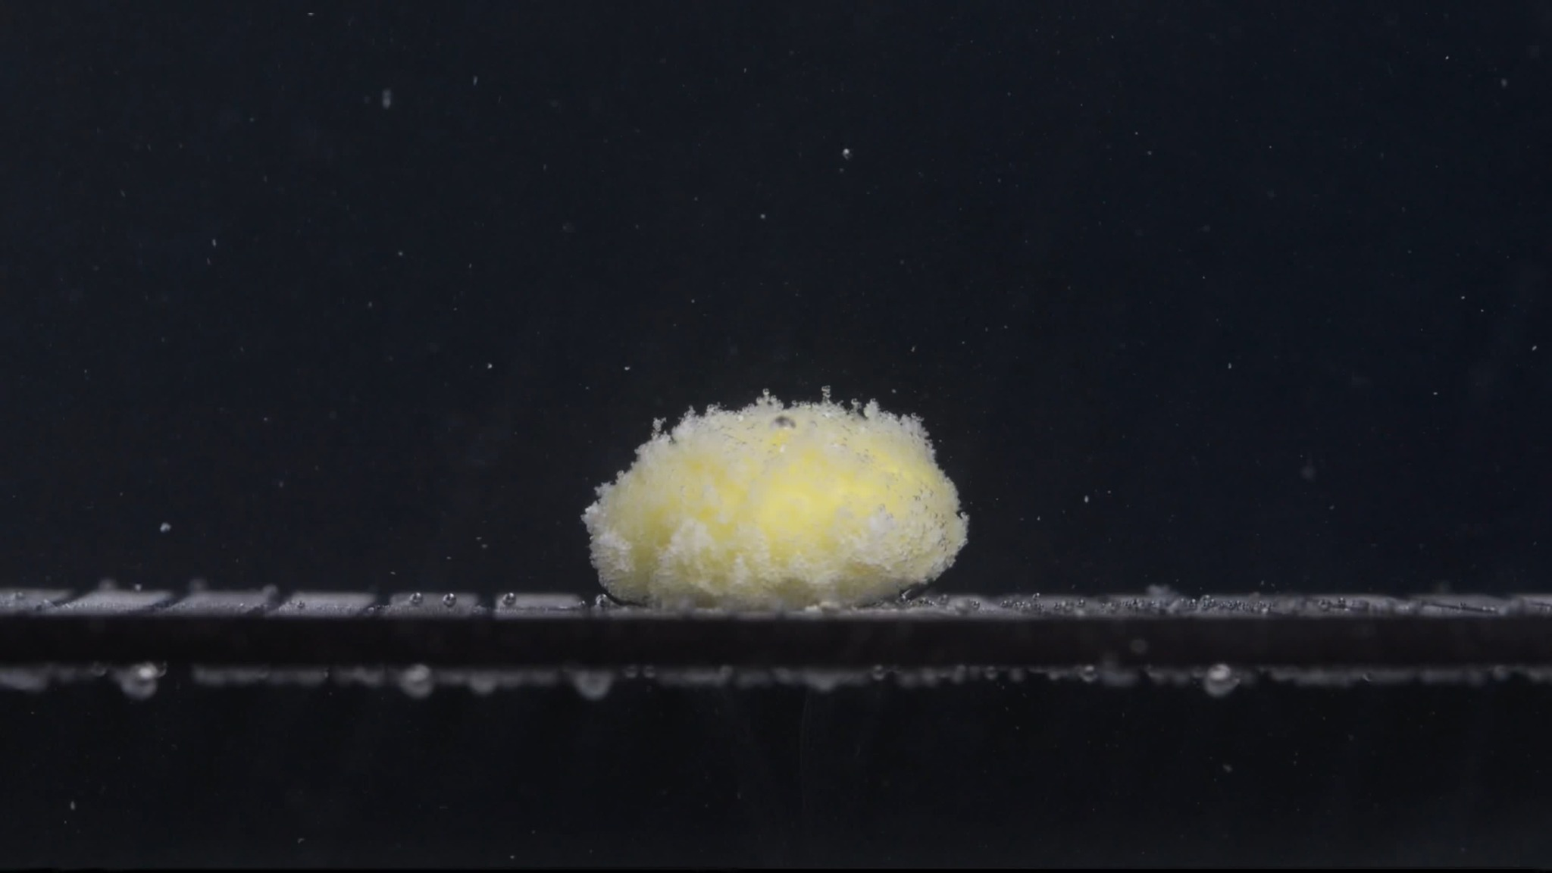  Group A — 15 min
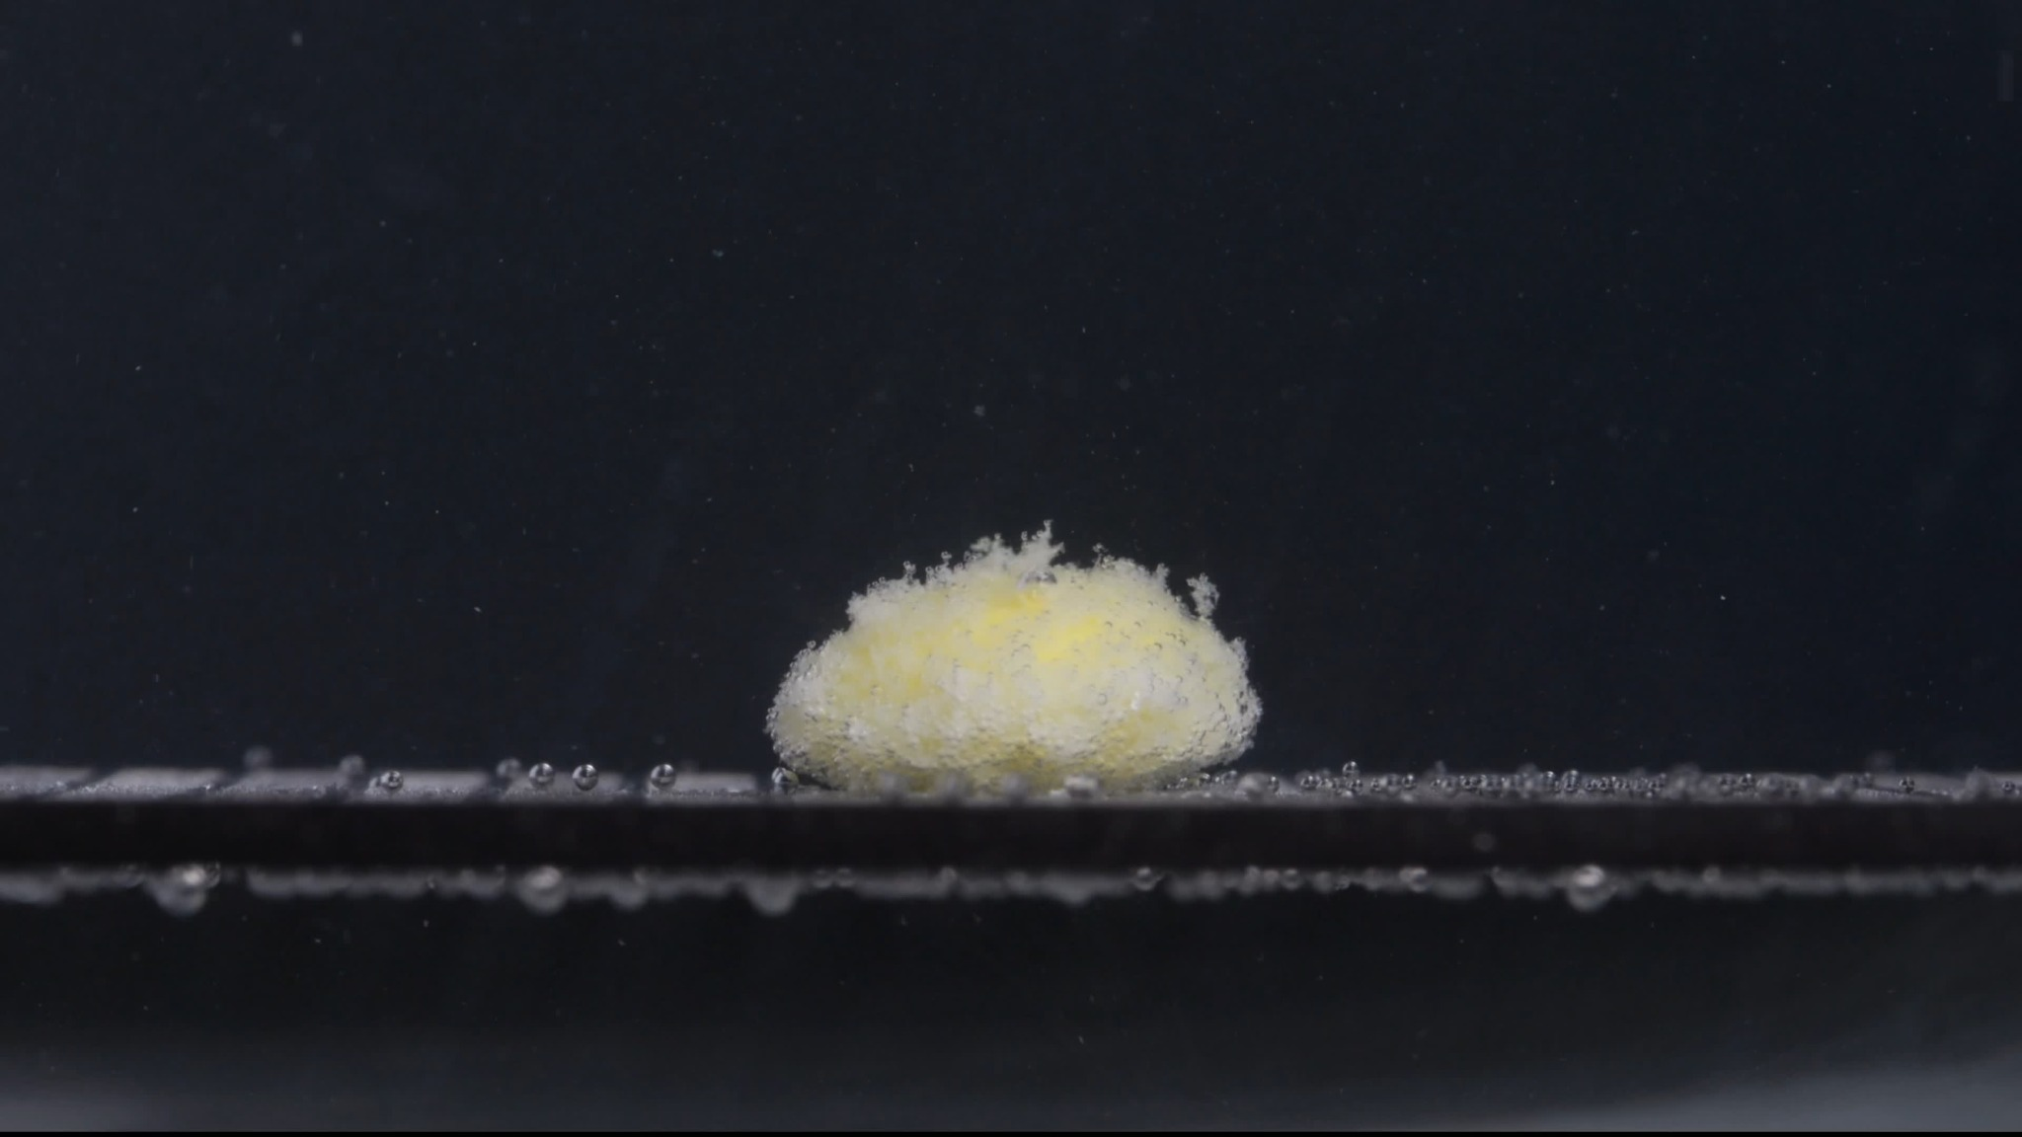  Group A — 30 min | 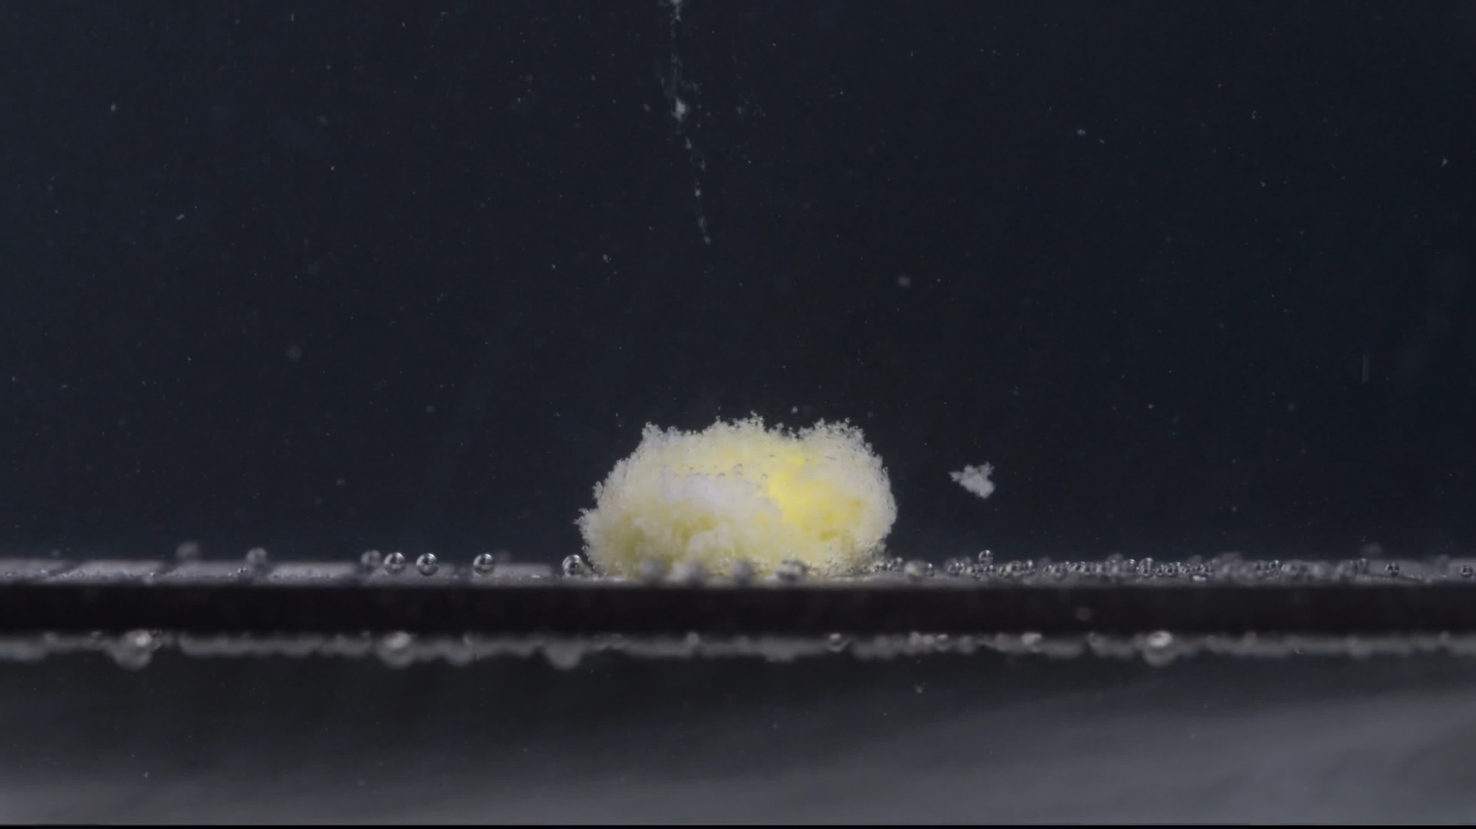  Group A — 45 min
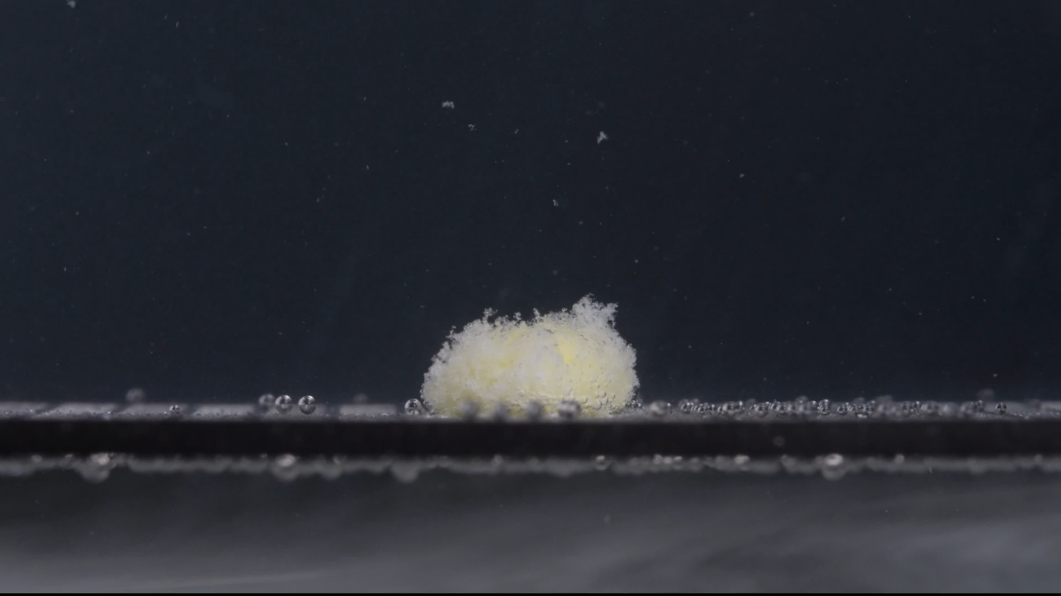
Group A — 60 min

Assistant
I have analyzed the five Group A images at 0, 15, 30, 45, and 60 minutes. I will keep the description conservative and image-based only. I will not claim chemical identity from the image alone.
The Knowledge Base framework says that disintegration should be described across color change, shape change, surface texture, volume/size change, dissolution speed/time, physical state, dissolution medium, and fragment distribution/density. It also emphasizes tracking tablet size, shape, contour, turbidity, cracking, swelling, collapse, and fragment behavior over time. Size and shape are also useful comparison markers when judging whether two image groups may represent the same or different tablets.

Group A — 0 min
Color change:
The tablet appears mostly white. No obvious yellow inner material is exposed yet. The surrounding medium/background appears visually clear; no visible turbidity cloud is present.
Shape change:
The tablet is still intact. It appears as a thick, round or oval, biconvex tablet viewed from the side, with a defined side wall and curved upper surface. The outline is sharp and regular.
Surface texture change:
The surface is mostly smooth, with shallow markings or embossing visible on the upper face. No clear cracks, peeling, pores, or powdery surface are visible.
Volume / size change:
This is the baseline size. The tablet maintains its full original height and width. No swelling or shrinkage is visible.
Dissolution speed and time:
At 0 min, disintegration has not visibly started.
Physical state change:
The tablet remains a solid, compact unit. No collapse, fragmentation, or internal exposure is visible.
Dissolution medium:
The visible medium remains clear. No obvious color diffusion or cloudy zone appears around the tablet.
Fragment distribution and density:
No fragments are visible around the tablet. Fragment density is essentially zero.

Group A — 15 min
Color change:
A clear color transition is visible. The outer region remains white to off-white, while the central exposed area appears yellow, suggesting that the outer surface or coating has hydrated or eroded enough to reveal inner material.
Shape change:
The original tablet shape is largely lost. Instead of a smooth, defined tablet, it has become a rounded, swollen mound. The contour is irregular and fluffy at the edges.
Surface texture change:
The surface has changed from smooth to porous, rough, and wool-like or flocculent. Fine particles appear attached to the outer surface, giving it a fuzzy texture.
Volume / size change:
The apparent volume looks increased or swollen compared with the original compact tablet. The mass is broader and more irregular, likely because liquid penetration has loosened the structure. The compact core may be smaller, but the visible hydrated mass occupies more space.
Dissolution speed and time:
A major change has occurred within the first 15 minutes. This suggests an initial phase of rapid liquid penetration and surface breakdown, but the tablet has not dispersed completely.
Physical state change:
The tablet has shifted from a hard compact solid to a hydrated, swollen, porous mass. The inner yellow material is exposed, but most of the material remains attached as one main body.
Dissolution medium:
The medium remains mostly clear. Small bubbles are visible along the platform, but there is no strong, uniform turbidity throughout the whole image.
Fragment distribution and density:
Most material is still concentrated in the original tablet position. There are some fine particles near the base and around the surface, but few large detached fragments.

Group A — 30 min
Color change:
The tablet mass still shows a yellow central region surrounded by white/off-white hydrated material. The yellow color remains localized rather than spreading uniformly through the medium.
Shape change:
The tablet remains as a low, rounded mound. Compared with 15 min, the mound appears slightly more compact and less sharply elevated, but it is still not fully broken apart.
Surface texture change:
The surface remains highly rough, porous, and granular. The upper edge has many fine protrusions, suggesting ongoing erosion of softened material.
Volume / size change:
The apparent size is slightly reduced or compacted compared with 15 min, especially in height. The original tablet outline is no longer recognizable.
Dissolution speed and time:
From 15 to 30 min, the disintegration appears slower than in the first 15 minutes. The main body persists, indicating gradual erosion rather than rapid complete dissolution.
Physical state change:
The mass remains hydrated and weakened, but it has not collapsed into many separate pieces. The structure is still cohesive.
Dissolution medium:
The medium is still mostly clear, with only scattered suspended specks. There is no dense cloud filling the surrounding liquid.
Fragment distribution and density:
Fine particles are present around the tablet, mainly close to the base. Fragment density is still highest at the original tablet location.

Group A — 45 min
Color change:
The mass remains pale yellow and white, with yellow material still visible, especially toward the central or right region. The color distribution remains localized in the tablet residue rather than diffusing widely.
Shape change:
The mound is still present but appears more eroded and irregular. A small detached piece is visible to the right of the main mass, showing that fragmentation has begun beyond surface roughening.
Surface texture change:
The surface remains fluffy, porous, and crumbly. The top edge is uneven, with loose particles and small flakes.
Volume / size change:
The height appears lower than at 15 min and slightly lower than at 30 min. The width is still relatively broad, meaning the mass is flattening and eroding slowly rather than disappearing rapidly.
Dissolution speed and time:
Between 30 and 45 min, disintegration continues slowly. The appearance of a detached fragment suggests ongoing weakening, but most of the residue remains as one main mound.
Physical state change:
The tablet is now a partially collapsed, hydrated residue. It has begun to shed material, but the main body remains cohesive.
Dissolution medium:
The medium remains relatively clear. Some suspended particles are visible, but the image does not show heavy overall turbidity.
Fragment distribution and density:
Fragment density is still greatest around the main residue. One larger detached fragment appears on the right side, and smaller particles are scattered near the base.

Group A — 60 min
Color change:
The residue remains white to pale yellow. Yellow material is still visible inside or beneath the white porous layer, so the tablet is not fully dissolved by 60 minutes.
Shape change:
The drug remains as a small, rounded, irregular mound. The original tablet shape is completely lost, but a single main residue body is still present.
Surface texture change:
The surface is still coarse, porous, and powdery or flocculent. The top and sides show loose granular material rather than a smooth coating.
Volume / size change:
Compared with 15 min, the residue appears smaller and lower. Compared with 45 min, the size change is modest; the remaining mass persists with slow erosion.
Dissolution speed and time:
The process appears to have slowed after the initial 15-minute transformation. By 60 min, disintegration is incomplete because a substantial residue remains.
Physical state change:
The tablet has transformed from a compact solid into a soft, porous, partially eroded residue. It has not fully dispersed into fine particles.
Dissolution medium:
The medium is still mostly clear, with only localized particles. There is no strong evidence of complete dissolution into a uniformly cloudy medium.
Fragment distribution and density:
Most fragments remain concentrated near the original tablet position. Fine particles are visible nearby, but large-scale dispersion is limited.

Group A Overall Disintegration Pattern
Group A shows a rapid early transformation from 0 to 15 minutes, followed by slow, gradual erosion from 15 to 60 minutes. The most important size and shape changes are:
- The intact white tablet at 0 min loses its defined biconvex shape by 15 min.
- It swells into a larger, porous, fluffy mound with yellow inner material exposed.
- From 15 to 60 min, the mass slowly becomes lower and more irregular, but it does not fully disappear.
- Fragmentation is limited: most material remains in one main residue body, with only small detached particles and one clearer fragment visible around 45 min.
- The medium remains mostly clear, so the disintegration appears localized rather than producing strong whole-medium turbidity.
Preliminary Group A conclusion: Group A appears to be a tablet that hydrates and exposes yellow inner material quickly, then undergoes slow erosion while retaining a porous residual mound for at least 60 minutes.

4. Group B Images and Analysis
User
When you describe the drug, please make sure your English description is accurate, think carefully, and reduce the occurrence of hallucinations. Each picture is taken 15 minutes apart. This is Group B.

Group B Uploaded Images
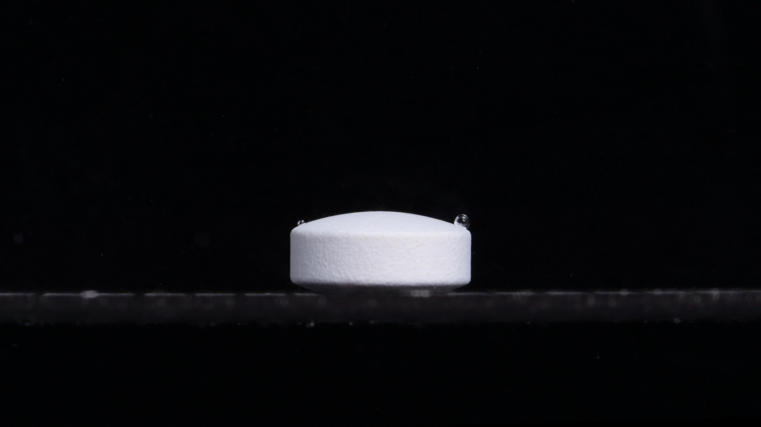  Group B — 0 min | 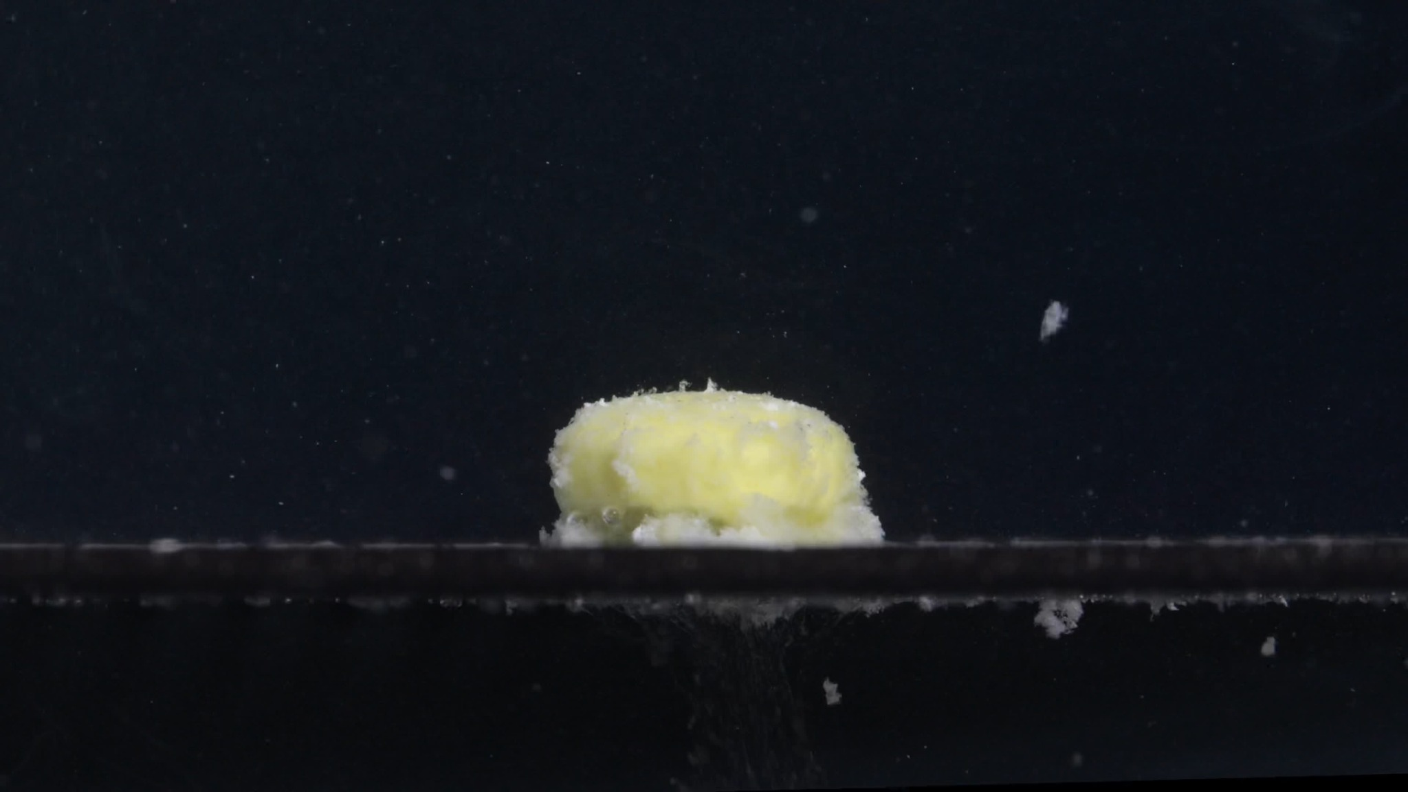  Group B — 15 min
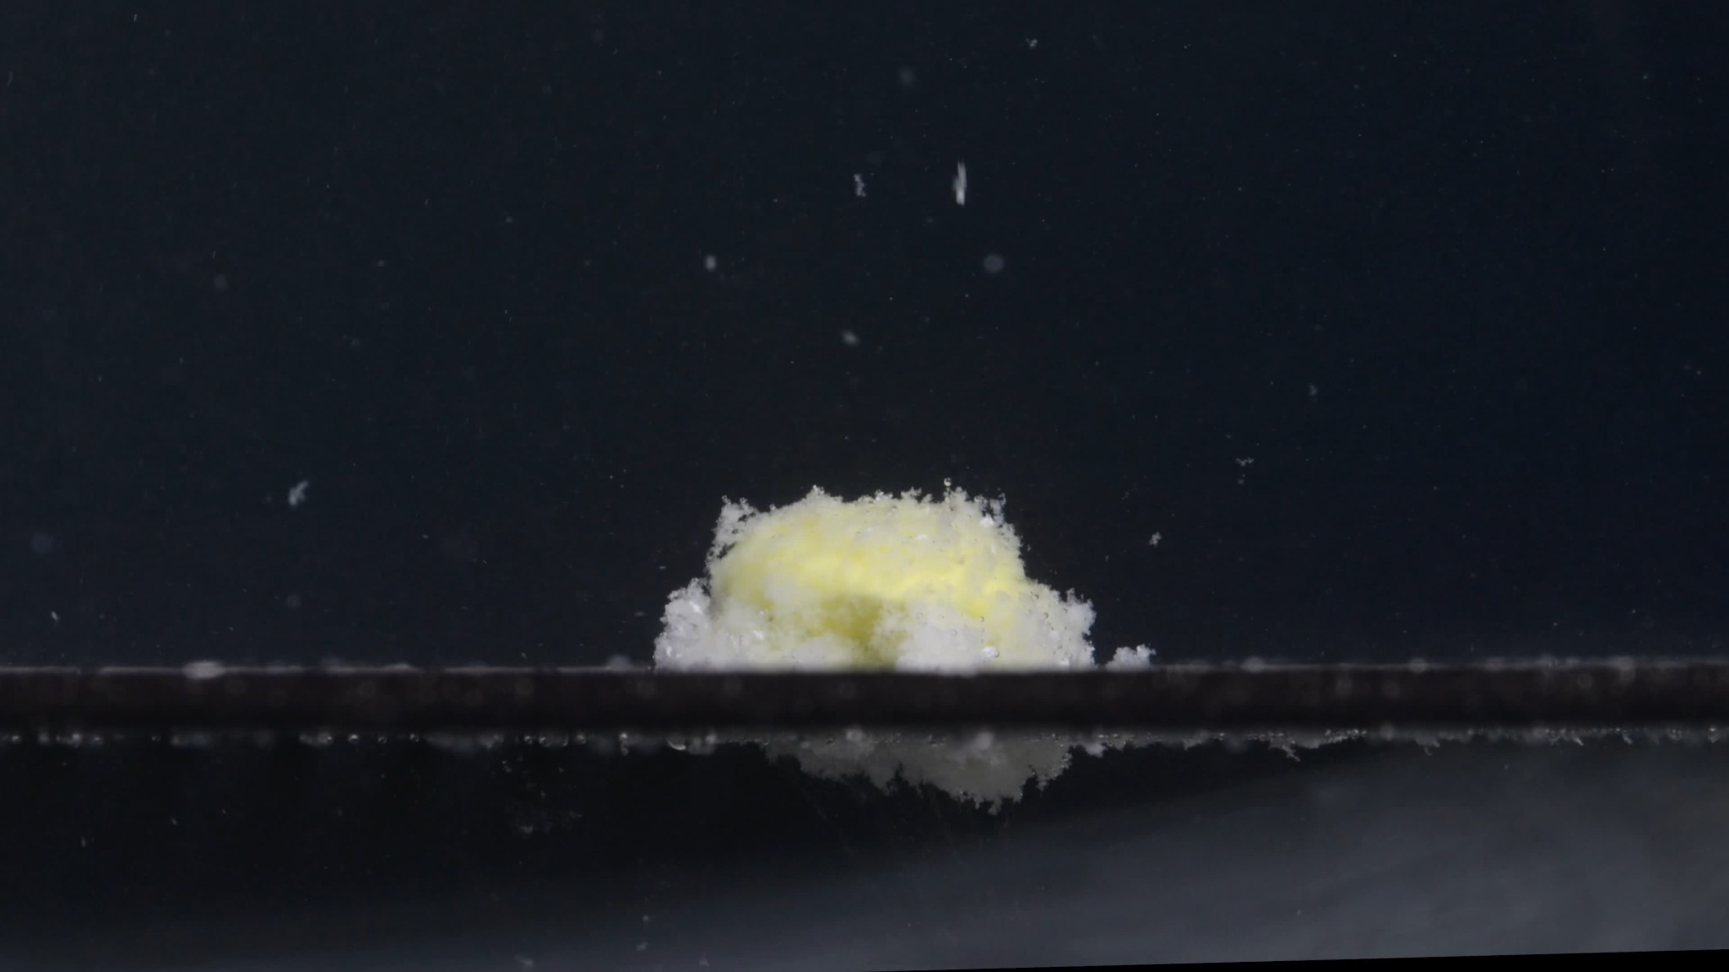  Group B — 30 min | 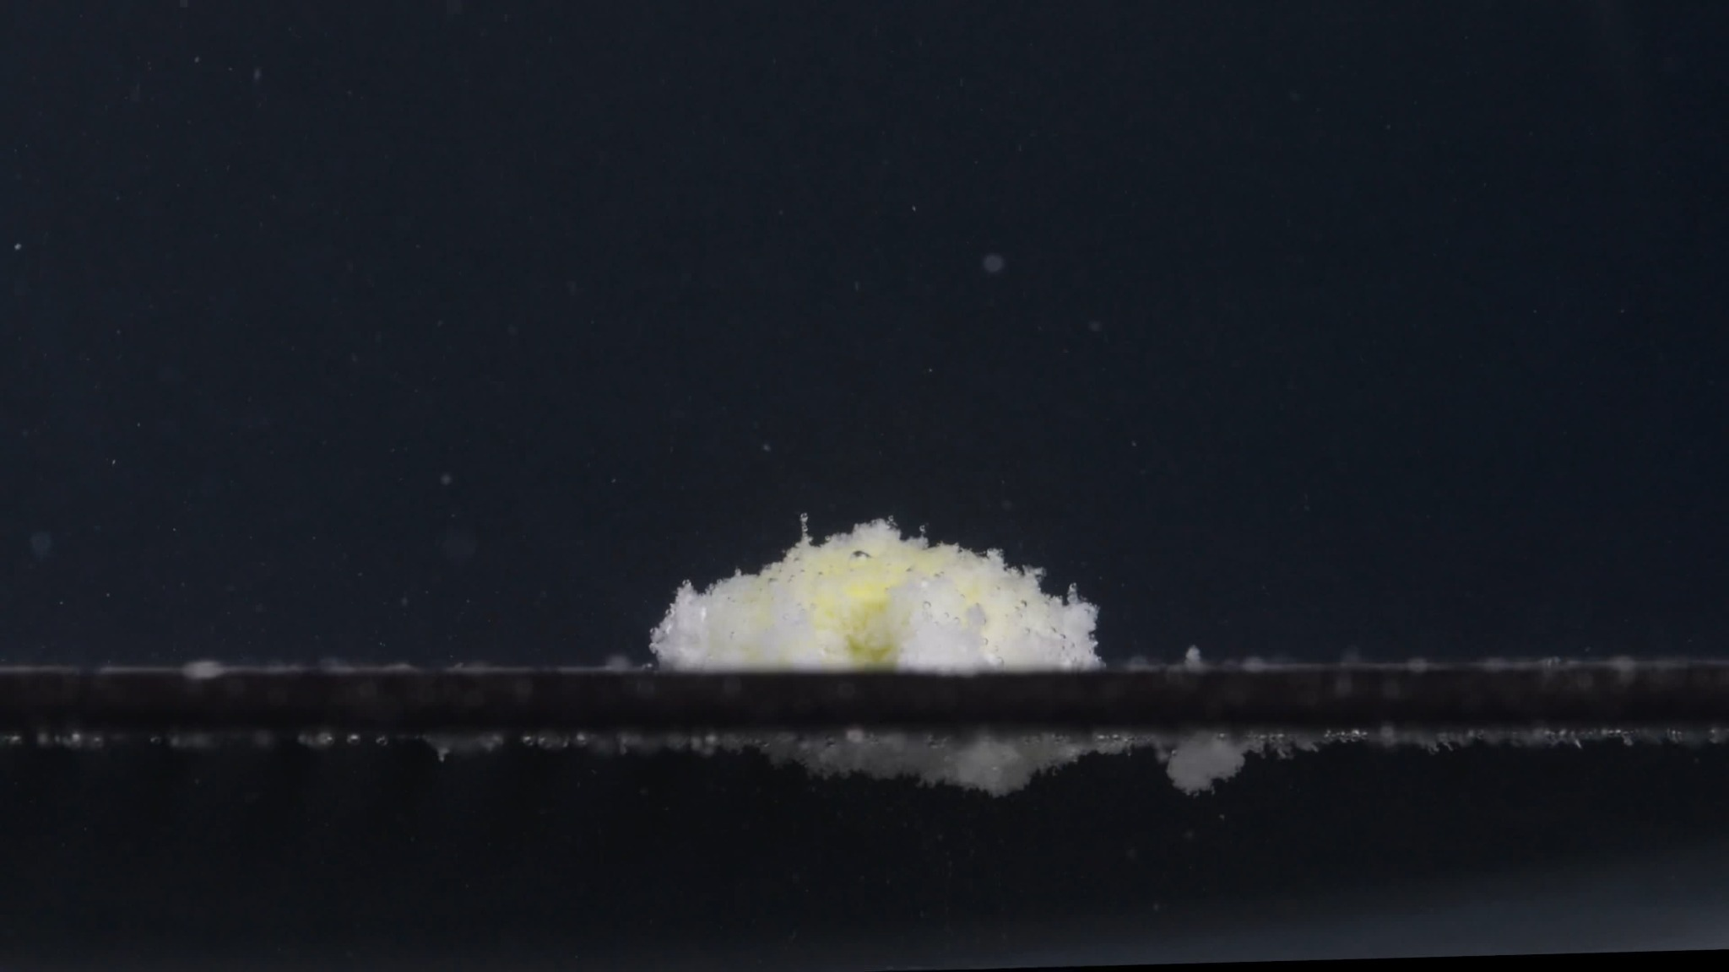  Group B — 45 min
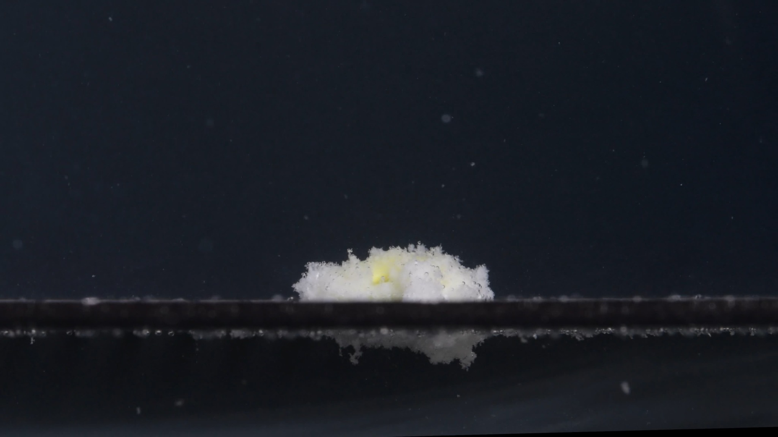
Group B — 60 min

Assistant
I re-applied the uploaded eight-dimension framework: color change, shape change, surface texture, volume/size change, dissolution speed/time, physical state, dissolution medium, and fragment distribution/density. This framework specifically emphasizes describing tablet contour, roughness, swelling/collapse, liquid interaction, and fragment distribution over time. Size and shape are important comparison markers for judging whether two tablet image groups may represent the same or different products.

Group B — 0 min
Color change:
The tablet is uniformly white. No yellow internal material is visible at this time. The surrounding medium appears mostly clear.
Shape change:
The tablet is intact and has a regular cylindrical tablet shape with a relatively flat side wall and gently convex upper surface. Compared with Group A at 0 min, this tablet appears more level and upright, while Group A looked slightly tilted or more obliquely positioned.
Surface texture change:
The visible surface is mostly smooth, with very fine surface granularity. No obvious cracks, peeling, swelling, or exposed inner core is visible.
Volume / size change:
This is the baseline state. The tablet keeps its full height and diameter. No visible shrinkage or swelling is present.
Dissolution speed and time:
At 0 min, no visible disintegration has begun.
Physical state change:
The tablet remains a compact solid body.
Dissolution medium:
The medium appears clear. A few bubbles are visible near the tablet, but these should not be interpreted as drug fragments.
Fragment distribution and density:
No drug fragments are visible around the tablet.

Group B — 15 min
Color change:
The tablet has changed strongly from white to a white-and-yellow mass. A yellow inner region is exposed across the central area, while white softened material remains around the outer edge and base.
Shape change:
The original cylindrical outline is mostly lost, but the residue still keeps a relatively block-like central mound. The upper surface is no longer smooth; it has become irregular and eroded.
Surface texture change:
The surface is now rough, porous, and crumbly. White material at the base appears softened and fluffy, while the yellow central region looks swollen and exposed.
Volume / size change:
The apparent structure has expanded and loosened. The compact tablet is no longer visible as a solid cylinder; instead, it becomes a larger hydrated residue with a softened base. The height is still substantial at this stage.
Dissolution speed and time:
A major transformation occurs within the first 15 minutes. This suggests rapid liquid penetration and early breakdown of the outer layer.
Physical state change:
The tablet changes from a hard compact solid into a hydrated, weakened mass. The internal yellow material is exposed, but most of the drug remains as one main body.
Dissolution medium:
The medium remains mostly clear, but more suspended small particles are visible than at 0 min. Some material appears to have detached and moved away from the main tablet.
Fragment distribution and density:
Most fragments remain near the main residue, but several detached white pieces are visible, including a noticeable floating or suspended fragment on the right side. Some material also appears below or near the support surface, suggesting early particle shedding.

Group B — 30 min
Color change:
The residue still shows a yellow central region surrounded by white softened material. The yellow color remains localized in the tablet mass rather than spreading uniformly through the entire medium.
Shape change:
The residue becomes lower and more spread out than at 15 min. The original tablet shape is completely gone. The mass now looks like an irregular mound with white material spreading laterally along the base.
Surface texture change:
The surface remains coarse, porous, and flocculent. The upper contour is uneven, with small protrusions and loose particles.
Volume / size change:
The height decreases compared with 15 min, while the base appears broader. This suggests partial collapse and lateral spreading after hydration.
Dissolution speed and time:
Disintegration continues between 15 and 30 min, but the rate appears slower than the initial 0–15 min phase. The main body still persists.
Physical state change:
The tablet is now a soft, partially collapsed residue. The central yellow region remains cohesive, while the white outer material appears more fragmented.
Dissolution medium:
The surrounding liquid remains relatively clear, with scattered suspended particles. There is no strong uniform turbidity across the whole image.
Fragment distribution and density:
Fragment density is highest around the original tablet position. Fine particles and small white fragments are visible around the base, with some material appearing below the support surface.

Group B — 45 min
Color change:
The yellow region is still present but appears less dominant than at 15 min. White/off-white residue surrounds much of the remaining mass.
Shape change:
The residue is now a lower, flatter, irregular mound. It has lost most vertical structure and appears more spread along the support surface.
Surface texture change:
The surface remains rough and crumbly, with a porous, fluffy appearance. The edge is uneven and broken.
Volume / size change:
The visible height is clearly reduced compared with 15 min and 30 min. The residue is flattening rather than maintaining a rounded dome.
Dissolution speed and time:
The process continues gradually. The most rapid change happened before 15 min; after that, the residue erodes and collapses more slowly.
Physical state change:
The tablet has become a weakened residue with partial collapse. It still has a central mass, but the structure is much less compact.
Dissolution medium:
The medium remains mostly clear, although small suspended particles are visible. No dense cloud fills the full field.
Fragment distribution and density:
Small fragments are distributed mainly near the base. Some material appears to have fallen or settled below the support surface. Fragment spread is greater than in Group A at the same time point.

Group B — 60 min
Color change:
Only a small yellow area remains visible near the center. Most of the residue appears white to off-white. The yellow core is reduced but not completely gone.
Shape change:
The residue is now a low, flattened, irregular pile. The original tablet shape is fully absent.
Surface texture change:
The remaining material is still rough, powdery, and porous. The surface looks loose and granular rather than smooth.
Volume / size change:
The residue is lower than at 45 min and much lower than at 15 min. The mass has decreased in height and appears more collapsed.
Dissolution speed and time:
By 60 min, disintegration is still incomplete because visible residue remains. However, Group B shows more flattening and collapse than Group A at 60 min.
Physical state change:
The tablet has transformed into a soft, fragmented residue. A cohesive center remains, but the structure is much weaker and more spread out than before.
Dissolution medium:
The liquid remains mostly transparent with scattered particles. The disintegration is localized around the tablet rather than producing strong whole-medium cloudiness.
Fragment distribution and density:
Fragments are concentrated around the original tablet position, but there is also visible scattered material below or near the support surface. The remaining residue is less compact than in Group A.

Group A vs. Group B Initial Comparison

Strong similarities
- Both start as white round or cylindrical tablets.
- Both expose a yellow internal region by 15 min.
- Both develop a white, porous, fluffy or flocculent outer residue.
- Both show a rapid early change from 0 to 15 min, followed by slower erosion from 15 to 60 min.
- Both remain incomplete at 60 min, with visible residue still present.
- Both keep most disintegrated material localized near the original tablet position, with only limited whole-medium turbidity.
These similarities are important because the Knowledge Base indicates that color transition, tablet shape loss, surface roughening, swelling/collapse, and fragment distribution are central markers in comparing disintegration behavior.

Observable differences
- Initial shape: Group A at 0 min looks slightly tilted or oblique and may show surface marking or embossing; Group B appears more upright, level, and cylindrical.
- At 15 min: Group A becomes a rounder, fluffier mound; Group B keeps a more block-like central yellow mass and shows more detached fragments.
- From 30 to 60 min: Group B appears to flatten and collapse more than Group A. Group A retains a more rounded mound-like residue, while Group B becomes lower and more spread out.
- Fragment behavior: Group B shows somewhat more visible particle shedding and material below or around the support surface, especially after 15 min.
Initial judgment: the two groups are more likely from the same drug type or a very similar formulation, but not necessarily the exact same tablet product or batch. They should not be classified as clearly different drugs based on these images alone, because the dominant disintegration signatures are highly similar: white exterior, yellow interior exposure, rapid early swelling, porous white residue, localized erosion, and persistent residue at 60 min. However, image-based analysis cannot chemically confirm drug identity.

5. Final Eight-Dimension Comparison and Determination
User
Please compare Groups A and B based on their disintegration characteristics across the eight dimensions to determine if they are from the same drug or not, and explain why you think so.
Assistant
Using the eight-dimension disintegration framework, the two groups are more likely from the same drug type or a very similar formulation, rather than clearly different drugs. However, this is an image-based judgment only, not chemical confirmation. The framework emphasizes comparing color, shape, texture, volume, time course, physical state, medium appearance, and fragment distribution.

1. Color change
Group A: Starts as a white tablet at 0 min. By 15 min, a yellow inner region becomes visible, surrounded by white/off-white loosened material. From 30 to 60 min, the yellow remains localized in the central residue.
Group B: Also starts as a white tablet. By 15 min, a yellow central region is exposed, with white softened material around it. From 30 to 60 min, the yellow region gradually becomes smaller but remains visible.
Comparison: This is a strong similarity. Both groups show the same key color pattern: white exterior → yellow internal exposure → persistent white/yellow residue. This supports the idea that they may be the same drug or a very similar tablet formulation.

2. Shape change
Group A: The original tablet is intact at 0 min, then changes into a rounded, swollen, fluffy mound by 15 min. It remains mound-like through 60 min.
Group B: The original tablet is also intact at 0 min, then changes into a yellow-white softened mound by 15 min. However, from 30 to 60 min, Group B becomes flatter and more spread out than Group A.
Comparison: Both lose the original tablet shape quickly, especially between 0 and 15 min. The main difference is that Group A keeps a more rounded mound, while Group B collapses into a flatter residue. This difference is noticeable but not large enough by itself to prove they are different drugs.

3. Surface texture change
Group A: The surface changes from smooth to rough, porous, fluffy, and granular. The residue looks wool-like or flocculent.
Group B: The surface also becomes rough, porous, crumbly, and flocculent. White softened material accumulates around the base.
Comparison: The surface texture behavior is highly similar. Both show hydration, roughening, porosity, and crumbly white residue, which strongly supports similarity.

4. Volume / size change
Group A: The tablet appears to swell strongly by 15 min. After that, the visible mound slowly decreases in height but remains relatively bulky through 60 min.
Group B: The tablet also swells or loosens by 15 min, but then its height decreases more clearly. By 60 min, Group B appears flatter and more collapsed than Group A.
Comparison: Both show early swelling followed by gradual collapse. The difference is that Group B seems to reduce in height faster. This could reflect a formulation difference, but it could also come from imaging angle, tablet orientation, local liquid contact, or batch variation.

5. Dissolution speed and time
Group A: The fastest visible change occurs during the first 15 minutes. After 15 min, disintegration slows, and a substantial residue remains at 60 min.
Group B: The same pattern appears: rapid change from 0 to 15 min, followed by slower erosion from 15 to 60 min. Group B may progress slightly further by 60 min because the residue is flatter and less compact.
Comparison: The time-course pattern is very similar: rapid early disintegration, then slow residual erosion. This is one of the strongest reasons to judge them as likely the same or closely related.

6. Physical state change
Group A: Changes from a compact solid tablet into a hydrated, porous, weakened mass. It does not fully disperse by 60 min.
Group B: Also changes from a compact solid into a hydrated, porous, weakened residue. It shows somewhat more collapse and spreading by the later time points.
Comparison: Both show the same physical transition: solid tablet → swollen hydrated mass → porous eroded residue. The difference is mainly the degree of late-stage collapse.

7. Dissolution medium
Group A: The surrounding medium remains mostly clear, with only localized suspended particles. There is no strong whole-field turbidity.
Group B: The medium also remains mostly clear, although Group B shows slightly more visible detached particles and material near or below the support surface.
Comparison: Both groups show localized disintegration rather than strong diffusion into the whole medium. This supports similarity. Group B may shed slightly more particles, but the overall medium behavior is still close to Group A.

8. Fragment distribution and density
Group A: Fragments remain mainly near the original tablet position. Most material stays as one central mound, with limited detached fragments.
Group B: Fragments are also concentrated near the original tablet position, but more loose material appears around the base and below the support surface. Group B shows somewhat greater spreading and collapse.
Comparison: The fragment pattern is similar in location but different in degree. Group B has slightly more dispersed residue, while Group A remains more compact.

Final Determination
Conclusion: Groups A and B are likely from the same drug type or a very similar formulation.
This judgment is based on the close match in the most important disintegration characteristics: both begin as white tablets, both expose a yellow internal region by 15 min, both develop a white/off-white porous outer residue, both show rapid early hydration and disintegration from 0 to 15 min, both retain visible residue at 60 min, and both show mostly localized disintegration with limited whole-medium turbidity.
The differences are real but secondary: Group B appears more upright and cylindrical at 0 min; Group A appears slightly tilted or more visibly biconvex at 0 min; Group B collapses and spreads more by 45–60 min; and Group B shows slightly more detached particles. These differences could come from tablet orientation, imaging angle, local liquid contact, small batch variation, or manufacturer/formulation differences within the same drug type. They do not outweigh the strong shared pattern of color exposure, swelling, porous texture, slow erosion, and persistent residue.
Best image-based judgment: same drug type or very similar formulation is likely.
Definitely identical product or batch cannot be confirmed from images alone.
Estimated confidence: moderate, around 70%.

