Complete English Dialogue
Doxycycline Hyclate Tablets — Disintegration Image Analysis for Groups A and B
Scope: This document includes only the drug-related discussion and ends with the final comparison. Later Chinese requests about document formatting are intentionally excluded. User prompts have been rendered in English for clarity.

1. Preparation and Knowledge-Base Framework
User
I need you to try analyzing the disintegration images of two groups of Doxycycline Hyclate Tablets, A and B. These may be images of the same drug or different drugs. I need you to determine whether the images are from the same drug or not.
For each group, I will upload 5 images. Each picture is taken 15 minutes apart. Please describe the drug disintegration process in English for each image in the group, and finally determine whether the two sets of images are from the same drug.
You can call the Knowledge Base to remember how to describe drug disintegration. As you describe the tablets in English, pay attention to the changes in the size and shape of the tablets. If you are prepared, then I will upload Group A picture 1 at 0 minutes.
Assistant
I am ready. Please upload Group A, picture 1 at 0 minutes.
I will analyze each image using the eight disintegration dimensions: color change, shape change, surface texture, volume/size change, dissolution speed and time, physical state, dissolution medium, and fragment distribution/density. I will pay special attention to tablet size and shape changes, then compare all 5 images from Group A with all 5 images from Group B to judge whether they are likely the same drug or different drugs.
User
You are not fully prepared. Please call the Knowledge Base again to remember how to describe drug disintegration.
Assistant
You are right — I have called the Knowledge Base again and refreshed the description framework.
For every uploaded image, I will describe the tablet disintegration using these eight fixed dimensions:
1. Color change — color intensity, transparency, turbidity, and whether the color spreads locally or uniformly. 2. Shape change — whether the tablet remains intact, cracks, loses its contour, or breaks into irregular fragments. 3. Surface texture change — smoothness, roughness, pores, cracks, peeling, flaky or fibrous structures. 4. Volume / size change — reduction in tablet height, width, diameter, swelling, collapse, or uneven shrinkage. 5. Dissolution speed and time — slow, moderate, or rapid disintegration; changes every 15 minutes; relation to particle formation and liquid penetration. 6. Physical state change — swelling, softening, cracking, internal collapse, powdering, or formation of suspended particles. 7. Dissolution medium — clarity, turbidity, sediment, floating matter, possible effect of medium condition if visible. 8. Fragment distribution and density — where fragments are located, whether they settle at the bottom, remain near the tablet, or disperse through the liquid.
For the final comparison between Group A and Group B, I will focus especially on initial tablet size, shape, color, coating, and contour; the rate of size reduction over 0, 15, 30, 45, and 60 minutes; whether the tablets crack, swell, peel, collapse, or powder in the same pattern; fragment density, sediment amount, and turbidity pattern; and whether both groups show a consistent disintegration “fingerprint”.
The knowledge base also notes that tablet size and shape can help distinguish drug behavior, because small round tablets, large oval capsules, and film-coated tablets may show different disintegration speeds and color/turbidity patterns.
Now I am prepared. Please upload Group A — picture 1 at 0 minutes.

2. Group A Image Series

Group A — Picture 1 — 0 minutes
User
When you describe the drug, please make sure your English description is accurate, think carefully, and reduce hallucinations. Each picture is taken 15 minutes apart. This is Group A picture 1.
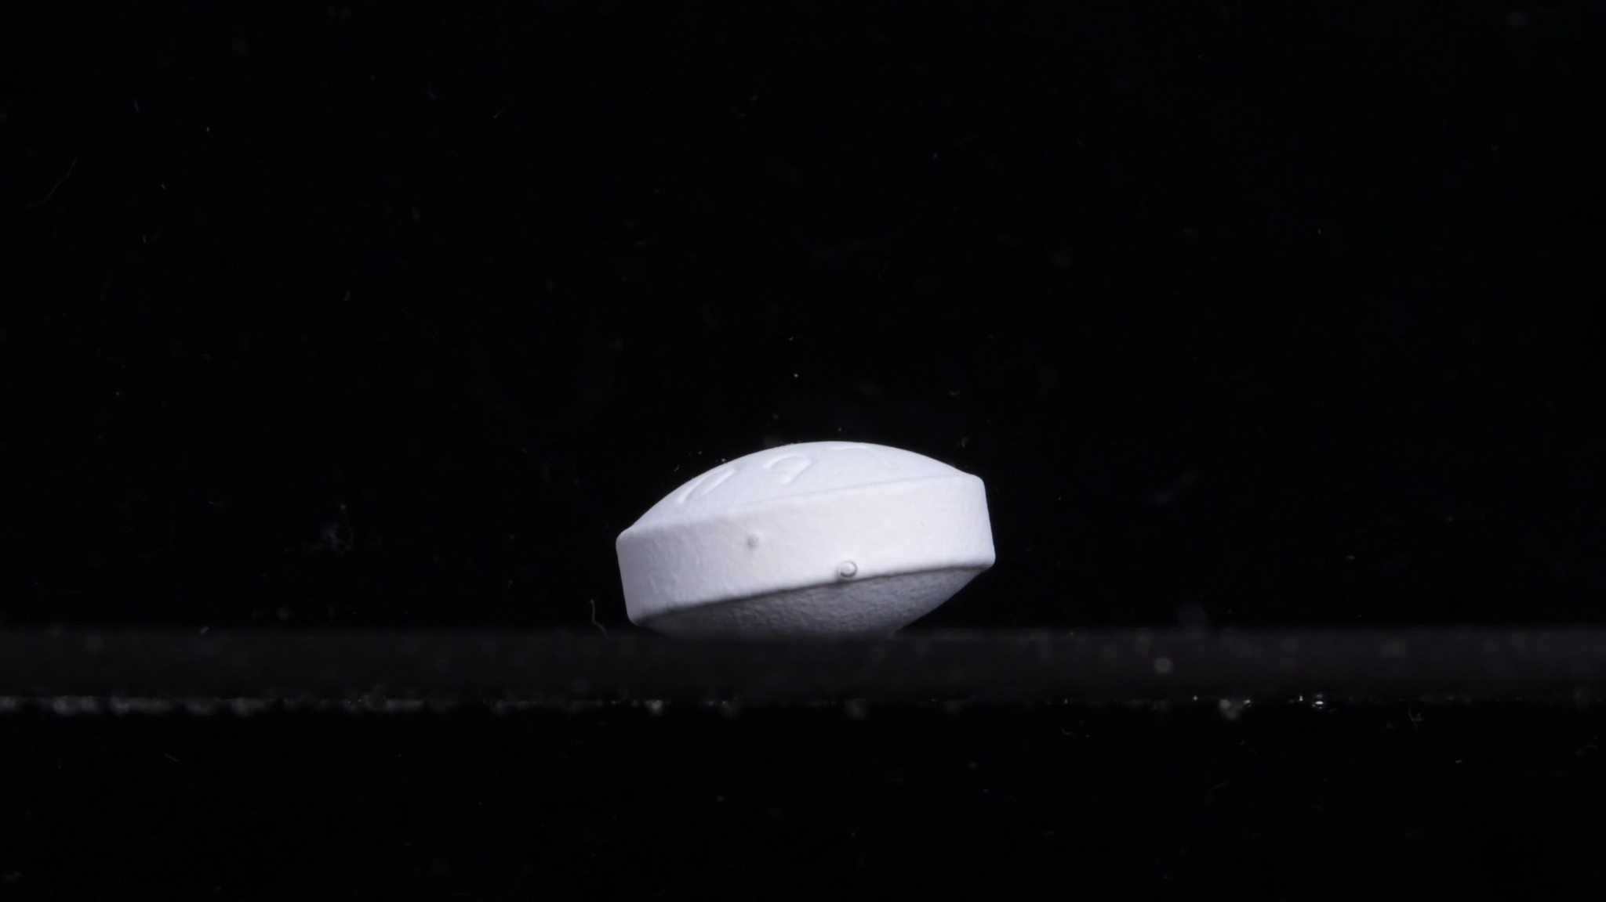
Group A, picture 1 — 0 minutes
Assistant
Overall observation: The tablet appears intact at the starting point. It is a white to off-white, oval / caplet-like tablet viewed from the side. The body looks relatively large, thick, and film-coated, with a smooth curved upper surface and a flatter side wall. No obvious disintegration, cracking, swelling, or fragment release is visible yet.
1. Color change - The tablet remains uniformly white / off-white. - The surrounding medium appears clear, with no visible yellowing, cloudiness, or turbidity around the tablet. - Any darker area on the lower part of the tablet appears more likely due to shadow/contact with the vessel bottom, not confirmed discoloration.
2. Shape change - The tablet keeps its original solid oval / caplet-like shape. - The outline is still clear and continuous. - No broken edges, corner loss, splitting, or collapse are visible.
3. Surface texture change - The upper surface appears mostly smooth and film-coated. - A few small surface marks or droplets/bubbles are visible, but I cannot confirm them as pores or cracks. - No peeling, roughening, powder layer, or erosion is evident at this time point.
4. Volume / size change - This image should be treated as the baseline size for Group A. - The tablet appears thick and intact, with no measurable visual reduction in height, width, or overall volume. - No swelling is clearly visible yet.
5. Dissolution speed and time - At 0 minutes, the apparent dissolution/disintegration speed is not yet observable. - There is no visible release of particles, no clouding of the medium, and no contour loss.
6. Physical state change - The tablet remains in a solid, coherent physical state. - No visible cracking, softening, expansion, fragmentation, or internal collapse can be identified from this image.
7. Dissolution medium - The medium appears transparent and still. - No visible sediment, suspended particles, or colored diffusion zone is present around the tablet.
8. Fragment distribution and density - No fragments are visible. - Fragment density is therefore zero or not detectable in this image. - The tablet is resting as a single intact unit at the bottom of the vessel.
Baseline note for later comparison: For Group A, picture 1 shows a white, intact, oval/caplet-like, thick film-coated tablet with a clear outline and no visible early disintegration. I will compare later images against this baseline, especially changes in tablet size, edge definition, surface roughness, cracking, swelling, and fragment release.

Group A — Picture 2 — 15 minutes
User
When you describe the drug, please make sure your English description is accurate, think carefully, and reduce hallucinations. Each picture is taken 15 minutes apart. This is Group A picture 2.
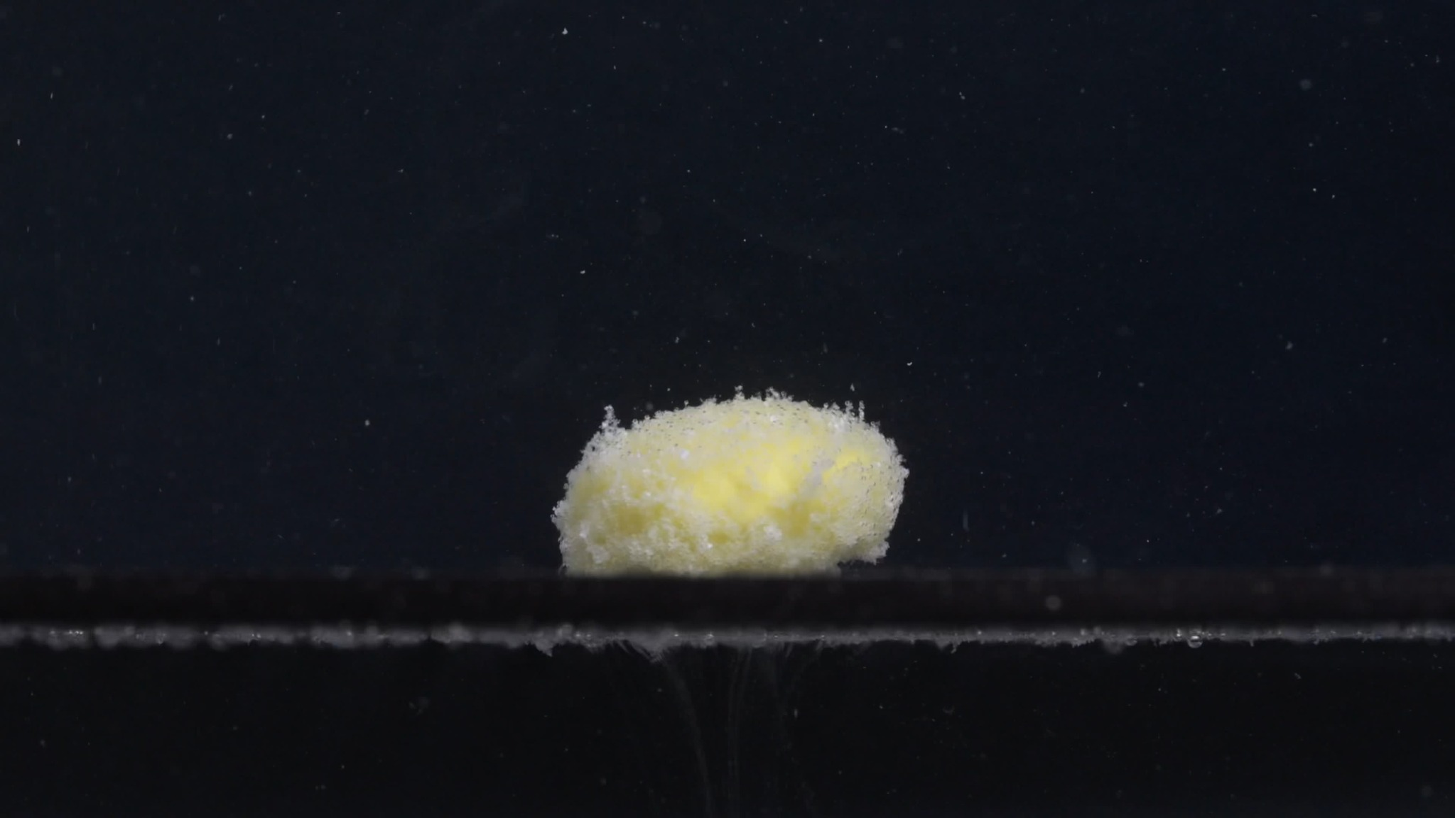
Group A, picture 2 — 15 minutes
Assistant
Overall observation: Compared with Group A picture 1 at 0 minutes, the tablet has undergone clear and substantial disintegration. The original smooth white oval/caplet-like tablet is no longer intact in appearance. It now looks smaller, rougher, more swollen/eroded, and partially collapsed, with a yellow inner material exposed and many fine particles around the surface.
1. Color change - The tablet has changed from mostly white/off-white to a mixture of white and pale yellow. - The yellow color appears mainly in the central exposed region, suggesting that the inner tablet material is now visible after surface erosion. - The surrounding liquid does not show a strong uniform yellow color in this frame; the color change is mainly localized on and near the tablet.
2. Shape change - The original smooth oval/caplet outline has become less regular and less sharply defined. - The tablet still exists as one main mass, but it is now more like a rounded, softened mound rather than a clean, film-coated caplet. - The edges appear uneven and crumbly, especially along the upper and side margins.
3. Surface texture change - The surface has changed from smooth to rough, porous, and granular. - Many tiny particles or granules are attached to the surface, giving it a fuzzy or powdery appearance. - The surface coating appears to have been disrupted or removed in several areas, exposing the yellow interior.
4. Volume / size change - The apparent tablet height has decreased compared with the 0-minute image. - The tablet looks shorter and more collapsed, while the horizontal width is still relatively broad. - The volume reduction is not uniform: the upper surface and edges appear more eroded, while a central mass remains.
5. Dissolution speed and time - By 15 minutes, disintegration is already moderate to advanced. - The change from an intact white tablet to a rough yellow-white mass indicates that liquid penetration and coating breakdown occurred during the first 15-minute interval. - The process appears faster at the surface and edges than in the central core.
6. Physical state change - The tablet has softened and partially lost structural integrity. - It appears to have undergone surface erosion, internal exposure, and partial collapse, but it has not completely dispersed. - No large detached chunks are clearly visible, but fine particle generation is evident.
7. Dissolution medium - The medium remains mostly visually dark/clear in the background, so strong overall turbidity cannot be confirmed from this frame. - Fine particles are visible around the tablet area, but most visible material remains concentrated near the tablet rather than evenly clouding the whole medium.
8. Fragment distribution and density - Fragment density is highest directly on and around the tablet surface. - The fragments are mainly fine, powder-like granules, rather than large broken pieces. - Some small particles appear suspended nearby, while heavier material seems to remain close to the bottom and the tablet body.
15-minute interpretation for Group A: At 15 minutes, Group A shows a major transition from an intact white coated tablet to a partially disintegrated yellow-white granular mass. The most important changes are loss of smooth shape, reduction in height/volume, exposure of yellow inner material, and formation of dense fine surface particles.

Group A — Picture 3 — 30 minutes
User
When you describe the drug, please make sure your English description is accurate, think carefully, and reduce hallucinations. Each picture is taken 15 minutes apart. This is Group A picture 3.
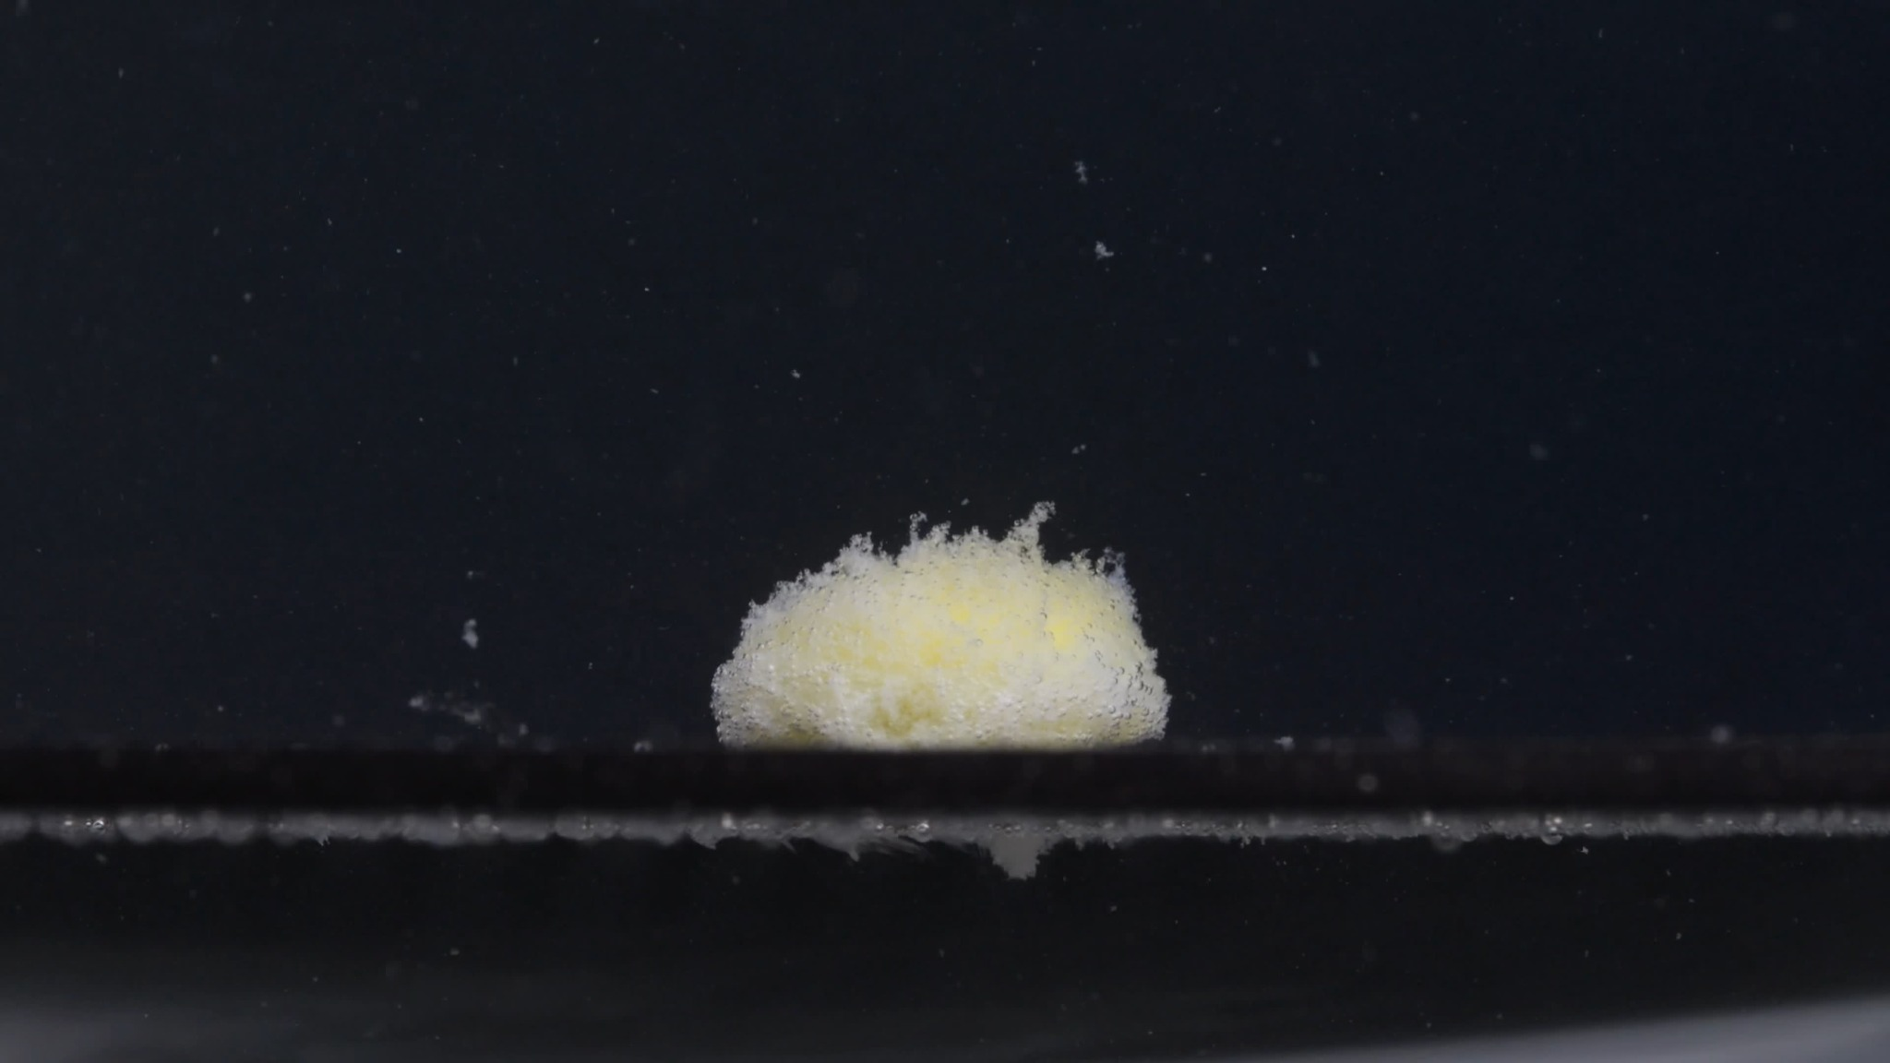
Group A, picture 3 — 30 minutes
Assistant
Overall observation: At 30 minutes, the tablet remains as a single main mound-like mass, but it is clearly no longer a smooth intact tablet. Compared with the 0-minute image, the original oval/caplet shape has largely disappeared. Compared with the 15-minute image, the tablet looks more flattened, more porous, and more diffusely yellow-white, with a dense granular surface.
1. Color change - The tablet is now mainly pale yellow to yellow-white. - White material remains on the outer surface, especially as fine powdery particles. - The yellow color appears more widely distributed across the tablet than at 15 minutes, suggesting further exposure of the inner material. - The surrounding medium still does not appear strongly colored; the visible color change is concentrated on the tablet mass.
2. Shape change - The original caplet-like contour is no longer clear. - The tablet has changed into a low, rounded, irregular mound. - The upper edge is uneven and fluffy-looking, with small protruding granular structures. - No large separated chunks are clearly visible, but the main body has lost its smooth geometric shape.
3. Surface texture change - The surface is very rough, porous, and granular. - The top and side surfaces look covered with fine particles, giving a sponge-like or powder-covered appearance. - The surface is no longer film-like or smooth. - Some small raised clusters are visible on the upper edge, which may represent loosened material rather than firm cracks.
4. Volume / size change - The tablet appears lower in height than in the original 0-minute image. - Compared with the 15-minute image, the mass appears slightly more flattened and spread along the bottom. - The width is still relatively broad, but the vertical thickness has decreased. - The size reduction appears mainly due to collapse and erosion from the upper and side surfaces, rather than complete separation into large fragments.
5. Dissolution speed and time - Between 15 and 30 minutes, the disintegration appears to continue at a moderate rate. - The major change is not a sudden breakup into large pieces, but progressive softening, erosion, and conversion into fine particles. - The tablet still has a central mass, so disintegration is not complete at 30 minutes.
6. Physical state change - The tablet has changed from a solid coated tablet into a softened, porous, partially collapsed mass. - The internal yellow material is exposed over much of the visible surface. - The structure appears weakened, but the tablet still retains one main cohesive body.
7. Dissolution medium - The medium around the tablet appears mostly clear to slightly particulate. - There are small suspended specks visible in the field, but strong uniform turbidity is not clearly seen. - Most visible disintegration material remains close to the tablet and the bottom surface.
8. Fragment distribution and density - Fragment density is highest on the tablet surface and immediately around the base. - The fragments are mainly fine granules or powder-like particles, not large pieces. - A few small particles are visible above and around the tablet, but the main particle cloud remains localized near the disintegration site.
30-minute interpretation for Group A: At 30 minutes, Group A shows continued progressive disintegration. The tablet has become a flattened yellow-white granular mound, with marked loss of original size and shape, strong surface roughening, and dense fine-particle formation. However, it has not fully dispersed; a central cohesive mass remains.

Group A — Picture 4 — 45 minutes
User
When you describe the drug, please make sure your English description is accurate, think carefully, and reduce hallucinations. Each picture is taken 15 minutes apart. This is Group A picture 4.
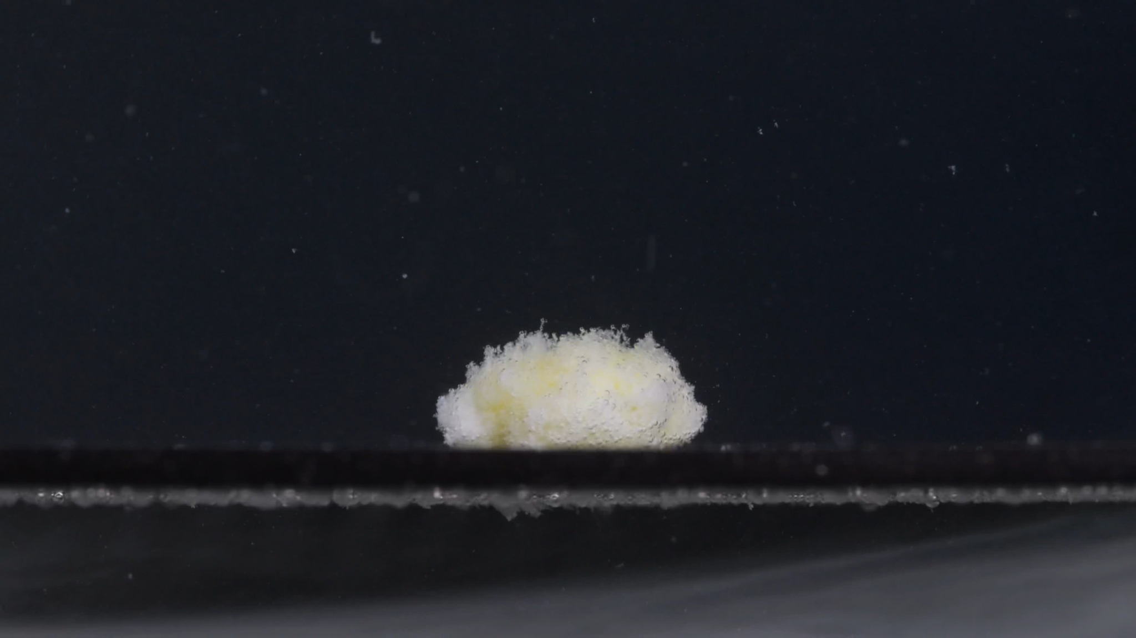
Group A, picture 4 — 45 minutes
Assistant
Overall observation: At 45 minutes, the tablet remains as a single residual mound, but the original white oval/caplet shape is completely lost. The visible mass is now low, rounded, irregular, porous, and granular, with mixed white and pale-yellow areas. Compared with the 30-minute image, the disintegration appears to have progressed slightly, mainly through continued surface erosion and soft collapse rather than a dramatic breakup into large fragments.
1. Color change - The tablet shows a white to pale-yellow mixed color. - Yellow areas are still visible inside the mass, but the outer surface appears covered by many white fine particles. - The surrounding liquid does not show strong uniform yellow staining; color change remains mainly localized around the tablet body.
2. Shape change - The tablet no longer has its original caplet-like contour. - It appears as an irregular, flattened mound resting on the bottom surface. - The top edge is uneven and fluffy-looking, suggesting loosened surface material. - No clear large separated pieces are visible in this frame.
3. Surface texture change - The surface is highly rough, porous, and powdery. - Fine granules cover most of the visible tablet surface. - The surface looks fragile and loosened, with no remaining smooth film-coated appearance. - The upper margin has small irregular projections, consistent with ongoing erosion.
4. Volume / size change - Compared with the 0-minute baseline, the tablet has undergone a major reduction in visible height and structural definition. - Compared with 30 minutes, the mass appears similar or slightly flatter, with continued edge softening. - The reduction is mainly vertical collapse and surface loss; the remaining mass still occupies a moderate horizontal width.
5. Dissolution speed and time - From 30 to 45 minutes, the disintegration appears progressive but not abrupt. - The tablet continues to erode slowly into fine particles. - Because a central mound remains, complete disintegration has not occurred by 45 minutes.
6. Physical state change - The tablet has changed from a solid coated tablet into a soft, weakened, porous aggregate. - The remaining structure appears cohesive but fragile. - The visible state suggests partial collapse, surface powdering, and continued internal weakening.
7. Dissolution medium - The medium appears mostly clear/dark in the background, with scattered small particles visible. - There is no obvious dense cloud spreading through the whole liquid. - Most disintegration material appears concentrated near the tablet and the bottom surface.
8. Fragment distribution and density - Fragment density remains highest on the surface of the residual mound and immediately around its base. - The fragments are mainly fine powder-like particles, not large detached chunks. - A few small suspended particles are visible above and around the tablet, but the main debris remains localized.
45-minute interpretation for Group A: At 45 minutes, Group A shows a slow continuing erosion stage. The tablet is now a flattened yellow-white porous mound with substantial loss of original shape and size, but it still has one central residual body. The main disintegration pattern is surface granulation, powder formation, vertical collapse, and localized particle accumulation, rather than complete dispersion.

Group A — Picture 5 — 60 minutes
User
When you describe the drug, please make sure your English description is accurate, think carefully, and reduce hallucinations. Each picture is taken 15 minutes apart. This is Group A picture 5.
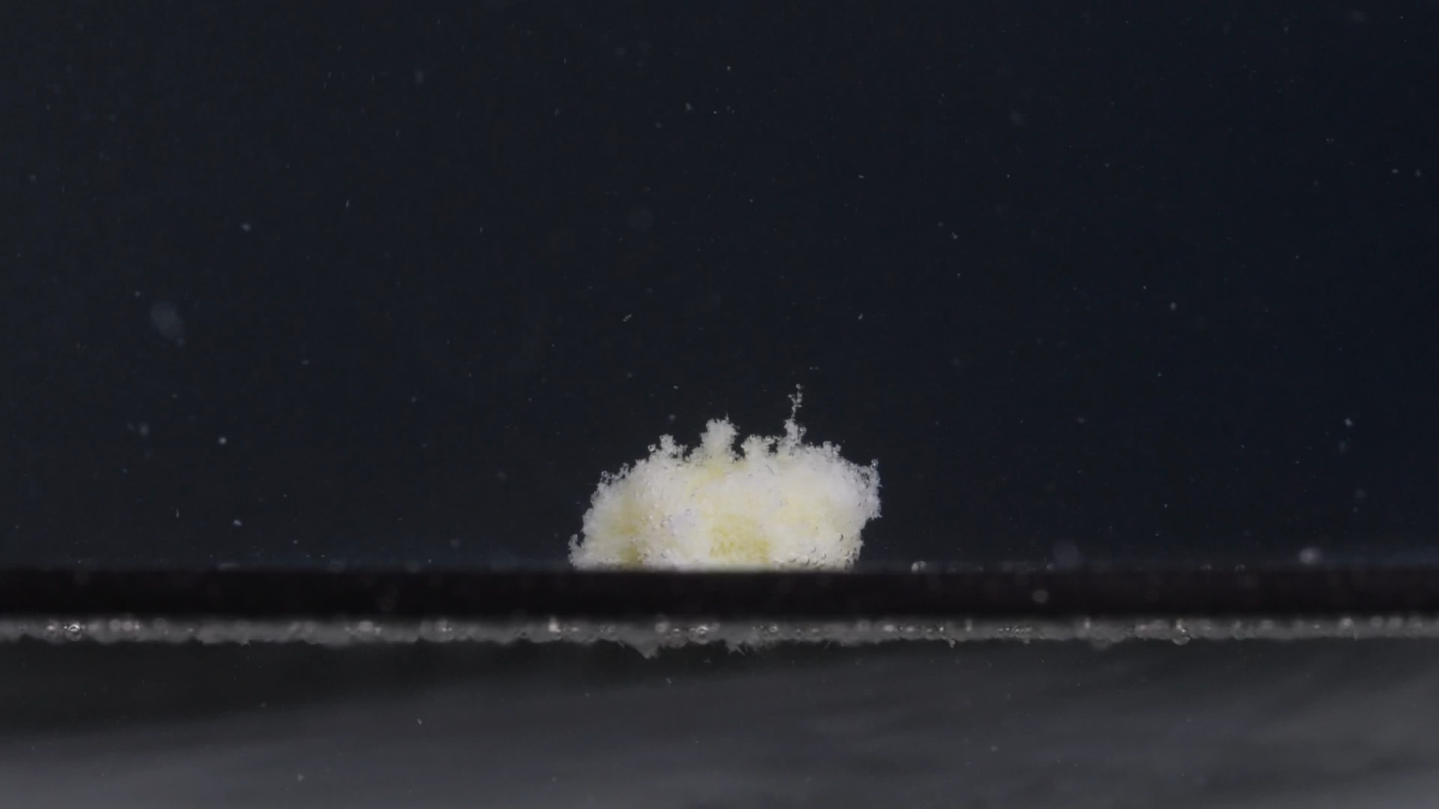
Group A, picture 5 — 60 minutes
Assistant
Overall observation: At 60 minutes, the tablet is still visible as a small residual mound, but it has lost the original smooth oval/caplet form completely. The remaining material appears soft, porous, fluffy, and granular, with mixed white and pale-yellow areas. Compared with 45 minutes, the change is gradual rather than dramatic: the tablet seems slightly more eroded and less compact, but it has not fully dispersed.
1. Color change - The remaining mass is mainly white to off-white, with pale yellow regions visible inside or beneath the powdery surface. - The yellow color is still localized within the tablet residue rather than spreading strongly through the whole medium. - The surrounding medium does not appear uniformly yellow or strongly turbid in this image.
2. Shape change - The original tablet shape is no longer recognizable. - The residue appears as an irregular, low mound with a loose, uneven upper boundary. - Several small upward projections are visible on the top surface, suggesting loosened or lifted granular material rather than a firm intact tablet surface.
3. Surface texture change - The surface is highly rough, porous, and powder-like. - The outer layer looks fragile and fluffy, with many fine granules attached to the remaining mass. - No smooth film-coated surface remains visible.
4. Volume / size change - Compared with the 0-minute baseline, the visible tablet volume has decreased substantially. - Compared with 45 minutes, the mound appears slightly smaller and less compact, although the difference is not large. - The main size reduction pattern is still loss of height, surface erosion, and soft collapse, rather than complete breakup into large pieces.
5. Dissolution speed and time - From 45 to 60 minutes, the disintegration appears slow and continuing. - Most rapid visible change occurred earlier, especially between 0 and 15 minutes. - At 60 minutes, the process is in a later erosion stage, with fine-particle formation continuing but a central residue still present.
6. Physical state change - The tablet has changed from a solid coated caplet into a weak, porous, partially collapsed aggregate. - The structure appears soft and fragile, but still cohesive enough to remain as one main mound. - Complete collapse into dispersed powder has not occurred by this time point.
7. Dissolution medium - The medium appears mostly clear/dark in the background, with scattered fine particles visible. - There is no obvious dense cloud spreading throughout the whole liquid. - Most visible material remains near the tablet residue and along the bottom area.
8. Fragment distribution and density - Fragment density is highest on the residual mound and immediately around its base. - The fragments are mostly fine powder-like particles, not large detached pieces. - A few small suspended particles are visible above the tablet, but the dominant debris remains localized.
Group A preliminary progression summary, 0–60 minutes: Group A shows a pattern of rapid early structural change followed by slower erosion. The tablet begins as a white, intact, thick oval/caplet-like tablet at 0 minutes. By 15 minutes, it has already lost much of its smooth surface and exposes a yellow inner material. From 30 to 60 minutes, it remains as a yellow-white porous granular mound, gradually becoming flatter, fluffier, and more eroded, but not fully disappearing. The most characteristic features are major loss of original shape, reduction in height, exposure of pale-yellow interior, powdery surface granulation, and localized fragment accumulation.
Please upload Group B — picture 1 at 0 minutes.

3. Group B Image Series

Group B — Picture 1 — 0 minutes
User
When you describe the drug, please make sure your English description is accurate, think carefully, and reduce hallucinations. Each picture is taken 15 minutes apart. This is Group B picture 1.
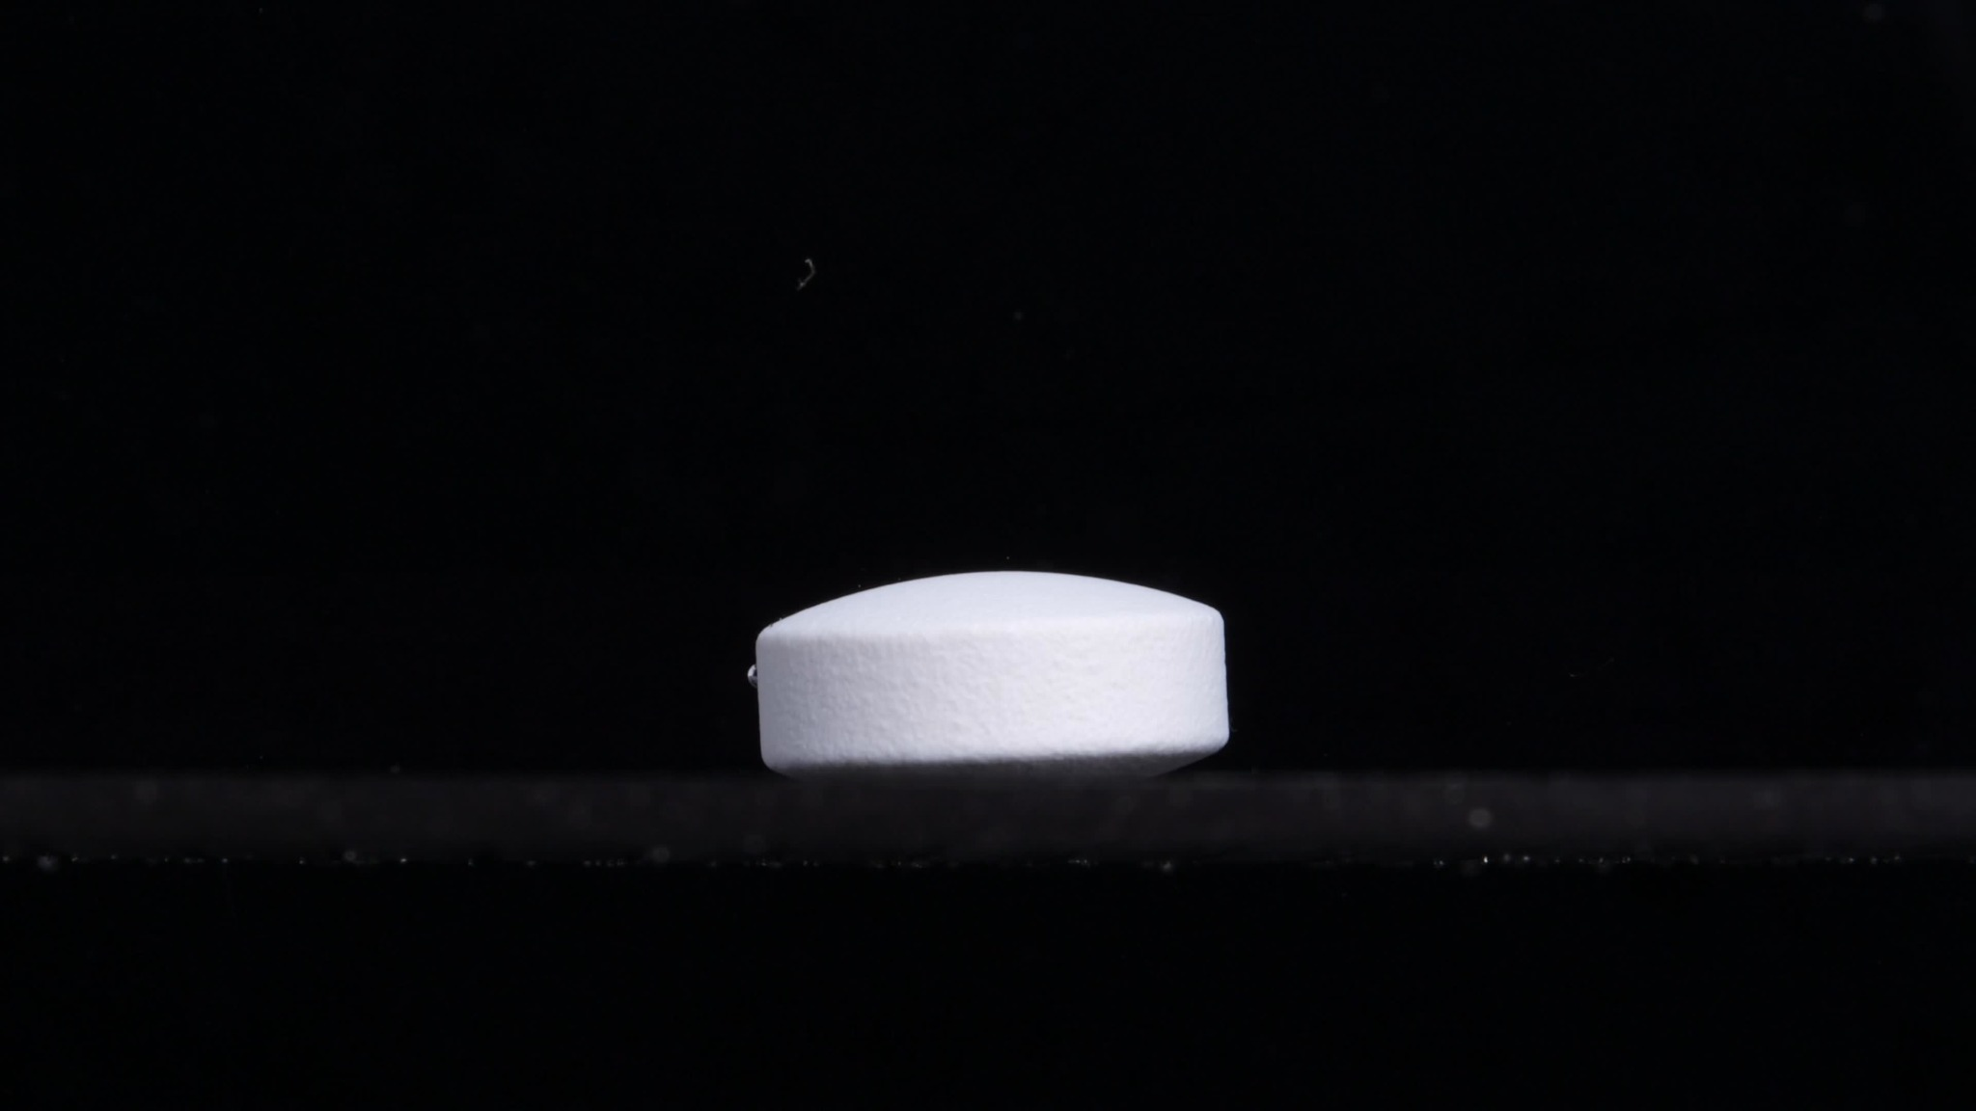
Group B, picture 1 — 0 minutes
Assistant
Overall observation: The tablet is intact at the starting point. It appears as a white to off-white, oval / caplet-like tablet seen from the side. The upper surface is smoothly curved, the side wall is relatively straight, and the lower edge is in contact with the bottom surface of the vessel. No visible disintegration is present yet.
1. Color change - The tablet is uniformly white / off-white. - No yellow inner material is visible at this time point. - The surrounding medium appears clear or visually dark due to the background; no obvious turbidity, colored diffusion, or cloudy zone is visible.
2. Shape change - The tablet keeps a clear oval/caplet-like side profile. - Its contour is regular and continuous. - No cracks, splits, edge loss, bending, or collapse can be seen.
3. Surface texture change - The surface appears mostly smooth and compact. - The side wall has a very fine texture, but this may be normal tablet surface texture rather than disintegration. - No obvious pores, peeling, rough granular layer, or powder detachment is visible.
4. Volume / size change - This image should be used as the baseline size for Group B. - The tablet appears thick and structurally complete. - There is no visible reduction in height, width, or total volume.
5. Dissolution speed and time - At 0 minutes, dissolution or disintegration has not visibly started. - No particle release, surface erosion, medium clouding, or contour loss is observable.
6. Physical state change - The tablet remains in a solid, coherent state. - There is no visible swelling, softening, cracking, fragmentation, or internal collapse.
7. Dissolution medium - The visible medium around the tablet appears mostly clear, with no obvious suspended drug particles. - A small bubble or bright spot near the side may be present, but it should not be interpreted as tablet disintegration.
8. Fragment distribution and density - No fragments are visible. - Fragment density is zero or not detectable. - The tablet remains as one intact body resting on the bottom.
Preliminary comparison with Group A at 0 minutes: Group B picture 1 is very similar to Group A picture 1 at 0 minutes: both show a white, intact, thick, oval/caplet-like tablet with a smooth surface and no visible initial disintegration. However, this baseline similarity alone is not enough to conclude that they are the same drug. The later 15, 30, 45, and 60-minute disintegration patterns will be more important for the final judgment.

Group B — Picture 2 — 15 minutes
User
When you describe the drug, please make sure your English description is accurate, think carefully, and reduce hallucinations. Each picture is taken 15 minutes apart. This is Group B picture 2.
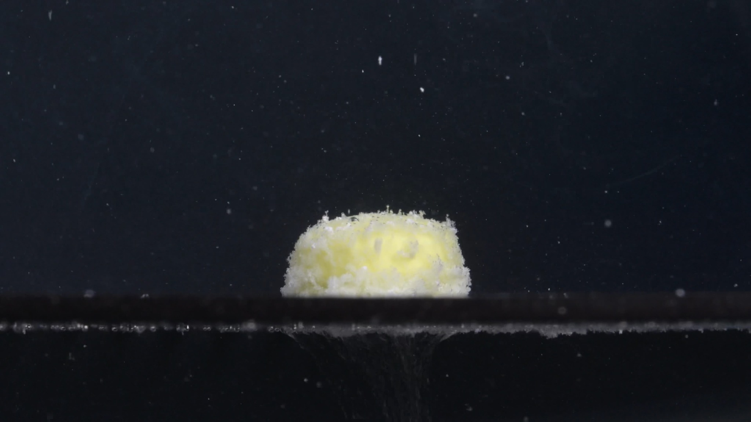
Group B, picture 2 — 15 minutes
Assistant
Overall observation: At 15 minutes, Group B shows clear and substantial disintegration. The original smooth white caplet-like tablet has changed into a shorter, rounded, yellow-white granular mound. The tablet is still present as one main body, but the surface coating appears disrupted, and yellow inner material is widely exposed.
1. Color change - The tablet has changed from uniform white/off-white at 0 minutes to a mixed white and pale yellow appearance. - The yellow region is broad and central, suggesting exposure of the inner tablet material. - The surrounding liquid does not appear uniformly yellow; the color change is mainly localized on the tablet mass.
2. Shape change - The original oval/caplet outline is largely lost. - The tablet has become a rounded, shortened mound with an uneven upper edge. - It remains as a single main mass; no large detached pieces are clearly visible.
3. Surface texture change - The surface is now rough, porous, and granular. - Fine white particles cover the outer surface, especially around the top and lower edges. - The smooth film-coated appearance seen at 0 minutes is no longer visible.
4. Volume / size change - Compared with Group B picture 1, the tablet height appears clearly reduced. - The width remains relatively broad, but the tablet is more compact and lower. - The size reduction appears mainly due to surface erosion, softening, and vertical collapse, rather than complete fragmentation.
5. Dissolution speed and time - By 15 minutes, the tablet has already reached a moderate to advanced early disintegration stage. - The most obvious change is rapid surface breakdown with exposure of yellow inner material. - The central body remains, so disintegration is not complete.
6. Physical state change - The tablet has changed from a firm solid caplet into a softened, porous, partially collapsed aggregate. - The internal material appears exposed and weakened. - Fine particle generation is visible, but the main mass is still cohesive.
7. Dissolution medium - The background medium appears mostly clear/dark, with many small bright specks visible in the field. - Some specks may be suspended particles or imaging artifacts, so I would not overinterpret them as all being drug fragments. - There is no obvious dense cloud spreading through the entire medium.
8. Fragment distribution and density - Fragment density is highest on the tablet surface and around the base. - The fragments are mainly fine powder-like granules, not large pieces. - Some small particles are visible above the tablet, but the main disintegration material remains localized near the tablet.
Preliminary comparison with Group A at 15 minutes: Group B at 15 minutes looks very similar to Group A at 15 minutes: both show a white tablet becoming a yellow-white, rough, porous, granular mound, with reduced height and exposed yellow inner material. At this stage, the two groups appear highly consistent, but I will wait for the remaining Group B images before making the final same-drug/different-drug judgment.

Group B — Picture 3 — 30 minutes
User
When you describe the drug, please make sure your English description is accurate, think carefully, and reduce hallucinations. Each picture is taken 15 minutes apart. This is Group B picture 3.
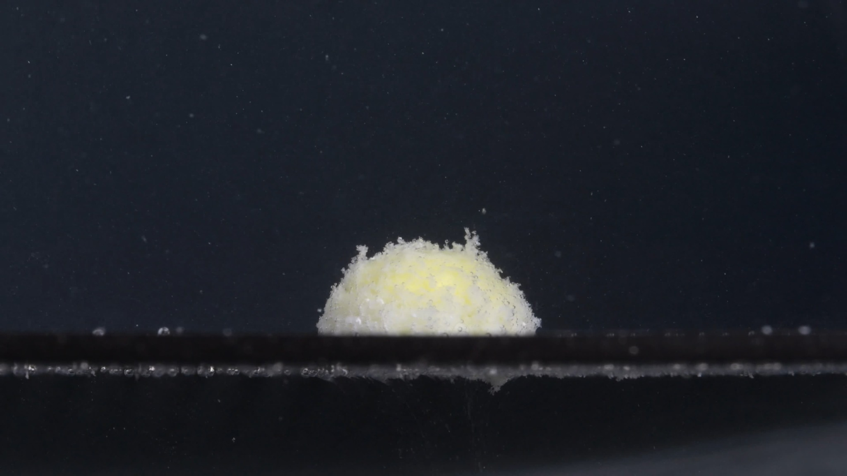
Group B, picture 3 — 30 minutes
Assistant
Overall observation: At 30 minutes, Group B remains as one main yellow-white residual mound. The original smooth caplet shape is no longer visible. Compared with 15 minutes, the tablet appears to have continued disintegrating mainly through surface erosion, granular loosening, and partial collapse, but it has not broken apart into large separated pieces.
1. Color change - The visible mass is mostly pale yellow with white/off-white granular material on the surface. - The yellow inner material remains broadly exposed, especially in the central area. - The surrounding medium does not show obvious uniform yellow staining; the color change is still mainly localized to the tablet residue.
2. Shape change - The tablet has changed from an intact caplet into a rounded, irregular mound. - The top boundary is uneven, with small raised granular projections. - The original straight side wall and smooth curved top are no longer recognizable. - No large detached fragments are clearly visible.
3. Surface texture change - The surface is rough, porous, and powdery. - Fine particles cover the visible surface, giving it a fluffy or sponge-like texture. - The surface appears fragile rather than compact or film-coated.
4. Volume / size change - Compared with the 0-minute baseline, the tablet has clearly lost height and structural definition. - Compared with 15 minutes, the mass appears slightly more eroded and less regular, though the remaining central mound is still substantial. - The main size change is vertical reduction and edge softening, not complete disappearance.
5. Dissolution speed and time - From 15 to 30 minutes, the process appears moderate and progressive, not sudden. - The most rapid visible transformation likely occurred during the first 15 minutes, when the coating/surface integrity was lost. - At 30 minutes, dissolution continues mainly by gradual conversion of the residual mass into fine particles.
6. Physical state change - The tablet is no longer a firm solid body; it appears as a softened, porous, weakened aggregate. - The residual mound still holds together, so complete structural collapse has not occurred. - The visible surface suggests ongoing internal weakening and particle generation.
7. Dissolution medium - The medium appears mostly clear/dark in the background, with scattered small bright specks. - Some specks may be suspended particles, bubbles, or imaging artifacts, so I would not treat all of them as drug fragments. - No dense, uniform turbidity cloud is clearly visible.
8. Fragment distribution and density - Fragment density is highest on the tablet surface and around the base. - The fragments are mainly fine powder-like particles rather than large broken pieces. - A small number of particles are visible above the mound, but most material remains localized near the tablet.
Comparison with Group A at 30 minutes: Group B at 30 minutes is highly similar to Group A at 30 minutes. Both show a pale yellow-white, flattened granular mound, loss of the original caplet outline, strong surface roughening, and localized fine-particle accumulation. At this stage, the two groups continue to look consistent with the same disintegration pattern, but I will wait for Group B pictures 4 and 5 before giving the final same-drug judgment.

Group B — Picture 4 — 45 minutes
User
When you describe the drug, please make sure your English description is accurate, think carefully, and reduce hallucinations. Each picture is taken 15 minutes apart. This is Group B picture 4.
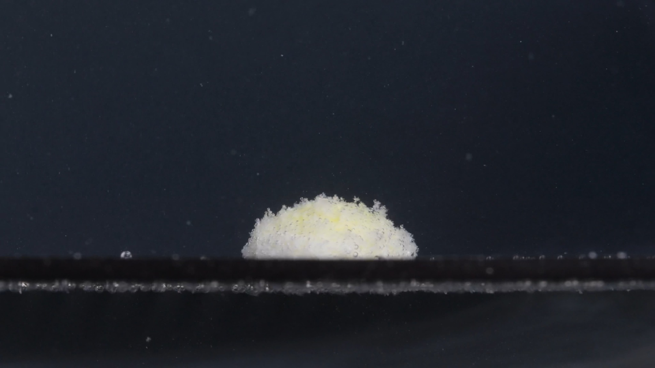
Group B, picture 4 — 45 minutes
Assistant
Overall observation: At 45 minutes, the tablet remains as a single residual mound on the bottom surface. The original intact caplet shape has disappeared. The remaining mass is low, rounded, porous, and granular, with a mainly white/off-white surface and faint pale-yellow areas visible within the mass. Compared with Group B picture 3 at 30 minutes, the change appears gradual: the tablet is slightly more eroded and flatter, but it is still not fully dispersed.
1. Color change - The residue is mostly white to off-white, with some pale yellow visible in the central and upper areas. - The yellow color is less sharply exposed than at 15 minutes, partly because the surface is covered by white powder-like material. - The surrounding medium does not show obvious strong yellow staining or uniform turbidity.
2. Shape change - The original oval/caplet outline is no longer recognizable. - The tablet has become a rounded, irregular mound. - The top boundary is uneven and fuzzy, but the mass still remains cohesive. - No large separated fragments are clearly visible.
3. Surface texture change - The surface is rough, porous, and granular. - Fine particles cover most of the visible surface, producing a powdery or fluffy appearance. - The original smooth coating is no longer visible. - Small raised granules are present along the upper edge, indicating continuing surface loosening.
4. Volume / size change - Compared with the 0-minute baseline, the tablet has lost much of its original height and clean side-wall structure. - Compared with 30 minutes, it appears slightly lower and more eroded, but the main residual body remains. - The size reduction is mainly due to vertical collapse and surface erosion, not complete fragmentation.
5. Dissolution speed and time - Between 30 and 45 minutes, the disintegration appears slow to moderate. - The fastest visible transformation occurred earlier, between 0 and 15 minutes. - At 45 minutes, the tablet is in a later erosion stage, with gradual powder formation rather than rapid breakup.
6. Physical state change - The tablet has changed into a softened, porous, weakened aggregate. - It appears fragile and partially collapsed, but it still holds together as one main mass. - Complete collapse into dispersed particles has not occurred.
7. Dissolution medium - The medium appears mostly clear/dark in the background. - Some small bright specks are visible, but they may include suspended particles, bubbles, or imaging noise, so I would not treat all of them as drug fragments. - No dense cloud spreading through the entire medium is clearly visible.
8. Fragment distribution and density - Fragment density is greatest on the surface of the residual mound and around the base. - The fragments are mainly fine powder-like particles rather than large pieces. - Most debris remains localized near the tablet, with only limited visible suspension above it.
Comparison with Group A at 45 minutes: Group B at 45 minutes is still very similar to Group A at 45 minutes. Both show a yellow-white porous mound, major loss of the original caplet shape, reduced height, rough powdery surface, and localized fine-particle accumulation. Group B may appear slightly more compact and dome-like in this frame, while Group A looked a little more irregular, but this difference could be due to viewing angle, lighting, or natural variation in disintegration.
Please upload Group B — picture 5 at 60 minutes.

Group B — Picture 5 — 60 minutes
User
When you describe the drug, please make sure your English description is accurate, think carefully, and reduce hallucinations. Each picture is taken 15 minutes apart. This is Group B picture 5.
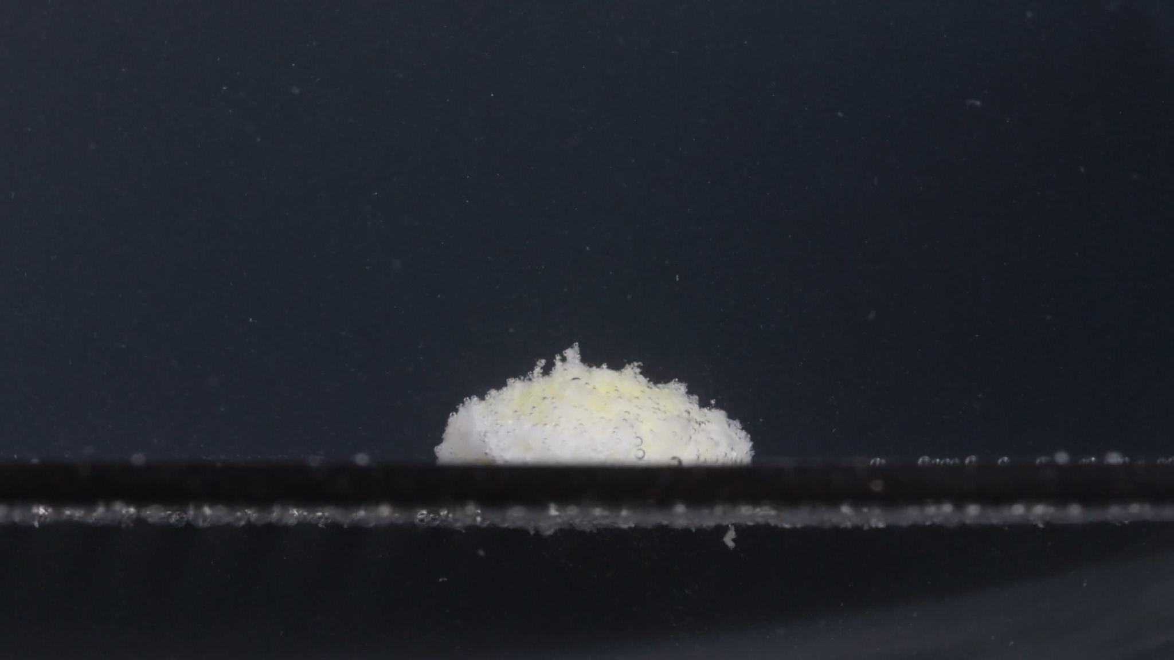
Group B, picture 5 — 60 minutes
Assistant
Overall observation: At 60 minutes, Group B remains as a low, irregular residual mound. The original white, smooth, oval/caplet-like tablet shape is no longer recognizable. The remaining material is porous, powdery, and granular, with a mainly white/off-white surface and faint pale-yellow areas still visible inside the mass.
1. Color change - The residue is mostly white to off-white, with some pale yellow visible near the upper-central area. - The yellow inner material is still present but partly masked by white powdery surface material. - The surrounding medium does not show strong uniform yellow staining or dense turbidity.
2. Shape change - The original caplet shape has completely disappeared. - The tablet has become a flattened, rounded, irregular mound. - The upper edge is uneven and slightly fluffy, with small protruding granular structures. - No large detached pieces are clearly visible.
3. Surface texture change - The surface is rough, porous, and powder-like. - Fine granules cover most of the visible surface. - The smooth film-coated appearance is no longer present.
4. Volume / size change - Compared with Group B picture 1, the tablet has lost substantial height and structural definition. - Compared with picture 4 at 45 minutes, the mound appears slightly lower and more eroded, but the change is not dramatic. - The main size change is vertical collapse and surface erosion, while a central residual mass remains.
5. Dissolution speed and time - From 45 to 60 minutes, the disintegration appears slow and gradual. - The fastest visible change occurred earlier, especially from 0 to 15 minutes. - At 60 minutes, the tablet is still not fully dispersed; it remains in a late-stage erosion phase.
6. Physical state change - The tablet has changed from a firm solid caplet into a soft, weakened, porous aggregate. - It appears fragile but still cohesive enough to remain as one main residual mound. - Complete collapse into freely dispersed powder is not observed.
7. Dissolution medium - The medium appears mostly clear/dark, with scattered small specks visible. - Some specks may be suspended particles, bubbles, or imaging artifacts, so they should not all be assumed to be drug fragments. - No dense cloud of drug material is clearly spreading throughout the whole medium.
8. Fragment distribution and density - Fragment density is highest on the tablet residue and immediately around its base. - The visible fragments are mainly fine powder-like particles, not large broken fragments. - Most material remains localized near the original tablet position.
Final comparison: Group A vs Group B: Based on the full 0–60 minute image series, Group A and Group B are highly likely to be images of the same drug or at least the same/similar tablet formulation under similar conditions. This is an image-based judgment, not a chemical confirmation.
The strongest matching features are: - Initial appearance: both begin as a white/off-white, thick, oval/caplet-like tablet with a smooth surface and clear contour. - 15-minute change: both rapidly lose the smooth white surface and expose a pale-yellow inner material, forming a rough granular mound. - 30–45 minutes: both remain as yellow-white porous residual mounds, with strong surface granulation and localized fine-particle accumulation. - 60 minutes: both still show a cohesive residual mound, meaning neither group fully disperses within the observed 60-minute period. - Size and shape pattern: both show major early loss of height and original caplet contour, followed by slower erosion rather than sudden breakup into large fragments.
Minor differences are visible: Group A appears slightly more irregular/fluffy in some later frames, while Group B appears slightly more compact or dome-like in some images. However, these differences are small and could be caused by viewing angle, lighting, tablet position, or natural variation during disintegration.
Conclusion: My judgment: Group A and Group B are likely from the same drug/formulation. Confidence: high, but not absolute, because image analysis alone cannot confirm chemical identity. The disintegration “fingerprint” of the two groups is very similar across color, shape, size reduction, surface texture, residual mass formation, and fragment distribution.

4. Final Eight-Dimension Comparison and Determination
User
Please compare Groups A and B based on their disintegration characteristics across the eight dimensions to determine if they are from the same drug or not, and explain why you think so.
Assistant
Final judgment: My conclusion: Group A and Group B are very likely from the same drug or from an extremely similar formulation of the same drug. This is an image-based judgment, not chemical confirmation. I would rate the similarity as high because the two groups share the same disintegration “fingerprint” across the full 0–60 minute sequence.
I compared them using the eight dimensions required for drug-disintegration image description: color, shape, surface texture, volume, dissolution speed/time, physical state, dissolution medium, and fragment distribution/density.
Eight-dimension comparison:
Dimension | Group A | Group B | Comparison
1. Color change | Starts white/off-white. By 15 min, pale yellow inner material is exposed. From 30–60 min, residue remains yellow-white. | Same pattern: white/off-white at 0 min, yellow inner material exposed by 15 min, yellow-white residue afterward. | Highly similar. Both show localized yellow exposure rather than strong yellow diffusion through the whole medium.
2. Shape change | Starts as an intact thick oval/caplet-like tablet. By 15 min, becomes a rounded mound. By 30–60 min, original caplet outline is lost. | Same: intact caplet-like shape at 0 min, then rounded mound by 15 min, with no recognizable original shape later. | Highly similar. Both lose the original shape early and remain as one main mound rather than breaking into large pieces.
3. Surface texture change | Smooth surface at 0 min. Becomes rough, porous, granular, and fluffy after 15 min. | Same rough, porous, powdery surface develops after 15 min. | Highly similar. Both show surface granulation rather than clean cracking or large flaking.
4. Volume / size change | Major early height reduction from 0 to 15 min. Afterward, slow flattening and erosion continue. | Same major early height loss, followed by slow erosion from 30 to 60 min. | Highly similar. The size-reduction pattern is almost the same: rapid early vertical collapse, then slower late-stage erosion.
5. Dissolution speed and time | Fastest visible change occurs in the first 15 minutes. From 15–60 min, the process slows and remains incomplete. | Same timing: strong early disintegration by 15 min, then gradual slow erosion through 60 min. | Highly similar. Both show a rapid early phase followed by a slower residual phase.
6. Physical state change | Changes from solid coated tablet to softened, porous, partially collapsed aggregate. Still cohesive at 60 min. | Same: solid tablet becomes soft porous aggregate and remains cohesive at 60 min. | Highly similar. Neither group fully disperses into free powder within 60 min.
7. Dissolution medium | Medium remains mostly visually clear/dark, with scattered fine particles. No strong whole-medium turbidity is obvious. | Same appearance: no dense uniform cloud, only scattered specks and localized material near the tablet. | Similar. No major difference in medium turbidity or color spreading is visible.
8. Fragment distribution and density | Fragments are mainly fine powder-like particles concentrated on the tablet surface and around the base. Few large detached fragments. | Same: fine particles concentrated around the residual mound and base, with limited dispersion upward. | Highly similar. Both show localized fine-particle accumulation rather than wide fragment dispersal.
Assistant
Why I think they are the same drug/formulation: The strongest evidence is that both groups show the same time-dependent disintegration sequence.
At 0 minutes, both are white/off-white, thick, smooth, oval/caplet-like tablets with clear contours. At 15 minutes, both undergo a major transition: the white exterior is disrupted, pale-yellow inner material appears, and the tablet becomes a rough granular mound. At 30 and 45 minutes, both remain as yellow-white porous mounds with strong surface roughness and localized fine-particle accumulation. At 60 minutes, both still retain a cohesive residual mound; neither fully dissolves or disperses.
The small differences are not enough to suggest a different drug. Group A appears slightly more irregular or fluffy in some later frames, while Group B appears slightly more compact or dome-like. However, those differences could reasonably come from camera angle, lighting, tablet orientation, local fluid movement, or normal tablet-to-tablet variation.
Final determination: Groups A and B are likely the same drug or the same/similar Doxycycline Hyclate tablet formulation. The conclusion is based mainly on the matched initial size/shape, early yellow exposure, rapid first-15-minute collapse, porous granular surface formation, slow late-stage erosion, and similar localized fragment distribution.

